For this week my task is to experience with markers and find ways to interact with them and create some kind of a controller with the markers. This controllers should be able to perform basic actions such as a slide to the right or to the left.

I have created 2 layouts with a big marker and 4 smaller markers. The big marker on both layout are identical and are used to see the effects of the hand gestures performed on the other 4 markers. Hand gestures are performed by hovering over at least 2 markers and the models on top of the markers should disappear to make that motion registered as a hand gesture. With the help of the knowledge about marker detection that I gathered from my last week’s work I was able to detect whether a marker’s model is present in the scene or not.

On the first layout (see Figure 1.) I created, there are 2 small markers on the left, aligned horizontally and 2 small markers aligned vertically on the right. I believe this layout is more traditional and easy to grasp with 4 small markers are being used as a controller interface and resembling 4 directions. The bigger markers is used for presenting the real content. I have numbered the smaller markers for convenience.
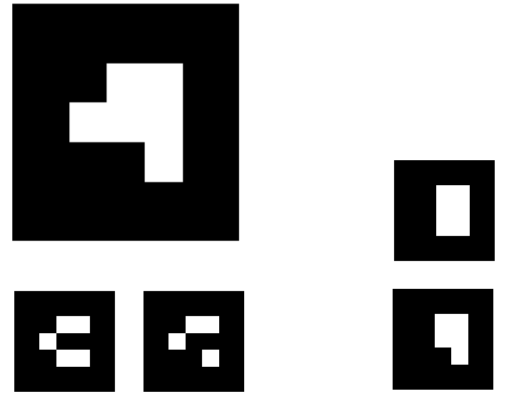

3

1
2
1
2
Figure 1.
4

I have defined 4 hand gestures for this layout. They are as follows:
- swipe from left to right covering marker 1 and marker 2 in that order(swipe right)
- swipe from right to left covering marker 2 and marker 1 in that order(swipe left)
- swipe from up to down covering marker 3 and marker 4 in that order(swipe down)
- swipe from down to up covering marker 4 and marker 3 in that order(swipe up)
Also I have created an easy to use Javascript interface for defining new hand gestures.

Every swipe action is able to emit an event which can later be used to manipulate the real content which is present in the bigger marker. For the following example swiping right moves the big red cube to right and swiping left moves it back to its original position. Please notice that the frames in Figure 2. are rotated 90 degrees. Although it is not demonstrated with a screenshot swiping up and down (using marker 3 and 4) can be used to change the big cube’s material color from red to white or from white to red.
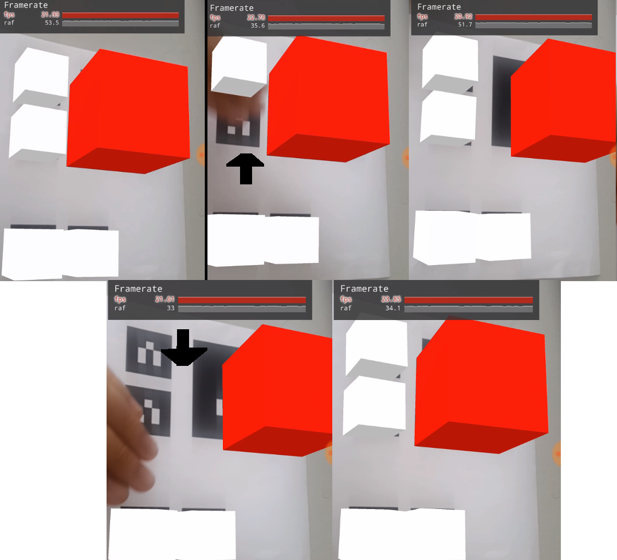
Figure 2.
I find this layout easier to interact with as I and probably the majority of computer users are more comfortable with 4 direction arrows which is a somewhat closer approach than the following marker layout.

Although I defined how hand gestures should be performed, sometimes on poor lighting conditions some markers may disappear and reappear quickly when AR.js can’t recognize markers for a brief time and this behaviour may register as a hovering action. I believe this is a problem that can be fixed by using some kind of thresholding technique, I haven’t had the time to fix it this week but I plan to do it next week. However, if the lighting is good and no flickering happens on the markers the hand gestures should be able to be performed as intended.

The second layout(Figure 3.) consists of 1 big marker for main content and 4 smaller markers for hand gestures. I numbered the smaller ones for convenience.

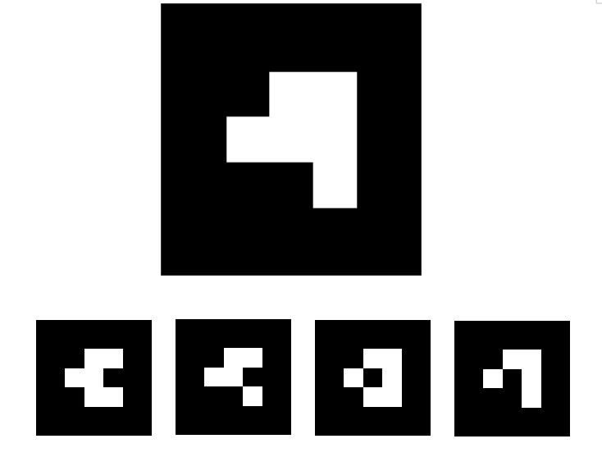

1
2
3

4

Figure 3.
I have defined 4 hand gestures for this marker which emit 4 separate events. They are as follows:
- swipe from left to right covering marker 3 and marker 4 in that order(short swipe right)
- swipe from right to left covering marker 2 and marker 1 in that order(short swipe left)
- swipe from left to right covering marker 2 and marker 3 and marker 4 in that order(long swipe right)
- swipe from right to left covering marker 3 and marker 2 and marker 1 in that order(long swipe left)
This events emit manipulation events(rotation and material color) for the cube on the bigger marker.
I have uploaded my work to my github for you to check my work at:
https://github.com/uygaruyaniksoy/ucd-aha
and pushed the code to my domain so you can check the gestures yourself without cloning the repo:
https://uygar.me
Also I attached the 2 marker layout file to this e-mail so you can print and test them

