# Exercise 1: nslookup

## 1.

> ip addresses of www.google.com

203.5.76.212#53; 203.5.76.213#53; 203.5.76.214#53; 203.5.76.215#53; 203.5.76.216#53; 203.5.76.217#53; 203.5.76.218#53; 203.5.76.219#53; 203.5.76.208#53; 203.5.76.209#53; 203.5.76.210#53; 203.5.76.211#53

Different servers can be access through different IP addresses. Using more servers makes website load balancing.

## 2.

Name is localhost.

It points to local computer itself.

# Exercise 2: ifconfig

## 1.

Eth0:

Ipv4 addr:129.94.242.19

Ipv6 addr:fe80::250:56ff:fe8f:a9/64

Eth1:

inet6 addr: fe80::250:56ff:fe8f:790a/64 Scope:Link

inet6 addr: 2001:388:c:4193:129:94:242:19/64 Scope:Global

## 2.

Eth1, eth2, lo

# Exercise 3: netstat

## 1.

Proto Recv-Q Send-Q Local Address Foreign Address State

tcp 0 0 oboe02.orchestra.:57155 14.17.42.125:https ESTABLISHED

tcp 0 0 oboe02.orchestra.:48918 cache.google.com:https ESTABLISHED

tcp 0 0 oboe02.orchestra.:54343 syd15s01-in-f14.1:https ESTABLISHED

tcp 1 0 oboe02.orchestra.:57314 bandleader.orchest:ldap CLOSE_WAIT

tcp 1 0 oboe02.orchestra.:57330 bandleader.orchest:ldap CLOSE_WAIT

tcp 398 0 oboe02.orchestra.:48917 cache.google.com:https ESTABLISHED

tcp 0 0 oboe02.orchestra.:48596 151.101.100.133:https ESTABLISHED

tcp 1 0 oboe02.orchestra.:57327 bandleader.orchest:ldap CLOSE_WAIT

tcp 0 0 oboe02.orchestra.:39574 103.7.30.100:https ESTABLISHED

tcp 1 0 oboe02.orchestra.:57337 bandleader.orchest:ldap CLOSE_WAIT

tcp 0 0 oboe02.orchestra.:48597 151.101.100.133:https ESTABLISHED

tcp 1 0 oboe02.orchestra.:57304 bandleader.orchest:ldap CLOSE_WAIT

tcp 0 0 oboe02.orchestra.:43586 oboe02.orchestra.cs:x11 TIME_WAIT

tcp 1 0 oboe02.orchestra.:57084 bandleader.orchest:ldap CLOSE_WAIT

tcp 0 0 oboe02.orchestra.:44458 tj-in-f188.1e100.n:5228 ESTABLISHED

tcp 1 0 oboe02.orchestra.:57352 bandleader.orchest:ldap CLOSE_WAIT

tcp 0 0 oboe02.orchestra.:59175 103.7.30.100:www TIME_WAIT

tcp 0 0 oboe02.orchestra.:60170 syd10s01-in-f14.1:https ESTABLISHED

tcp 0 0 oboe02.orchestra.:52730 103.7.30.66:https TIME_WAIT

tcp 1 0 oboe02.orchestra.:57338 bandleader.orchest:ldap CLOSE_WAIT

tcp 1 0 oboe02.orchestra.:57319 bandleader.orchest:ldap CLOSE_WAIT

tcp 0 0 oboe02.orchestra.:57362 bandleader.orchest:ldap ESTABLISHED

tcp 1 0 oboe02.orchestra.:57346 bandleader.orchest:ldap CLOSE_WAIT

tcp 1 0 oboe02.orchestra.:57320 bandleader.orchest:ldap CLOSE_WAIT

tcp 0 0 oboe02.orchestra.:48598 151.101.100.133:https ESTABLISHED

tcp 0 0 oboe02.orchestra.:46225 203.205.151.215:https ESTABLISHED

tcp 0 0 oboe02.orchestra.:42917 113.108.11.37:https ESTABLISHED

tcp 0 0 oboe02.orchestra.:48599 151.101.100.133:https ESTABLISHED

tcp 0 0 oboe02.orchestra.:39582 14.18.245.239:https ESTABLISHED

tcp 0 0 oboe02.orchestra.:39581 14.18.245.239:https ESTABLISHED

tcp 0 0 oboe02.orchestra.:49450 59.37.96.191:https ESTABLISHED

tcp 1 0 oboe02.orchestra.:57350 bandleader.orchest:ldap CLOSE_WAIT

tcp 0 0 oboe02.orchestra.:53738 203.205.150.121:https ESTABLISHED

tcp 1 0 oboe02.orchestra.:59174 103.7.30.100:www CLOSE_WAIT

tcp 0 0 oboe02.orchestra.:48591 151.101.100.133:https ESTABLISHED

tcp 0 0 oboe02.orchestra.:60209 syd10s01-in-f14.1:https ESTABLISHED

tcp 1 0 oboe02.orchestra.:57318 bandleader.orchest:ldap CLOSE_WAIT

tcp 0 0 oboe02.orchestra.:43893 163.177.71.148:https ESTABLISHED

tcp 0 0 oboe02.orchestra.:54355 syd15s01-in-f14.1:https ESTABLISHED

tcp 0 0 oboe02.orchestra.:59657 syd09s01-in-f3.1e:https ESTABLISHED

tcp 1 0 oboe02.orchestra.:57344 bandleader.orchest:ldap CLOSE_WAIT

tcp 1 0 oboe02.orchestra.:57331 bandleader.orchest:ldap CLOSE_WAIT

tcp 1 0 oboe02.orchestra.:57083 bandleader.orchest:ldap CLOSE_WAIT

tcp 0 0 oboe02.orchestra.:42918 113.108.11.37:https ESTABLISHED

tcp 0 0 oboe02.orchestra.:38393 14.17.18.193:https ESTABLISHED

tcp 1 0 oboe02.orchestra.:57351 bandleader.orchest:ldap CLOSE_WAIT

tcp 1 0 oboe02.orchestra.:57325 bandleader.orchest:ldap CLOSE_WAIT

tcp 0 0 oboe02.orchestra.:54683 cache.google.com:https ESTABLISHED

tcp 1 0 oboe02.orchestra.:47700 117.18.237.29:www CLOSE_WAIT

tcp 0 0 oboe02.orchestra.:52731 103.7.30.66:https TIME_WAIT

tcp 1 0 oboe02.orchestra.:57332 bandleader.orchest:ldap CLOSE_WAIT

tcp 1 0 oboe02.orchestra.:57303 bandleader.orchest:ldap CLOSE_WAIT

tcp 0 0 oboe02.orchestra.:49581 syd10s01-in-f109.:https ESTABLISHED

tcp 0 0 oboe02.orchestra.:43058 ec2-52-22-186-229:https ESTABLISHED

tcp 0 0 oboe02.orchestra.:43876 163.177.71.148:https TIME_WAIT

tcp 1 0 oboe02.orchestra.:57339 bandleader.orchest:ldap CLOSE_WAIT

tcp 0 0 oboe02.orchestra.:48590 151.101.100.133:https ESTABLISHED

tcp 1 0 oboe02.orchestra.:57301 bandleader.orchest:ldap CLOSE_WAIT

tcp 0 0 oboe02.orchestra.:49451 59.37.96.191:https TIME_WAIT

tcp 0 0 oboe02.orchestra.:60147 syd15s01-in-f10.1:https ESTABLISHED

tcp 0 0 oboe02.orchestra.:59682 syd09s01-in-f3.1e:https ESTABLISHED

tcp 1 0 oboe02.orchestra.:57357 bandleader.orchest:ldap CLOSE_WAIT

tcp 0 0 oboe02.orchestra.:48964 cache.google.com:https ESTABLISHED

tcp 0 0 oboe02.orchestra.:54342 syd15s01-in-f14.1:https ESTABLISHED

tcp 1 0 oboe02.orchestra.:57333 bandleader.orchest:ldap CLOSE_WAIT

tcp 0 0 oboe02.orchestra.:48603 151.101.100.133:https ESTABLISHED

tcp 0 0 oboe02.orchestra.:34490 syd10s01-in-f10.1:https ESTABLISHED

tcp 0 0 oboe02.orchestra.:39549 103.7.30.100:https ESTABLISHED

tcp 1 0 oboe02.orchestra.:57334 bandleader.orchest:ldap CLOSE_WAIT

tcp 1 0 oboe02.orchestra.:57343 bandleader.orchest:ldap CLOSE_WAIT

tcp 1 0 oboe02.orchestra.:57324 bandleader.orchest:ldap CLOSE_WAIT

tcp 0 0 oboe02.orchestra.:38394 14.17.18.193:https ESTABLISHED

tcp 1 0 oboe02.orchestra.:57340 bandleader.orchest:ldap CLOSE_WAIT

# Exercise 4: Using ping to test host reachability

Ping command for ‘Compnet.epfl.ch’ is not reachable. Using web browser cannot reach either.

8.8.8.8 is reachable.

The domain name cannot be resolved. Or the website has firewall.

# Exercise 5: Use traceroute to understand network topology

## 1.

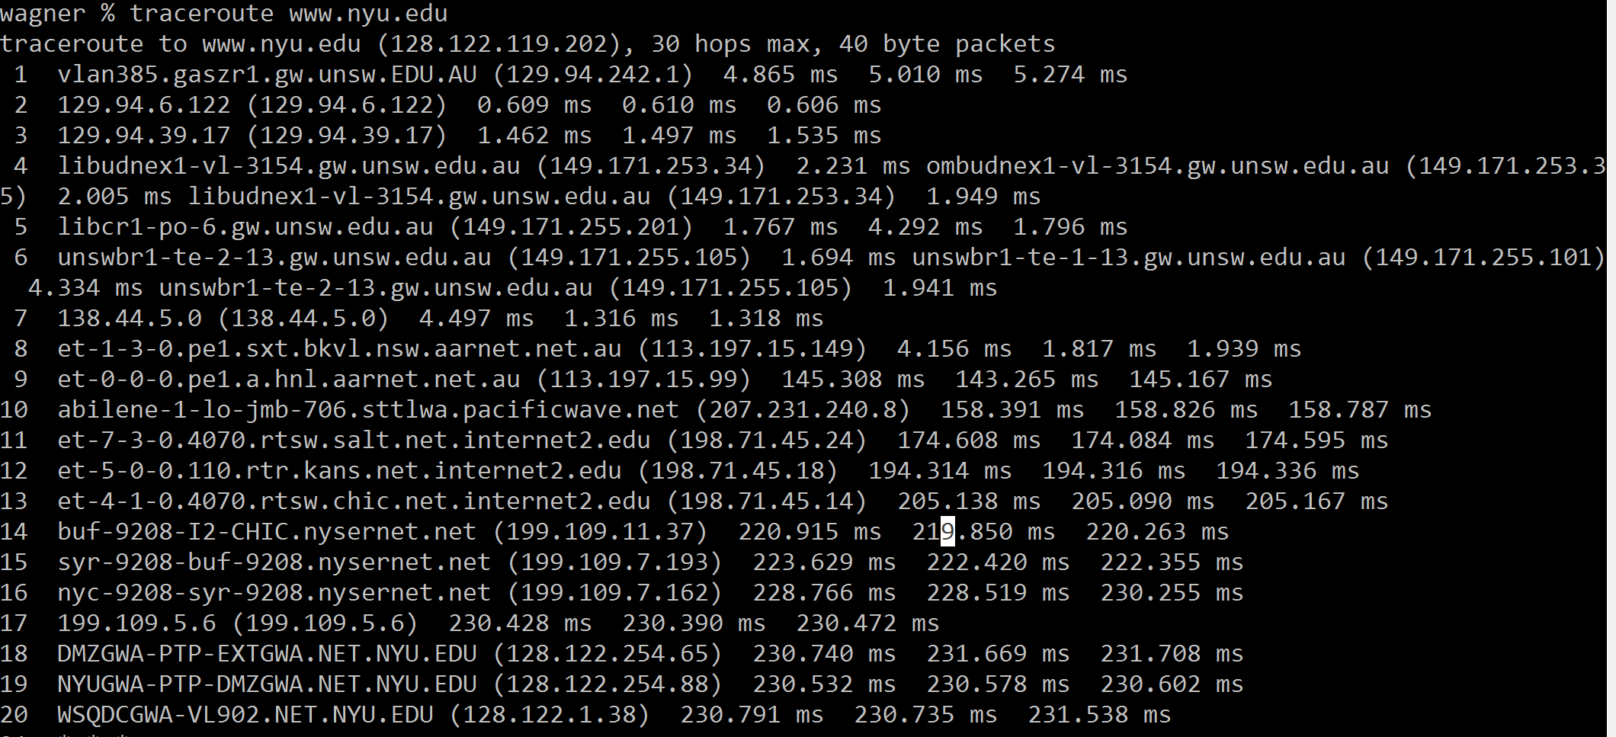

There are 6 routers along the path of the UNSW network.

The 8th and 9th router cross the Pacific Ocean.

et-1-3-0.pe1.sxt.bkvl.nsw.aarnet.net.au and et-0-0-0.pe1.a.hnl.aarnet.net.au

## 2.

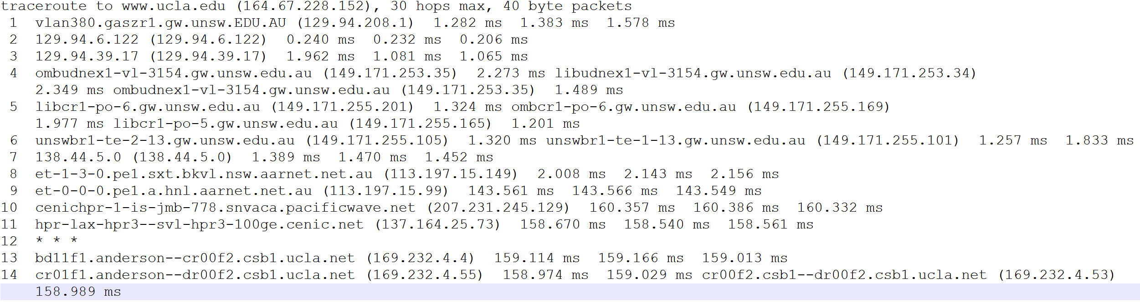

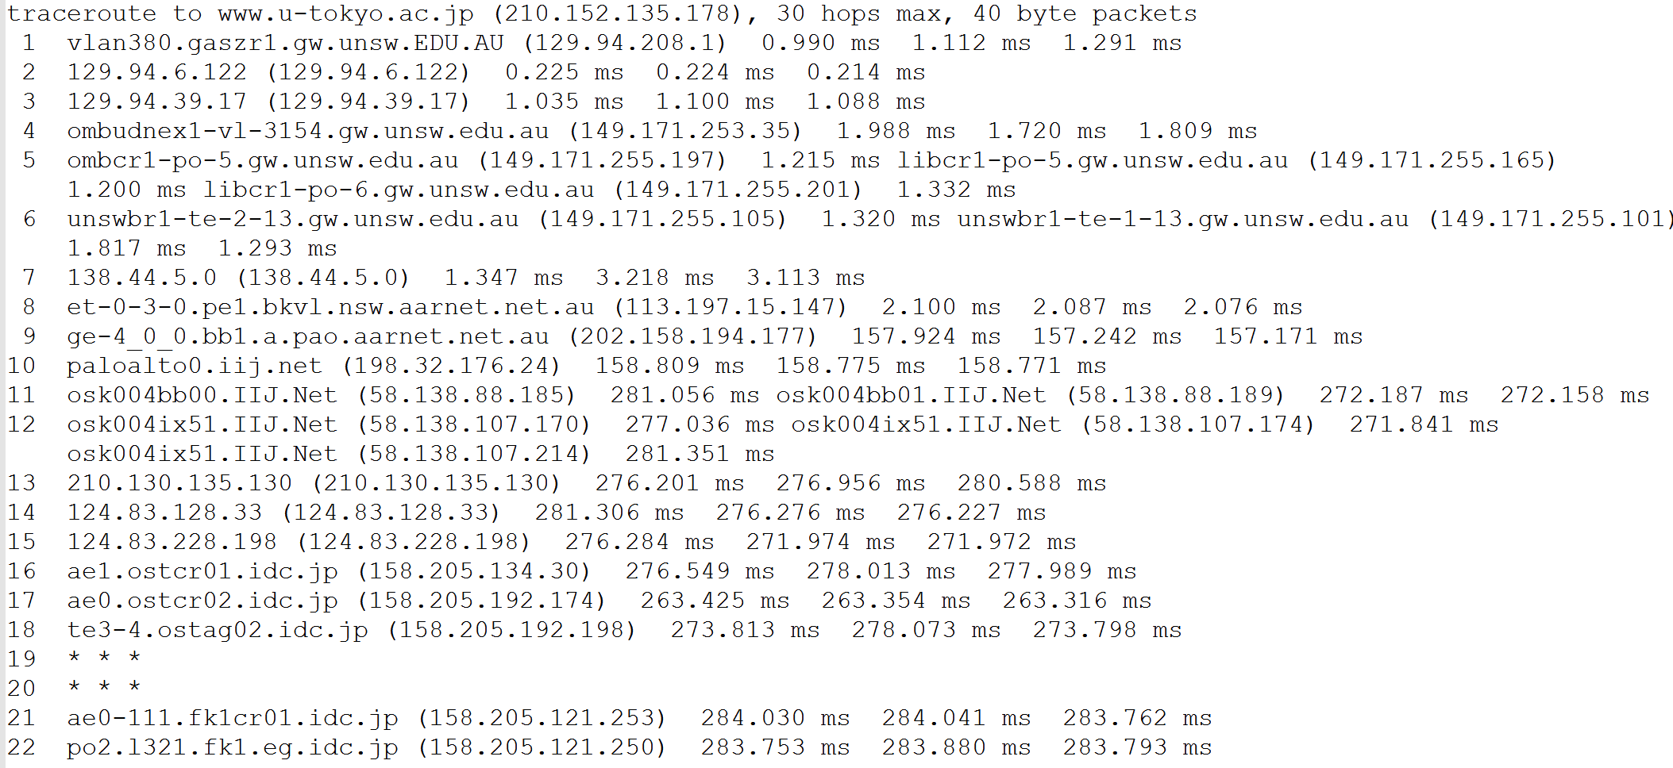

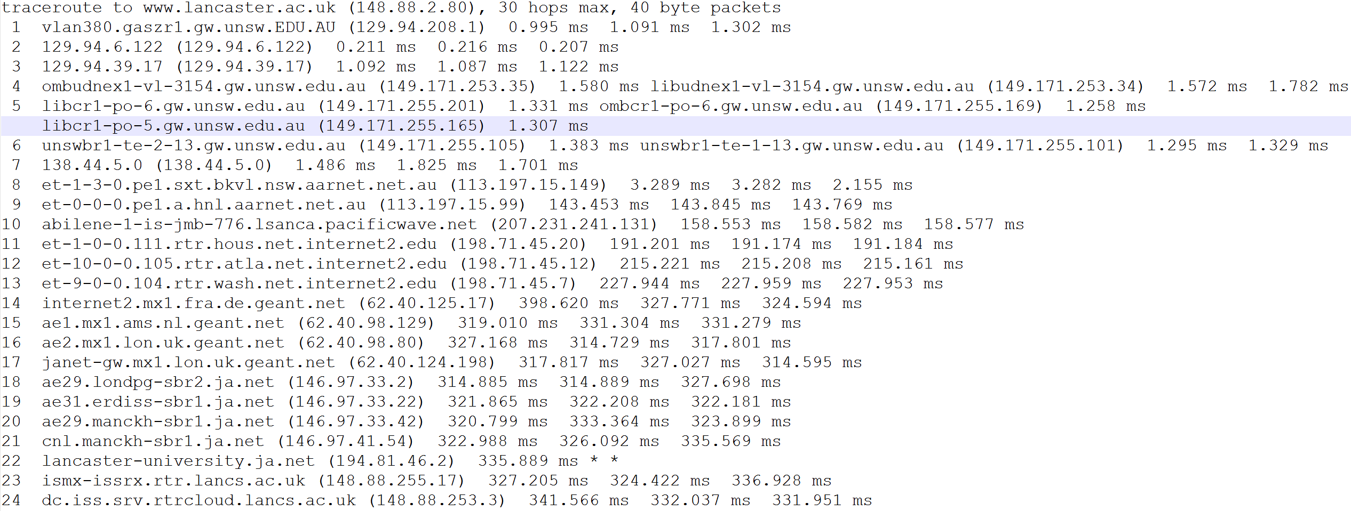

at 7th 138.44.5.0 (138.44.5.0) three destinations diverge.

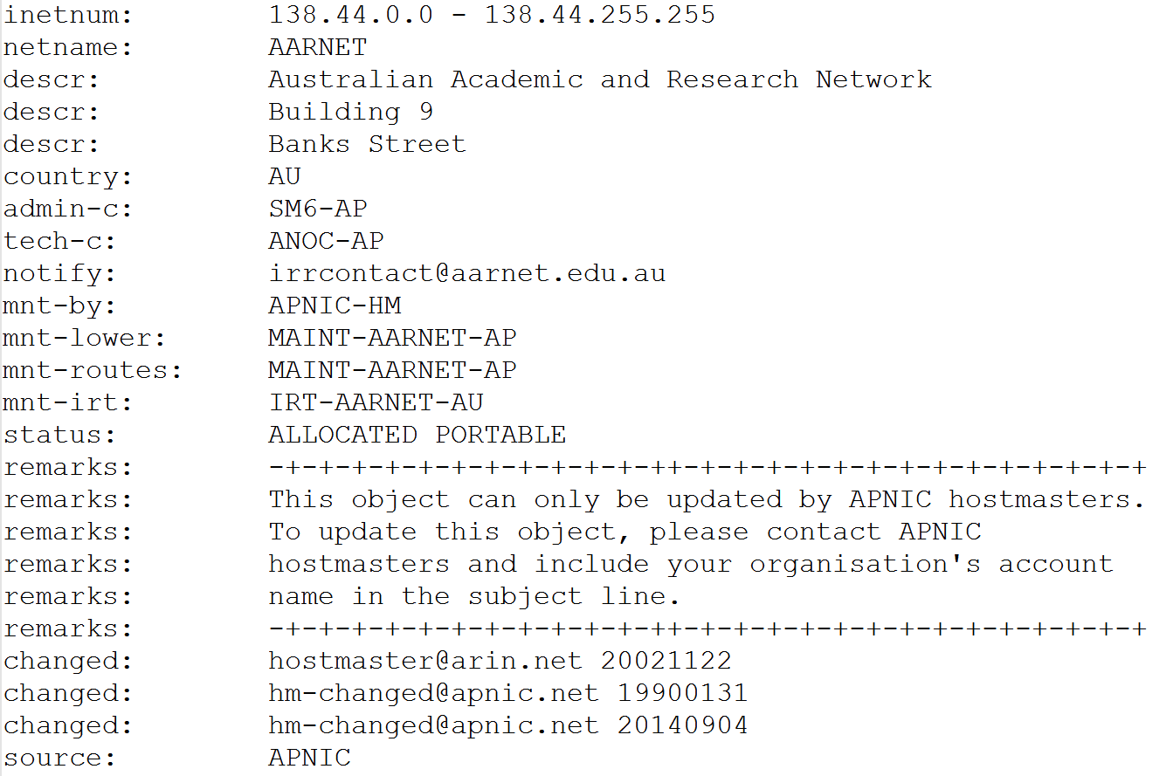

14 - 7500miles

22 - 5558miles

24 - 5797miles

No

## 3.

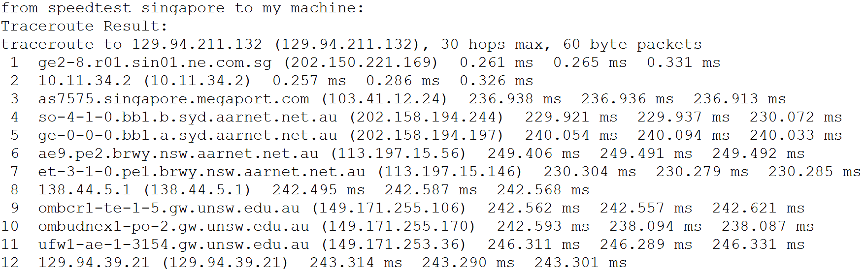

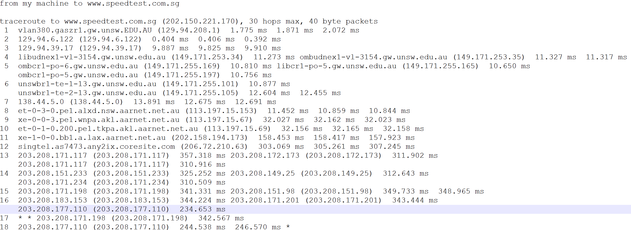

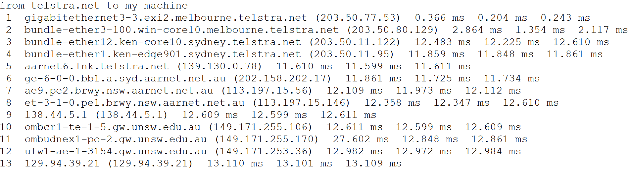

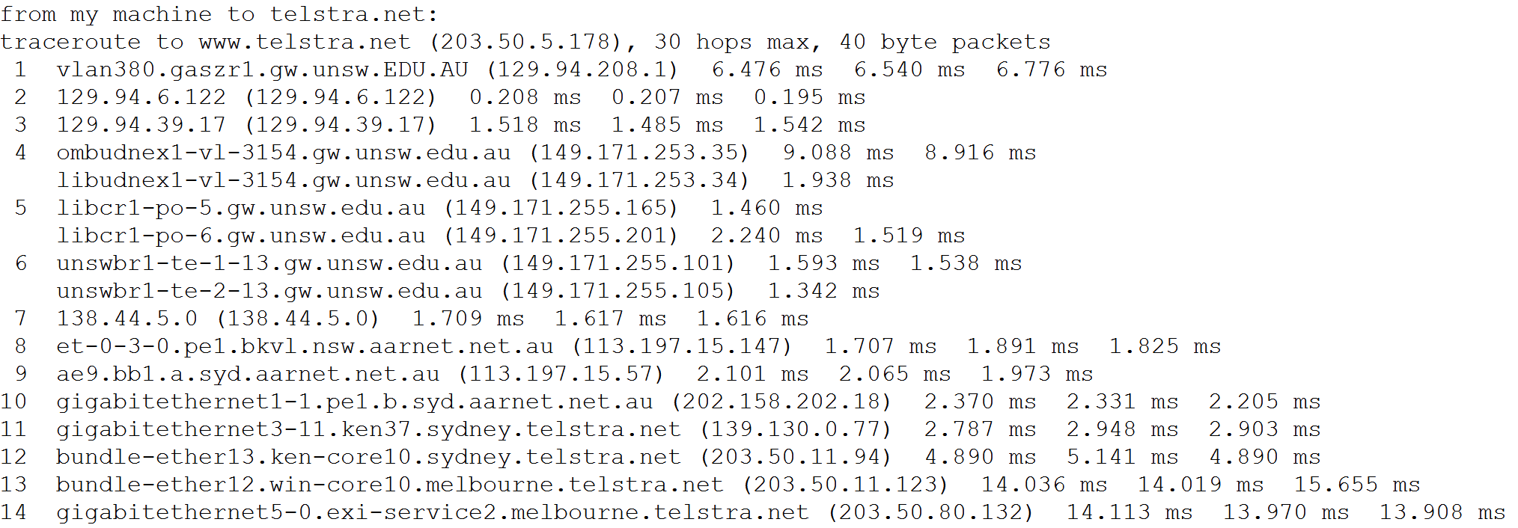

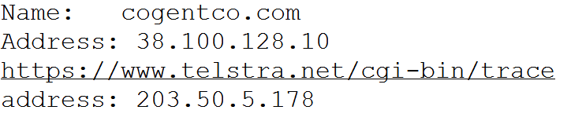

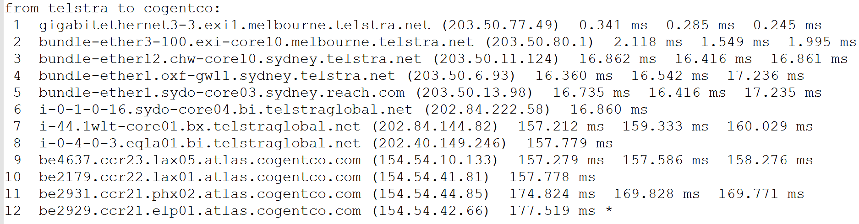

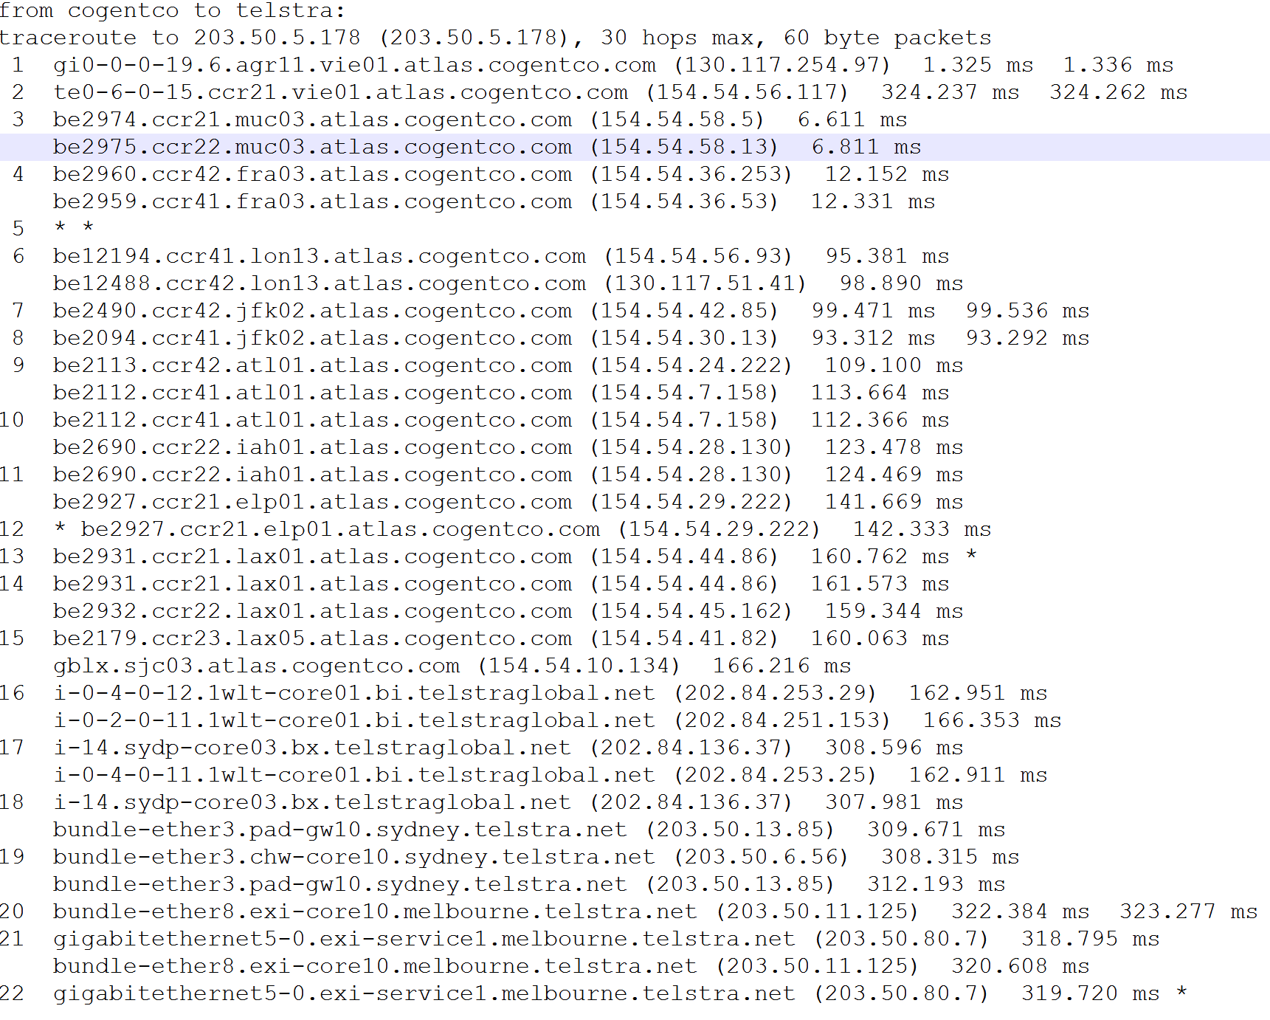

they do not use the same path.

# Exercise 6:

## 1.

www.tu-berlin.de:   
distance:16114km shortest time:53.7ms

[www.uq.edu.au](http://www.uq.edu.au):

distance:454km shortest time:1.5ms

[www.nus.edu.sg:  
distance:6316km](http://www.nus.edu.sg:distance:6316km) shortest time:21.1ms

Fig.1 distance and time ratio

Reason:

1. The router is not arranged along a straight line. So the real distance is longer than the theory distance.
2. 3 kinds of delay. Processing delay, queue delay, transmission delay.

## 2.

The delay varies over the time. Because it related on current network condition. If the traffic is busy, the queue delay would be longer.

Singapore’s delay depend on the size of the ping packets.

## 3.

Processing delay and transmission delay are depending on the packet size.

Propagation delay and queuing delay are not.