Shixin Wang

Henry Boateng

MATH 400-01

Homework 1

2/5/2022

Homework 1

1. I have my answer written in python in file “question_01.py”.

To run the program, please run “python -u ./question_01.py” in terminal and make sure your current path is where “question_01.py” at.

The program will print out the value of the integral, the average of the function and the total random points created.

Here is output might have after running program:

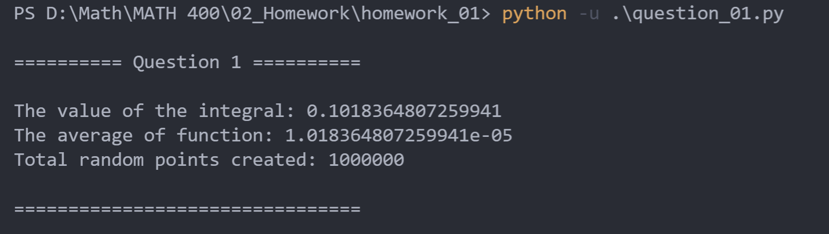

1. Here is the diagram of for in :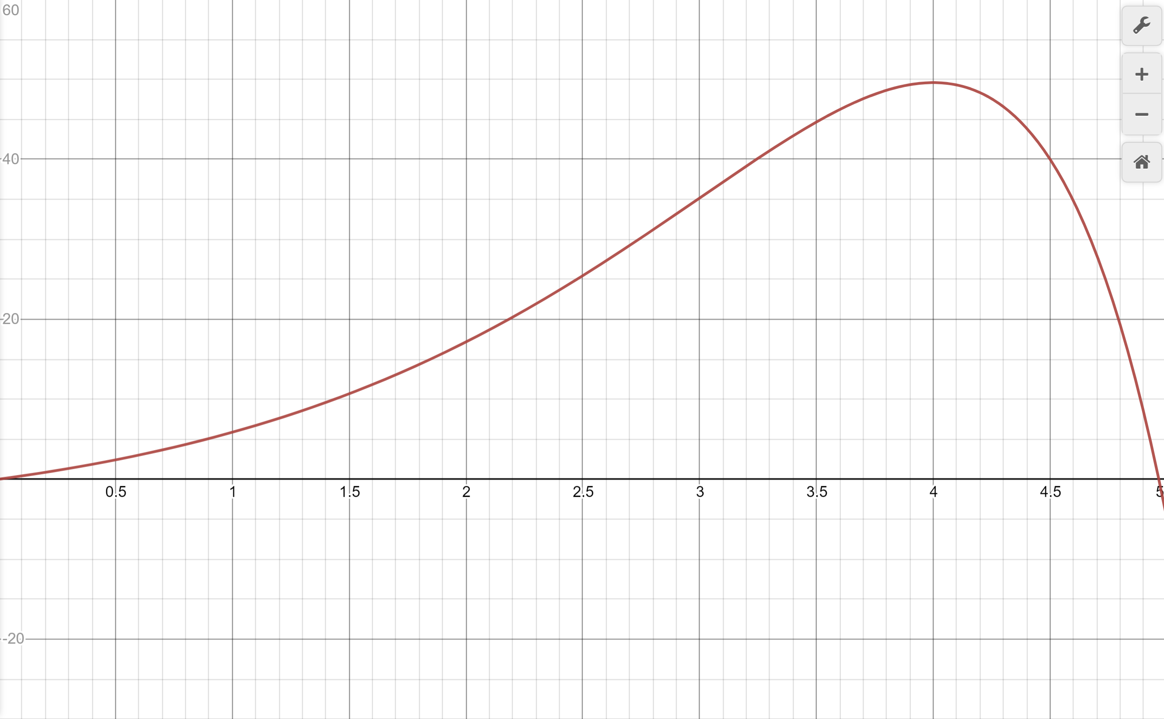
2. I wrote my answer in python in the file “question_02b.py”

To run the program, please run “python -u ./question_02b.py” in terminal and make sure your current path is where “question_02b.py” at.

The program will print out all values for each recursion and these values is round in 7 decimos, but you can feel free to change it by change the value of “format_output_decimos”. At the end of iteration, it will printout total amount of iterations and the estimate root of function in the given range.

Here is the output will have after running the program:

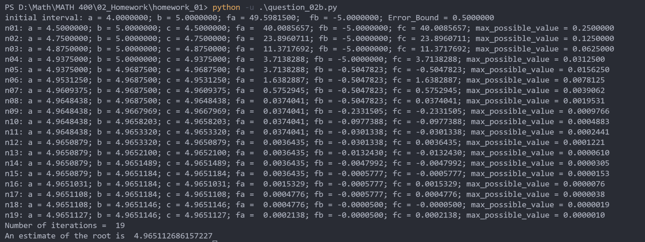

We can see the number of iterations is 19. If we take the size of interval , we can calculate the value of n(how many steps needed):

Therefore, the program is running exactly right steps to getting the size of interval

Therefore, we need 39 steps to reduce the size of the interval of this interval to .

According to the formula:

We can get:

So next we just need to solve the equation

Here is the formula explanation documented on my note:

