Shixin Wang

Henry Boateng

MATH 400

4/21/2022

Homework 6

2. Code is in “question_01a_code.py”

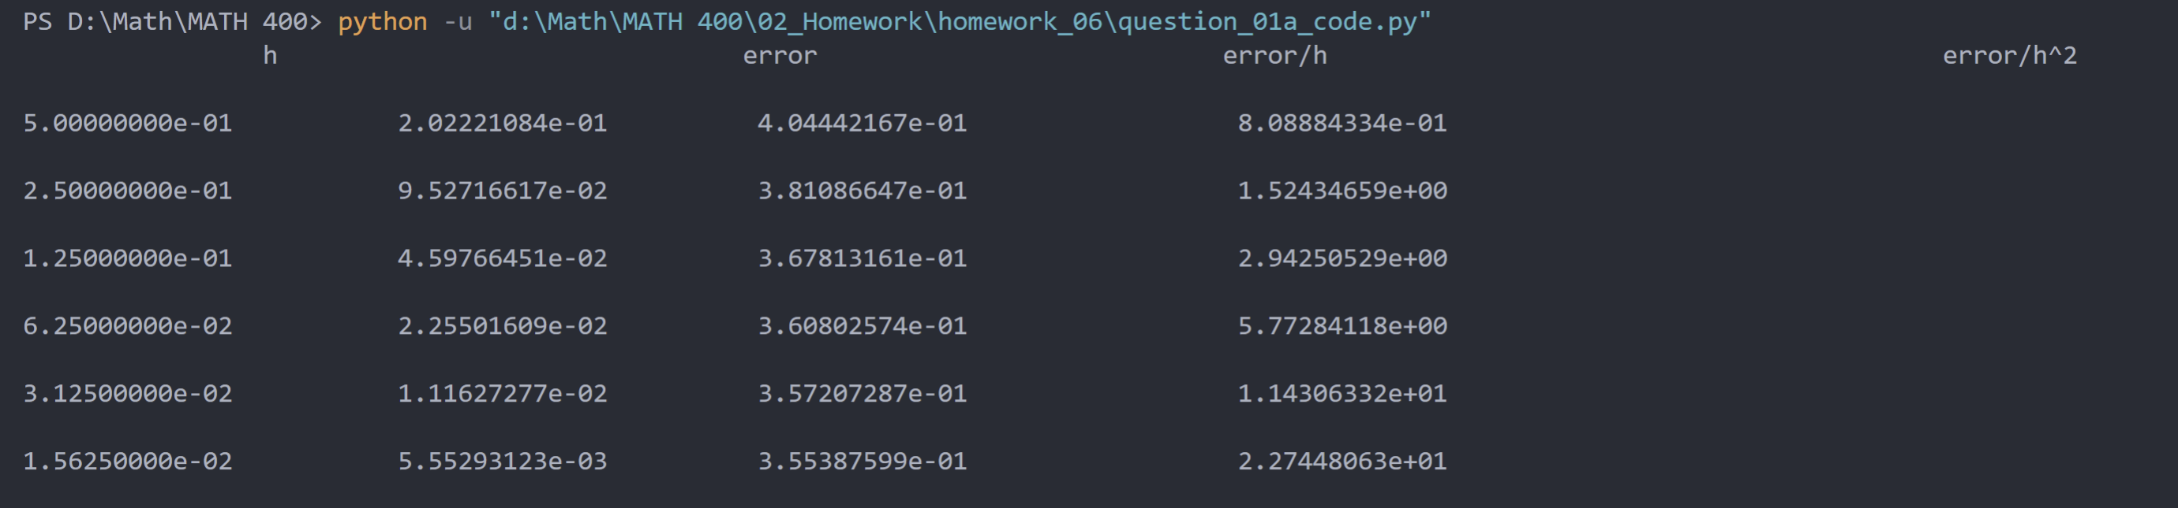

1. Code is in “question_01b_code.py”

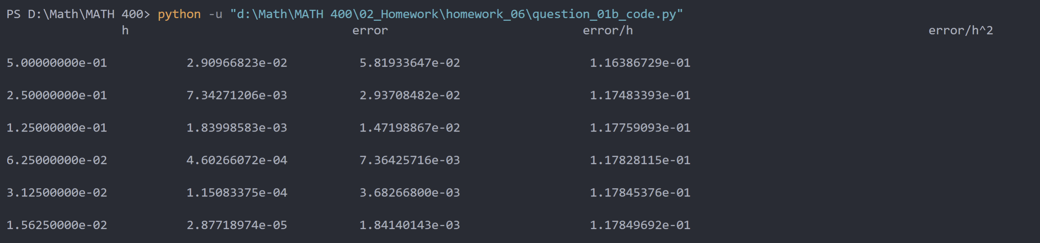

I think the approximation of b is more accurate since it has smaller error number.