*Figure 18:Interarrival Times for Autogas Weekdays Between (00:00-02:00)*

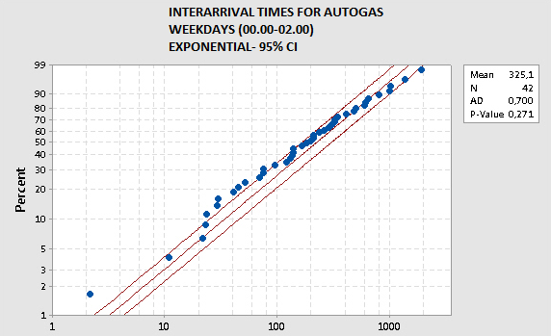

In *figure 18*, we observed 42 purchases between time interval 00:00-02:00 in the week excluding saturday. We used Minitab to fit a distribution to our estimators. Suggested distribution was exponential distribution with mean rate 325.1 sec.

*Figure 19:Interarrival Times for Autogas Weekends Between (00:00-02:00)*

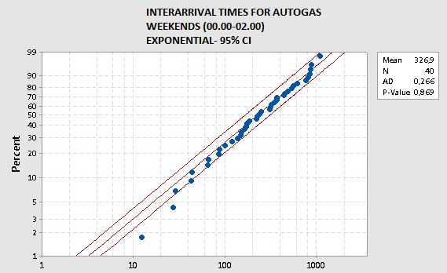

In *figure 19,* we observed 40 purchases between time interval 00:00-02:00 in the saturday only. We used Minitab to fit a distribution to our estimators. Suggested distribution was exponential distribution with mean rate 326.9 sec. Although the above distribution fit with weekdays and weekends seems nearly identical, we aimed to be as accurate as we can be therefore, this approximately 2 seconds difference was not neglected.

*Figure20:Interarrival Times for Autogas Weekdays Between (13:00-15:00)*

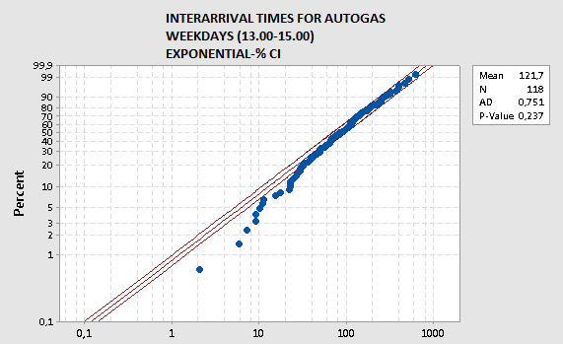

*Figure21:Interarrival Times for Autogas Weekends Between (13:00-14:00)*

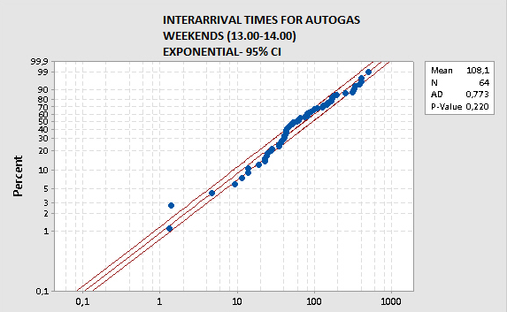

*Figure22:Interarrival Times for Autogas Weekends Between (14:00-16:00)*

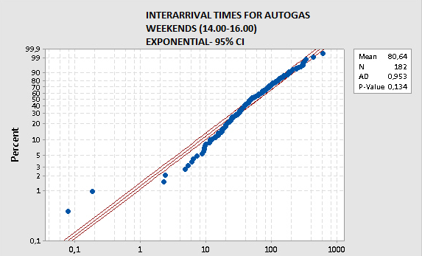

*Figure23:Interarrival Times for Fuel Weekdays Between (00:00-03:00)*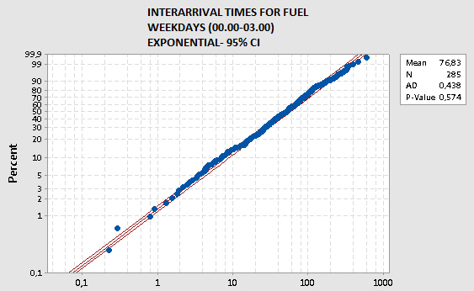

*Figure24:Interarrival Times for Fuel Weekends Between (00:00-02:00)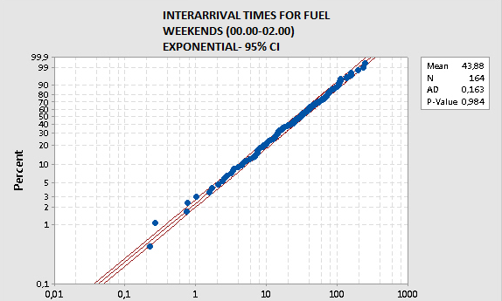*

*Figure25:Interarrival Times for Fuel Weekends Between (12:00-14:00)*

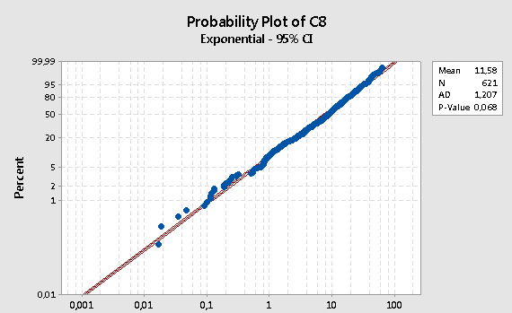

*Figure26:Interarrival Times for Fuel Weekdays Between (11:00-13:00)*

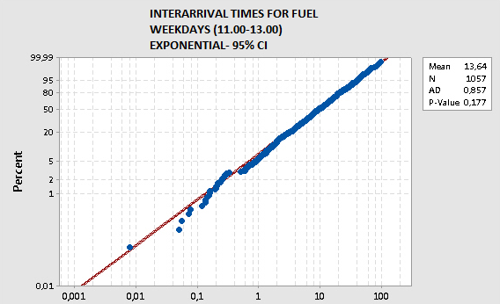

*Figure27:Interarrival Times for Fuel Weekdays Between (13:00-15:00)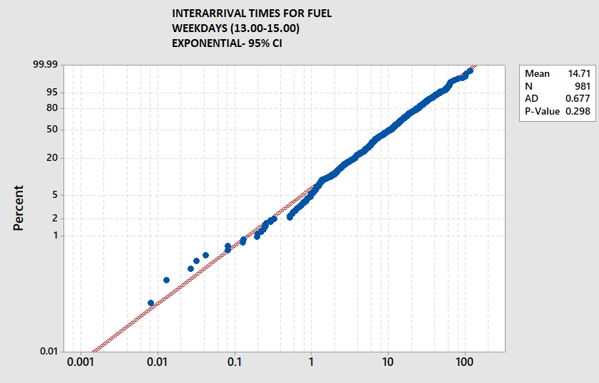*

6.ARENA MODEL DESCRIPTION AND MODELING ASSUMPTIONS

6.1 ARENA MODEL

Our model is a non-terminating model, but includes transitions through-out time. Interarrival rates of customers are different in various time intervals of a day, also Saturday has different interarrival rates when compared to the other days.

                Another transition factor is that attendants are scheduled based on 3 shifts in a day. So, the resources and their quantity is dependent on the time.

6.1.1 INTERARRIVAL TIMES

We used Boolean expressions to evaluate distributions of different time intervals and different days. *(Figure 28 and Figure 29)*

*Figure 28 : Interarrival Time Expression*

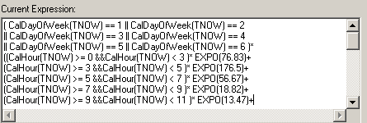

*Figure 29 : Full Expression Of Fuel Customer Interarrival Time*

*( CalDayOfWeek(TNOW) == 1 || CalDayOfWeek(TNOW) == 2*

*|| CalDayOfWeek(TNOW) == 3 || CalDayOfWeek(TNOW) == 4*

*|| CalDayOfWeek(TNOW) == 5 || CalDayOfWeek(TNOW) == 6 )\**

*((CalHour(TNOW) >= 0 &&CalHour(TNOW) < 3 )* EXPO(76.83)+(CalHour(TNOW) >= 3*

*&&CalHour(TNOW) < 5 )* EXPO(176.5)+(CalHour(TNOW) >= 5*

*&&CalHour(TNOW) < 7 )* EXPO(56.67)+(CalHour(TNOW) >= 7*

*&&CalHour(TNOW) < 9 )* EXPO(18.82)+(CalHour(TNOW) >= 9*

*&&CalHour(TNOW) < 11 )* EXPO(13.47)+(CalHour(TNOW) >= 11*

*&&CalHour(TNOW) < 13 )* EXPO(13.64)+(CalHour(TNOW) >= 13*

*&&CalHour(TNOW) < 15 )* EXPO(14.71)+(CalHour(TNOW) >= 15*

*&&CalHour(TNOW) < 17 )* EXPO(16.76)+(CalHour(TNOW) >= 17*

*&&CalHour(TNOW) < 19 )* EXPO(31.87)+(CalHour(TNOW) >= 19*

*&&CalHour(TNOW) < 21 )* EXPO(21.33)+(CalHour(TNOW) >= 21*

*&&CalHour(TNOW)<22)*EXPO(20.58)+(CalHour(TNOW)>=22)* EXPO(25.94))+(CalDayOfWeek(TNOW) == 7 )*((CalHour(TNOW) >= 0*

*&&CalHour(TNOW) < 2 )* EXPO(43.88)+(CalHour(TNOW) >= 2*

*&&CalHour(TNOW) < 4 )* EXPO(113.8)+(CalHour(TNOW) >= 4*

*&&CalHour(TNOW) < 6 )* EXPO(137.1)+(CalHour(TNOW) >= 6*

*&&CalHour(TNOW) < 8 )* EXPO(39.28)+(CalHour(TNOW) >= 8*

*&&CalHour(TNOW) < 10 )* EXPO(16.43)+(CalHour(TNOW) >= 10*

*&&CalHour(TNOW) < 12 )* EXPO(14.55)+(CalHour(TNOW) >= 12*

*&&CalHour(TNOW) < 14 )* EXPO(11.58)+(CalHour(TNOW) >= 14*

*&&CalHour(TNOW) < 16 )* EXPO(12.19)+(CalHour(TNOW) >= 16*

*&&CalHour(TNOW) < 18 )* EXPO(12.37)+(CalHour(TNOW) >= 18*

*&&CalHour(TNOW) < 20 )* EXPO(13.52)+(CalHour(TNOW) >= 20*

*&&CalHour(TNOW) < 22 )* EXPO(19.22)+(CalHour(TNOW) >= 22)* EXPO(21.33))*

6.1.2 ASSIGNMENT OF CUSTOMERS

*Figure 30: Assignment of Fuel Customer*

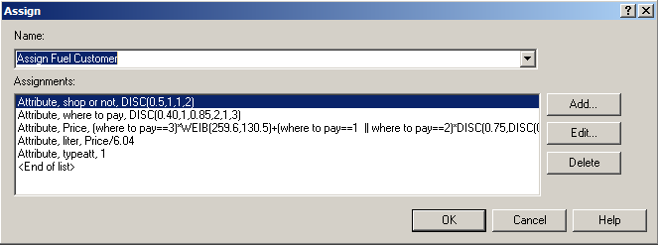

*Figure 31: Assignment of Gas Customer*

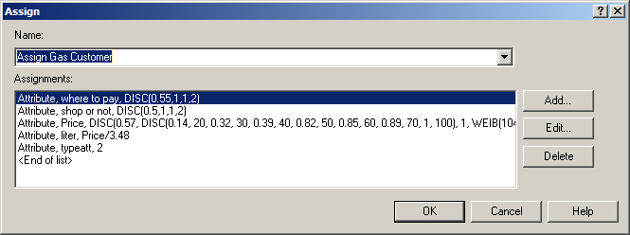

**Attribute - shop or not:** Determines whether the customer will shop at the market or not.

1 is for *to shop*

2 is for *not to shop*.

**Attribute - where to pay:** Determines if the customer will pay at the dispenser or at the cashier. ( For fuel customer there is also the Otobil option).

1 is for *paying at the dispenser*

2 is for *paying at the cashier*

3 is for *paying with Otobil.*

**Attribute - Price :** Assigns the price of the fuel or gas. Choices of purchases are mostly based on prices.

Customer not using Otobil will have purchases such as 50, 100, 200 TL with probability 75% . With probability %75, their purchase has a discrete distribution, and with %25 it has a Weibull distribution.

*Example* **Price expression for fuel :** (where to pay==3)*WEIB(259.6,130.5)+(where to pay==1 || where to pay==2)*DISC(0.75,DISC(0.04,20,0.09,30,0.12,40,0.38,50,0.4,60,0.41,70,0.77,100,0.86,150,0.97,200,0.99,250,1,300),1,WEIB(235.72,101,24))

**Attribute - liter:** Price divided by unit price of fuel or gas

6.1.3 DETERMINING THE TIME INTERVAL

*Figure 32: Deciding Time Interval*

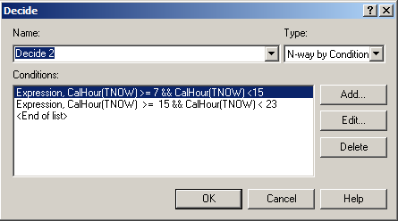

Since there are 3 worker shifts of in a day for intervals 7-15, 15-23, 23-7; We separately investigated those 3 shifts by creating different Seize modules for them and a Decide module was used at the beginning to determine which shift to seize from. *(Figure 32)*

6.1.4 DECIDING THE SET OF DISPENSERS

*Figure 33: Decide Which Set of Dispensers*

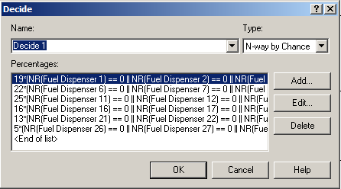

According to our data set, there is a pattern when choosing dispenser set. The closest ones to the exit, the entrance and the market are the most used ones, whereas the furthest away from the entrance is the least used one.

We used the data of dispenser usage and obtain basic probabilities by the proportion of each set to all sets. *(Figure 33)*

*Figure 34: Hold If All Dispensers Are Busy*

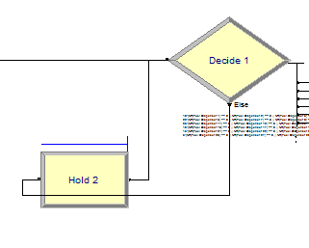

Hold module scans the condition if any dispenser is available currently. *(Figure 34)*

6.1.5 SEIZING DISPENSER AND ATTENDANT

*Figure 35 And 36: Graphs Of Pump Usages*

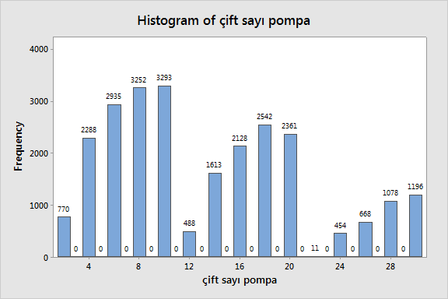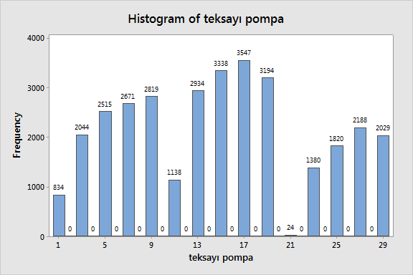

*Figure 37: An Example of a Fuel Dispenser Set*

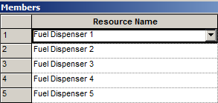

The most used dispensers at a set are mostly the closest ones to the exit (or market). In other words, a customer chooses the closer one to the exit, among two dispensers in the same set. This preference was expressed via the “Selection Rule” being “Preferred Order”. *(Figure 38)*

*Figure 38: An Example: Seizing of Dispenser*

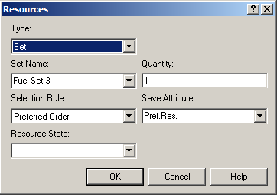

*Figure 39: Seizing Dispenser and Attendant*

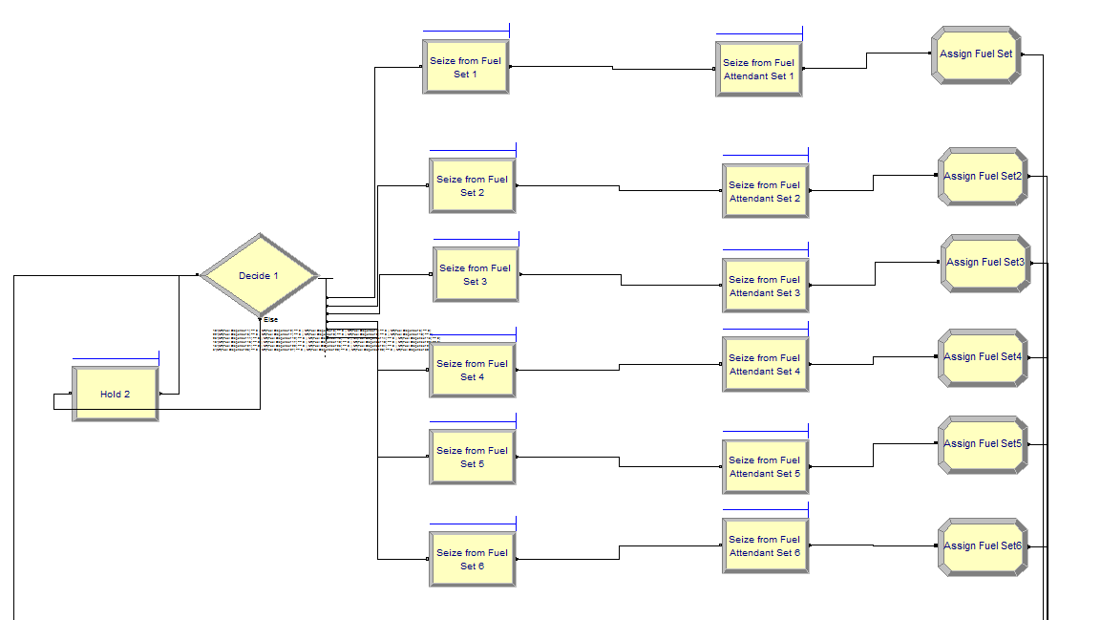

Attendant is seized according to the dispenser which was previously seized by the customer. *(Figure 40)*

*Figure 40: An Example of Seizing of Attendant*

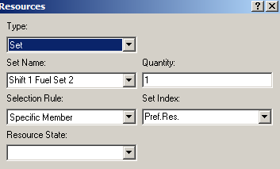

*Figure 41: Assigning Resources*

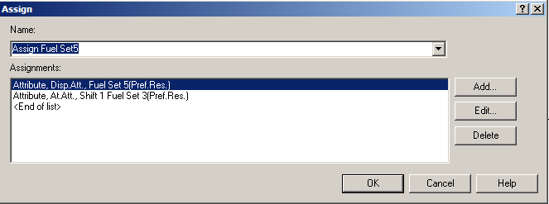

Entities are assigned their dispenser and attendant resources for later releases and seizes. *(Figure 41)*

6.1.6 RELEASE MODULE FOR RELEASING ATTENDANT TEMPORARILY

*Figure 42: Releasing Attendant Until the Next Encounter*

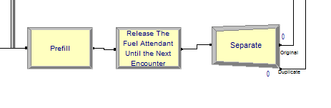

After attendant starts the pumping, s/he can leave and give service to other customers until the pumping stops. This scenario is performed by Release module. *(Figure 42)*

6.1.7 SEPARATE MODULE

*Figure 43: Separating Module for Duplicating The Entity*

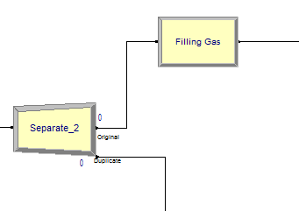

After telling the attendant the desired amount of fuel or gas, the customer can leave their car. This scenario is performed by the Separate module. Original entity proceeds to pumping of gas or fuel, whereas duplicate entity can go to the market, cashier or stay where they are. *(Figure 43)*

6.1.8 FILLING TIME DEPENDING ON LITER PURCHASED

*Figure 44: Filling Time Based on An Attribute*

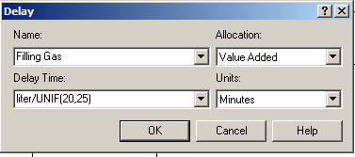

This time is expressed as the liter divided by the rate of pumping, which is estimated by a uniform distribution. *(Figure 44)*

6.1.9 DIFFERENT ATTRIBUTES AND PATHS

*Figure 45 and 46: Determining Paths Based on Attributes*

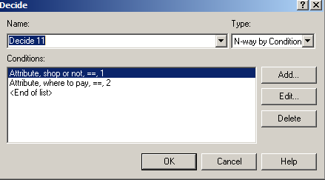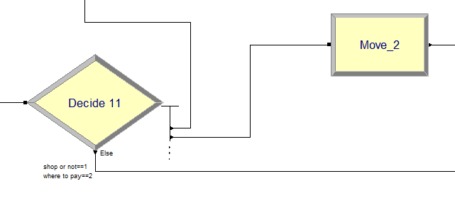

Customers proceed to different modules based on their attributes, which are “where to pay” and “shop or not”*(Figure 45 and Figure 46)*

6.1.10 WALKING TIME BASED ON DISTANCE

*Figure 47: Delay Time Depending on Attribute*

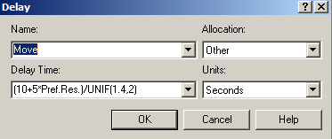

Distance from the closest dispenser to the market is estimated as 10 meters. Distances between each dispenser in the direction of exit and entrance are estimated as 5 meters. Distances on the other direction were not considered in the model. The distance determined by the dispenser is divided by a uniform random variable which was assumed to represent average walking speed. *(Figure 47)*

6.1.11 BATCH MODULE

*Figure 48: Batch Module To Unite The Original And The Duplicate*

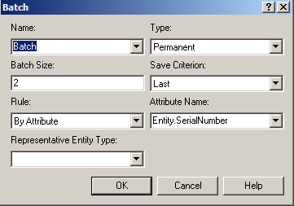

Batch module unites by Serial Number attribute which ensures that only original and duplicate is batched. *(Figure 48)*

6.1.12 SEIZING THE SAME ATTENDANT RESOURCE FOR THE 2ND TIME

*Figure 49: Seize Module for Selecting the Same Resource as Before*

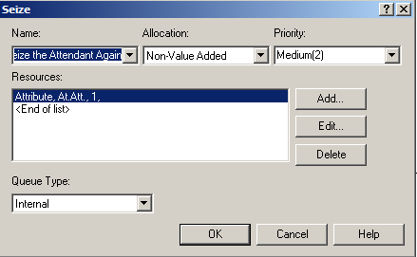

Seizing is done by “At.Att” attribute which represents the attendant seized at the first place. At this encounter; the slip given by the cashier can be delivered to the attendant, payment can be made by credit card or cash. *(Figure 49)*

6.1.13 RELEASE AND LEAVE

*Figure 50: From Batch to Leave*

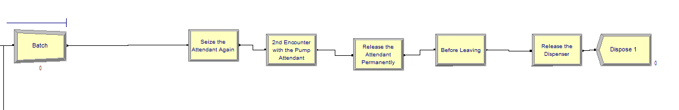

After Batch and Seize modules, the attendant is released permanently for this time. Then the dispenser is released, and the customer entity is disposed. *(Figure 50)*