**ANKARA UNIVERSITY**

**COMPUTER ENGINEERING DEPARTMENT**

**COM258 LAB3**

**2020 SPRING**

Create the following table and answer the questions using SQL queries.

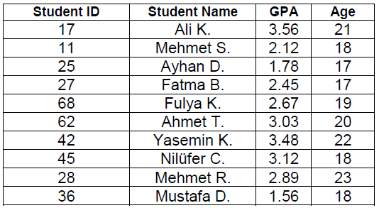

1. Find the names and ages of all the students.
2. Find the students (names and ids) who have GPA above 3.00.
3. Find the average of GPAs of students who have GPA above 2.50.
4. Find the maximum age.
5. Find average of ages and average of GPAs.
6. Find the average of student’s ages whose name start with the letter ‘M’.
7. Display all the information sorted on age with descending order.