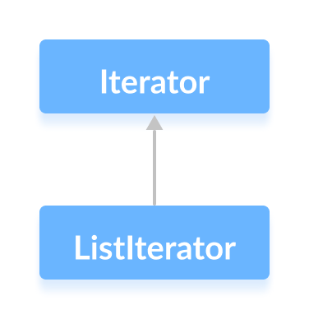

| **Sr. No.** | **Key** | **Iterator** | **ListIterator** |
| --- | --- | --- | --- |
| 1 | Applicable | Iterator can be used to traverse **any collection** irrespective of the type of collection. | ListIterator can only be used to iterate **only List collection** implemented classes like arraylist,linkedlist etc. |
| 2 | Calling | Iterator object can be created by calling **iterator()** method of Collection interface. | The object of ListIterator can be created by calling **listIterator()** method present in List interface. |
| 3 | Data traverse | Data traverse in case of the iterator is possible only in **one direction** as Iterator can traverse in the **forward direction only** | List iterator could traverses both in **forward and backward** directions which makes data traverse in both directions. |
| 4 | Deletion | The **deletion** **of in between element is** **not allowed** in the case of the iterator.(remove() removes last element) | ListIterator can **replace** an element in list collection. |
| 5 | Addition | The **addition** of an element **is not allowed** in case of an iterator as it throws ConcurrentModificationException. | ListIterator **can add** an element in list collection any time easily. |
| 6 | Modification | **Modification** of an element is **not allowed** in case of an iterator as it throws ConcurrentModificationException. | ListIterator **can modify** an element in list collection any time easily by calling set() method. |
| 7 | Index of element | One **can't get the index** of the traversed element in collection while using an iterator. | ListIterator has methods like nextIndex() and previousIndex() to **obtain indexes** of elements at any time while traversing List. |
|  |  |  |  |

Iterator

|  |  |
| --- | --- |
| **Methods** | **Description** |
| forEachRemaining(Consumer<? super E>action) | Performs the given action on each of the element until and unless all the elements have been processed or unless an exception is thrown by the action. |
| hasNext() | Returns a true value if the more number of elements are encountered during iteration. |
| next() | Returns the next specified element during the iteration. |
| remove() | Removes the last element from the collection as provided by the iterator. |