<dependency>

<groupId>org.projectlombok</groupId>

<artifactId>lombok</artifactId>

<version>1.18.30</version>

<scope>provided</scope>

</dependency>

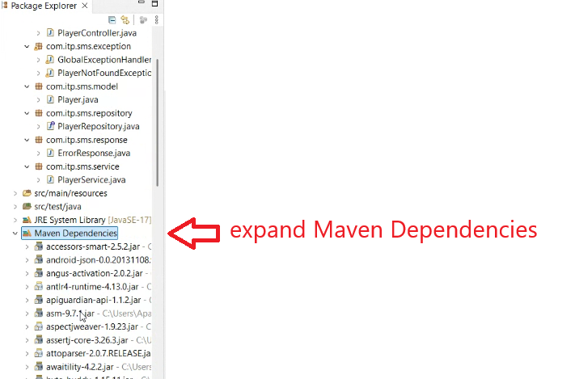

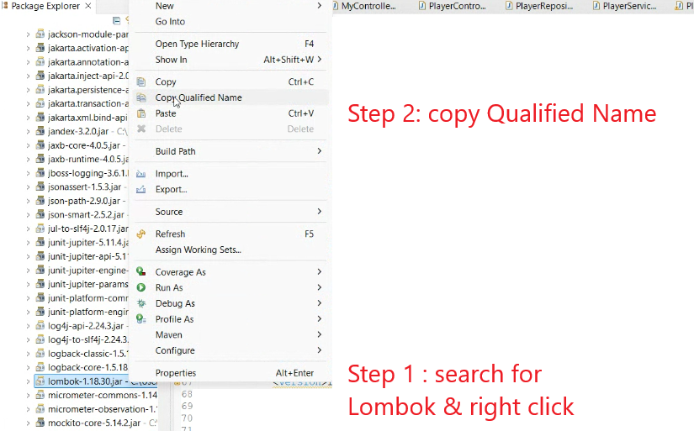

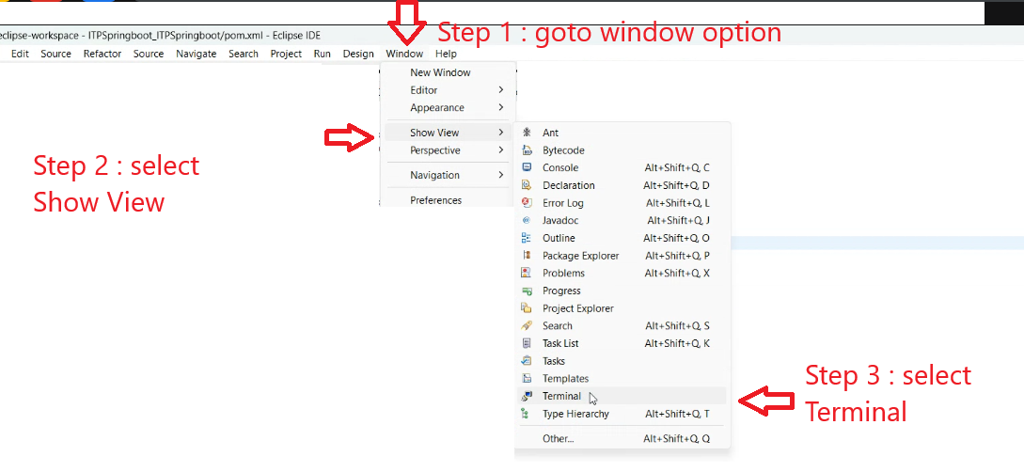

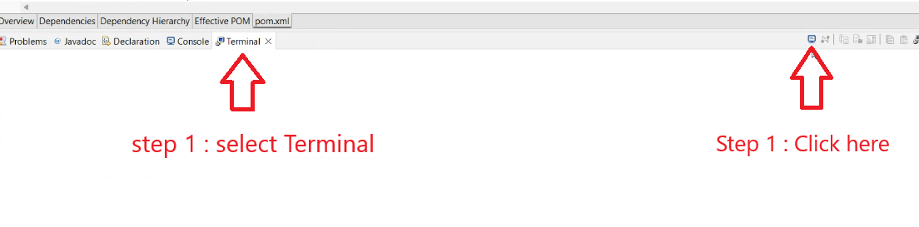

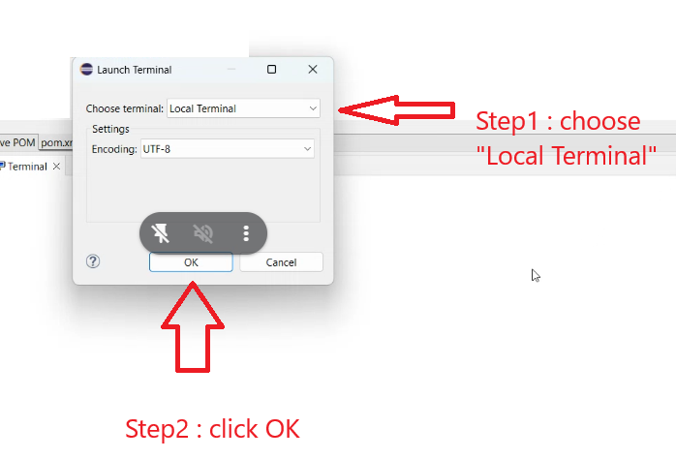

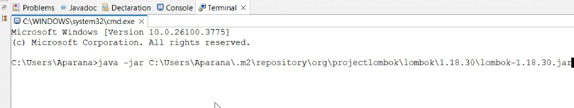

Command is

Java –jar paste

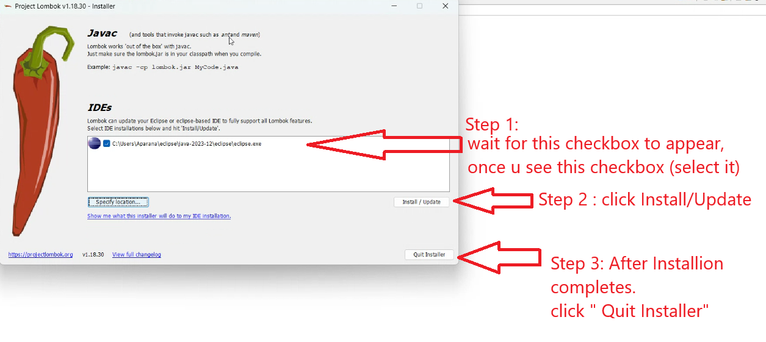

Please NOTE : Restart Eclipse

How to Use

