Step 1 : Download & Extract Tomcat 9

**Step 1a:**

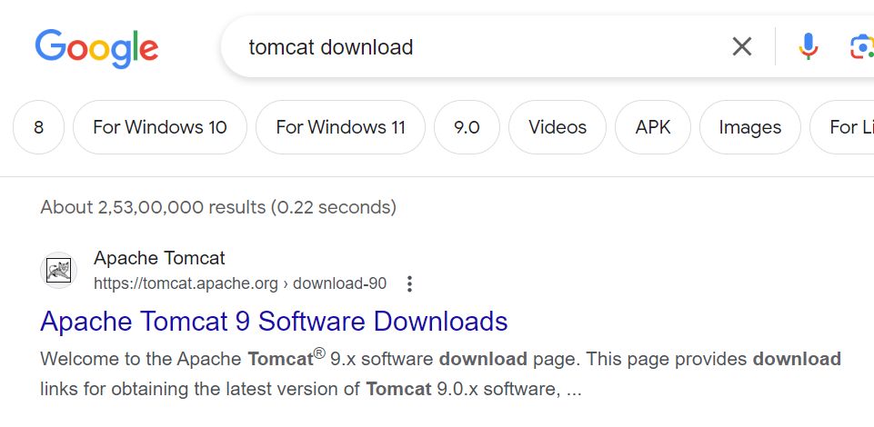

Step 1b:

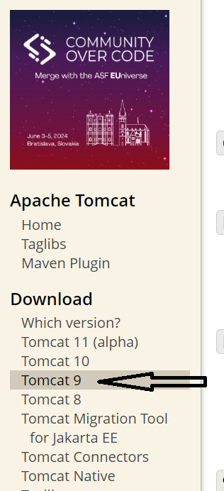

Step 1c:

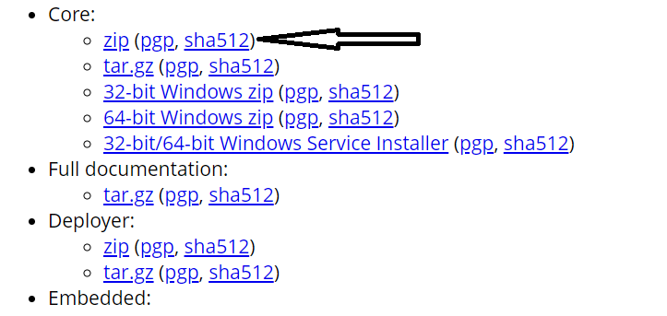

Step 1d : Cut paste the downloaded file to a folder and extract it

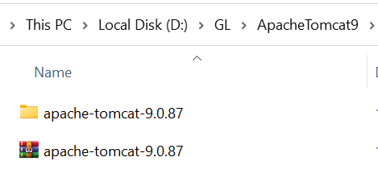

Step 2 : Create Dynamic Web Project

Step 2a : New -->others-> 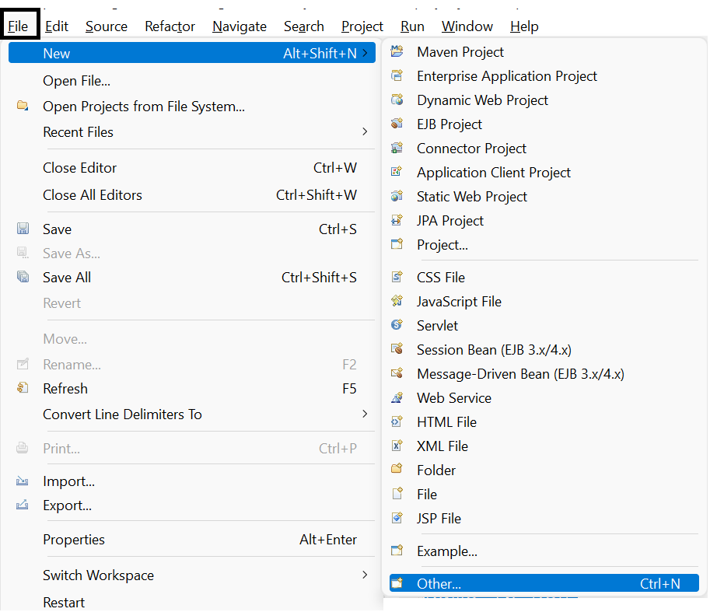

Step 2b :Dynamic Web Project

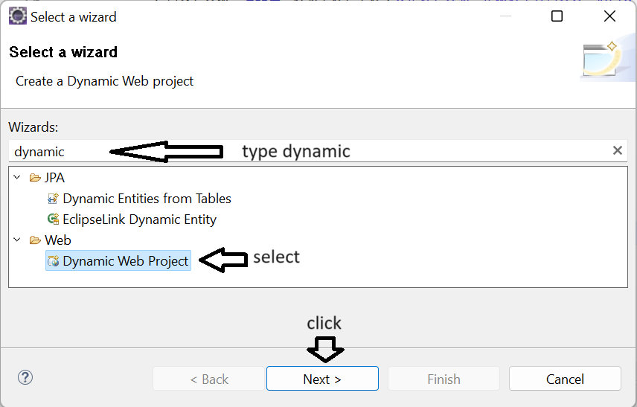

Step 2c : Name of the Project->choose web module version 4.0->Finish

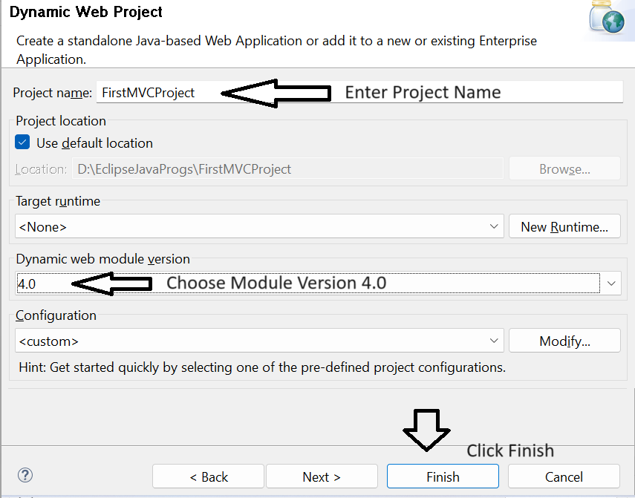

Step 3: Add the Tomcat server in eclipse

Step 3a : Windows->show view-> Servers

NOTE : If Servers option not found choose **Others** and search for **servers**

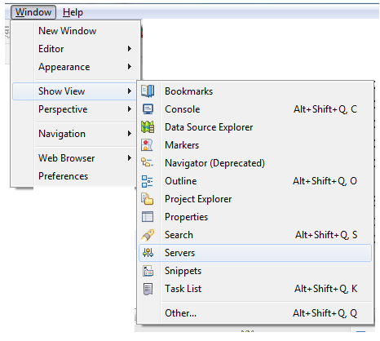

Step 3b : Add the server

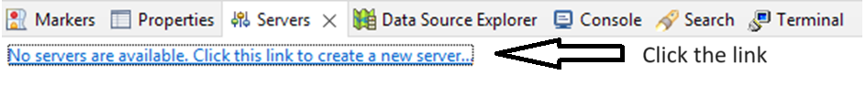

Step 3c : select Tomcat Version

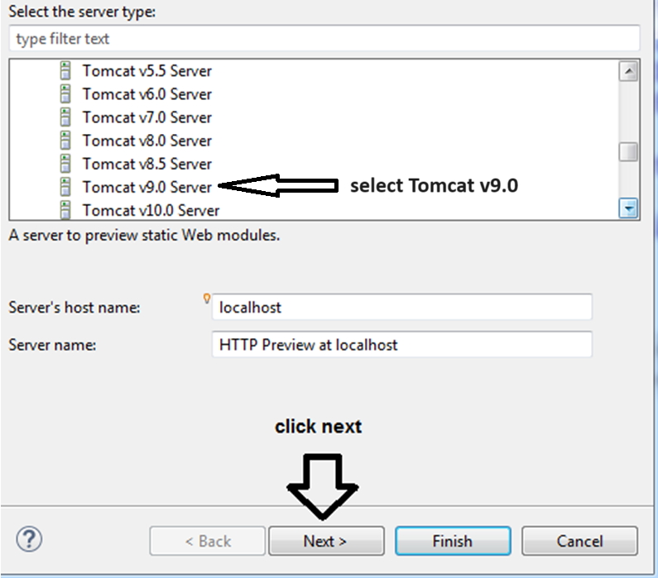

Step 3d : select Root Directory

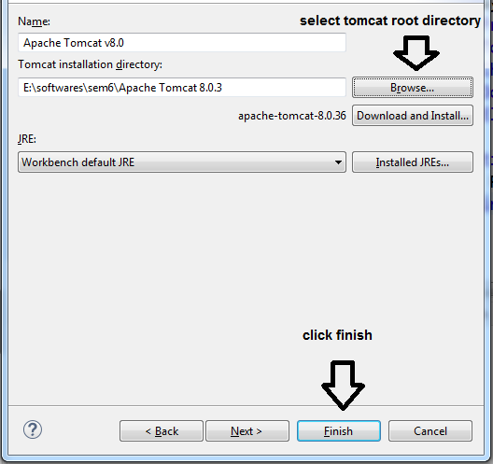

Step 3e : Server should be visible

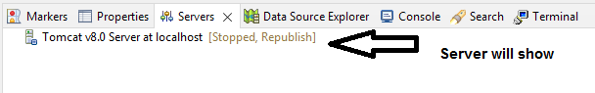

Step 3f : switch on/off the server

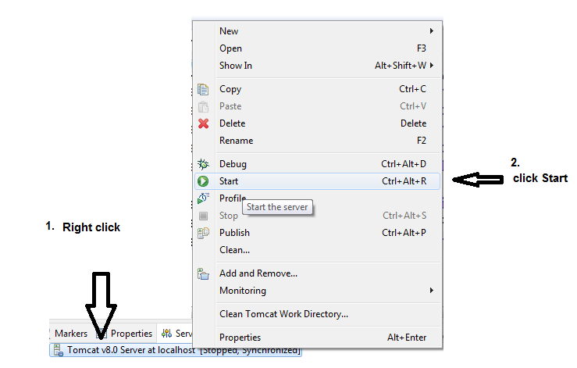

**Step 4: Configuring version of project (JDK & Tomcat are in sync)**

Step 4a : Right Click on the Project Name 🡪 Properties

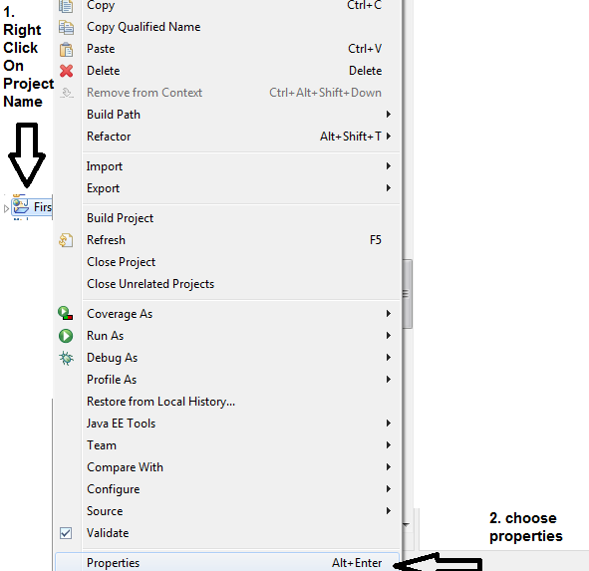

Step 4b : choose Project Facets

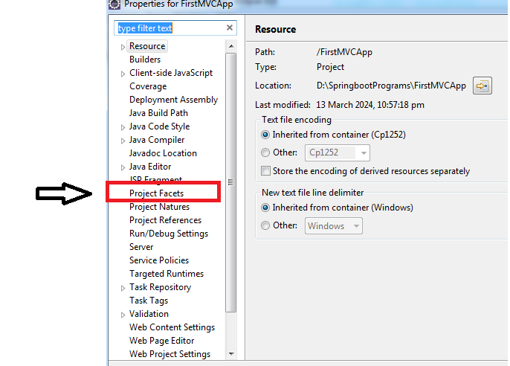

Step 4c : choose JDK Version & Runtime server , Apply and close

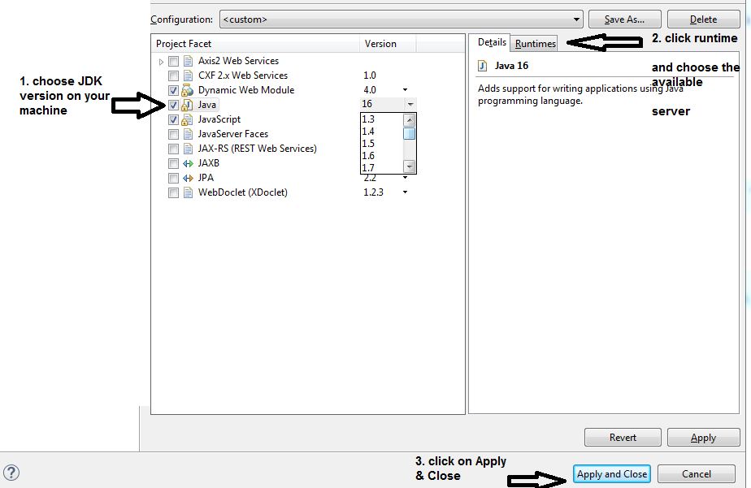

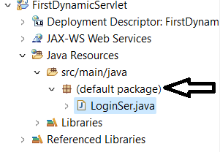

Right click on the default package

New

Servlet

Give Name of the Servlet and “finish”

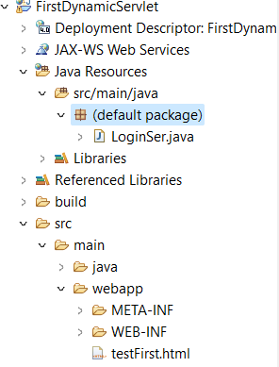

In WEB-INF

Make a html file

<!DOCTYPE html>

<html>

<head>

<meta charset="ISO-8859-1">

<title>Insert title here</title>

</head>

<body>

<form name="f1" action="LoginSer" method="get">

<input type="submit" name="s1" value="ADDITION"> <br>

</form>

</body>

</html>

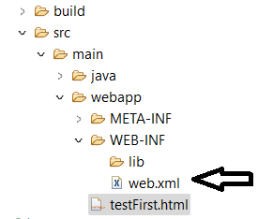

In web.xml add the following line

<welcome-file>testFirst.html</welcome-file>

run the codeon Server

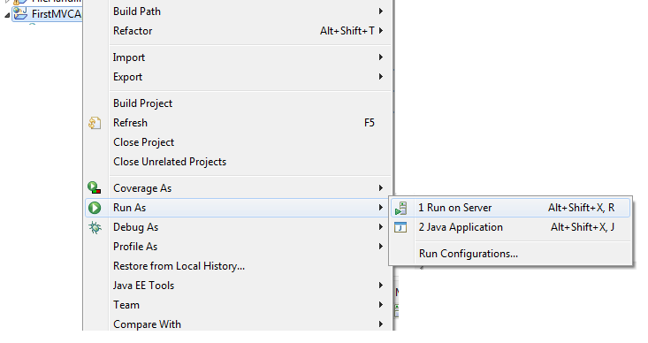

to open in browser

windows

preferences

general

web browser

check the browser apply & close.

Forward , include & sendRedirect

**if**(n1>0 && n2>0)

{

RequestDispatcher rd=request.getRequestDispatcher("success");

rd.forward(request, response);

}

**else**

{

out.println("Please enter Positive numbers only");

RequestDispatcher rd=request.getRequestDispatcher("/testFirst.html");

rd.include(request, response);

}

String n=request.getParameter("t1");

response.sendRedirect("https://www.google.com/search?q="+n);

HttpSession session=request.getSession(**true**);

session.setAttribute("n1", n1);

session.setAttribute("n2", n2);

HttpSession session=request.getSession(**false**);

**int** n1 = (Integer) session.getAttribute("n1");

**int** n2 = (Integer) session.getAttribute("n2");

out.println("In Success Session Servlet<br>");

out.println(n1+n2);

session.invalidate();

<welcome-file-list>

<welcome-file>index.html</welcome-file>

</welcome-file-list>

<context-param>

<param-name>dname</param-name>

<param-value>com.mysql.jdbc.Driver</param-value>

</context-param>

<servlet>

<servlet-name>tiger</servlet-name>

<servlet-class>MyDbConfig</servlet-class>

<init-param>

<param-name>pname</param-name>

<param-value>jdbc:mysql://localhost:3306/subjugators</param-value>

</init-param>

</servlet>

<servlet-mapping>

<servlet-name>tiger</servlet-name>

<url-pattern>/praj</url-pattern>

</servlet-mapping>

ServletConfig config=getServletConfig();

String pname=config.getInitParameter("pname");

ServletContext context=getServletContext();

String dname=context.getInitParameter("dname");