Car [carID=301, modelName=Q3, mfgName=Audi, price=1000.0, myEngine=Engine [engineID=102, engineMfgName=Honda Diesel, engineCapacity=12, engineCC=1500], myGear=Gear [gearID=201, gearMfgName=Prime Auto, gearType=Automatic]]

Car [carID=301, modelName=Q3, mfgName=Audi, price=1000.0, myEngine=Engine [engineID=102, engineMfgName=Honda Diesel, engineCapacity=12, engineCC=1500], myGear=Gear [gearID=201, gearMfgName=Prime Auto, gearType=Automatic]]

Core container The BeanFactory interface provides an advanced configuration mechanism capable of managing any type of object. (core.io)
Resource res=new ClassPathResource("resources/application-context.xml");
BeanFactory factory= new XmlBeanFactory(res);

J2EE Container ApplicationContext is a sub-interface of BeanFactory. It adds easier integration with Spring's AOP features; message resource handling.
ClassPathXmlApplicationContext beanFactory = new ClassPathXmlApplicationContext("resources/application-context.xml");

In short, the BeanFactory provides the configuration framework and basic functionality, and the ApplicationContext adds more enterprise-specific functionality.

Beans forms the backbone of your Spring application
they are instantiated, assembled & managed by the Spring IoC container.
beans are created with the configuration metadata that you supply to the container. in the form of XML <bean/> definitions

Bean definition contains the information called configuration metadata, which is needed for the container to know the following −
1. How to create a bean
2. Bean's lifecycle details
3. Bean's dependencies

1) download spring 5 jars from https://github.com/uysolanki/Spring5Jars
2) create new Java Application
3) add the jars
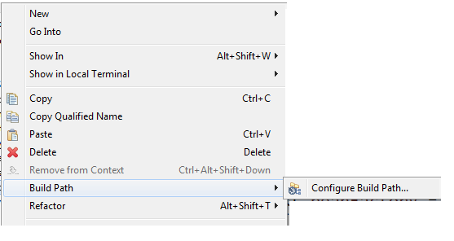
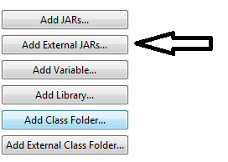
upload all the jars

Step 3 : inside the "src" folder create a package/folder by the name "resources"


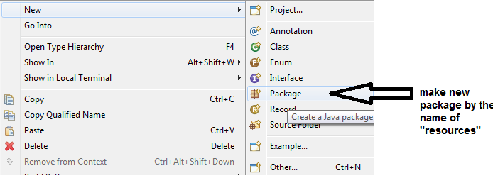

4) in the "resources" folder make a file by the name "application-context.xml" (you can specify any other name also) , paste the following in that file.
<?xml version="1.0" encoding="UTF-8"?>
<beans xmlns="http://www.springframework.org/schema/beans"
xmlns:xsi="http://www.w3.org/2001/XMLSchema-instance"
xmlns:context="http://www.springframework.org/schema/context"
xsi:schemaLocation="http://www.springframework.org/schema/beans
http://www.springframework.org/schema/beans/spring-beans.xsd
http://www.springframework.org/schema/context
http://www.springframework.org/schema/context/spring-context.xsd">
</beans>
5) Right click on "src" and make a new package "com.gl.app"
6) Create the DriverApp class and add the "main()" in it
7) load the J2EE container
ClassPathXmlApplicationContext beanFactory = new ClassPathXmlApplicationContext("resources/application-context.xml");

8) Right click on "src" and make a new package "com.gl.service"
9) add a POJO class to it with Constructors, setter/getter, toString
e.g public class Player {
private int jno;
private String pname;
private int runs;
private int mp;

10) to the xml file add
1. BEAN CREATION (USING XML)

CONSTRUCTOR DEPENDENCY INJECTTION
<bean id="p1" class="com.gl.service.Player">
<constructor-arg value="18"></constructor-arg>
<constructor-arg value="Virat"></constructor-arg>
<constructor-arg value="5000"></constructor-arg>
<constructor-arg value="50"></constructor-arg>
</bean>

SETTER DEPENDENCY INJECTTION
<bean id="a1" class=" com.gl.service.Player">
<property name="jno">
<value>18</value>
</property>
<property name="pname">
<value>Virat Kohli</value>
</property>
<property name="runs">
<value>5000</value>
</property>
<property name="mp">
<value>50</value>
</property>
</bean>
ARRAY, LIST, SET
<property name="cities">
<list>
<value>Delhi</value>
<value>Pune</value>
<value>Jaipur</value>
</list>
</property>

MAP
<property name="catalog">
<map>
<entry key="bmw" value="1000"></entry>
<entry key="audi" value="2000"></entry>
<entry key="maruti" value="3000"></entry>
</map>
</property>

PASSING REFERENCE USING SETTER

<property name="engine" ref="e1"></property>

PASSING REFERENCE USING CONSTRUTOR

<constructor-arg ref="e1"></constructor-arg>

Bean element attributes
id
class
scope = "prototype" / "singleton"(default)
autowire= "byName" / "byType" (Ref no need to be coded explicitly)
autowire-candidate= "true" / "false"

2. BEAN CREATION USING (JAVA+XML)
<context:component-scan base-package="com.gl.service">
</context:component-scan>

3. BEAN CREATION USING (ONLY JAVA, without any xml file)
1) create a new package com.gl.config
2) make a config class names "MyConfig"
@Configuration
@ComponentScan(basePackages="com.gl.model")
public class MyConfig {

}
3) put the Player & Student class in the com.gl.model package
3) In driver App
Player b1=factory.getBean(Player.class);
Student b2=factory.getBean(Student.class);

BEAN LIFECYCLE
1)PROGRAMATIC APPROACH
public class Player implements InitializingBean,DisposableBean{

overide the following methods
public void destroy()
public void afterPropertiesSet()
}

2) USING XML
<bean destroy-method="abc" init-method="xyz">
3)USING ANNOTATIONS
@PreDestroy
@PostConstruct
3) USING ANNOTATION APPROACH
A) ADD THIS BELOW THE <BEAN> OPEN TAG
<context:annotation-config />
B) MAKE THE BEAN SCOPE=”SINGLETON” MAKE IT EXPLICITLY SINGLETON DON’T KEEP IT DEFAULT
C) @PostConstruct
public void apple(){
System.out.println("Immidiately After the Constructor using xml approach");
}

@PreDestroy
public void mango(){
System.out.println("Just Befroe the Destructor using xml approach");
}

@Override
protected void finalize() throws Throwable {
System.out.println("Destructor of Player Class");
}

D) DRIVER APP
ClassPathXmlApplicationContext beanFactory = new ClassPathXmlApplicationContext("resources/application-context.xml");
System.out.println("Hiiii");
Player player1=beanFactory.getBean("p1",Player.class);
System.out.println(player1);
player1=null;
beanFactory.close();
Runtime.getRuntime().gc();

spring core application using MAVEN
create a Maven Application
add the following dependencies
Dependency
1.Spring core 5.3.24
2.Spring context 5.3.24

AbstractApplicationContext abs=( AbstractApplicationContext) factory;
abs.registerShutdownHook();

Autowired
Step 1: add the following in the xml file
<context:annotation-config />

Step 2: remove autowire attribute from bean

Step 3 :
@Autowired
@Qualifier("e1")
Engine engine; //Dependency

Using Java Classes
NOTE :you can delete the xml file if u wish or comment it entirely
Step 1 : make a package by the name com.companyname.config
Step 2 : make a class by the name AppConfig(user def name),
Annot this class by @Configuration
Step 3 : IOC container will have predefined beans for class which are marked with
@Component
Step 4 : create the bean (NOTE bean method should always be public)
@Configuration
@ComponentScan(basePackages = "com.itp")
public class BeanConfig {

{
@Bean
public Engine getEngineUsingConstructor()
{
Engine e1=new Engine(44, "Mahindra", 2800, 40);
return e1;
}
}

Step 5 : Driver App
ApplicationContext beanFactory = new AnnotationConfigApplicationContext(AppConfig.class);
Engine myEngine=(Engine) beanFactory.getBean("getEngineUsingConstructor");
System.out.println(myEngine);

Step 6 :
Scope : prototype /singleton
@Bean
@Scope("prototype")
public Engine getEngineUsingSetter()

Step 7 :
@Bean(name="apple")
public Engine getEngineUsingConstructor()

Now once you have given name attribute we have to use only 1 option
- beanFactory.getBean("apple");

error :
in run configuration
in vm arguements write

--add-opens java.base/java.lang=ALL-UNNAMED

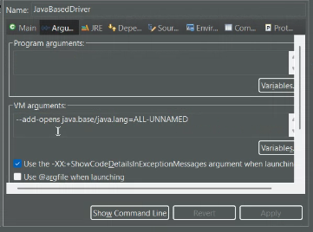

public class Car// implements InitializingBean,DisposableBean
{

private String carMfgName;
private String carModelName;
private double price;
private String color;

@Autowired
@Qualifier("eng2")
private Engine engine;

@Autowired
private Gear gear;

package com.itv.config;

import org.springframework.context.annotation.Bean;
import org.springframework.context.annotation.Configuration;

import com.itv.model.Car;
import com.itv.model.Engine;
import com.itv.model.Gear;

@Configuration
public class BeanConfig {

@Bean(name="eng1")
public Engine makeEngineUsingConstructor()
{
Engine e1=new Engine("Toyota", 30, 3000, "Petrol");
return e1;
}

@Bean(name="eng2")
public Engine makeEngineUsingConstructor1()
{
Engine e1=new Engine("Volvo", 40, 4000, "Diesel");
return e1;
}

@Bean(name="g2")
public Gear makeGearUsingSetter()
{
Gear gear=new Gear();
gear.setGearLever(10);
gear.setGearMfgName("Tata");
gear.setNumberOfGears(18);
return gear;
}

@Bean(name="car1")
public Car makeCarUsingSetter()
{
Car car=new Car();
car.setCarMfgName("Mercedes");
car.setCarModelName("C Class");
car.setColor("white");
car.setPrice(3333);
return car;
}
}

Driver app

Car myCar=beanFactory.getBean("car1", Car.class);
System.out.println(myCar);

NOTE : While using autowire in constructor-arg bean we have to make a separate constructor in the entity class with only the primitive types,
The non primitives DI will be done by Autowire

<bean id="c2" class="com.itp.model.Car" autowire="byName">
<constructor-arg value="2022"></constructor-arg>
<constructor-arg value="White"></constructor-arg>
<constructor-arg value="Swift"></constructor-arg>
<constructor-arg value="Maruti"></constructor-arg>
</bean>

public Car(int carModelYear, String carColor, String carModelName, String carMfgName) {
this.carModelYear = carModelYear;
this.carColor = carColor;
this.carModelName = carModelName;
this.carMfgName = carMfgName;
}

