https://console.cloud.google.com/

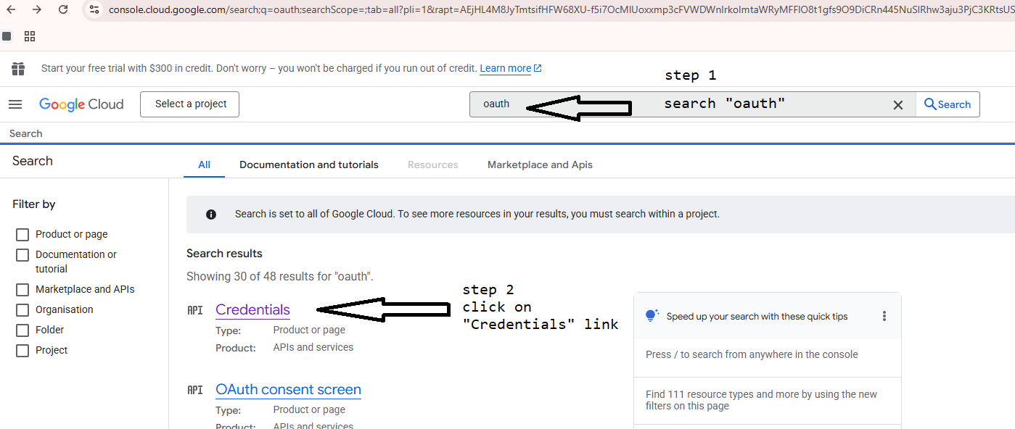

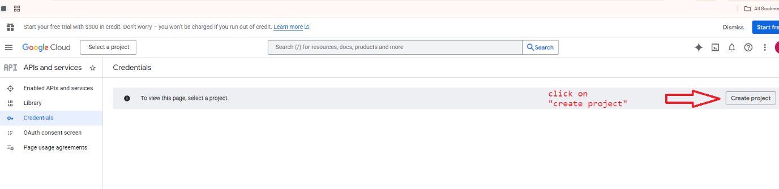

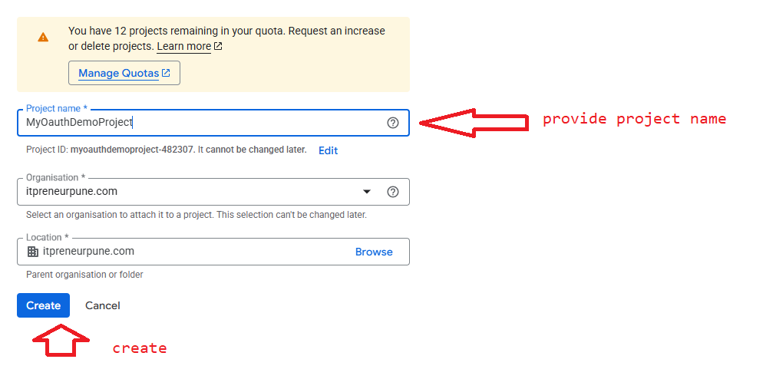

MyOauthDemoProject
myoauthdemoproject-482307

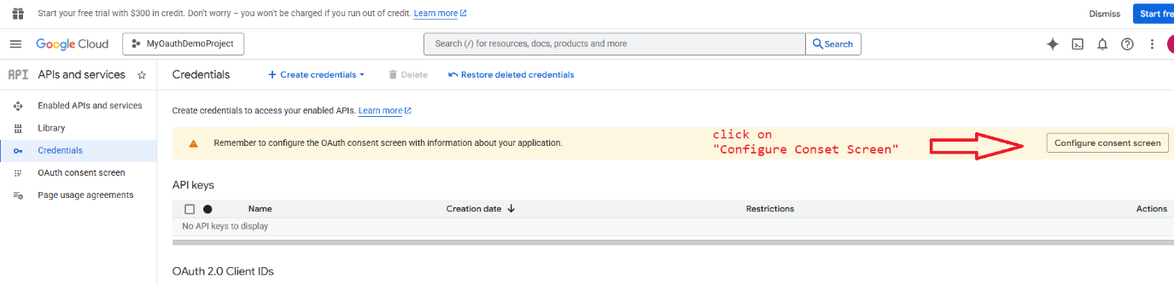

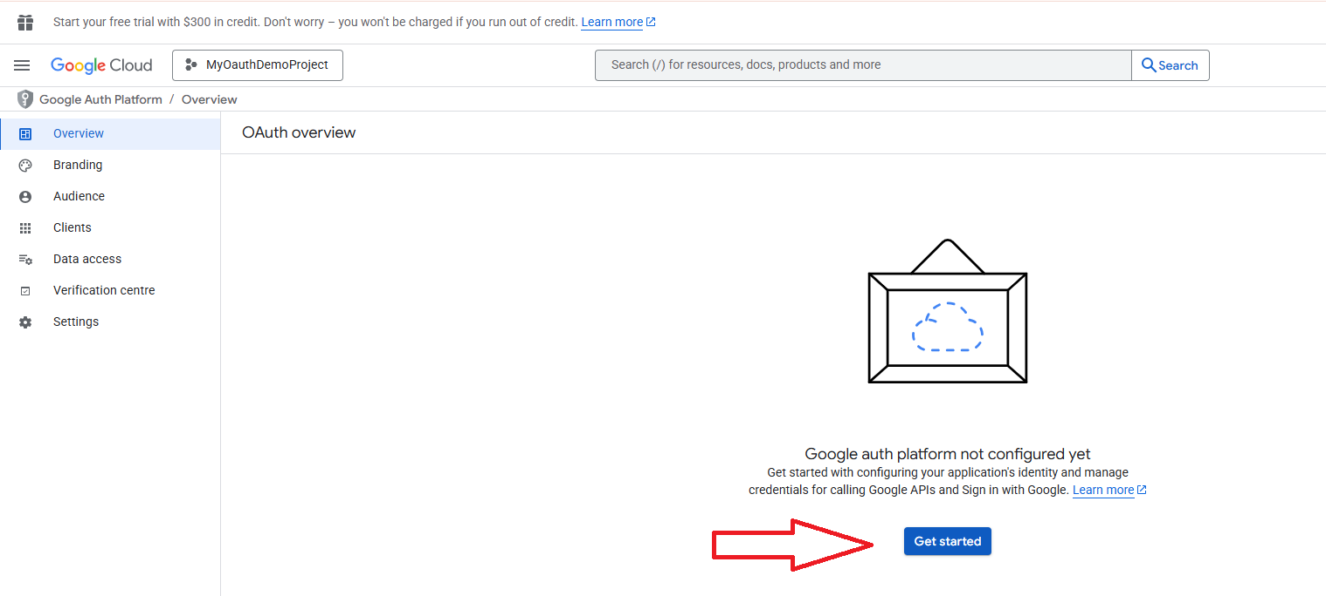

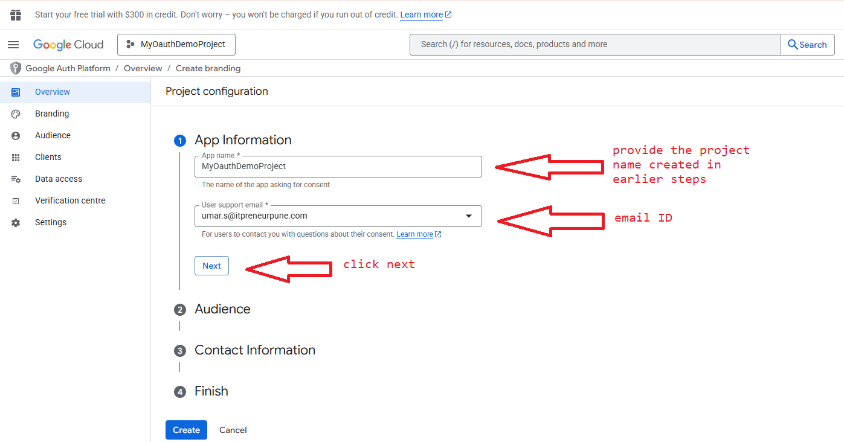

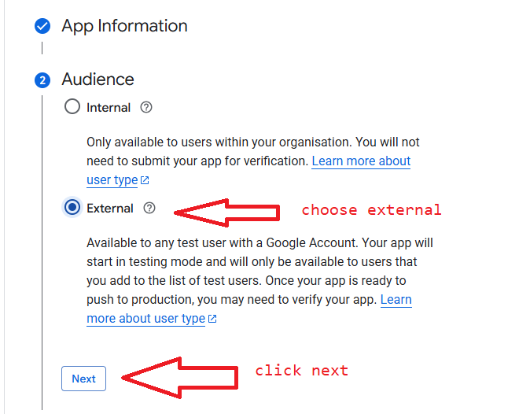

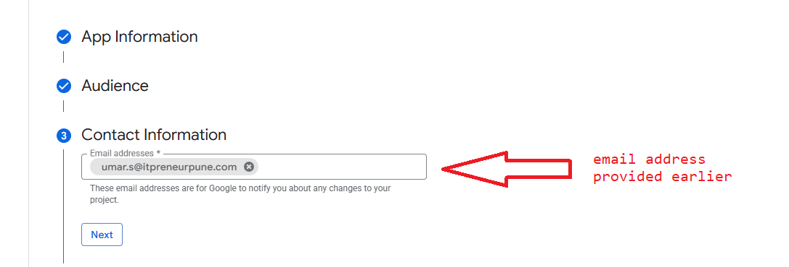

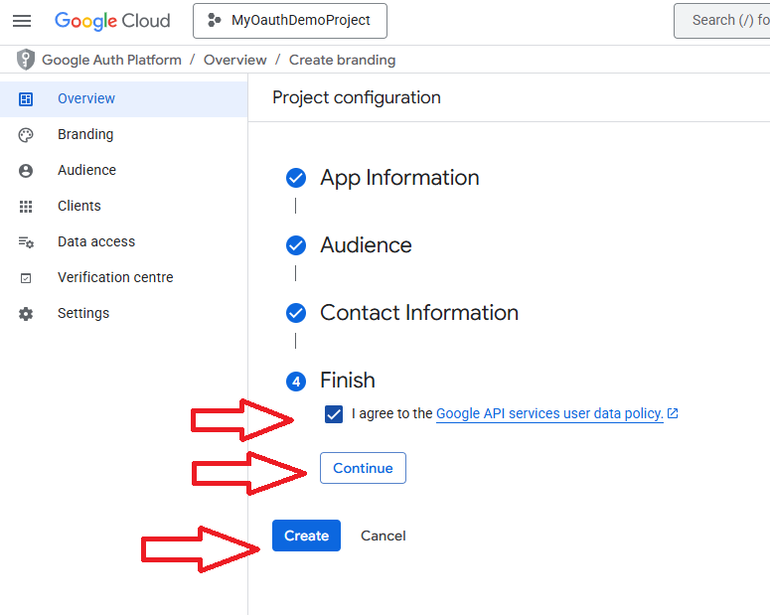

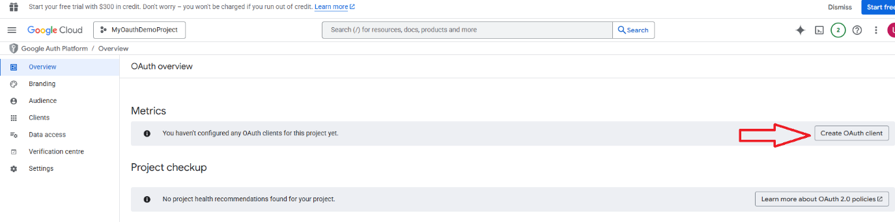

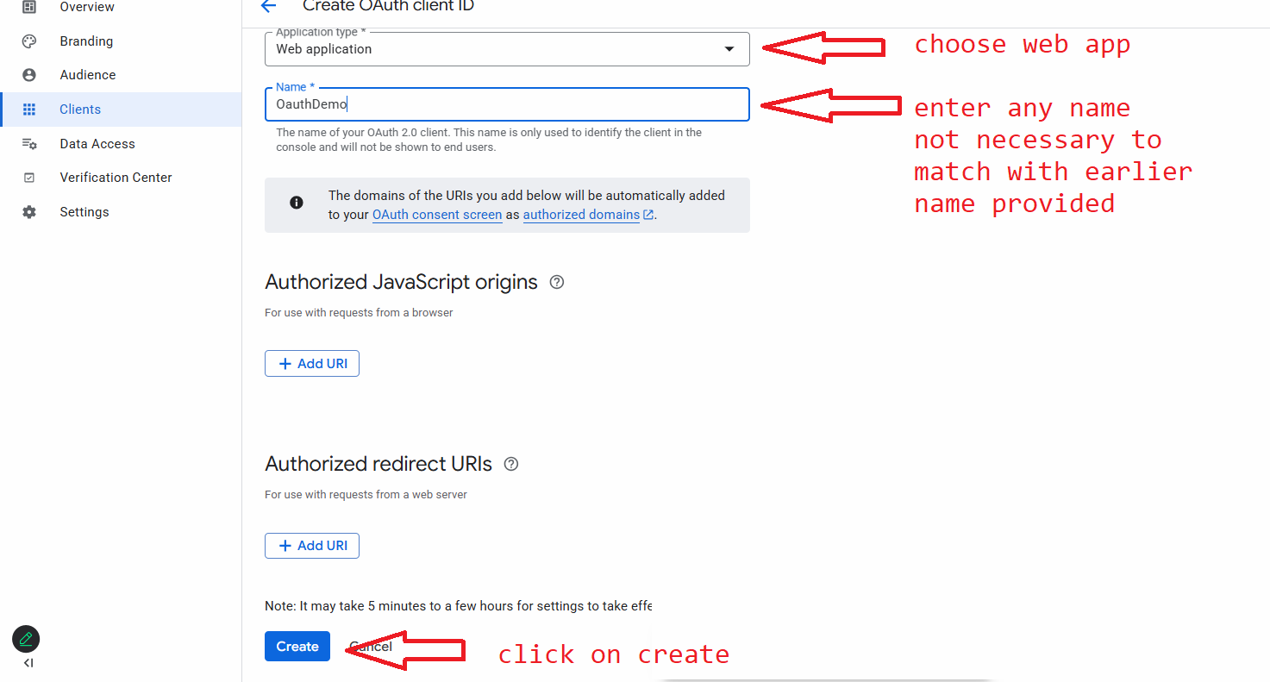

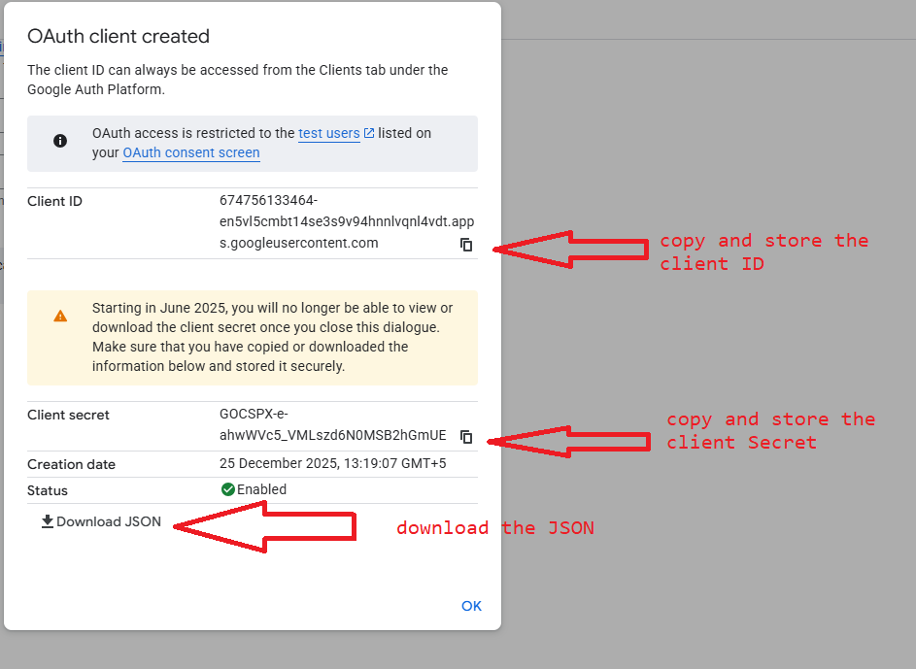

Client ID : 674756133464-en5vl5cmbt14se3s9v94hnnlvqnl4vdt.apps.googleusercontent.com
Client Secret : 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

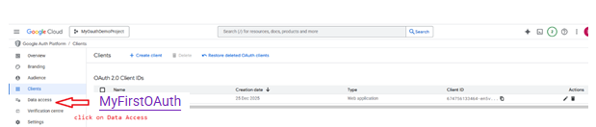

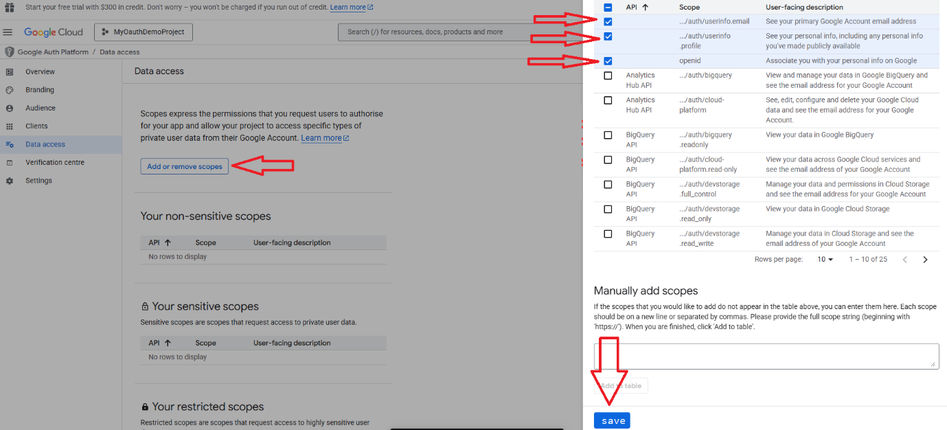

Stage 2 :
https://developers.google.com/oauthplayground/

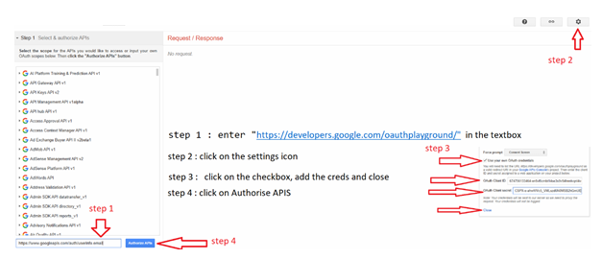
https://www.googleapis.com/auth/userinfo.email

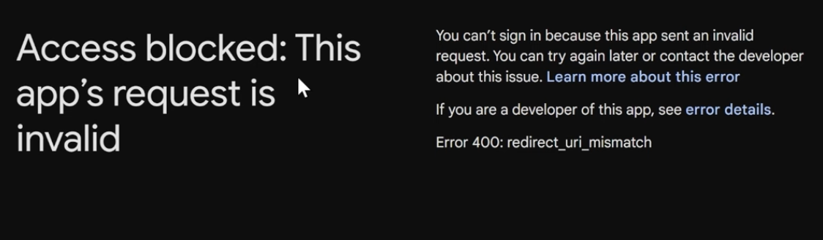

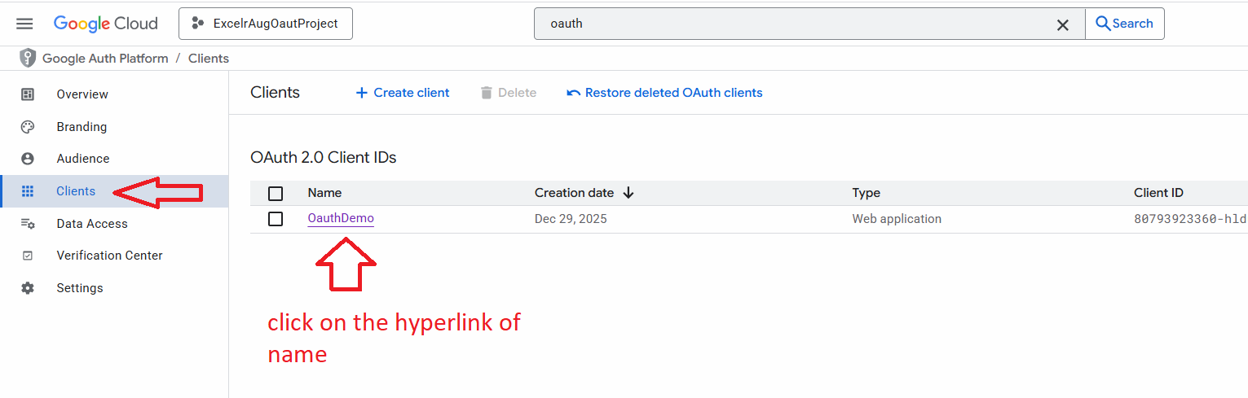

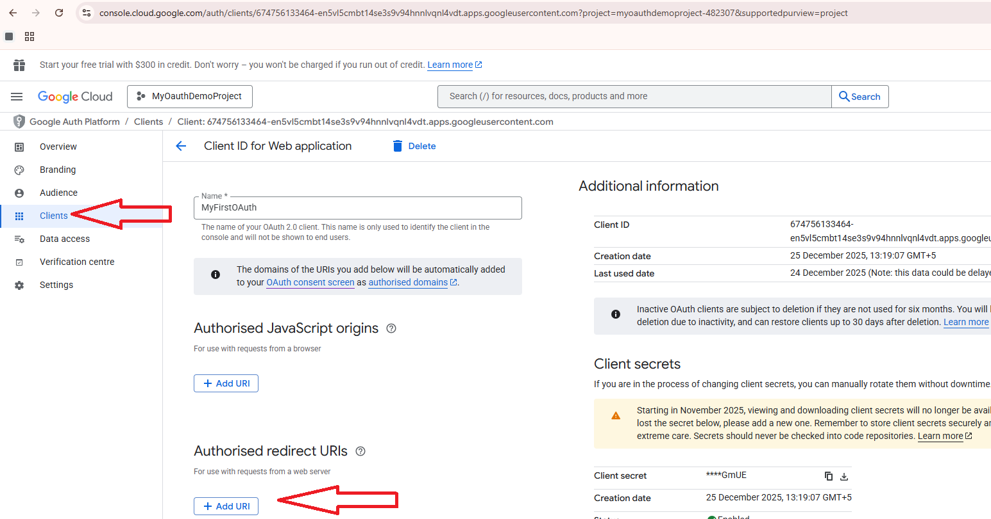

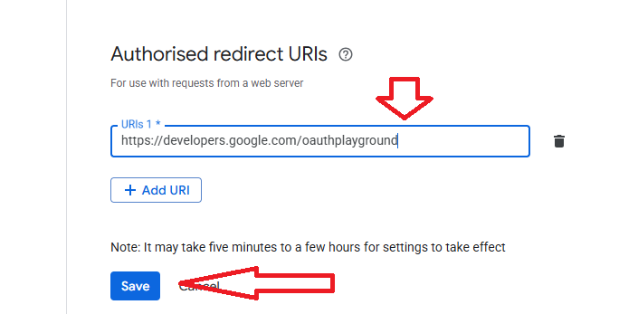


https://www.googleapis.com/auth/userinfo.email

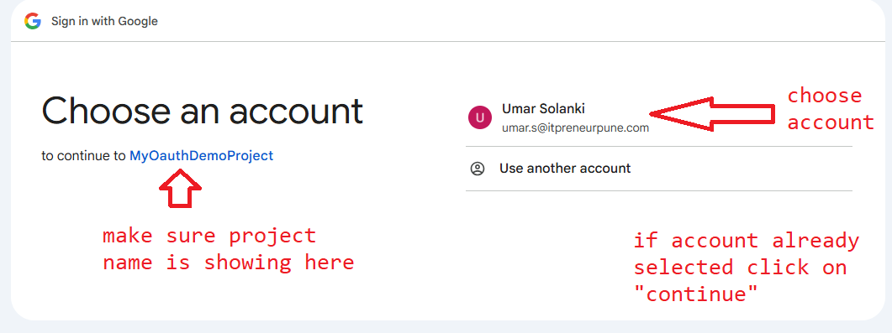

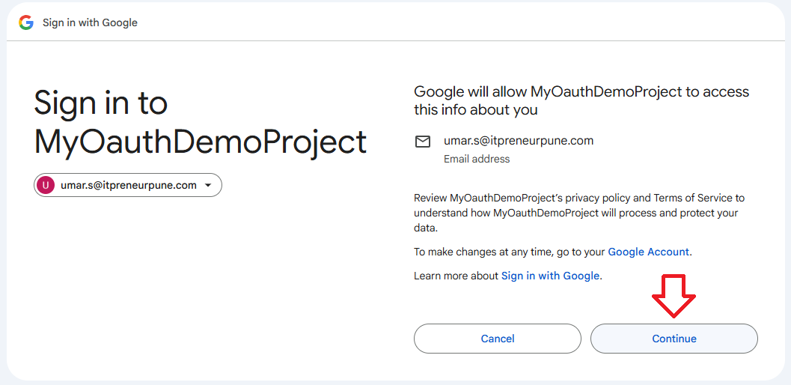

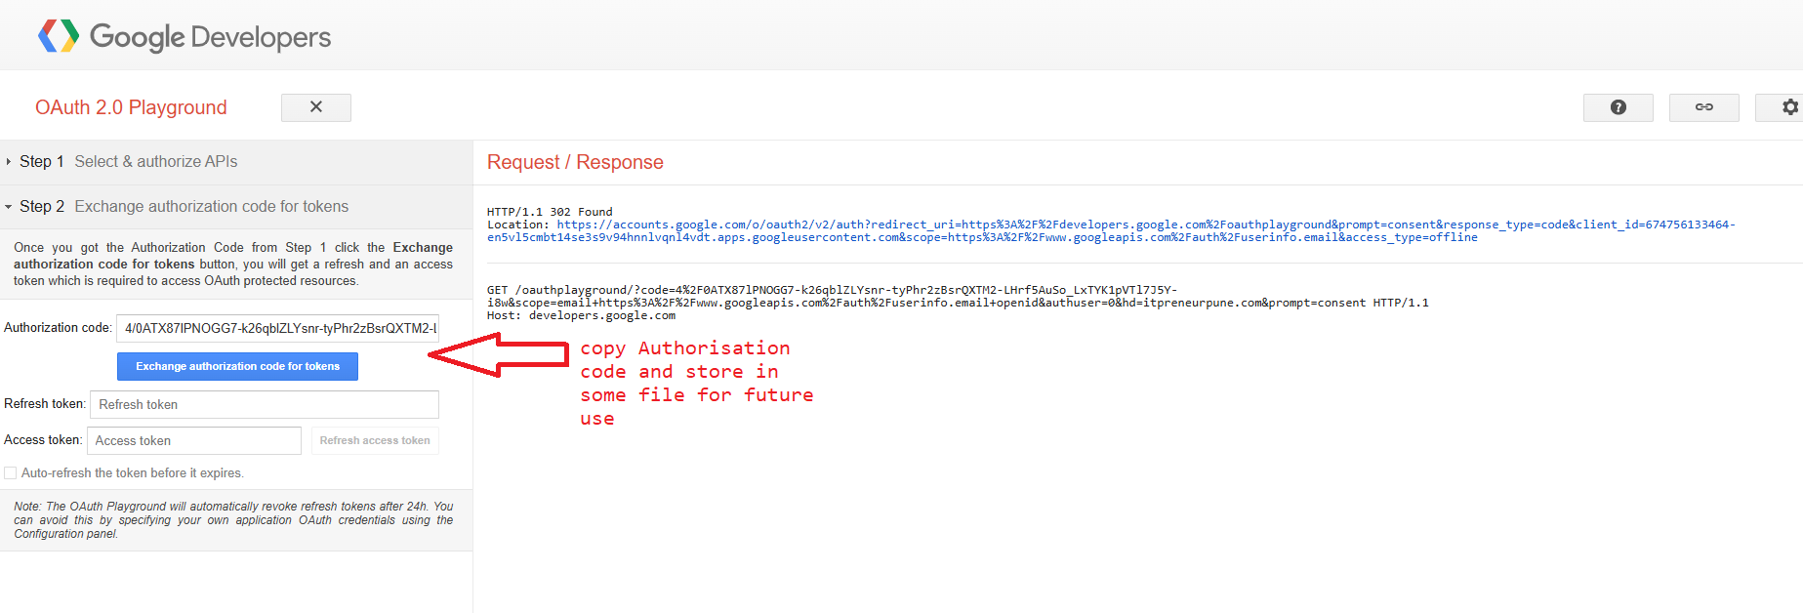

4/0ATX87lPNOGG7-k26qblZLYsnr-tyPhr2zBsrQXTM2-LHrf5AuSo_LxTYK1pVTl7J5Y-i8w

Write the code and run the application

To test

Go to https://developers.google.com/oauthplayground

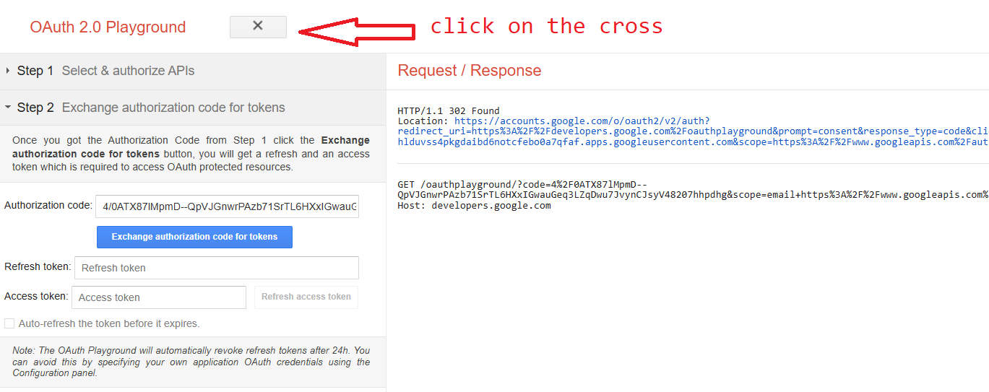
Go to https://developers.google.com/oauthplayground

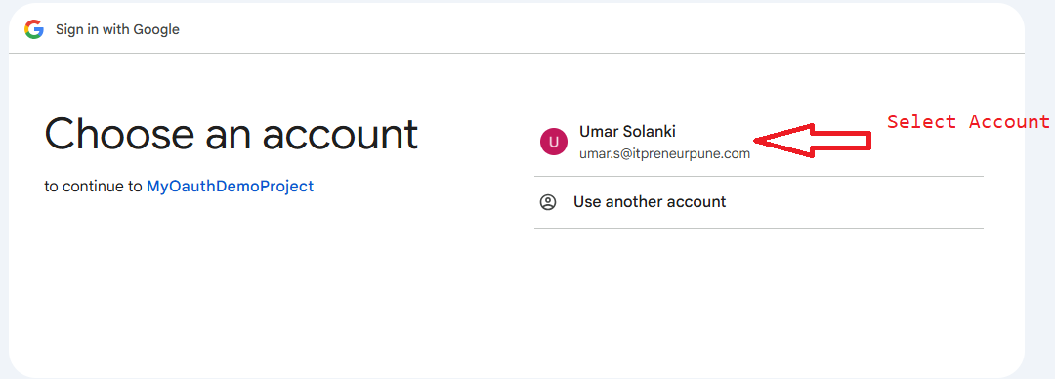

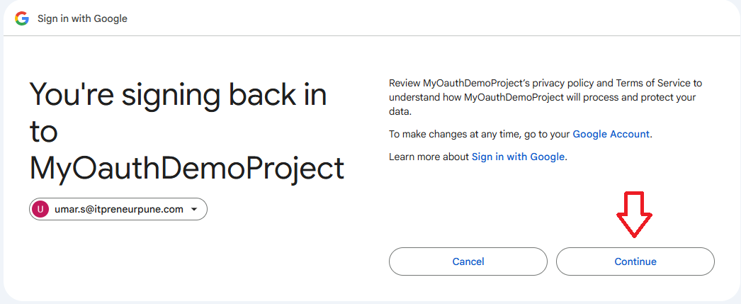

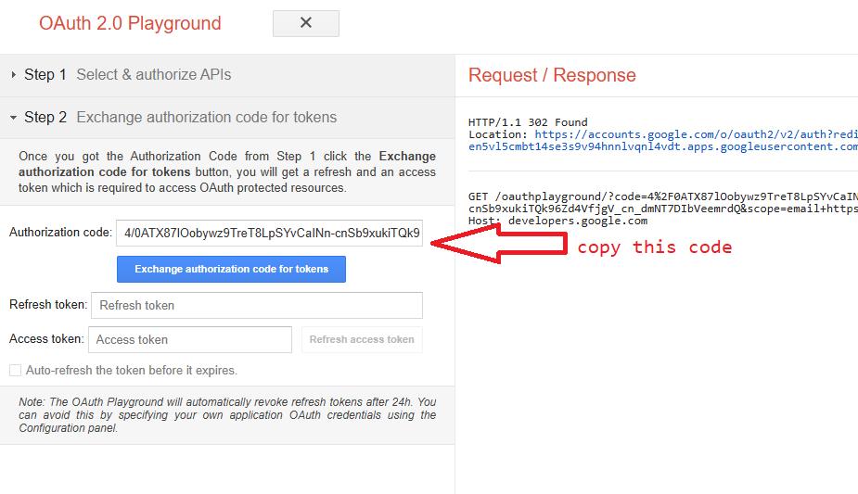

Hit the localhost:8089/auth/google/callback
Pass the copied code as request param “key” code

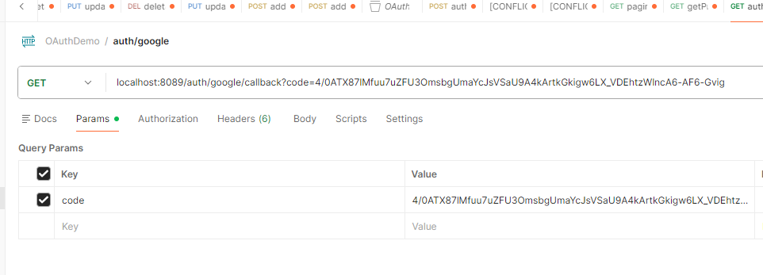

Token will be returned as response

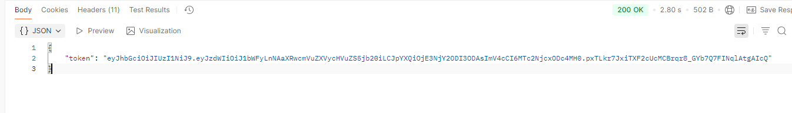

Copy the token and hit the other user endpoints passing the token in header

