Types of IoC Containers

1)Core container

The [BeanFactory](http://static.springsource.org/spring-framework/docs/current/javadoc-api/org/springframework/beans/factory/BeanFactory.html" \t "_top) interface provides an advanced configuration mechanism capable of managing any type of object. (core.io)

Resource res=new ClassPathResource("resources/application-context.xml");

BeanFactory factory= new XmlBeanFactory(res);

2) J2EE Container

[ApplicationContext](http://static.springsource.org/spring-framework/docs/current/javadoc-api/org/springframework/context/ApplicationContext.html) is a sub-interface of BeanFactory. It adds easier integration with Spring's AOP features; message resource handling.

ClassPathXmlApplicationContext beanFactory = **new** ClassPathXmlApplicationContext("resources/application-context.xml");

In short, the BeanFactory provides the configuration framework and basic functionality, and the ApplicationContext adds more enterprise-specific functionality.

Beans forms the backbone of your application

they are instantiated, assembled & managed by the Spring IoC container.

beans are created with the configuration metadata that you supply to the container. in the form of XML <bean/> definitions

Bean definition contains the information called configuration metadata, which is needed for the container to know the following −

1. How to create a bean

2. Bean's lifecycle details

3. Bean's dependencies

1) download spring 5 jars from https://github.com/uysolanki/Spring5Jars

2) create new Java Application

3) add the jars, right click on the application name

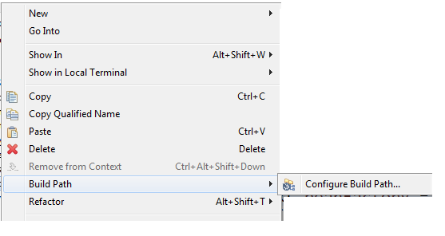

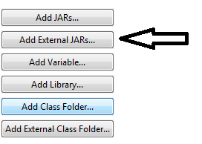

upload all the jars

Step 3 : inside the "src" folder create a package/folder by the name "resources"



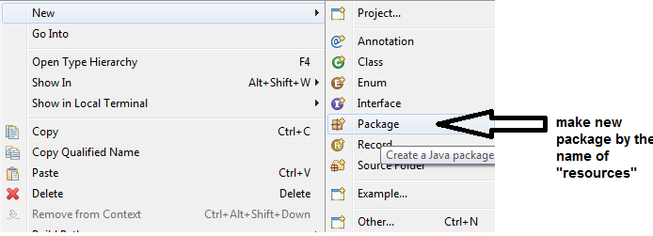

4) in the "resources" folder make a file by the name "application-context.xml" (you can specify any other name also) , paste the following in that file.

<?xml version=*"1.0"* encoding=*"UTF-8"*?>

<beans xmlns=*"http://www.springframework.org/schema/beans"*

xmlns:xsi=*"http://www.w3.org/2001/XMLSchema-instance"*

xmlns:context=*"http://www.springframework.org/schema/context"*

xsi:schemaLocation=*"http://www.springframework.org/schema/beans*

*http://www.springframework.org/schema/beans/spring-beans.xsd*

*http://www.springframework.org/schema/context*

*http://www.springframework.org/schema/context/spring-context.xsd"*>

</beans>

5) Right click on "src" and make a new package "com.gl.app"

6) Create the DriverApp class and add the "main()" in it

7) load the J2EE container

ClassPathXmlApplicationContext beanFactory = **new** ClassPathXmlApplicationContext("resources/application-context.xml");

8) Right click on "src" and make a new package "com.gl.service"

9) add a POJO class to it with Constructors, setter/getter, toString

e.g **public** **class** Player {

**private** **int** jno;

**private** String pname;

**private** **int** runs;

**private** **int** mp;

10) to the xml file add

**1. BEAN CREATION (USING XML)**

**Types of DI :**

**1) CONSTRUCTOR DEPENDENCY INJECTTION**

<bean id=*"p1"* class=*"com.gl.service.Player"*>

<constructor-arg value=*"18"*></constructor-arg>

<constructor-arg value=*"Virat"*></constructor-arg>

<constructor-arg value=*"5000"*></constructor-arg>

<constructor-arg value=*"50"*></constructor-arg>

</bean>

**2) SETTER DEPENDENCY INJECTTION**

<bean id=*"a1"* class=*" com.gl.service.Player"*>

<property name=*"jno"*>

<value>18</value>

</property>

<property name=*"pname"*>

<value>Virat Kohli</value>

</property>

<property name=*"runs"*>

<value>5000</value>

</property>

<property name=*"mp"*>

<value>50</value>

</property>

</bean>

**3) @Autowired Dependency Injection**

Pre-requisite :

in the context.xml file below the bean tag put

<context:annotation-config />

@Autowired // byType

@Qualifier("e2")//By Name

Engine myEngine;

@Autowired

Gear myGear;

**ARRAY, LIST, SET**

<property name=*"cities"*>

<list>

<value>Delhi</value>

<value>Pune</value>

<value>Jaipur</value>

</list>

</property>

**MAP**

<property name=*"catalog"*>

<map>

<entry key=*"bmw"* value=*"1000"*></entry>

<entry key=*"audi"* value=*"2000"*></entry>

<entry key=*"maruti"* value=*"3000"*></entry>

</map>

</property>

**PASSING REFERENCE USING SETTER**

<property name="engine" ref="e1"></property>

**PASSING REFERENCE USING CONSTRUTOR**

<constructor-arg ref="e1"></constructor-arg>

Bean element attributes

id

class

scope = "prototype" / "singleton"(default)

autowire= "byName" / "byType" (Ref no need to be coded explicitly)

autowire-candidate= "true" / "false"

**2. BEAN CREATION USING (JAVA+XML)**

<context:component-scan base-package="com.gl.service">

</context:component-scan>

**3. BEAN CREATION USING (ONLY JAVA, without any xml file)**

you can delete the context.xml file

1) create a new package com.gl.config

2) make a config class names "MyConfig"

@Configuration

@ComponentScan(basePackages="com.gl.model")

**public** **class** MyConfiguration {

}

3) Annot the Student class in the com.gl.model package with @Component

@Component

**public** **class** Student {

4) In driver App

ApplicationContext beanFactory = **new** AnnotationConfigApplicationContext(MyConfiguration.**class**);

Student s1=(Student)beanFactory.getBean(Student.**class**);

System.***out***.println(s1);

**BEAN LIFECYCLE**

1)PROGRAMATIC APPROACH

**public** **class** Player **implements** InitializingBean,DisposableBean{

overide the following methods

**public** **void** destroy()

**public** **void** afterPropertiesSet()

}

2) USING XML

<bean destroy-method=*"abc"* init-method=*"xyz"*>

3)USING ANNOTATIONS

@PreDestroy

@PostConstruct

**spring core application using MAVEN**

create a Maven Application

add the following dependencies

Dependency

1.Spring core 5.3.24

2.Spring context 5.3.24

AbstractApplicationContext abs=( AbstractApplicationContext) factory;

abs.registerShutdownHook();