Position

Like the header keeps its position on the top even if the page is scrolled vertically.

  .header{

        background-color: black;

        color:white;

        height: 100px;

    }

NOTE : As div is a block level element it is occupying the entire width of the body

body{

            height: 3000px;

        }

To stick the header at a particular co-od when the page scrolls

  .header{

        background-color: black;

        color:white;

        height: 55 px;

        position: fixed;

    }

But as we make position : fixed , the <div> will become inline-block and will only occupy the space which its needs.

So we need to specify the top, left, length & height co-ords of the header now so that it occupies that much space at the top

position: fixed;

        top:20px;

        right: 50px;

        bottom: 500px;

        left: 40px;

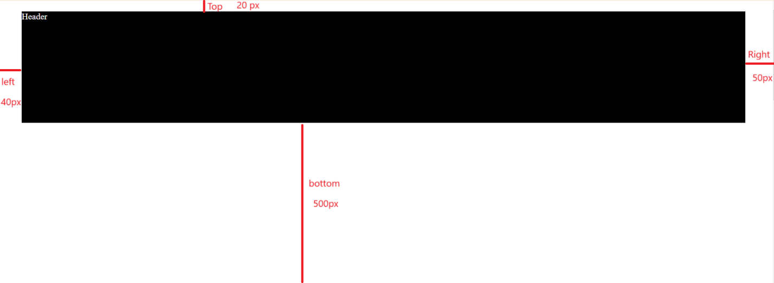

NOTE : when we set the top right bottom and left property of position it will resize according to these corners.

 position: fixed;

        top:0px;

        right: 0px;

        left: 0px;

        height: 100px;

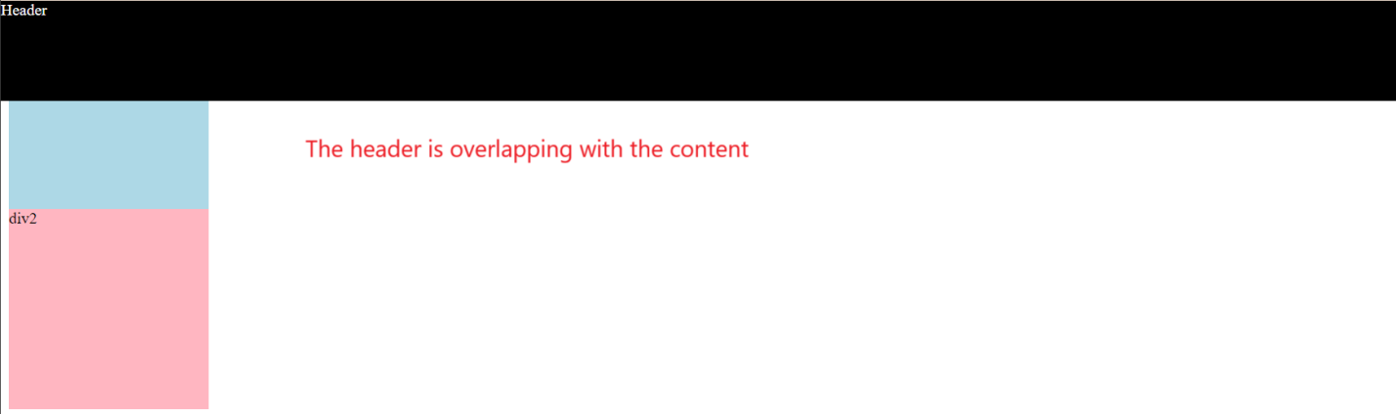

 body{

            height: 3000px;

            padding-top: 105px;

        }

Youtube application

.header{

    height:55px;

    display: flex;

    flex-direction: row;

    justify-content: space-between;

    position: fixed;

    top:0px;

    right: 0px;

    left: 0px;

    background-color: white;

  border-bottom-width: 1px;

    border-bottom-style: solid;

    border-bottom-color:gray;

}



Add padding-top to body of 60px

  body{

    margin:0px;

    height: 3000px;

    padding-top: 60px;

  }