Flexbox

Similar to css grid but its more flexible

1.the box will auto adjust to the content

2.the box take their width along if there are moved from one place to another

Use case



e.g 1

<style>

        .color1{

            background-color: lightblue;

        }

        .color2{

            background-color: lightpink;

        }

        .flexbox1{

            display: flex;

            flex-direction: row; //default value

        }

    </style>

</head>

<body>

    <div class="flexbox1">

        <div class="color1">div1</div>

        <div class="color2">div2</div>

      </div>

</body>

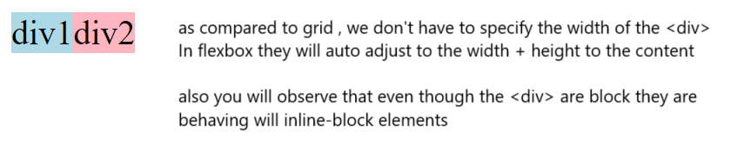

e.g 2

<div class="flexbox1">

        <div class="color1">div1</div>

        <div class="color2">div2<p>Welcome</p></div>

      </div>

If we add any other element in the div the flexbox will maintain the vertical alignment



e.g 3

like in grid layout we can also specify the width of the <div>

 <div id="flexbox2">

        <div id="color3">100px</div>

        <div id="color4">1fr</div>

</div>

 #flexbox2{

            display: flex;

            flex-direction: row;

            margin-top: 10px;

        }

        #color3{

            width: 100px;

            background-color: lightblue;

        }

        #color4{

            flex:1;

            background-color: lightpink;

        }

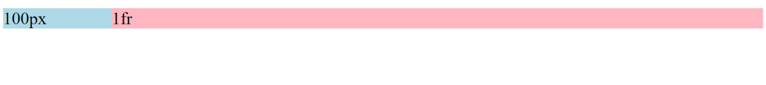

e.g 4 :

<div id="flexbox2">

        <div id="color3">100px</div>

        <div id="color4">1fr</div>

        <div id="color5">2fr</div>

    </div>

#color5{

            flex:2;

            background-color: lightblue;

        }



e.g 5 difference between Gridlayout & Flexbox

Gridbox

.grid1{

            display: grid;

            grid-template-columns: 50px 100px 1fr;

        }

<div class="grid1">

      <div class="color1">50px</div> //if we swap the order of 50px & 100px

      <div class="color2">100px</div> // then the 100px div will get the 1st grid i.e of 50px

      <div class="color1">1fr</div> // and the 50px will get the 2nd Grid i.e of 50px

</div> //thus we can conclude that grid layout is RIGID

Bcoz in Gridbox we first define the columns and the elements then go inside the columns

Flexbox

<div id="flexbox2">

        <div id="color3">100px</div> //if I swap the order of the div

        <div id="color4">1fr</div> //there will not be any change in the width

        <div id="color5">2fr</div>

    </div>

<div id="flexbox2">

<div id="color4">1fr</div>

        <div id="color3">100px</div>

        <div id="color5">2fr</div>

    </div>

The element takes their width whenever swapped, thus helps us to create a flexible layout

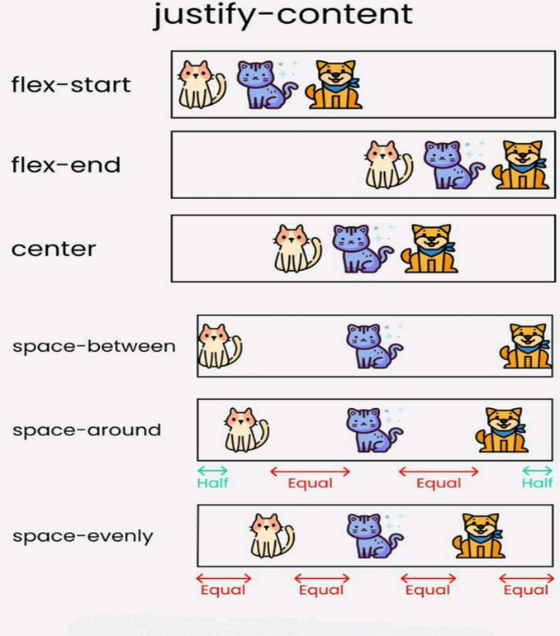

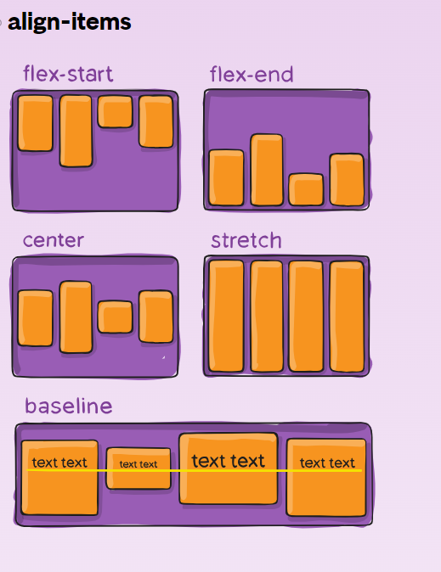

e.g 6

#flexbox2{

            display: flex;

            flex-direction: row; //default value

            margin-top: 10px;

            height: 70px;

            border:1px Solid red;

            justify-content:space-evenly;

            align-items:center;

        }

<div id="flexbox2">

        <div id="color3">100px</div>

        <div id="color4">100px</div>

        <div id="color5">100px</div>

    </div>

