Step 1 : Download & Extract Tomcat 9
Step 1a:
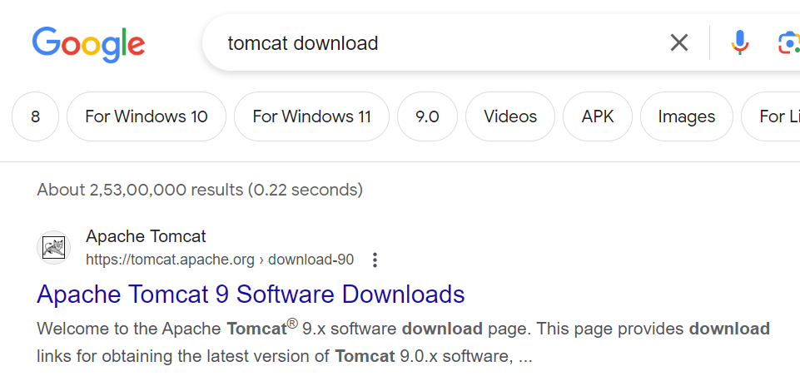
Step 1b:
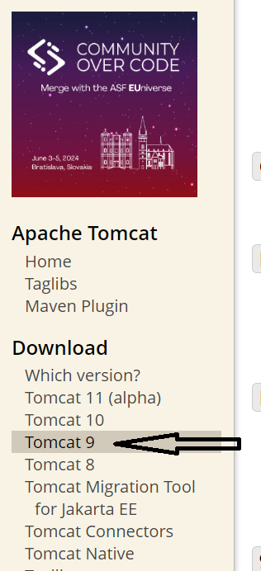
Step 1c:
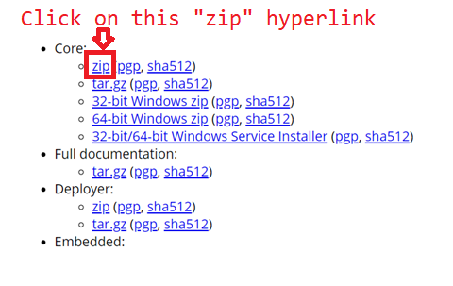

Step 1d : Cut paste the downloaded file to a folder and extract it
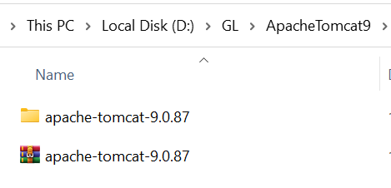

Step 2 : Create Dynamic Web Project
Step 2a : New -->others-> 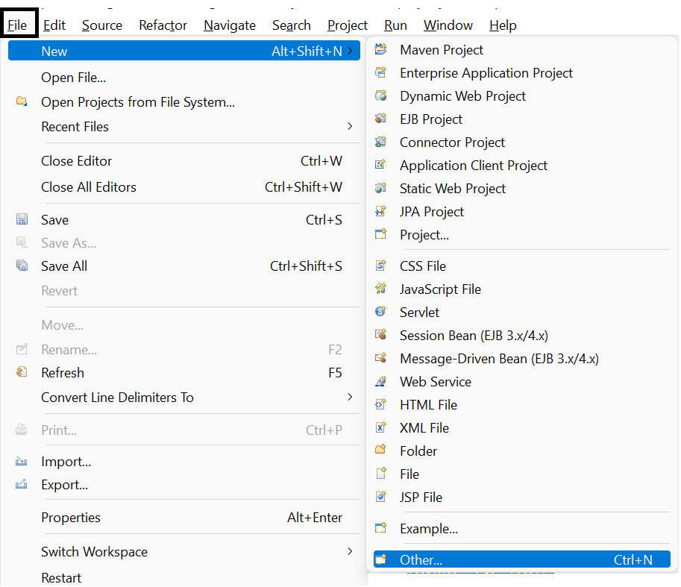

Step 2b :Dynamic Web Project

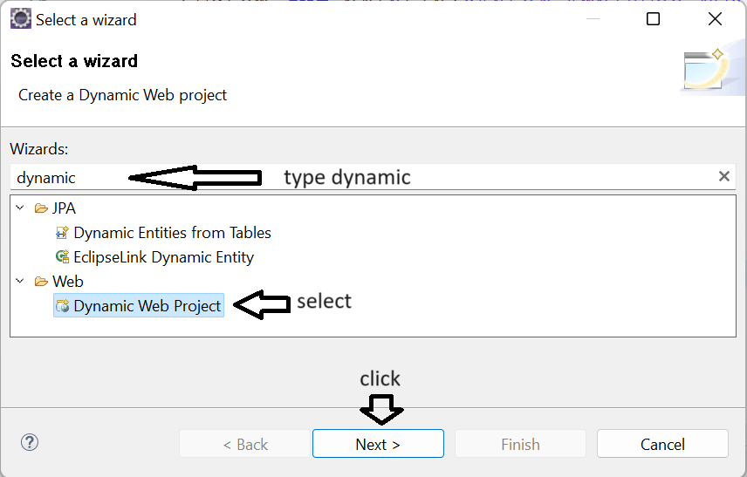
Step 2c : Name of the Project->choose web module version 4.0->Finish

If you do not see the option of dynamic web project
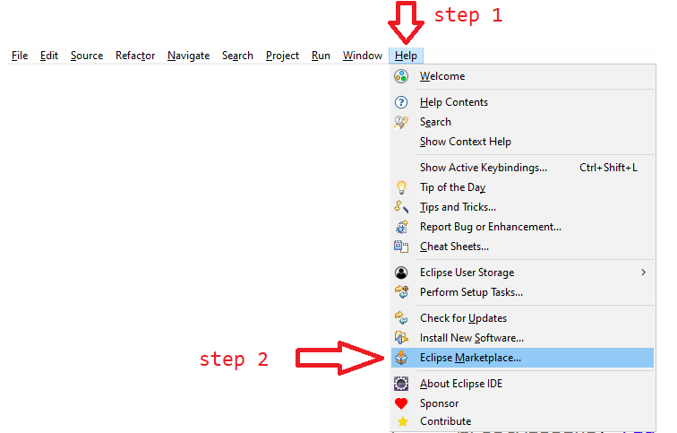

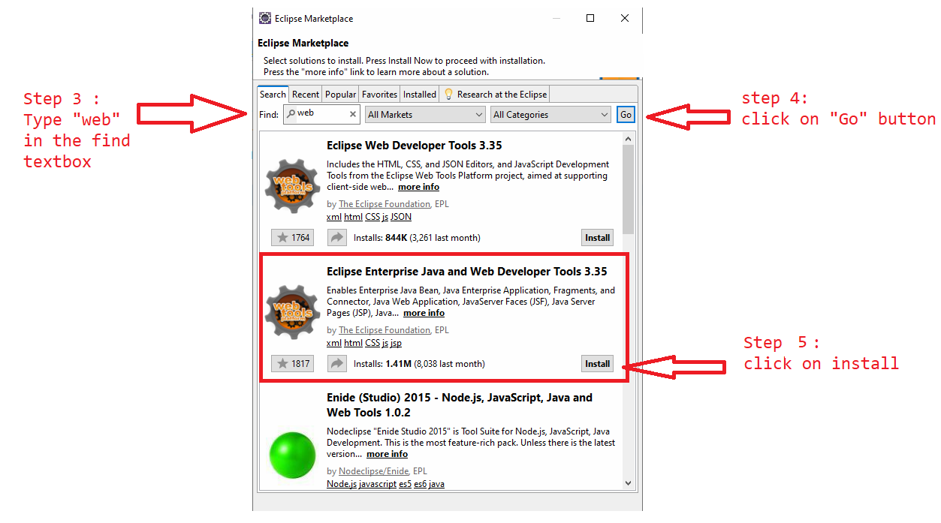

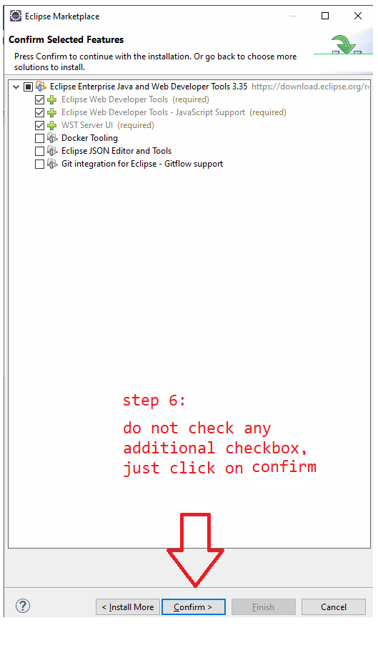
Step 7 : Shutdown and restart eclipse

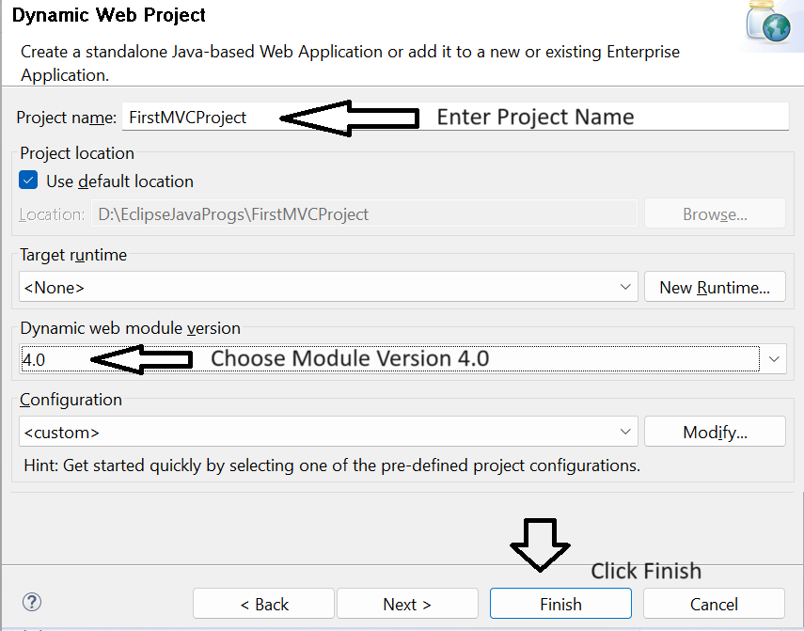
Step 3: Add the Tomcat server in eclipse
Step 3a : Windows->Servers
NOTE : If Servers option not found choose Others and search for servers
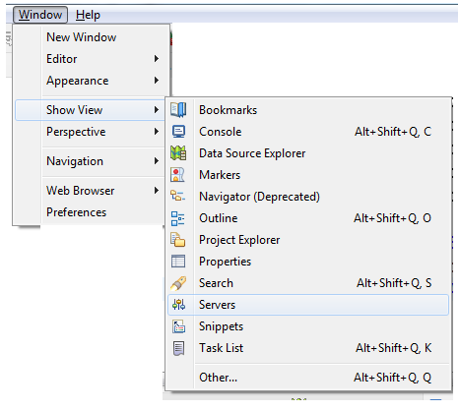
Step 3b : Add the server
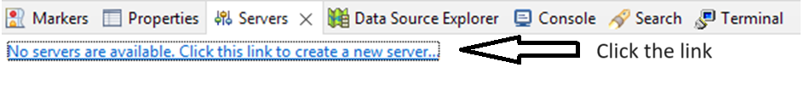

Step 3c : select Tomcat Version
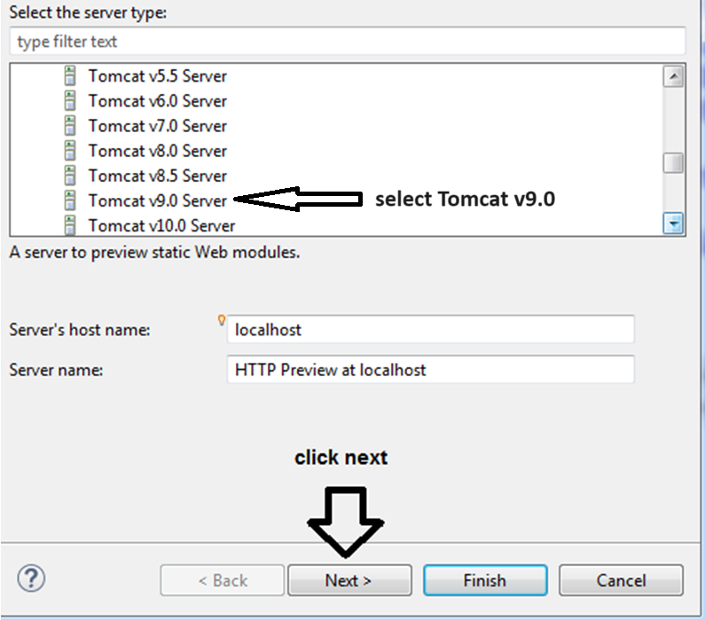

Step 3d : select Root Directory

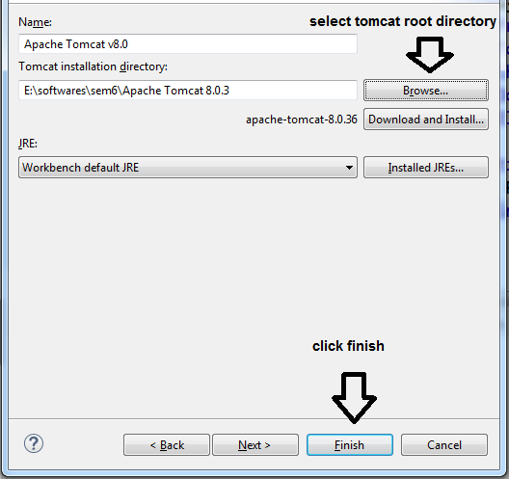

Step 3e : Server should be visible
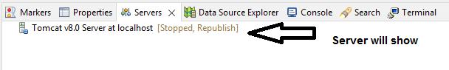

Step 3f : switch on/off the server
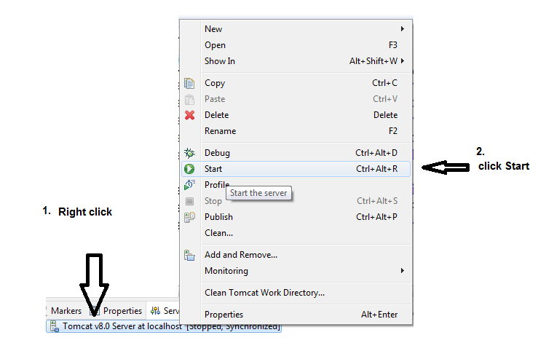

Step 4: Configuring version of project (JDK & Tomcat are in sync)

Step 4a : Right Click on the Project Name Properties
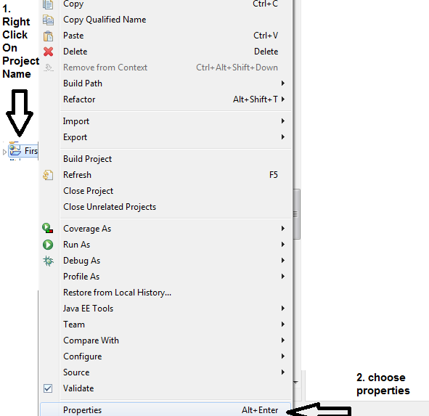

Step 4b : choose Project Facets

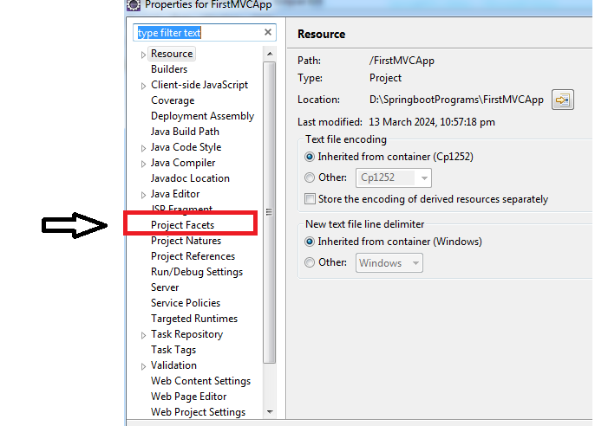

Step 4c : choose JDK Version & Runtime server , Apply and close

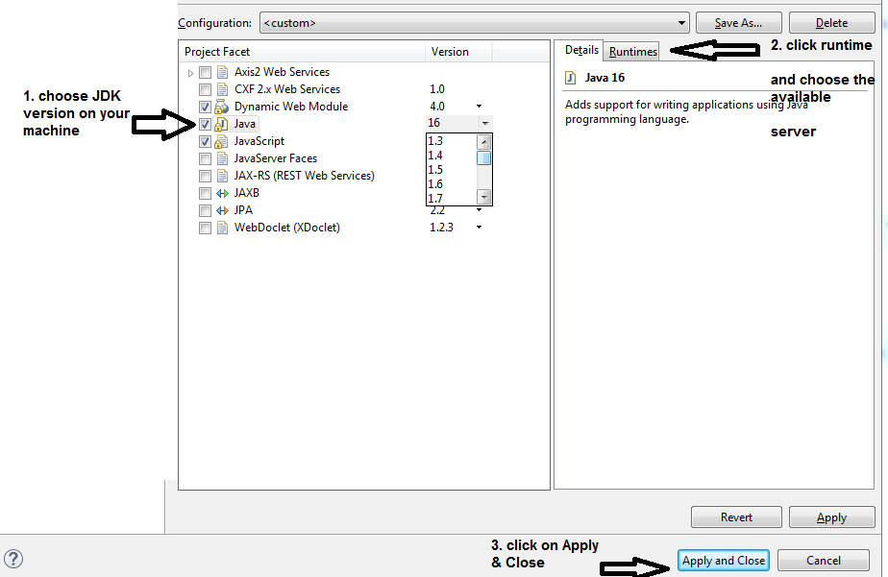

Step 5 : https://github.com/uysolanki/downloads-for-MVC-Hello-World
Download the
i)web.xml
ii)spring-mvc-demo.xml
iii)Spring Libs.zip (NOTE : merge the part1 & part2 zip files from the above git repo)
step 6: copy paste the files downloaded in step 5 in the eclipse project
6a : copy the web.xml & spring-mvc-demo.xml files and paste in WEB-INF folder
6b: extract the Spring Libs.zip and paste all the jars in the "lib folder"
step 7 :
7a : make a package by the name "com.companyname.controller" in the src/main/java
7b : make a class HelloController in the above package

Step 8 : configure the Dispatcher Servlet in web.xml
8a : NOTE the config param file value is the name of second xml file downloaded from git .
8b : open the second file and check the base package @line 15 com.greatlearning

Step 9 : go to the HelloController class
@Controller
public class HelloController {

@RequestMapping("/hello")
public String greet()
{
return "virat";
}

}

Step 10 : in WEB-INF make a folder by the name "view"
in the view folder make a jsp file by the return value of the function made in step 9
i.e virat.jsp
<body>
<h1> Hi Virat </h1>
</body>

Step 11 : run the codeon Server
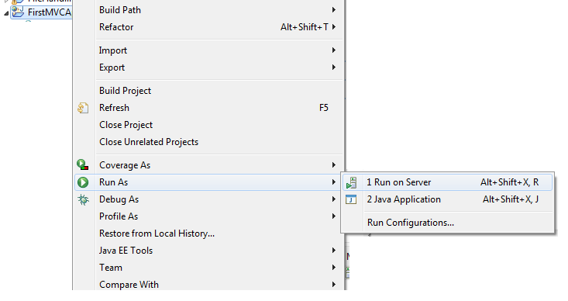

explain view resolver
create few more sample RequestMapping methods & explain
create new Controller class with a sample RequestMapping method & explain and explain

to open in browser
windows
preferences
general
web browser
check the browser apply & close.

