Model - Simplest way to add attributes
ModelMap- Works like a Map → key–value storage, Allows put() which is more flexible
ModelAndView - Contains both Model data AND View name , Used when returning different views dynamically (after login route to Admin/user dashboard)

example 1: passing string as a model attribute
@RequestMapping("/welcome")
public String welcomeBack(Model model)
{
model.addAttribute("test", "Virat Kohli");
return "welcome";
}

welcome.jsp
<body>
<h1>Welcome here, ${test}</h1>
</body>

output:
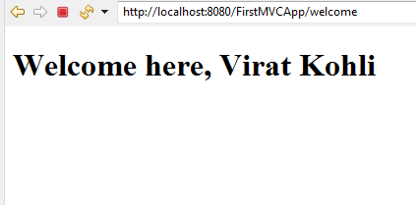

example 2 : passing object as a model attribute
public class Student {
private int rno;
private String sname;
private double percentage;
constructors, setter getter , toString
}

@RequestMapping("/hello")
public String greet(Model model)
{
Student s1=new Student(101,"Alice",78.5);
model.addAttribute("stud",s1);
return "hello";
}

<body>
<h1> Welcome Student, ${stud.sname} </h1>
</body>

output :
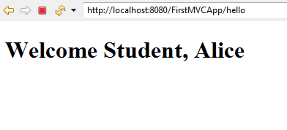

ModelAndView : Used when returning different views dynamically

@PostMapping("/login")
public ModelAndView login(@RequestParam String username, @RequestParam String password)
{
ModelAndView mv = new ModelAndView();
if (username.equals("admin") && password.equals("admin1234")) {
mv.setViewName("admin-dashboard"); // dynamic view
mv.addObject("message", "Welcome Admin!");
}
Else if (username.equals("user") && password.equals("user1234")) {
mv.setViewName("use-dashboard"); // dynamic view
mv.addObject("message", "Welcome User!");
}
else {
mv.setViewName("error"); // another dynamic view
mv.addObject("message", "Invalid Credentials!");
}
return mv;
}

