<dependency>
<groupId>org.springframework.boot</groupId>
<artifactId>spring-boot-starter-actuator</artifactId>
</dependency>

Localhost:8080/actuator

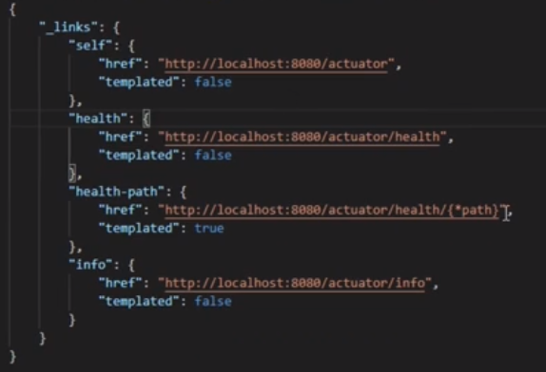

On Cloud environment you can check whether your microservices are deployed properly and the services are up.

Info end points

In the application.properties
info.project.name=Library Design
info.project.team=Great Learning
info.project.instructor=Umar Solanki
info.project.env=prod

Localhost:8080/actuator/info
Will show the above details in JSON format

Info about each MS we can put here

Metric end points
Exposing all the endpoints comprises on the security
To make the metric end points visible add to the properties file
management.endpoints.web.exposure.include=metrics, info, health

manually stop & start the server for the metrics to be visible

1st
Jdbc connection active
Jvm memory max
Jvm thread live

#to view all actuator endpoints
management.endpoints.web.exposure.include=*

#to change default base url to custom ur
management.endpoints.web.base-path=/app/health

Localhost:8080/app/health

