<dependency>
<groupId>org.projectlombok</groupId>
<artifactId>lombok</artifactId>
<version>1.18.30</version>
<scope>provided</scope>
</dependency>

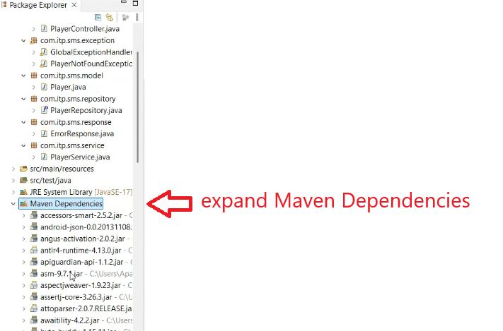

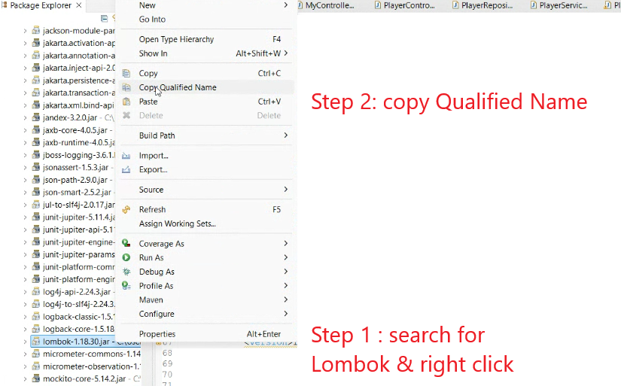

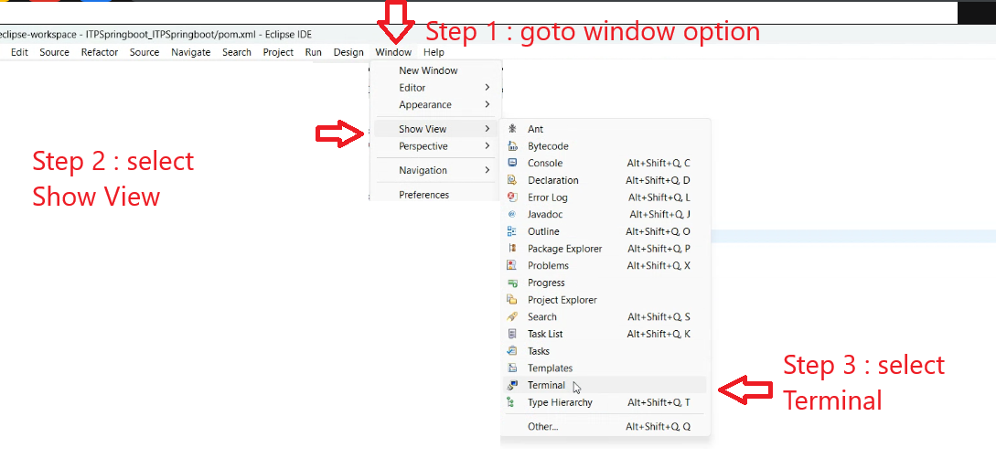

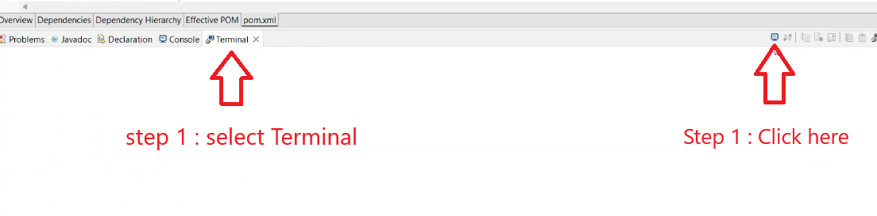

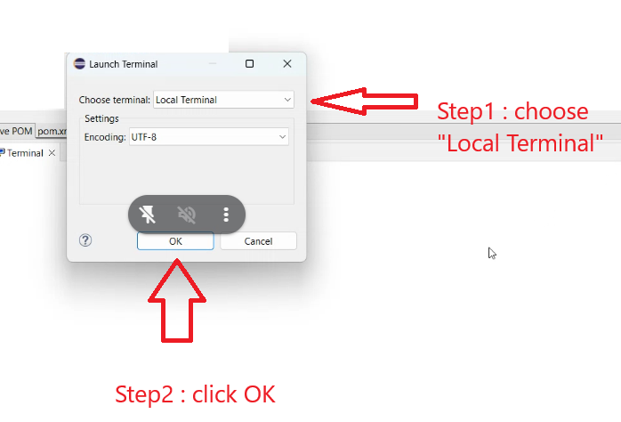

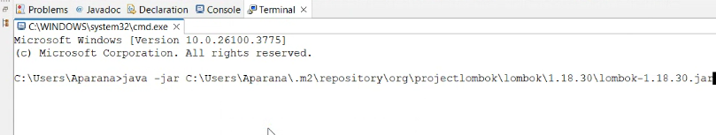

Command is
Java –jar paste

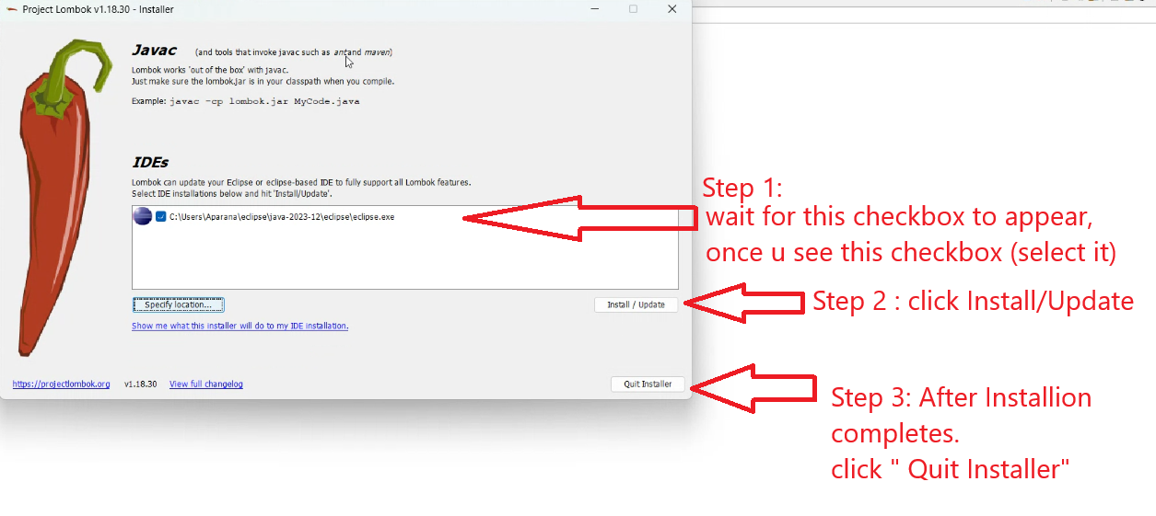

Restart Eclipse

How to Use
