Step 1 : Download & Extract Tomcat 9

**Step 1a:**

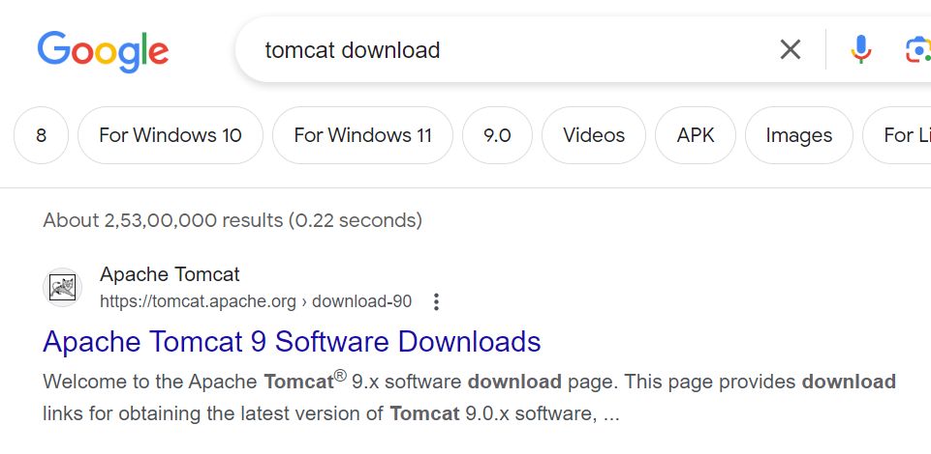

Step 1b:

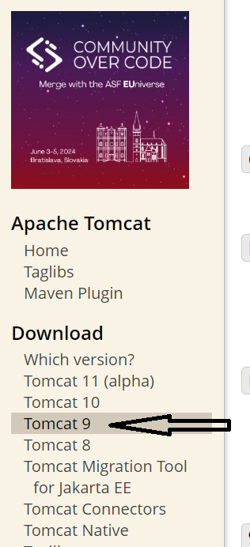

Step 1c:

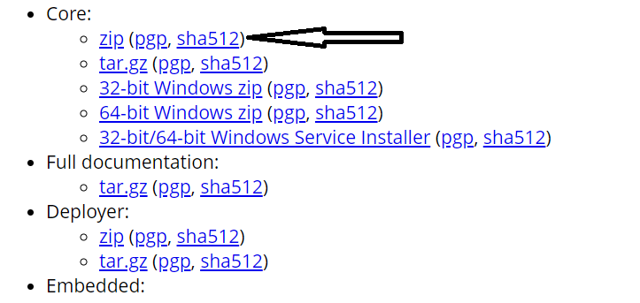

Step 1d : Cut paste the downloaded file to a folder and extract it

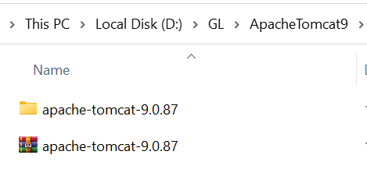

Step 2 : Create Dynamic Web Project

Step 2a : New -->others-> 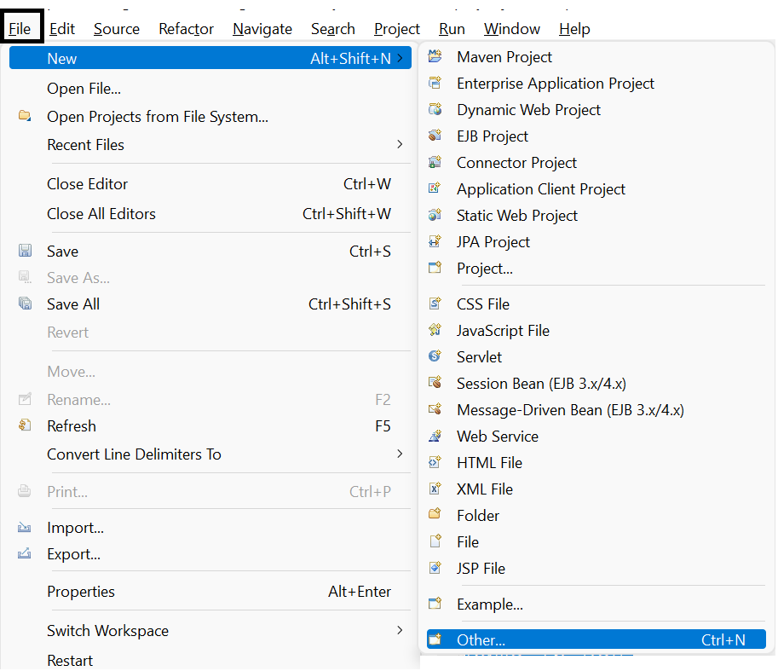

Step 2b :Dynamic Web Project

If not able to See

1. Click help MenuOption
2. Choose Eclipse Marketplace
3. Search “*Web Tools Platform*” & click install, keep the default checkboxes and submit.
4. restart eclipse

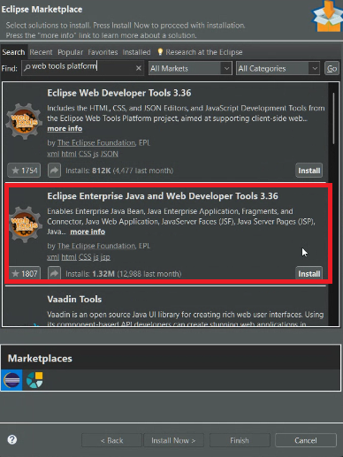

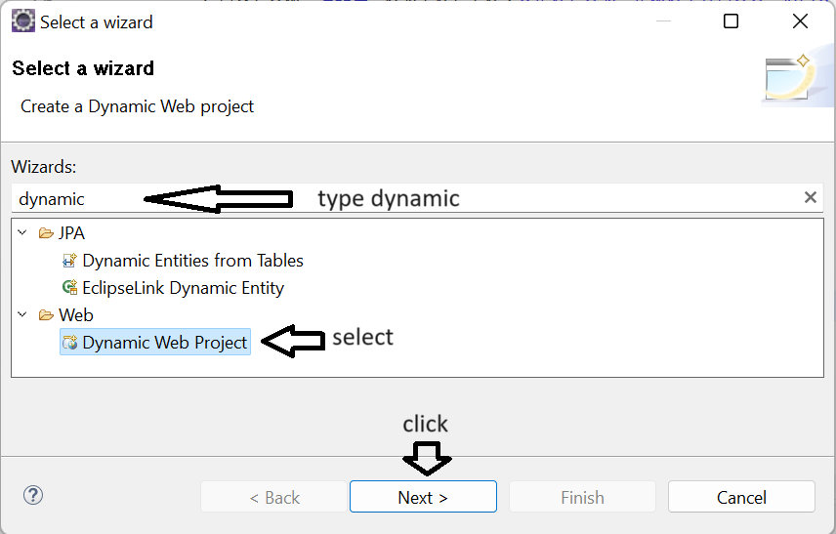

Step 2c : Name of the Project->choose web module version 4.0->Finish

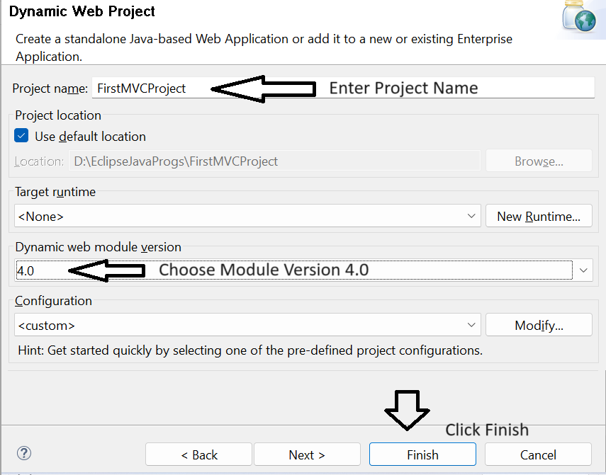

Step 3: Add the Tomcat server in eclipse

Step 3a : Windows->show view-> Servers

NOTE : If Servers option not found choose **Others** and search for **servers**

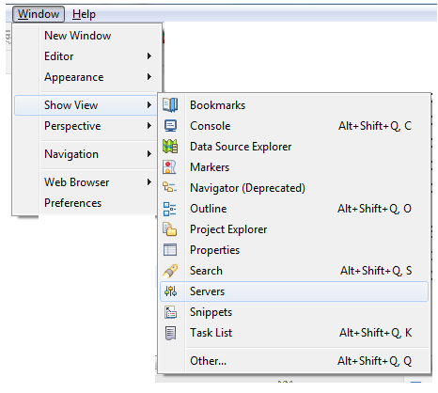

Step 3b : Add the server

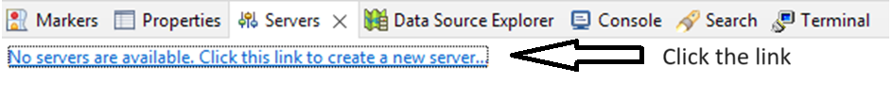

Step 3c : select Tomcat Version

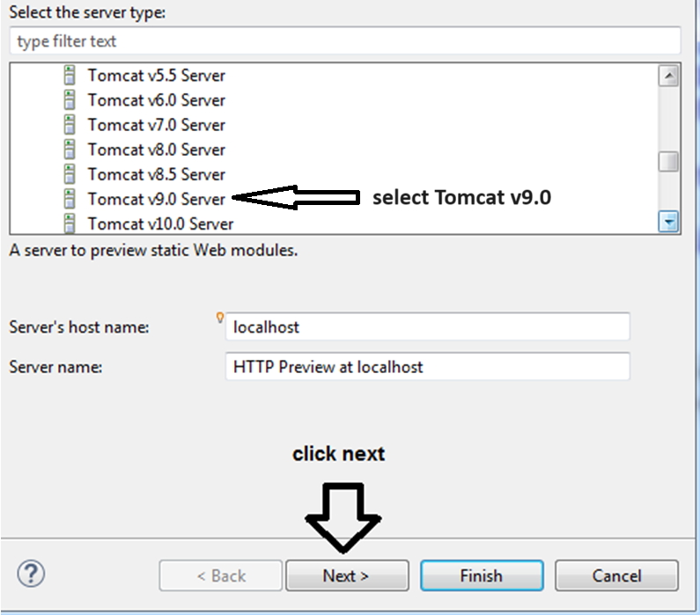

Step 3d : select Root Directory

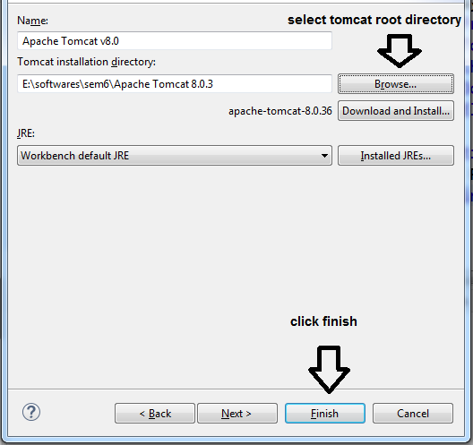

Step 3e : Server should be visible

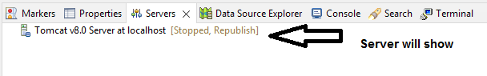

Step 3f : switch on/off the server

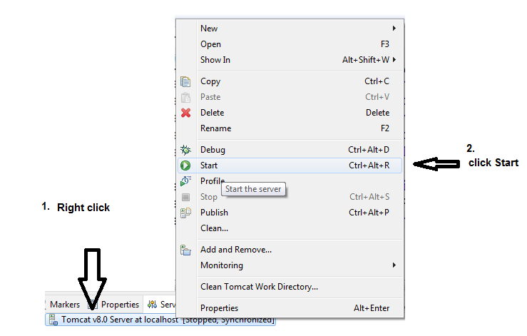

**Step 4: Configuring version of project (JDK & Tomcat are in sync)**

Step 4a : Right Click on the Project Name 🡪 Properties

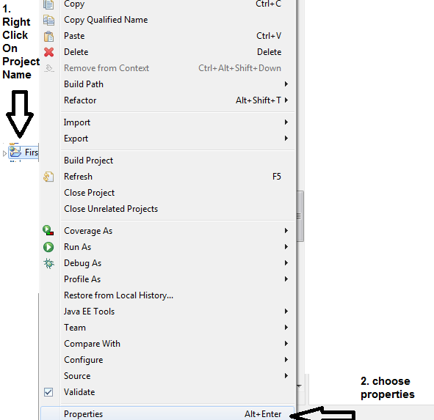

Step 4b : choose Project Facets

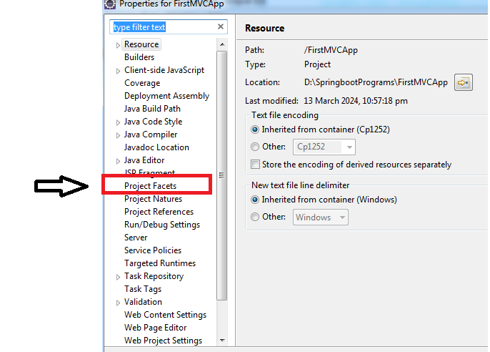

Step 4c : choose JDK Version & Runtime server , Apply and close

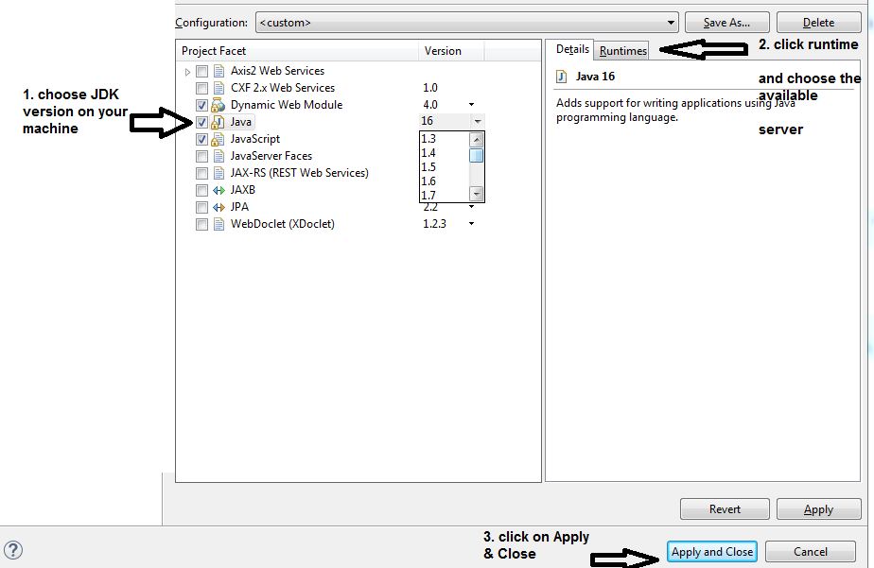

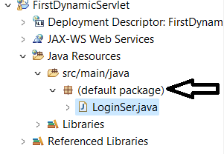

1. **Web.xml** in the WEB-INF folder
2. **.html** in the webapp folder
3. **.java** in the java resources -> src/main/java
4. **Also copy paste the jsp & servlet jars in the WEB-INF/lib folder**

Right click on the default package

New

Servlet

Give Name of the Servlet and “finish”

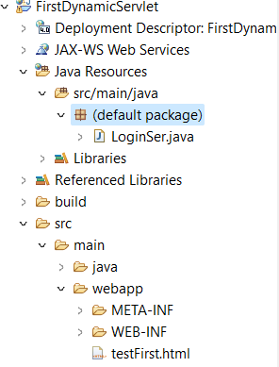

In webapp folder make Make a html file

<!DOCTYPE html>

<html>

<head>

<meta charset="ISO-8859-1">

<title>Insert title here</title>

</head>

<body>

<form name="f1" action="LoginSer" method="get">

<input type="submit" name="s1" value="ADDITION"> <br>

</form>

</body>

</html>

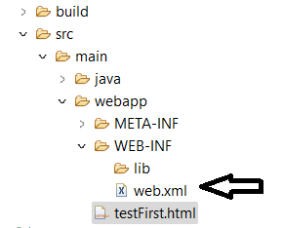

In web.xml add the following line

<welcome-file>testFirst.html</welcome-file>

run the codeon Server

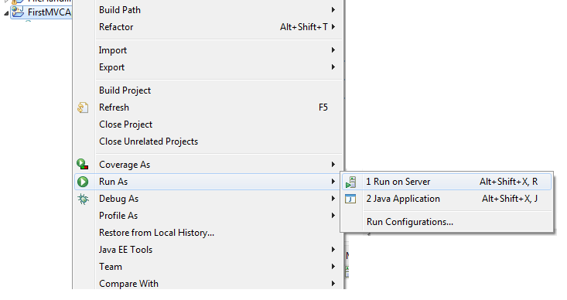

to open in browser

windows

preferences

general

web browser

check the browser apply & close.

**Html file : webapp folder**

**Xml file : webapp/WEB-INF folder**

Forward , include & sendRedirect

**if**(n1>0 && n2>0)

{

RequestDispatcher rd=request.getRequestDispatcher("success");

rd.forward(request, response);

}

**else**

{

out.println("Please enter Positive numbers only");

RequestDispatcher rd=request.getRequestDispatcher("/testFirst.html");

rd.include(request, response);

}

String n=request.getParameter("t1");

response.sendRedirect("https://www.google.com/search?q="+n);

HttpSession session=request.getSession(**true**);

session.setAttribute("n1", n1);

session.setAttribute("n2", n2);

HttpSession session=request.getSession(**false**);

**int** n1 = (Integer) session.getAttribute("n1");

**int** n2 = (Integer) session.getAttribute("n2");

out.println("In Success Session Servlet<br>");

out.println(n1+n2);

session.invalidate();

C:\apache-tomcat-9.0.87\webapps\examples\WEB-INF

<welcome-file-list>

<welcome-file>index.html</welcome-file>

</welcome-file-list>

<context-param>

<param-name>dbname</param-name>

<param-value>servletdb</param-value>

</context-param>

<context-param>

<param-name>dname</param-name>

<param-value>com.mysql.jdbc.Driver</param-value>

</context-param>

<servlet>

<servlet-name>tiger</servlet-name>

<servlet-class>MyDbConfig</servlet-class>

<init-param>

<param-name>pname</param-name>

<param-value>jdbc:mysql://localhost:3306/subjugators</param-value>

</init-param>

<init-param>

<param-name>username</param-name>

<param-value>root</param-value>

</init-param>

</servlet>

<servlet-mapping>

<servlet-name>tiger</servlet-name>

<url-pattern>/praj</url-pattern>

</servlet-mapping>

ServletConfig config=getServletConfig();

String pname=config.getInitParameter("pname");

ServletContext context=getServletContext();

String dname=context.getInitParameter("dname");

Cookie

Write:

Cookie c=**new** Cookie("firstcookie",username);

response.addCookie(c);

pw.print("<a href='shopservlet'>GO TO SHOP SERVLET</a>");

Read:

Cookie cookies[]=request.getCookies();

**if**(cookies==**null**)

{

pw.print("First Visit");

}

**else**

{

**for**(Cookie c:cookies)

{

**if**(c.getName().equals("firstcookie"))

{

String username=c.getValue();

pw.print(username+ "'s Cart");

}

}

}

Hit count cookie

Cookie cookies[]=r1.getCookies();

**int** hits;

**if**(cookies==**null**)

{

hits=1;

Cookie c1=**new** Cookie("hitCounter", String.*valueOf*(hits));

out.println(hits + " Visit");

r2.addCookie(c1);

}

**else**

{

**for**(Cookie c:cookies)

{

**if**(c.getName().equals("hitCounter"))

{

hits=Integer.*parseInt*(c.getValue());

hits++;

out.println(hits + " Visit");

c.setValue(String.*valueOf*(hits));

r2.addCookie(c);

}

}

}

Filter :

**public** **void** doFilter(ServletRequest request, ServletResponse response, FilterChain chain) **throws** IOException, ServletException {

PrintWriter out=response.getWriter();

LocalDateTime startdatetime=LocalDateTime.*now*();

System.***out***.println("INFO : Login Servlet Initiated "+startdatetime);

String username=request.getParameter("t1");

String password=request.getParameter("t2");

**if**(username.length()!=0 && password.length()!=0)

chain.doFilter(request, response);

LocalDateTime compdatetime=LocalDateTime.*now*();

System.***out***.println("INFO : Login Servlet Completed" +compdatetime);

}

/**

* **@see** Filter#init(FilterConfig)

*/

**public** **void** init(FilterConfig fConfig) **throws** ServletException {

String s=fConfig.getInitParameter("f1");

System.***out***.println("Filter Config Parameter "+s);

}

<filter>

<init-param>

<param-name>f1</param-name>

<param-value>500</param-value>

</init-param>

<filter-name>myFilter</filter-name>

<filter-class>LogFilter</filter-class>

</filter>

<filter-mapping>

<filter-name>myFilter</filter-name>

<url-pattern>/FilterLoginServlet</url-pattern>

</filter-mapping>

<context-param>

<param-name>driverName</param-name>

<param-value>com.mysql.jdbc.Driver</param-value>

</context-param>

<context-param>

<param-name>dbName</param-name>

<param-value>jdbc:mysql://localhost:3306/itpdb</param-value>

</context-param>

<context-param>

<param-name>userName</param-name>

<param-value>root</param-value>

</context-param>

<context-param>

<param-name>password</param-name>

<param-value></param-value>

</context-param>

import java.sql.Connection;

import java.sql.DriverManager;

import java.sql.SQLException;

import javax.servlet.ServletContext;

public class MySQLConnection1 {

public static Connection con;

public static Connection getConnection(ServletContext context) throws ClassNotFoundException, SQLException

{

String driverName=(String)context.getInitParameter("driverName");

String dbName=(String)context.getInitParameter("dbName");

String userName=(String)context.getInitParameter("userName");

String password=(String)context.getInitParameter("password");

Class.forName(driverName);

con=DriverManager.getConnection(dbName,userName,password);

return con;

}

}

**protected** **void** doGet(HttpServletRequest request, HttpServletResponse response) **throws** ServletException, IOException {

response.setContentType("text/html");

PrintWriter out=response.getWriter();

ServletContext context=getServletContext();

**try**

{

Connection con=MySQLConnection1.*getConnection*(context);