Model - used to add attributes

ModelMap- used to hold model Attributes

ModelAndView - used to hold model & View Attributes

example 1: passing string as a model attribute

@RequestMapping("/welcome")

**public** String welcomeBack(Model model)

{

model.addAttribute("test", "Virat Kohli");

**return** "welcome";

}

welcome.jsp

<body>

<h1>Welcome here, ${test}</h1>

</body>

output:

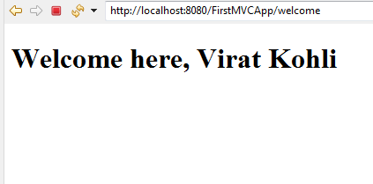

example 2 : passing object as a model attribute

**public** **class** Student {

**private** **int** rno;

**private** String sname;

**private** **double** percentage;

constructors, setter getter , toString

}

@RequestMapping("/hello")

**public** String greet(Model model)

{

Student s1=**new** Student(101,"Alice",78.5);

model.addAttribute("stud",s1);

**return** "hello";

}

<body>

<h1> Welcome Student, ${stud.sname} </h1>

</body>

**output :**

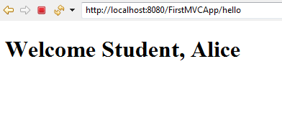

HyperLink:

<a href=*"homepage"*>Go to HomePage</a> <br>

@RequestMapping("/homepage")

**public** String absHomePage()

{

**return** "hyperlinkhome";

}