Step 1 :

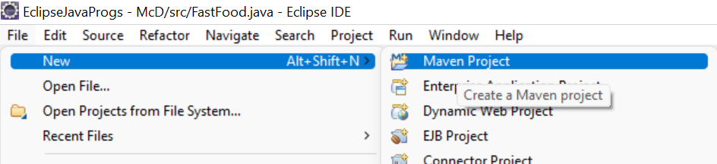

Step 2: Click Next

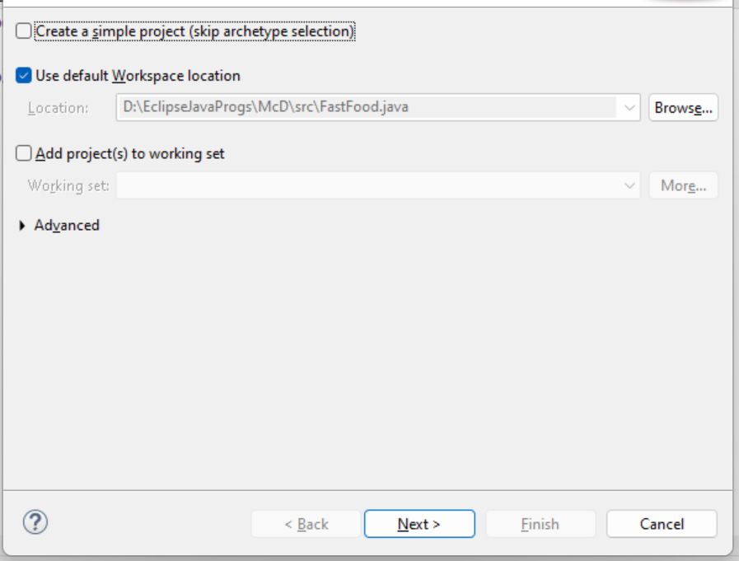

Step 3 : Catalog : choose Internal

Filter : type webapp , select the Archtye and click next

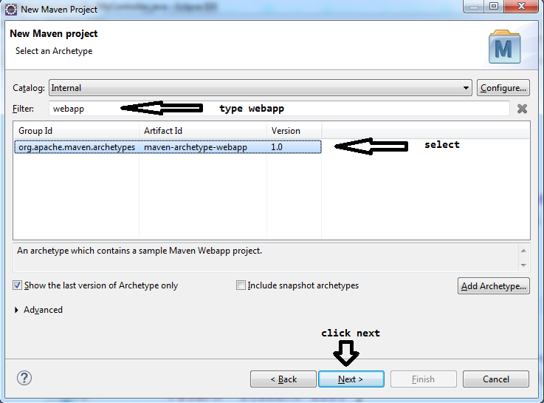

Step 4 :

Group ID : Base package name com.mvc

Artifact ID: Project Name : MavenMVCTest

Version : 0.0.1 SNAPSHOT (default)

Package name : (Group ID concat with ArtifactID, but we can keep it same as GroupID) com.mvc

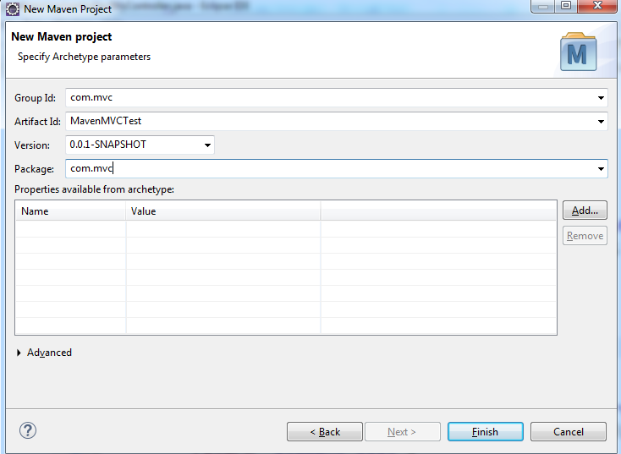

Step 5 : If the project creations is taking very log or is stuck at 33% go to console tab, scroll till the end

On Console it will ask you to enter capital **Y**

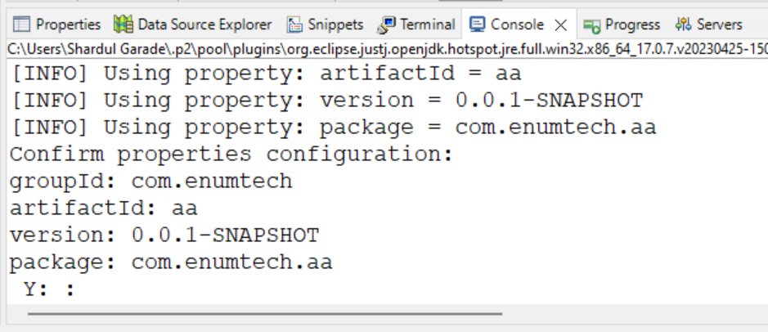

**Y**

<dependency>

<groupId>javax.servlet</groupId>

<artifactId>javax.servlet-api</artifactId>

<version>3.1.0</version>

<scope>provided</scope>

</dependency>

<dependency>

<groupId>org.springframework</groupId>

<artifactId>spring-webmvc</artifactId>

<version>5.2.22.RELEASE</version>

</dependency>

<dependency>

<groupId>jakarta.servlet</groupId>

<artifactId>jakarta.servlet-api</artifactId>

<version>4.0.4</version>

</dependency>

<dependency>

<groupId>jstl</groupId>

<artifactId>jstl</artifactId>

<version>1.2</version>

</dependency>

<dependency>

<groupId>org.springframework.security</groupId>

<artifactId>spring-security-taglibs</artifactId>

<version>5.2.2.RELEASE</version>

</dependency>

<build>

<finalName>MavenMVC</finalName>

<pluginManagement>

<plugins>

<plugin>

<artifactId>maven-clean-plugin</artifactId>

<version>3.1.0</version>

</plugin>

<plugin>

<artifactId>maven-resources-plugin</artifactId>

<version>3.0.2</version>

</plugin>

<plugin>

<artifactId>maven-compiler-plugin</artifactId>

<version>3.8.0</version>

</plugin>

<plugin>

<artifactId>maven-surefire-plugin</artifactId>

<version>2.22.1</version>

</plugin>

<plugin>

<artifactId>maven-war-plugin</artifactId>

<version>3.2.2</version>

</plugin>

<plugin>

<artifactId>maven-install-plugin</artifactId>

<version>2.5.2</version>

</plugin>

<plugin>

<artifactId>maven-deploy-plugin</artifactId>

<version>2.8.2</version>

</plugin>

</plugins>

</pluginManagement>

</build>

in WEB-INF

web.xml

<!DOCTYPE web-app PUBLIC

"-//Sun Microsystems, Inc.//DTD Web Application 2.3//EN"

"http://java.sun.com/dtd/web-app_2_3.dtd" >

<web-app>

<display-name>Archetype Created Web Application</display-name>

<servlet>

<servlet-name>dispatcher</servlet-name>

<servlet-class>org.springframework.web.servlet.DispatcherServlet</servlet-class>

<init-param>

<param-name>contextConfigLocation</param-name>

<param-value>/WEB-INF/Conf-servlet.xml</param-value>

</init-param>

<load-on-startup>1</load-on-startup>

</servlet>

<servlet-mapping>

<servlet-name>dispatcher</servlet-name>

<url-pattern>/</url-pattern>

</servlet-mapping>

</web-app>

Conf-servlet.xml

<?xml version=*"1.0"* encoding=*"UTF-8"*?>

<beans xmlns=*"http://www.springframework.org/schema/beans"*

xmlns:xsi=*"http://www.w3.org/2001/XMLSchema-instance"*

xmlns:context=*"http://www.springframework.org/schema/context"*

xmlns:mvc=*"http://www.springframework.org/schema/mvc"*

xsi:schemaLocation=*"*

*http://www.springframework.org/schema/beans*

*http://www.springframework.org/schema/beans/spring-beans.xsd*

*http://www.springframework.org/schema/context*

*http://www.springframework.org/schema/context/spring-context.xsd*

*http://www.springframework.org/schema/mvc*

*http://www.springframework.org/schema/mvc/spring-mvc.xsd"*>

<context:component-scan

base-package=*"com.greatlearning"* />

<!-- <bean class="org.springframework.web.servlet.view.InternalResourceViewResolver"

id="jspViewResolver"> <property name="viewClass" value="org.springframework.web.servlet.view.JstlView"></property>

<property name="prefix" value="/WEB-INF/views/"></property> <property name="suffix"

value=".jsp"></property> </bean> -->

<bean

class=*"org.springframework.web.servlet.view.InternalResourceViewResolver"*>

<property name=*"prefix"* value=*"/WEB-INF/views/"* />

<property name=*"suffix"* value=*".jsp"* />

</bean>

</beans>

To see the 2 folders

Edit library to 1.8

Project Facets

DynamicWeb Module to 4.0

Java 1.8

Runtime

Coding the 4 packages

**package** com.greatlearning.entity;

**public** **class** Student {

String studId;

String studName;

**int** score;

**public** Student() {}

**public** Student(String studId, String studName, **int** score) {

**this**.studId = studId;

**this**.studName = studName;

**this**.score = score;

}

**public** String getStudId() {

**return** studId;

}

**public** **void** setStudId(String studId) {

**this**.studId = studId;

}

**public** String getStudName() {

**return** studName;

}

**public** **void** setStudName(String studName) {

**this**.studName = studName;

}

**public** **int** getScore() {

**return** score;

}

**public** **void** setScore(**int** score) {

**this**.score = score;

}

@Override

**public** String toString() {

**return** "Student [studId=" + studId + ", studName=" + studName + ", score=" + score + "]";

}

}

------

package com.greatlearning.repository;

import java.util.ArrayList;

import org.springframework.stereotype.Repository;

import com.greatlearning.entity.Student;

@Repository

public class StudentDao {

ArrayList<Student> students;

public ArrayList<Student> getStudentsDao() {

students = new ArrayList<Student>();

students.add(new Student("S001", "Harsha", 89));

students.add(new Student("S002", "Suman", 82));

students.add(new Student("S003", "Mahesh", 87));

return students;

}

}

---

package com.greatlearning.service;

import java.util.ArrayList;

import org.springframework.beans.factory.annotation.Autowired;

import org.springframework.stereotype.Service;

import com.greatlearning.entity.Student;

import com.greatlearning.repository.StudentDao;

@Service

public class StudentService {

@Autowired

StudentDao studentDao;

public ArrayList<Student> getStudentsSvc() {

ArrayList<Student> students = studentDao.getStudentsDao();

return students;

}

}

----

package com.greatlearning.controller;

import java.util.ArrayList;

import org.springframework.beans.factory.annotation.Autowired;

import org.springframework.stereotype.Controller;

import org.springframework.ui.Model;

import org.springframework.web.bind.annotation.RequestMapping;

import com.greatlearning.entity.Student;

import com.greatlearning.service.StudentService;

@Controller

@RequestMapping("/hello")

public class MyController {

@Autowired

StudentService studentService;

@RequestMapping("/greet")

public String sayHello(Model model) {

String greeting = "Hi! Welcome to SpringMVC-JSP!!";

model.addAttribute("greetings", greeting);

return "welcome";

//WEB-INF/views/welcome.jsp

}

//Model ModelAttribute RequestAttribute

@RequestMapping("/students")

public String getStudentData(Model model) {

ArrayList<Student> mystudents = studentService.getStudentsSvc();

model.addAttribute("students", mystudents);

return "student-list";

}

}