<dependency>

<groupId>org.springframework.boot</groupId>

<artifactId>spring-boot-starter-actuator</artifactId>

</dependency>

Localhost:8080/actuator

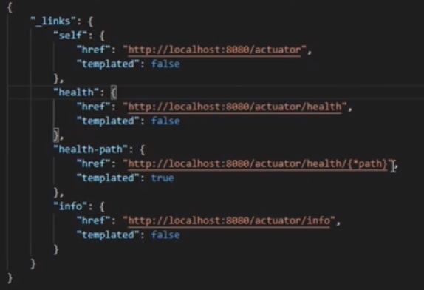

On Cloud environment you can check whether your microservices are deployed properly and the services are up.

**Info end points**

In the application.properties

info.project.name=Library Design

info.project.team=Great Learning

info.project.instructor=Umar Solanki

info.project.env=prod

Localhost:8080/actuator/info

Will show the above details in JSON format

Info about each MS we can put here

**Metric end points**

Exposing all the endpoints comprises on the security

To make the metric end points visible add to the properties file

management.endpoints.web.exposure.include=metrics, info, health

manually stop & start the server for the metrics to be visible

1st

Jdbc connection active

Jvm memory max

Jvm thread live

#to view all actuator endpoints

management.endpoints.web.exposure.include=*

#to change default base url to custom ur

management.endpoints.web.base-path=/app/health

Localhost:8080/app/health