Debuging

Step 1: Set a Breakpoint
Click in the left margin next to the line u wish to start debugging:

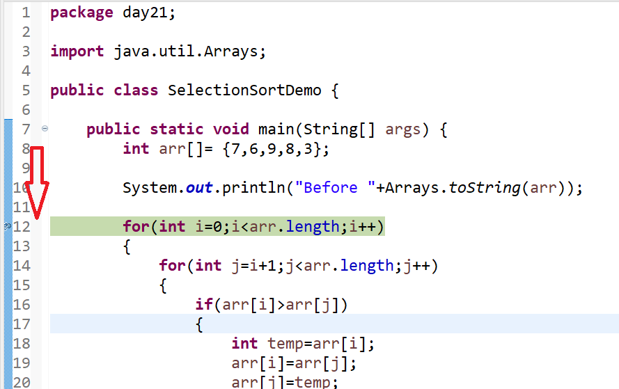

Step 2: Start Debugging
Right-click the file.
Choose
Debug As
→ Java Application

Step 3: see variables

You should now see the variables listed in the java files in a separate window

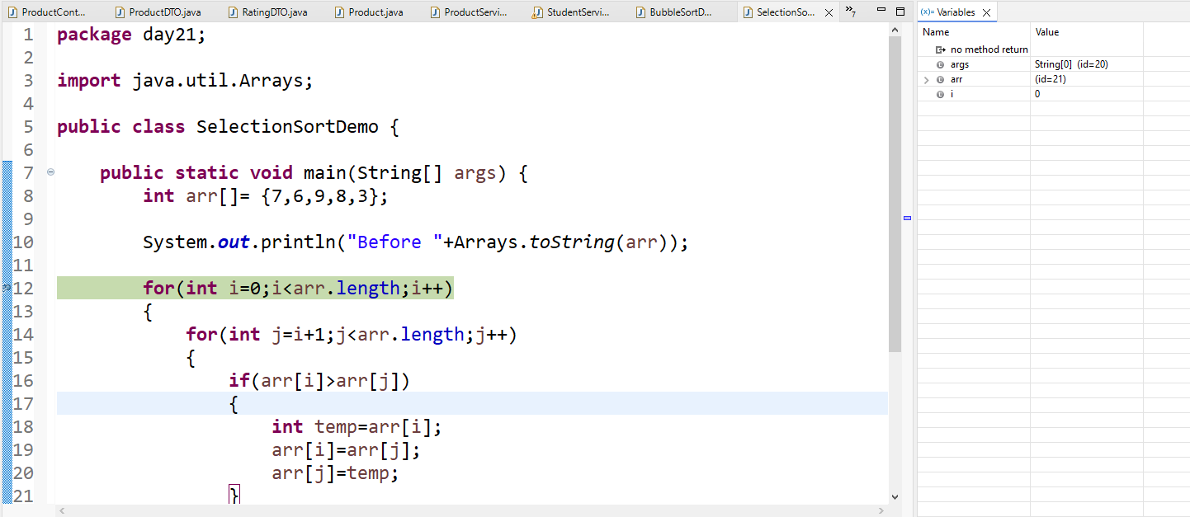

If you don’t see the variables

Method 1: Open the Variables View (Fastest)
- Click Window → Show View → Variables.

Step 4: start debugging

Press F5 to progress

