Title : Hibernate as an ORM
D:\GL\Hibernate\dependecy downlaoded\hibernate-release-5.2.18.Final\lib\required
State of Object is a java application is Temporary Permanant storage , making the object persistent
We store the object state in a Relational DBMS by mapping the object to a database row
Invented by Gavin King in 2001
Hibernate is ORM Object relational Mapping
Object in Java Mapped to a row in a database table
Its Open source Available for everyone without any cost
Its non invasive it will not insist in extending a class or implementing an interface
Its light weight it does not contain additional functionalities; it uses only those functionalities required for object-relational mapping.
High-Performance supports many different fetching techniques, caching, lazy initialization, and many more to achieve high performance.
Fetch type
EAGER
LAZY
Database Independent databases such as Oracle, MySql, Sybase, etc (as it provides ‘Database Dialect,’ so we need not write SQL queries.
Hibernate | TopLink | MyBatis | EclipseLink | Persism
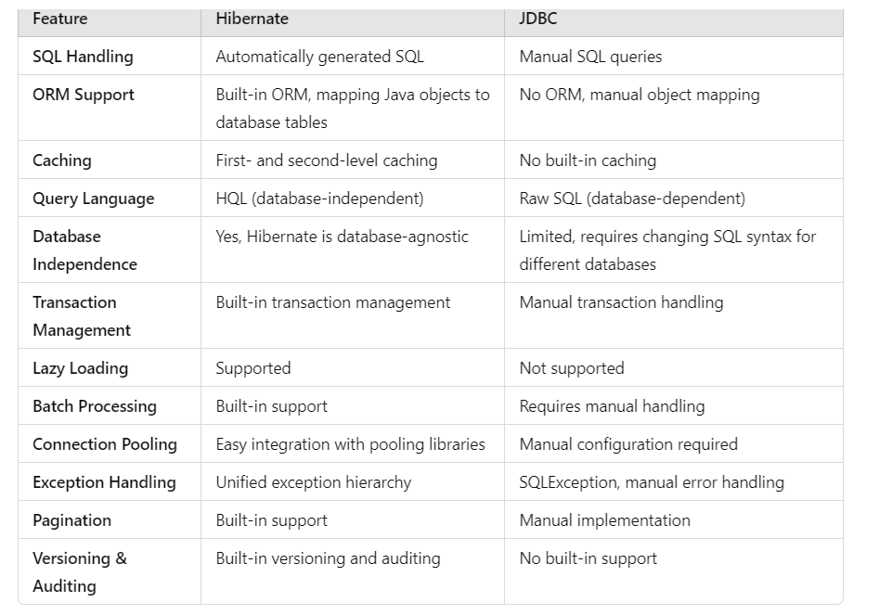
Traditional way(JDBC) --> Hibernate --> JPA
Limitation of JDBC
- Programmer had to register the db driver in the code
- Create & open the connection by passing the db credentials
- Programmer had to Create the database tables
- Write the SQL query and execute it
- Store the response of DML queries in the ResultSet Object
Advantage of Hibernate
- Basically Internally It is a wrapper on top of JDBC

We will only create an object and give it to hibernate and hibernate will do the remaining part creating table & of inserting in to the database.
Hibernate has given methods like save(), update(),get(),load()
The classname will be mapped to table name
The attributes will be mapped to the column name.

The mapping will be done by the help of various annotations

How to create a Hibernate Project in maven
Step 1 :
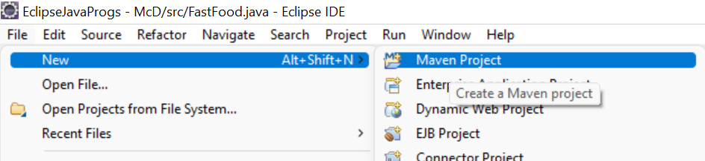

Step 2: simply Click Next(do not modify any setting)
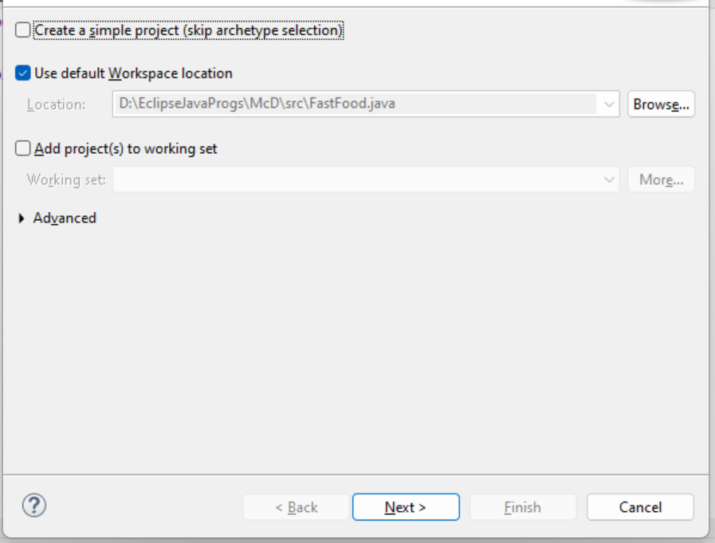

Step 3 : Catalog : choose Internal
Filter : type quick , select the Archtye and click next
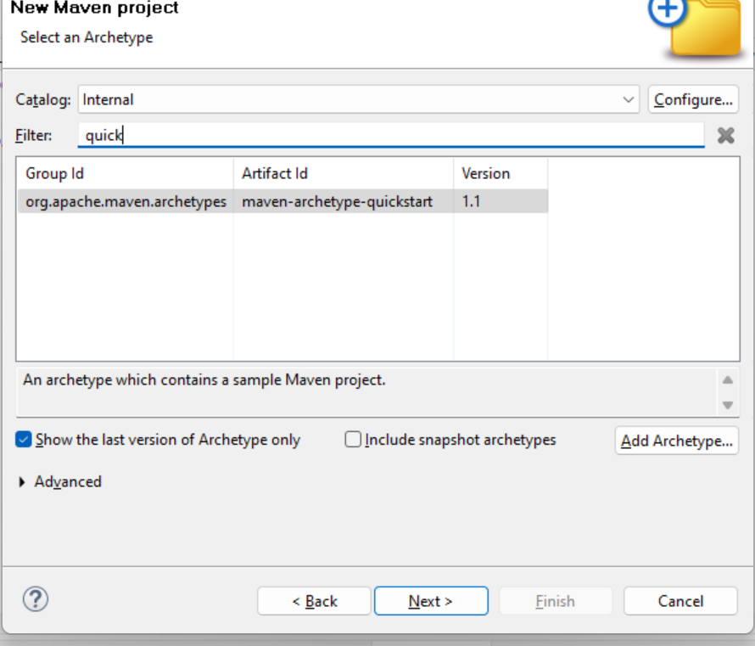

Step 4 :
Group ID : Base package name com.companyname
Artifact ID: Project Name : HIbernateWithMaven
Version : 0.0.1 SNAPSHOT (default)
Package name : (Group ID concat with ArtifactID, but we can keep it same as GroupID) com.companyname

Click “finish”

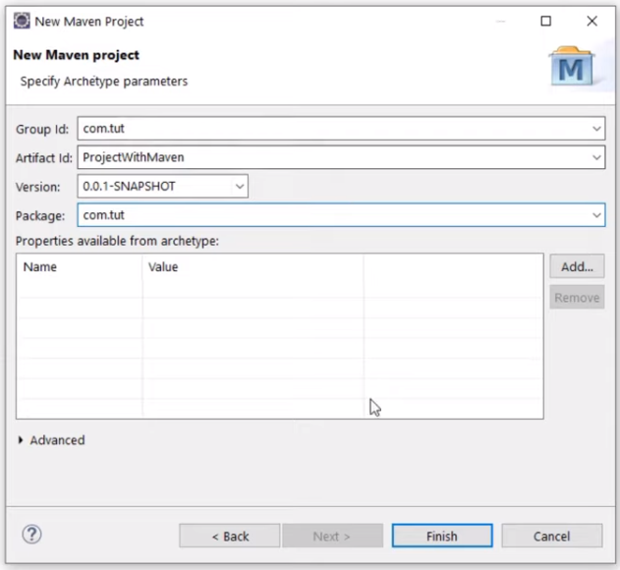

Step 5 : If the project creations is taking very long or is stuck at 33% go to console tab, scroll till the end
On Console it will ask you to enter capital Y and hit enter

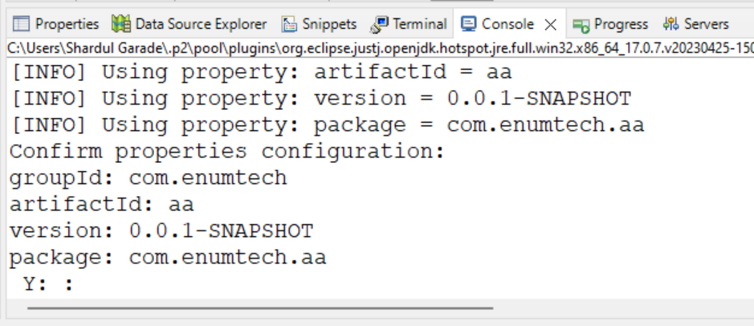

Add the dependencies
- Add the hibernate maven dependency
Go to google :
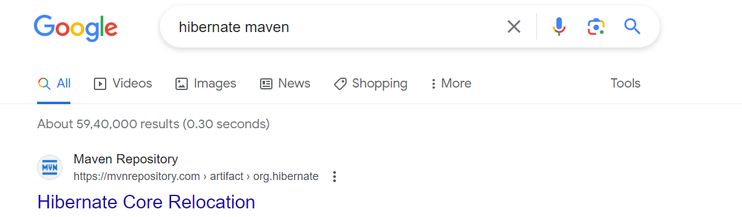
Go to mvnrepoisotry website
5.5.7 version
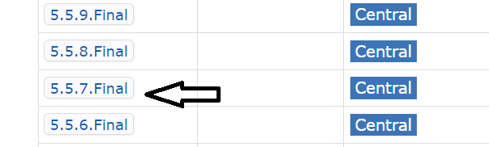
Copy the dependency and paste in pom.xml
<dependencies>
<!-- https://mvnrepository.com/artifact/org.hibernate/hibernate-core -->
<dependency>
<groupId>org.hibernate</groupId>
<artifactId>hibernate-core</artifactId>
<version>5.5.7.Final</version>
</dependency>
</dependencies>

- Add the hibernate mysql connector dependency
Mysql connector maven
<dependency>
<groupId>mysql</groupId>
<artifactId>mysql-connector-java </artifactId>
<version>5.1.15</version>
</dependency>

In Maven depecdencies look for the “hibernate-core- “ jar file if not visible add it externally

Day 3:
Configuring hibernate.cfg.xml file

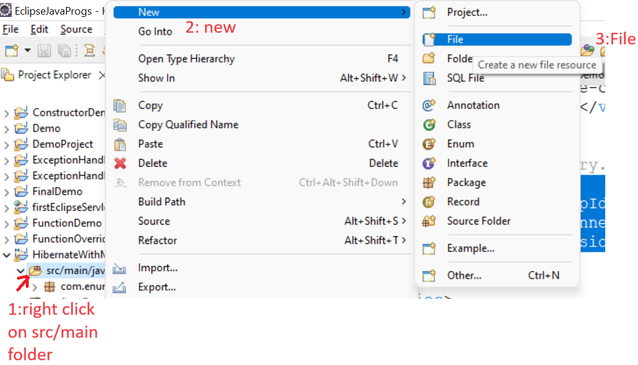

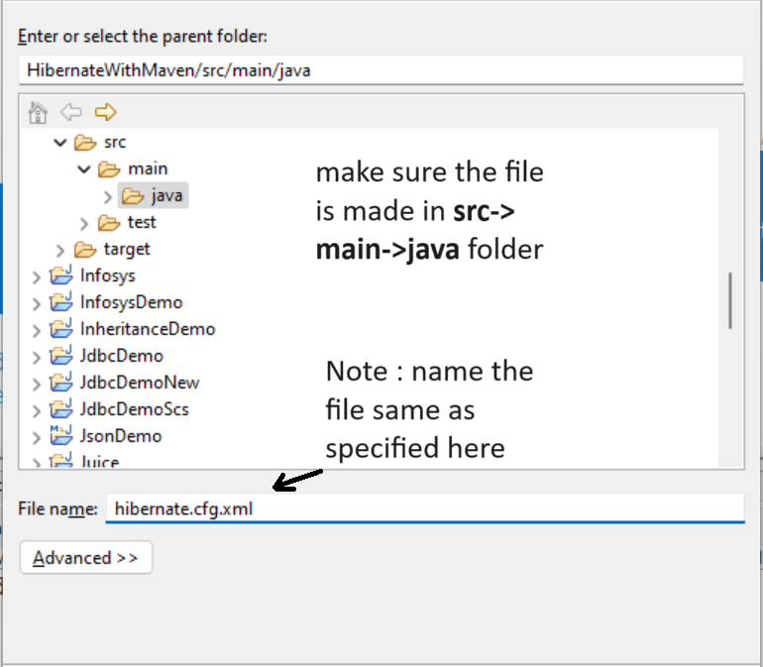

Add As the first line of the xml file
<?xml version='1.0' encoding='UTF-8' ?>

Need DTD
Google-hibernate dtd
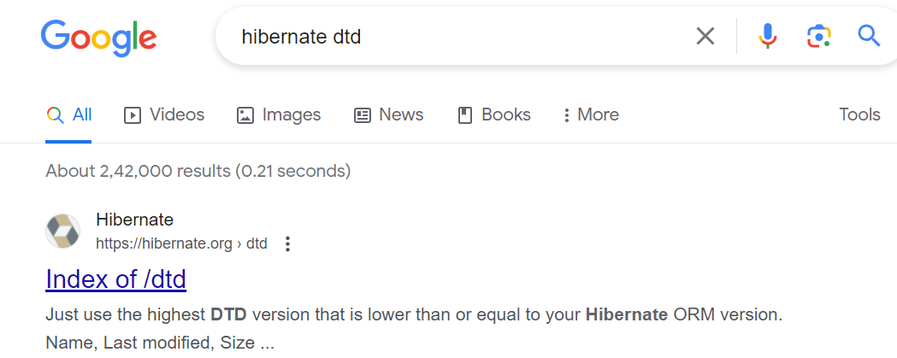

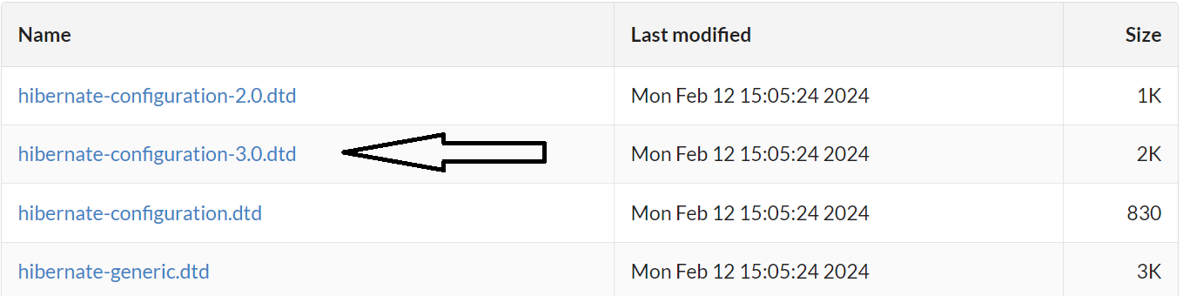
Open file in notepad
<!DOCTYPE hibernate-configuration PUBLIC
"-//Hibernate/Hibernate Configuration DTD 3.0//EN"
"http://www.hibernate.org/dtd/hibernate-configuration-3.0.dtd">

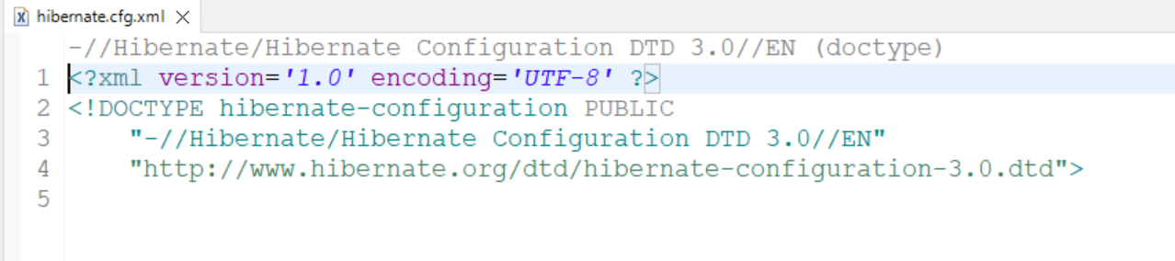

Do the following config in the hibernate.cfg.xml file
<hibernate-configuration>
<session-factory>
<property name="connection.driver_class">com.mysql.jdbc.Driver</property>
<property name="connection.url">jdbc:mysql://localhost:3306/myhiber</property>
<property name="connection.username">root</property>
<property name="connection.password"></property>
<property name="dialect">org.hibernate.dialect.MySQL5Dialect</property>
<property name="hbm2ddl.auto">update</property>
<property name="show_sql">true</property>
<property name="format_sql">true</property>

</session-factory>
</hibernate-configuration>

<mapping class="com.excelr.BanerAfternoonHibernate.entity.Student"/>
NOTE : <mapping > should be placed inside the <session-factory>
Create database named “myhiber” in mysql

To test whether the project is working copy pasted
Configuration cfg=new Configuration();
cfg.configure("hibernate.cfg.xml");
SessionFactory factory=cfg.buildSessionFactory();

/* this factory object will be used to execute the database functions*/

System.out.println(factory);
System.out.println(factory.isClosed());

NOTE : If you place the hibernate.cfg.xml in a different folder/package then you will have to give the whole path of that file
e.g if you placed the file in com.enumtech package then we have to give
cfg.configure("com/enumtech/hibernate.cfg.xml");

----
Make an entity class in the com.enumtech.entity package
package com.enumtech.entity;

import javax.persistence.Entity;
import javax.persistence.Id;

@Entity
public class Student {
@Id
private int rno;
private String sname;
private String scity;

public Student() {}
public Student(int rno, String sname, String scity) {
this.rno = rno;
this.sname = sname;
this.scity = scity;
}
public int getRno() {
return rno;
}
public void setRno(int rno) {
this.rno = rno;
}
public String getSname() {
return sname;
}
public void setSname(String sname) {
this.sname = sname;
}
public String getScity() {
return scity;
}
public void setScity(String scity) {
this.scity = scity;
}
@Override
public String toString() {
return "Student [rno=" + rno + ", sname=" + sname + ", scity=" + scity + "]";
}

}

In main method
Student s1=new Student(101,"Alice","Jaipur");

Session session=factory.openSession();
Transaction tx=session.beginTransaction();
session.save(s1);
tx.commit();
session.close();

most commonly used annotations
@Entity
@Table
@Id @GeneratedValue =identity
@column
@Transient -> don’t male this column in database
@Temporal ->format the date to remove the time
@Lob ->binay object
Mapping @ OneToOne, @ OneToMany, @ManyToMany

@Id
@GeneratedValue(strategy = GenerationType.IDENTITY)
private int rno;

@Column(length=20)
private String sname;

private String scity;

@Transient
private int x;

@Temporal(TemporalType.DATE)
private Date dob;

@Lob
private byte image[];

get
get()returns NULL if the object is not found in db & cache

use if you are not sure

get() will first look in the session cache (shop), if the object is found in cache, it will not hit the db(godown).

Student s1=(Student)session.get(Student.class, 101);
System.out.println(s1);
// get will first try to search for the 101 object in session cache,if not found it will query(“select”) the database [sign of which is SQL query will be printed on the console] and fetch the object and store it in the session cache.

Student s2=(Student)session.get(Student.class, 101);
System.out.println(s2);
// when subsequent get request is sent for the same 101 object , it will first search in session cache,if found it will not query(“select”) the database [hence no SQL query will be printed on the console] the return the existing 101 object from the session cache.

To confirm if we do a
System.out.println(s1==s2);
It will retun “True”

Student s5=(Student)session.get(Student.class, 177);
If this 177 object is not there it will retun null
Sysout(s5) will display null

load
load() throws ObjectNotFoundException but will not return NULL

use if you are 100% sure

load() returns a proxy object, lazy initialization
but will hit the db only when any function of that object is invoked, like toString/getter()[except getID].

Student s1=(Student)session.load(Student.class, 101);
Here it will fetch create a proxy/dummy object and return its reference[ the db will not queried [no sql query will be displayed on console] as of now, this is called lazy instantiation],

If this 101 object is not there it will throw ObjectNotFoundException

System.out.println(s1);
When we invoke any method(toString/getter) on the object, that time it will query the database [the sql query will now be displayed on console]

[like while using scanner, it does not import the scanner class until u invoke any method using that object]

@Embeddable
public class Address {..}

public class Student
{
Private int rno;
private String sname;
private String scity;
private Address address;
}

1-1

import javax.persistence.Entity;
import javax.persistence.GeneratedValue;
import javax.persistence.GenerationType;
import javax.persistence.Id;

import lombok.AllArgsConstructor;
import lombok.Builder;
import lombok.Data;
import lombok.NoArgsConstructor;

@AllArgsConstructor
@Data
@NoArgsConstructor
@Entity
@Builder
public class ChiefMinister {
@Id
@GeneratedValue(strategy = GenerationType.IDENTITY)
private int cmno;
private String cmName;
private int age;
}

import javax.persistence.CascadeType;
import javax.persistence.Entity;
import javax.persistence.FetchType;
import javax.persistence.GeneratedValue;
import javax.persistence.GenerationType;
import javax.persistence.Id;
import javax.persistence.JoinColumn;
import javax.persistence.OneToOne;

import lombok.AllArgsConstructor;
import lombok.Builder;
import lombok.Data;
import lombok.NoArgsConstructor;

@AllArgsConstructor
@Data
@NoArgsConstructor
@Entity
@Builder
public class State {

@Id
@GeneratedValue(strategy = GenerationType.IDENTITY)
private int sno;
private String sname;
private String capital;

@OneToOne(cascade = CascadeType.ALL,fetch = FetchType.EAGER)
@JoinColumn(name="cmno", referencedColumnName = "cmno")
ChiefMinister chiefMinister;
}

public static void main( String[] args )
{
Configuration cfg=new Configuration();
cfg.configure("hibernate.cfg.xml");
SessionFactory factory=cfg.buildSessionFactory();

Session session1=factory.openSession();
Transaction tx=session1.beginTransaction(); //DML Queries;

ChiefMinister cm1=ChiefMinister.builder()
.cmName("Fadnavis")
.age(55)
.build();

ChiefMinister cm2=ChiefMinister.builder()
.cmName("Sharma")
.age(60)
.build();

ChiefMinister cm3=ChiefMinister.builder()
.cmName("Patel")
.age(65)
.build();

State s1=State.builder()
.sname("Maharashtra")
.capital("Mumbai")
.chiefMinister(cm1)
.build();

State s2=State.builder()
.sname("Rajasthan")
.capital("Jaipur")
.chiefMinister(cm2)
.build();

State s3=State.builder()
.sname("Gujarat")
.capital("Ahmedabad")
.chiefMinister(cm3)
.build();
session1.save(s1);
session1.save(s2);
session1.save(s3);

tx.commit();

session1.close();
factory.close();

}

1-M
@Entity
public class Department {

@Id
@GeneratedValue(strategy = GenerationType.IDENTITY)
private int dno;
private String dname;
private String city;

@OneToMany(cascade = CascadeType.ALL,fetch = FetchType.LAZY)
@JoinColumn(name="dno", referencedColumnName = "dno")
List<Employee> employees;

@Entity
public class Employee {

@Id
@GeneratedValue(strategy = GenerationType.IDENTITY)
private int eno;
private String ename;
private double sal;

Configuration cfg=new Configuration();
cfg.configure("hibernate.cfg.xml");
SessionFactory factory=cfg.buildSessionFactory();

Session session=factory.openSession();
Transaction tx=session.beginTransaction();

Employee e1=Employee.builder()
.ename("Alice")
.sal(800.0)
.build();

Employee e2=Employee.builder()
.ename("Ben")
.sal(900.0)
.build();

Employee e3=Employee.builder()
.ename("Chris")
.sal(1000.0)
.build();

Employee e4=Employee.builder()
.ename("David")
.sal(1100.0)
.build();

Dept d1=Dept.builder()
.dname("IT")
.city("Pune")
.build();

Dept d2=Dept.builder()
.dname("Sales")
.city("Delhi")
.build();

d1.setEmployees(Arrays.asList(e1,e2));
d2.setEmployees(Arrays.asList(e3,e4));

session.save(d1);
session.save(d2);
tx.commit();
session.close();
factory.close();

M-M

import java.util.List;

import javax.persistence.CascadeType;
import javax.persistence.Entity;
import javax.persistence.FetchType;
import javax.persistence.GeneratedValue;
import javax.persistence.GenerationType;
import javax.persistence.Id;
import javax.persistence.JoinColumn;
import javax.persistence.JoinTable;
import javax.persistence.ManyToMany;

import lombok.AllArgsConstructor;
import lombok.Builder;
import lombok.Data;
import lombok.NoArgsConstructor;

@AllArgsConstructor
@Data
@NoArgsConstructor
@Entity
@Builder
public class Actor {
@Id
@GeneratedValue(strategy = GenerationType.IDENTITY)
private int ano;
private String aname;
private int age;

@ManyToMany(cascade = CascadeType.ALL,fetch = FetchType.EAGER)
@JoinTable(
name = "bollywood",
joinColumns = @JoinColumn(name="fkano"),
inverseJoinColumns = @JoinColumn(name="fkmno")
)
List<Movie> portfolio;

}

import javax.persistence.Entity;
import javax.persistence.GeneratedValue;
import javax.persistence.GenerationType;
import javax.persistence.Id;

import lombok.AllArgsConstructor;
import lombok.Builder;
import lombok.Data;
import lombok.NoArgsConstructor;

@AllArgsConstructor
@Data
@NoArgsConstructor
@Entity
@Builder
public class Movie {

@Id
@GeneratedValue(strategy = GenerationType.IDENTITY)
private int mno;
private String mname;
private int ryear;

}

import java.util.ArrayList;
import java.util.Arrays;
import java.util.List;

import org.hibernate.Session;
import org.hibernate.SessionFactory;
import org.hibernate.Transaction;
import org.hibernate.cfg.Configuration;

import com.itp.ITPAugustFirstHibenate.entity.Actor;
import com.itp.ITPAugustFirstHibenate.entity.Dept;
import com.itp.ITPAugustFirstHibenate.entity.Employee;
import com.itp.ITPAugustFirstHibenate.entity.Movie;

public class ManyToManyDemo
{
public static void main( String[] args )
{
Configuration cfg=new Configuration();
cfg.configure("hibernate.cfg.xml");
SessionFactory factory=cfg.buildSessionFactory();

Session session1=factory.openSession();
Transaction tx=session1.beginTransaction(); //DML Queries;

Movie m1=Movie.builder()
.mname("Jawan")
.ryear(2025)
.build();

Movie m2=Movie.builder()
.mname("CE")
.ryear(2010)
.build();

Actor a1=Actor.builder()
.aname("SRK")
.age(60)
.portfolio(new ArrayList(Arrays.asList(m1,m2)))
.build();

Actor a2=Actor.builder()
.aname("DP")
.age(40)
.portfolio(new ArrayList(Arrays.asList(m2)))
.build();

session1.save(a1);
session1.save(a2);

tx.commit();

session1.close();
factory.close();

}
}

LifeCycle states
Session Object database table

Student s1=new Student(101,’Alice’,800); //Transient State
When object has been initialized (either by constructor / setter)

Session.save(s1) // Persistant State
If you make any changes to the object and do a commit , it will reflect in the session & db
Sop(Session.contains(s1)) //will return true

Session.Clear() or Session.close() //detached State
Object is not in the session but the value is in the db

Session.delete() //removed State
It wil be in the session

 | Transient | Persistent | Detached | Removed
Session | N | Y | N | Y
Database | N | Y | Y | N

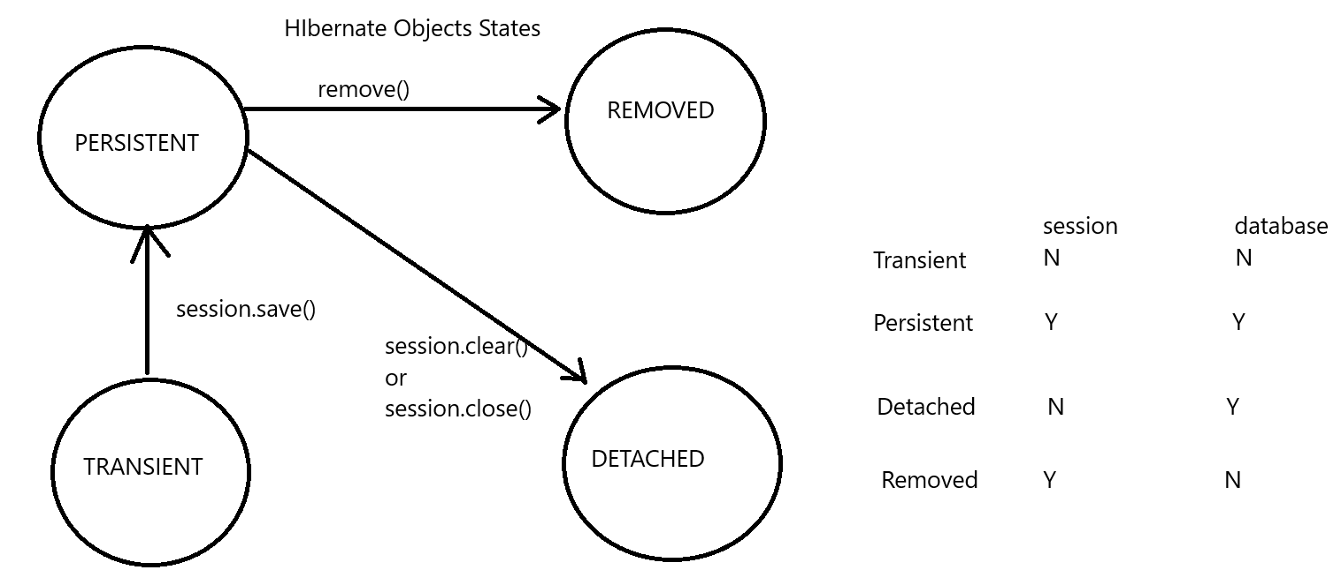

How to implement Second level cache (it creates a deep copy into the second session without querying the DB)

Step 1 : add the following 2 dependencies

<dependency>
<groupId>net.sf.ehcache</groupId>
<artifactId>ehcache</artifactId>
<version>2.10.3</version>
</dependency>

<dependency>
<groupId>org.hibernate</groupId>
<artifactId>hibernate-ehcache</artifactId>
<version>5.5.7.Final</version>
</dependency>

//Note use same version as your hibernate core
Step 2 : In the hibernate cfg file add
<property name="hibernate.cache.use_second_level_cache">true</property>
<property name="hibernate.cache.region.factory_class">org.hibernate.cache.ehcache.internal.EhcacheRegionFactory</property>

//Note check for the cache packages in the maven dependencies for the absolute path of the class “EhcacheRegionFactory”.

Step 3 : add the annotations to the entity class
@Cacheable
@Cache(usage = CacheConcurrencyStrategy.READ_ONLY)
@Entity
public class Employee {

HQL – Hibernate query language
Prerequisite add the following in cfg file
<property name="hibernate.cache.use_query_cache">true</property>

//Note in the queries we use the class name(not the table name) so use Capital letter.
import org.hibernate.Query;
import org.hibernate.SQLQuery;
import org.hibernate.Session;
import org.hibernate.SessionFactory;
import org.hibernate.cfg.Configuration;
;

// Query q1=session.createQuery("From Student where rno=2");
// q1.setCacheable(true);
// Student s1=(Student)q1.uniqueResult();
// System.out.println(s1);

// Query q1=session.createQuery("From Student where rno= :x");
// Scanner sc=new Scanner(System.in);
// System.out.println("Enter Rno");
// int rn=sc.nextInt();
// q1.setParameter("x",rn);
// Student s1=(Student)q1.uniqueResult();
// System.out.println(s1);

// Query q1=session.createQuery("select rno,sname from Student");
//
// List<Object[]> students=(List<Object[]>)q1.list();
// for(Object[] student:students)
// {
// System.out.println(student[0] + "" +student[1]);
// }

// Query q1=session.createQuery("select sum(per) from Student s where s.per>=40");
// double ans=(double)q1.uniqueResult();
// System.out.println(ans);

//Note in the SQLqueries we use the table name(all small will do)

All columns

//import org.hibernate.query.Query;

SQLQuery query=session.createSQLQuery("select * from student s where s.per>=60 order by per desc");
query.addEntity(Student.class);
List<Student> students=query.list();
System.out.println(students);

particular columns

SQLQuery query=session.createSQLQuery(“select eno,ename from employee where per>=60”)
query.setResultTransformer(Criteria.ALIAS_TO_ENTITY_MAP)
Query.addEntity(Employee.class)
List employees=query.list();

for(Object o:employees)
{
Map m=(Map)o;
System.out.println(m.get(“eno”) + m.get(“ename”));
}

