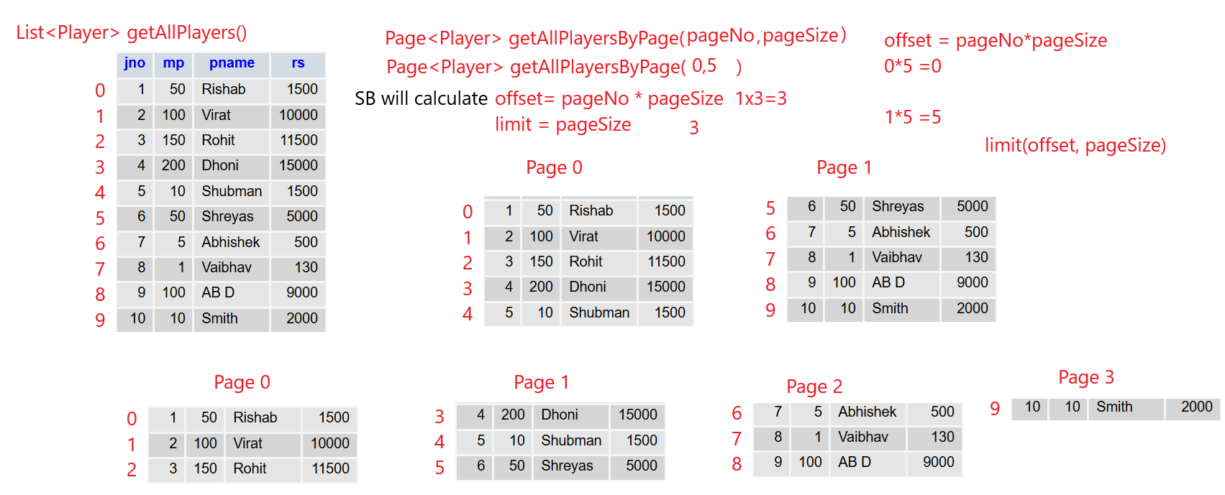
Pagination
import org.springframework.data.domain.Page;
import org.springframework.data.domain.PageRequest

Controller
@GetMapping("/getStudentsByPagination/{pageNumber}/{pageSize}")
public Page<Student> getSortedStudents(@PathVariable("pageNumber") int pageNumber,@PathVariable("pageSize") int pageSize)
{
return studservice.getStudentsByPagination(pageNumber, pageSize);
}

Service
public Page<Student> getStudentsByPagination(int pageNumber,int pageSize) {
Page<Student> studentPage= studrepo.findAll(PageRequest.of(pageNumber, pageSize));
return studentPage;
}

Postman
http://localhost:8085/getStudentsByPagination/0/2
offset 0 and limit 2 , offset is calculated as pageNumber*pagesize
http://localhost:8085/getStudentsByPagination/1/2
offset 2 and limit 2

Pagination and Sorting
Will first sort on the fieldname and then create the pages
Controller
@GetMapping("/getStudentsByPaginationAndSorting/{pageNumber}/{pageSize}/{field}")
public Page<Student> getStudentsByPaginationAndSorting(@PathVariable("offset") int offset,@PathVariable("pageSize") int pageSize,@PathVariable("field") String field)
{
return studservice.getStudentsByPaginationAndSorting(pageNumber, pageSize,field);
}

Service
public Page<Student> getStudentsByPaginationAndSorting(int pageNumber,int pageSize,String field) {
Page<Student> studentPage= studrepo.findAll(PageRequest.of(pageNumber, pageSize).withSort(Sort.by(Sort.Direction.ASC, field)));
return studentPage;
}

Postman
http://localhost:8085/getStudentsByPaginationAndSorting/0/3/per

public Page getCustomers(int pageNo, int pageSize, String sortBy)
{
Pageable pageable = PageRequest.of(pageNo, pageSize, Sort.by(sortBy));
return customerRepository.findAll(pageable);
}

