Errors

Error ) version of the Java Runtime (class file version 61.0), this version of the Java Runtime only recognizes class file versions up to 60.0

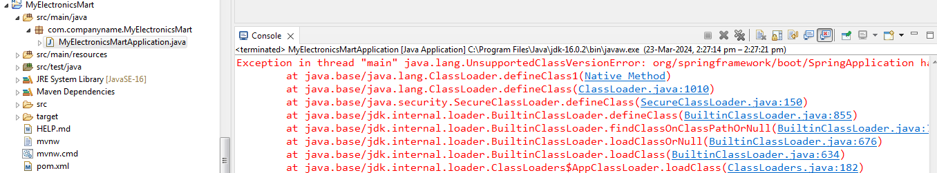

Solution :

If you aboserve the java version in the pom.xml is 17 & the vesrion refelcting in the MyElectronicsApplication is Java 16

so choose the matching jdk in the application

