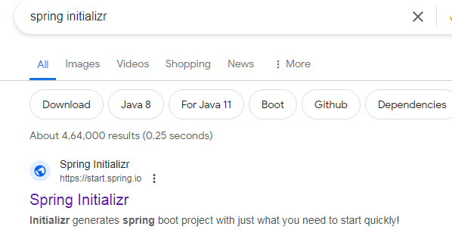

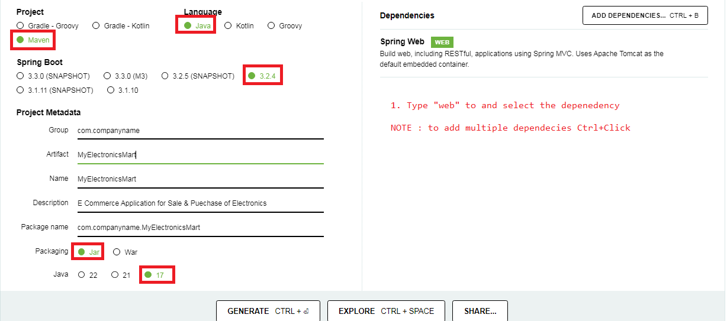

Jar file will be downloaded

extract it in a clean folder

copy paste the extracted folder in your eclipse work bench.

**TO OPEN THE PROJECT IN ECLIPSE**

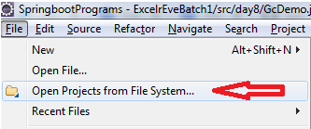

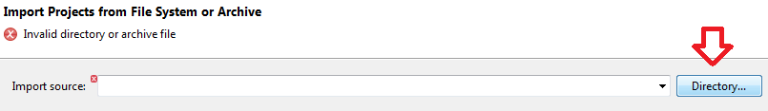

**NAVIGATE TO YOUR ECLIPSE WORKBENCH AND CHOOSE THE EXTRACTED FOLDER**



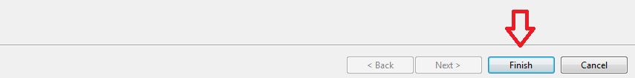

**NOTE : Make Sure Internet Connection is Active before you click "Finish"**

**Depending on the internet speed it might tike time to prepare the Project in eclipse**

**At the bottom right of the eclipse window it will show a progress bar stating the progess**





**wait for both of these progressbars to complete**

**once project configuration completes, the project will reflect in the project explorer**

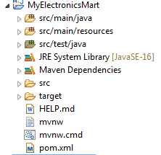

**To Run the Application**

