fullstack web development bootcamp udemy
html101

lesson.29 vs code shortcuts
ctrl + ğ/ü : indentation in-out
ctrl+c and ctrl+v when indexer on the leftmost(nothing is selected): copies entire line and pastes in a new line
ctrl+w: closes current file
ctrl+p: file explorer pop-up
ctrl+shift+f : search query for all of the files
(type 'html:5') : brings html base structure (on vscode and intellij)
ctrl + d : select next occurrence (multiple cursor)
ctrl + ö : comment out line
shift + alt + a : comment out block
ctrl + shift + space: show hint
alt + shift + f: format page (prettier)
lesson.38 base sctructure
<!doctype html> declare file as an html page

lesson.40 some tags and info
<h1> to <h6> headers
html ignores whitespaces
<b></b> bold
<i>/ italic
<u>/ underlined
<div> is a divider, has no special meaning
<a>/ link
href="link" : (link needs http/s)
link can also be a local file (file.html)
target="_blank" : opens in a new tab
<img/> image
src="file"
width=""
height="" : when only height or weight attr exists, it scales
based on attr
also instead of using pixels "500" you can use percentage "50%"
alt="" image explanation
<hr> horizontal rule (horizontal line)
<br> line break
<!-- comment -->

lesson.45 block elements vs inline elements
block elements takes entire width (p, div, h)
inline elements don't (i , b, u,a)

lesson.49 image link
<a href="">
<img src=""/>
</a>

lesson.52 lists
<ul>
<li> </li>
</ul>

<ol>
<li></li>
</ol>

lesson.53 css and js tags
<head>
<title>hello</title>
<style>
body
{
background-color: black;
color: red;
}
.lol
{
background-color: blue;
color: white;
}
</style>
</head>
body directly affects <body>
.lol can be used as attr class="lol"

<script > alert("helloworld"); </script>
or
<script src="file"> </script>

html201
lesson.58 underlines

<u>: deprecated

instead use
<span style="text-decoration: underline" </span>

style is css tag

lesson.59 internal links

as an example if you want a link to scroll bottom of the page:
create an element with an id attribute
<div id="bottom">

id must be unique

create a link href to the id with # at the beginning of the word
<a href="#bottom">go to bottom of the page</a>

lesson.60 favicon

favicons are icons of the website 

type link:favicon
<link rel="shortcut icon" href="favicon.ico" type="image/x-icon">

file can be png/jpg as well, change image/x-icon to image/png or jpg
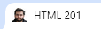 result
lesson.62 table
<table border="5" width="100%" style="text-align: center">
<thead style="background-color: yellow">
<tr>
<th colspan="3"><b>hello this is table</b></th>
</tr>
</thead>
<tbody>
<tr>
<td width="10%">cell 1</td>
<td>cell 2</td>
<td>cell 3</td>
</tr>
<tr>
<td colspan="2">cell 1</td>
<td>cell 2</td>
</tr>
</tbody>
</table>

<th> : table header (td can be used alternatively, th makes text bold and centered)

lesson.67 inline css

note: on opera right click - inspect - elements - (below) styles you can see and manipulate style attrs
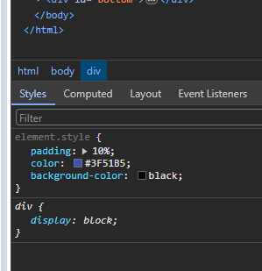

lesson.68 classes
<head>
<style>
.nameGoeshere
{
padding: 20%;
color: white;
background-color: black;
text-align: center;
}
.uppercase { text-transform: uppercase; }
</style>
</head>

<body>
<div class="nameGoesHere uppercase">
</div>
</body>

lesson.69 id
<head>
<style>
#idGoesHere {
color: red;
}
</style>
</head>

id = #
id must be unique
<div id=idGoesHere> </div>

lesson.70 formatted text

<pre> text </pre>
block element
does not ignore whitespaces
uses mono-spacing (all characters and whitespaces are same length)

<code> </code> inline version of <pre>

lesson.71 entities
normally you can not show <> since its a tag character
instead you can use &lt; for <
&gt; for >

<sup> </sup> places text up (like ®)
<sub> brings them down

lesson.74 textarea

<textarea> big input field
does not use value="" instead place text between tags in order to show text in field
between tags is whitecase sensitive
<textarea cols="30" rows="5">text here</textarea>

lesson.75 buttons
button for forms needs submit as type, type=button does not do anything its more to do with javascript
type=reset sets fields to default

lesson.76 forms
<form action="" method="get">
<input required type="email" name="email" placeholder="email"><br><br>
<textarea required name="address" cols="30" rows="10" placeholder="address"></textarea><br>
<select>
<option value="dis" disabled="disabled">select one</option>
<option value="val1">this is value1</option>
<option value="val2">this is value2</option>
<option value="default" selected="selected">default</option>
</select>
<br>
<button type="submit">Submit</button>
</form>

lesson.77 embedding videos

<iframe width="560" height="315" src="https://www.youtube.com/embed/Nc9cfXoOkJo?si=SAooKGUUTKFIWZl8" title="YouTube video player" frameborder="0" allow="accelerometer; autoplay; clipboard-write; encrypted-media; gyroscope; picture-in-picture; web-share" referrerpolicy="strict-origin-when-cross-origin" allowfullscreen></iframe>
copy from youtube video - embed paste in html

css101

lesson.80

css can be written in 3 different ways:
inline with html <style> attr
internal with <style> element
external css file

note: inline css is not a best course

lesson.86 element selectors

in header -> style
use html tag as value
h1 { color: red; }
also
h1,div,p { color: red; } is possible

lesson.86 id selector

in header -> style
#the-id { font-size: 10px; }

lesson.90 nested elements

if an inner element needs to specified:
<div>
<p> <strong> this is text </strong> text text </p>
************************
<style>
p strong { color: red; }

lesson.93 colors

there are three ways to specify a color in css
named colors ( color: red)
hex ( color: #ff0000)
rgb
color: rgb(125,125,125); (range is [0,255])
rgba
color: rgba(0,0,0,0.5); red-green-blue-alpha(transparency)
alpha is transparency ( range [0,1] float)

lesson.93 tag/link states

usually a link(<a>) is in blue color
there are some dynamic change options in css

<head>
<style>
a:hover { color: blue; }
</style>
</head>
(set color when cursor is on link)
a:active
(set *** when click and hold)
a:visited
works in other elements too
h1.sticky {position: sticky; top: 0px;}
(element sticks to the top of the site)

lesson.95 div.var

div.center
{
margin: auto;
width: 50%;
padding: 3px;
}
(use in div which is member of center class)
<div class="center">

lesson.96 measurement types
px, em, rem
(em and rem weren't explained)

lesson.98 background image

<head>
<style>
body
{
background-image: url("bgimage.jpg");
background-size: cover;
background-size: contain;
background-repeat: no-repeat;
background-repeat: repeat-x;
background-repeat: repeat-y;
background-position: center 0;
background-attachment: fixed; <- this makes background image position fixed to vp even when you scroll
}
</style>
</head>

note: check area and areamap

lesson.101 css border
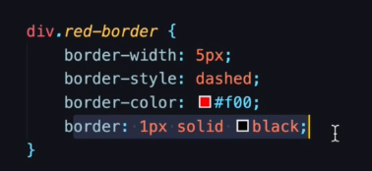
just using border is the same with three declarations above
border syntax : width style color
div.red-border
{
border: 10px solid red;
/* border-radius: 50%; */
width: 200px;
height: 200px;
border-radius: 0% 0% 50% 0%;
/* border-style: dashed; */

}
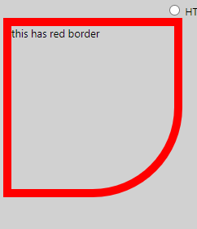 border radius does it

lesson.103 display types

div element is default block element
you can override this behaviour by using
display: inline
or display: inline-block

difference between inline and inline-block
inline: width, height, margin, top, float attrs are ignored
inline-block: they are not ignored

lesson.104 width

use 50% as width which will take half of width anytime
in order to use width element must be inline-block or block
inline elements do not use width , height properties they use the least space they have to use

lesson.105 box-shadow

box-shadow: 6px 6px 5px inset #333333;
x y blur inset color
inset means shadow is in-shadow

#box
{
border: 2px solid black;
width: 200px;
height: 200px;
background-image: url("image.png");
background-position: center center;
background-size: cover;
border-radius: 0 50% 0 50%;
box-shadow: 6px 6px 5px inset #444444;
}

<div id="box">

</div>

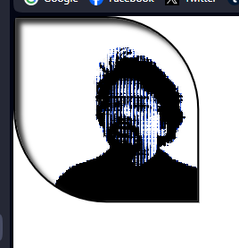 result

lesson.107 padding and margin

padding adds space inside element
but width of the inside stays the same
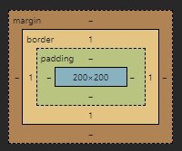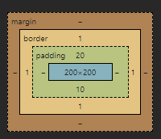
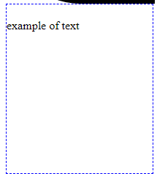 example

padding: 0px 0px 0px 0px;
top right bottom left (clockwise)

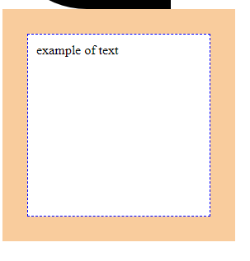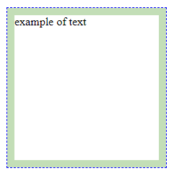
margin vs padding
margin: auto; centers block element (horizontally)

alternatively you can use
margin: 50px auto 50px auto;
top right bottom left
or:
margin: 0 auto;
top-bottom right-left (same)

lesson.109 max-width

use max-width with inline-block

max-width: 500px
width is 500px maximum

lesson.110 opacity

use opacity: 0.5; to set opacity of entire element OR
use rgba for background color

lesson.112 external css file

instead of using <head> <style>
<link rel="stylesheet" href="anyname.css">

body
{
background-color: #f5f5f5;
/* background-image: url("image.png"); */
background-position: center center;

}
anyname.css example
lesson.113 float

float: right; or left;
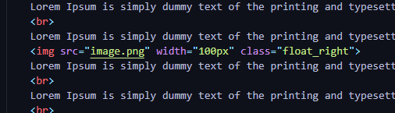
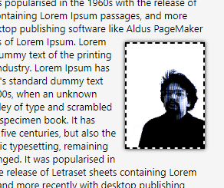

css201

lesson.116 box model

when a div element with a fixed height-weight has padding, default behaviour is that w/h inside the box stays same with extra padding, making div actually bigger than its supposed size.

box-sizing: border-box; makes it total of 300px cropping area from inside
box-sizing is default content-size

lesson.117 outline
similar to border but out of it,, for accessibility reasons
outline: 5px solid green;
outline-offset: 5px

118
texts also have shadows
text-shadow: x y blur color;

lesson.121-122 relative & absolute positioning

position: relative gives ability to slightly move element using
top, right, left, bottom

in order to correctly use absolute positioning parent element must be relative, or else absolute element uses the next parent element (to the viewport)
position: absolute;
top: 0;
righ: 0; <- element is on top-right of the parent element

lesson.123-124 fixed & sticky positioning

position: sticky; or position: fixed;
makes element stick to the viewport
fixed ignores parent element, sticky is also respectful to its parent
sticky also needs top: 0;

if theres two sticky element they can take over the position from each other

lesson.125 overflow
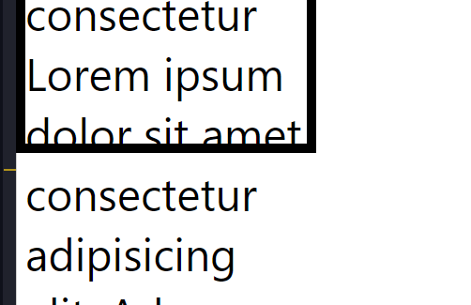
.box
{
width: 300px;
height: 300px;

if content doesn't fit in the element it overflows
in order to add a scrollbar (or make overflowed content hidden)

overflow: auto; can be used
options: visible (default), scroll, auto, hidden

lesson.127 selectors

<style>
.parent > .box {} affects .box elements which has a .parent
.box + .box2 {} affects box2 element which comes after box
.box ~ .box2 {} affects box2 element which comes after box??
</style>

https://www.w3schools.com/cssref/css_selectors.php

NOTE: css selects the most specific style

lesson.129 pseudo selectors

.box:not(.dontselect)
{
background-color: blue;
}
.box:hover{
background-color: black;
}
.box:nth-child(5):hover
{
background-color: wheat;
}

.box:not(.dontselect) : select box unless it is also dontselect
.box:hover : mouse on hover
.box:nth-child(1) : first box child

lesson.130 pseudo elements

.box
{
background-color: black;
width: 300px;
height: 300px;
position: relative;
margin: 40px auto;
}
.box::before
{
content: ' ';
border: 3px solid red;
display: block;
height: 100%;
width: 100%;
z-index: -1;
position: absolute;
box-sizing: border-box;
top: -5%;
left: -5%;
}

.box::after
{
content: ' ';
border: 3px solid blue;
display: block;
height: 100%;
width: 100%;
z-index: 1;
position: absolute;
box-sizing: border-box;
top: 5%;
left: 5%;
}

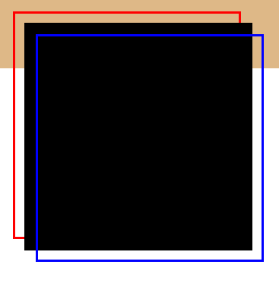
result

z-index brings element front or back (default 0) does not work on body{}

lesson.133 selection
::selection
{
background-color: green;
color: white;
}
(does not need specific element)
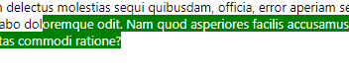result
text-size, margin does not work

lesson.134 smooth transitions

e.g. there is a css style for a and also a:hover

a
{
...
transition: background-color 2.2s,
color 5s, padding 2s, border 2s;
}

transition: attr time, attr2 time; sets the time for the transition (default instant)

lesson.135 gradient
background-image: linear-gradient(45deg, black, yellow);
direction
e.g. to right

or google: css gradient generator
background: rgb(2,0,36);
background: linear-gradient(90deg, rgba(2,0,36,1) 0%, rgba(109,109,136,1) 60%, rgba(0,212,255,1) 100%);
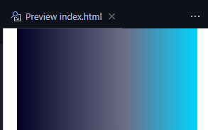 result
lesson.137 layer gradients and backgrounds together

background-image: linear-gradient(180deg, rgba(0,0,0,0) 0%, rgba(0,0,0,0.8) 80%), url("cover.jpg");

top to bottom invisible to black gradient, on top of cover image

note:
html,body
{
height: 100%;
margin: 0;
padding: 0;
}

div.header
{
position: absolute;
top: 50%;
left: 50%;
transform: translate(-50%);
text-align: center;
color: white;
font-size: 90px;
}

element is vertically and horizontally centered (if html is not styled, it is not)

lesson.137 custom web fonts

go to fonts.google.com
embed
<link> or import
paste

OR (to use local font)
@font-face {
font-family: papyrus;
src: url(papyrus.ttf);
}
in <style>

font-family: "papyrus", "Montserrat", sans-serif;
in <style> body{}

lesson.138 transformations

transform: translate(100px,100px);
rotate(45deg);
scale(0.5);
skew(22deg,22deg) (distorts element)

lesson.139 animations
css201/7/index.html

lesson.140 flexbox

#container
{
display: flex;
}

container needs display: flex and child elements obey flex rules

flexbox acts like a table-template

flex-wrap: wrap; to fit elements to screen
flex-basis: 20%; required width for element
flex-shrink: 1.5; shrink factor default 0
flex-grow: 1.3; grow factor def 0

.nav
{
flex-basis: 20%;
/* flex-grow: 0; */
flex-shrink: 3;
align-self: center;
}
.content
{
flex-basis: 80%;
/* flex-grow: 1; */
flex-shrink: 1;
}
.header
{
flex-basis: 100%;
/* flex-grow: 1; */
flex-shrink: 4;
background-color: #f5f5f5;
color: black;
border-bottom: 2px solid black;
padding: 20px;
text-align: center;
}

<div id="container">
<div class="header">HEADER</div>
<div class="nav">navigation</div>
<div class="content">
<h1>
HELLO
</h1>
<p>
Lorem ipsum dolor sit amet consectetur adipisicing elit. Excepturi architecto, possimus atque, ab non praesentium officia eaque ducimus mollitia tempore vero eius tenetur, illum delectus modi assumenda eos laboriosam impedit.
</p>
</div>
<div class="nav">nav</div>
<div class="content">
<p>
Lorem ipsum dolor sit amet consectetur adipisicing elit. Eligendi ipsum architecto alias optio quia molestias perferendis soluta error numquam porro consectetur id laborum, ipsam aliquam assumenda aspernatur tempore, sunt nisi!
</p>
</div>
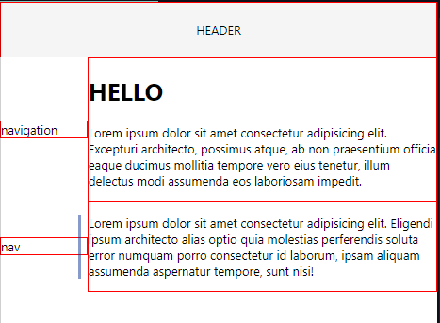 result

flexbox elements:
container
flex items(child elements)
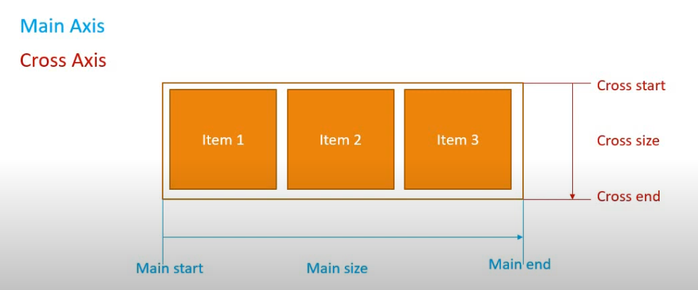

.flex container properties
display
flex-direction
flex-wrap
flex-flow - combination of direction and wrap
justify-content - alignment of the items along the main axis
align-items - cross axis
align-content - alignment of the cross axis(works only when
multiple rows is present

container display: flex, inline-flex

default flex flow direction is row ( from left to right)

flex-wrap prevents items from overflowing, works on column direction too

justify-content: default flex-start, center, flex-end,
space-between, (space is distributed between items)
space-around, (space is distributed between items and first and last element also has space on left-right handsight), space-evenly
align-items sets alignment of cross axis (vertical)
default strech (items are strected from top to bottom9
flext-start, center, flex-end,
baseline
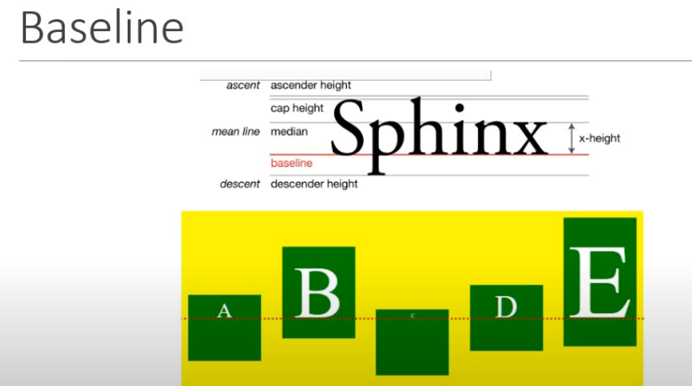

align-content: very similar to justify content but vertical, same values

.flex item properties:
order: [0-max] 0 default
flex-grow: 0 default
flex-shrink: 1 default
flex-basis: em,rem,px,%,auto, default auto
flex: flex-grow flex-shrink flex-basis | flex-grow
| flex-grow flex-basis | flex-grow flex-shrink
(if you enter unit value as second param, uses as basis, else ..)
align-self: align item individually (overrides align-items value of the container)

lesson.141 grid layout

https://fatihhayrioglu.com/fr-birimi/

#grid
{
display: grid;
grid-template-columns: 1fr 1fr 1fr;
column-gap: 10%;
row-gap: 10%;
}
.item
{
border: 1px solid red;
}
.item1, .item7
{
grid-column-start: 1;
grid-column-end: 4;
}
.item6
{
grid-row-start: 2;
grid-row-end: 4;
}

<div id="grid">
<div class="item item1 ">1</div>
<div class="item item4">4</div>
<div class="item item5">5</div>
<div class="item item6">6</div>
<div class="item item7">7</div>

</div>

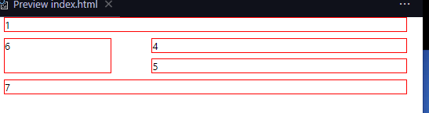

grid-template-columns can be: auto auto auto
or percentage or pixels
and also repeat(12, 1fr); : there are 12 columns, each one is 1fr
and also repeat(auto-fill, 300px) to auto determine column amount
instead of grid-column-start / end, grid-column can be used
grid-column: 1/8; 1 to 8
1/span 3; start from 1 and add 3 columns, same with 1/4
span 3; use 3 columns

note: check @media

css301

lesson.143 <meta

<meta > provides responsive web design support
<meta name="viewport" content="width=device-width, initial-scale=1.0">

lesson.144 media query
allows to change css styles depending on some specifications
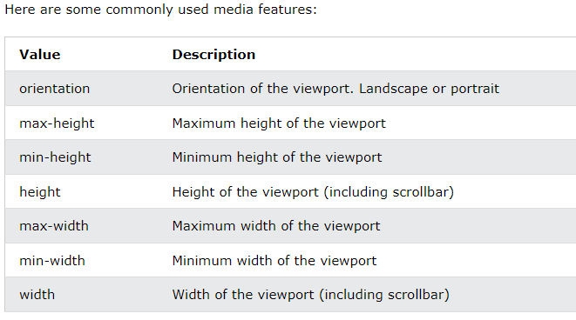
max-aspect-ratio: 16/9;
min-aspect-ratio
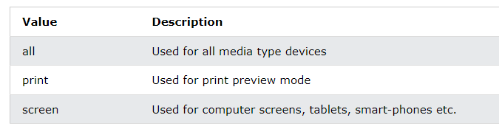

@media screen and (max-width: 640px)
{
body{
background-color: red;
}
}

keywords:
and
or
all
not
only
, (or)
lesson.145 mobile first
instead of making a website FOR desktop screens, make it for a mobile phone THEN use media to adapt it to a wide-screen

@media screen and (min-width: 640px)
{
body{
background-color: blue;
}
}

lesson.146 responsive img
img
{
width: 50%;
height: auto;
}

also use object-fit to fit img content

lesson.147 responsive embed
.i-container
{
position: relative;
overflow: hidden;
width: 100%;
/* height: 100%; */
margin: auto;
padding-top: 56.25%;
}
.i-container > iframe
{
position: absolute;
top: 0;
left: 0;
right: 0;
bottom: 0;
width: 100%;
height: 100%;
}

overrides embed's width/height,
this is actually trick to make embed responsive (always full width)

i-container -> width is width and effective
height has no effect
padding-top is 56.25% because 9/16 * 100 is 56.25 ??

iframe top,left,right,bottom 0 stretch embed to borders
this exact style makes video full-width and responsive
if you want to make it 50% width:
change container width to 50%
change padding-top to %28 or sth

NOT: flex elementlerinden birinin veya birkaçının içeriğini v/h center yapmak istiyorsan o elementin displayini flex yap, containerın ayarlarıyla boşuna oynama

NOT: vh : %1 of the viewport height - tarayıcının yüksekliğinin %1'i,
yükseklik için kullanılabilir

NOT: vh yerine dvh, svh, lvh kullanabilirsin (mobil için önemli)
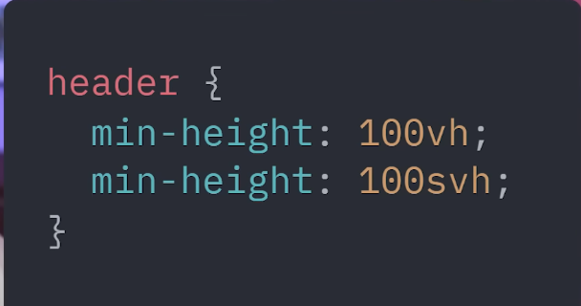
for older browser if not support svh , dvh lvh

javascript 101

lesson.156 javascript syntax

naming standard is camelCase;

<head>
<meta charset="UTF-8">
<meta name="viewport" content="width=device-width, initial-scale=1.0">
<title>Document</title>
<script></script>
</head>
<body>

<script></script>
</body>
there are two places to write script
head, body
in rare occasions when script is in the head it might not work as intended because of the top-down reading rule

<script src="javascript.js"></script>
script can be referenced as external file (must be in the same folder)

lesson.157 console logging
console.log
console.warn
console.error

lesson.159 variables

var website = "website"; <- var is also global, except for functions?
let <- local variable
const <- local variable, constant
const a = 3; | const a = "str"; | const a = true; | const a = 3.14;

lesson.161 comment out
// this is comment /* this is comment */

lesson.162 operators

3 ** 3 = 3^3;
10 % 4 = remainder

lesson.163 data str

const list = [item1, item2];
["str", 1, 3.14, []];
const thing = null; <- null
const thing = undefined; <- initiated but not declared
const getAge = function() { return 31; }
const obj = {
'name' = 'ugur',
'prof' = 'issiz'
} <- object , to access: obj['name']

lesson.164 conditional stm

if(str1 == str2)
{
console.log("true");
} else {
console.log("false");
}

lesson.166 get element by id

<div id="box">a thing in there</div>
html
const box = document.getElementById("box");
console.log(box);
box.innerHTML = "new text <strong> new </strong>";
box.innerText = "text";

js

lesson.167 objects
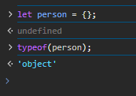
const person = {}; an object
person = {
'name' : 'ugur',
'lastName' : 'ucar',
'favFoods' : ['doner','doner','doner']
};
json gibi

lesson.168 string methods

strvar.search("param"); same as "stringvar.indexOf("param"); in java
strvar.slice(int,int); same as strvar.substring(int,int);
strvar.substr(int1,int2); same as strvar.substring(int1, int1+int2);
strvar.replace("param1", "param2"); DOES NOT CHANGE STRVAR YOU NEED TO SET STRVAR TO THIS FUNCTION
strvar.toUpperCase(); / toLowerCase();
strvar.trim(); gets rid of whitespaces (before and end of the string)
strvar.split("param");
strvar.length <- not a method exactly (no () )
strvar[index]
str1 + str2 = concatted strings

lesson.169 typeof
const arr = [1,2,3,4];
typeof(arr); (javascript says object)

lesson.170 type casting

age = "31";
age * 7; (returns 217, can see "31" as number)
age = "str";
str * 7; (returns NaN)

age = String(age); casts number as string
age = Number(age); casts string as number
age = Array(var); casts as an empty array, length = var

age = Boolean(0); casts as bool = false
age = Boolean(any var, not 0) casts as true

lesson.171 concatted strings

first method : ("My name is: " + name ". and my age is: " + age); second method: `My name is ${name}. my age is ${age}`;
second method is called template literal
note: (`) character is must

lesson.172 type casting (continued)
let a = 123;
let b = "345.7";

a + b ( returns concatted string)
b = Number(b);
a + b (returns float)

lesson.173 array manipulation/iteration (for loops)

arr.push(item);
arr.pop(); (removes last element)

for(let i =0; i<arr.length; i++) arr[i];

or

arr.forEach(num => { console.log(num) } );

or
arr.forEach( (num, index) => {console.log(`this is element ${index}`)} );

or
for(i in numbers)
{
console.log(i);
}

lesson.175 get element(s) by class/type

const elems = document.querySelector(".this-class");
gets first element with specified class name

const elems = document.querySelectorAll(".this-class");
gets all elements having specificed class name

const elements = document.querySelectorAll("li");
gets all list items

elems.forEach( node => {node.classList.add("custom-class", "second-class")});
add classes to items

lesson.176 functions

function addNumbers(param1,param2)
{
return param1 + param2;
}

function addNumbers(...numbers)
{
for(i in numbers)
{
console.log(i);
}
}
rest operator (...)
numbers is considered an array
function addNumbers(greetingName, ...numbers)
{
greetingName = prompt("what is your name", "username");
let total = 0;
//...excerpt...
rest operator can be used with other parameters (always has to be at the end of parameter list)

..default value
function hello(name="default")
{
console.log(name + " hello");
}
hello();
prints "default hello"

lesson.179 objects and functions

const person =
{
'age' : 31,
'name' : 'user',
'speak' : function(word = "cookies")
{
document.querySelectorAll("li").forEach(elm => {elm.innerText = word} );
}
,
talk(to = "user") {
document.querySelectorAll("li").forEach(elm => {elm.innerText += " " + to} );
}
}

'speak' : function(param = default) { doSth(); }
or
speak(param = default) { doSth(); }

person.speak("eben");
person.talk("user");

javascript 201

lesson.182 wait for the page to load

window.onload = function() { alert("page is loaded"); };

lesson.183 yaptığınız değişiklikler kaydolmamış olabilir

window.onbeforeunload = function() {console.log("you're leaving the page");
return "sure misin?";
}

lesson.184 strict comparison

=== value and type comparison, faster
== value but not type comparison

let value1 = "1";
let value2 = 1;

document.querySelectorAll("li")[0].innerText = value1 == value2;
document.querySelectorAll("li")[1].innerText = value1 === value2;

- true
- false
result

lesson.185 js hoisting

when theres a variable declared someplace in the code, js will declare variable as undefined as a first execution in its scope
console.log(value1);
let value1 = "1";
no error, console will log "undefined" because
let value1;
console.log(value1);
js will do this

note: i tried it gives error soooo idk
lesson.186 closure

functions can access variable outside their scope
let var1 = "i am var";
const func = function()
{
document.querySelectorAll("li")[1].innerText = var1;
}
func();

lesson.188 callback

setTimeout(function(param1) {
console.log("i did " + param1); },
3000,"helen");

function defined in the setTimeout is the callback function,
settimeout runs first and waits for defined ms, then runs function as a callback

lesson.189 activate strict mode
type
"use strict";
at the top of your js file or inside a function
strict mode prevents declaring variables without let,const or var (normally it is acceptable)

lesson.190 interval

let count = 0;
const myInterval = setInterval(function() {
console.log("test");
count++;
if(count === 3 )
{
console.log("last")
clearInterval(myInterval);
}
}, 2000);

lesson.191 while

let i = 0;
while(i < 100)
{
console.log(i);
i++;
}

while(true)
{
let name = prompt("name");
if(name === "admin")
{
break;
}
}

lesson.192 dates
let d1 = new Date(2024, 0, 24);

let d2 = new Date(2024, 1, 13);

console.log(d1.getFullYear());
if(d1 < d2) {console.log(true); }

an object type. has getter/setter methods, and supports hour/min/sec as well.

get current date: const d = new Date(); <- holds current date

lesson.193 destructring arrays and objects

const months = ['January', 'February', 'December'];
const [feb, dec] = months;
gets values from array, in order,
in example above feb = 'January' and dec = 'February'

const person1 = {
"name" : "ugur",
"instagram" : "insta",
"els" : "else"
};

const {name, els} = person1;
this one is name sensitive
name = "ugur" els = "else"

notice when desuctring array [] was used, while on object {} was used.

lesson.194 delete

const person2 = {
"age" : 31,
"name" : "ugur"
}
console.log(person2);
delete person2['age'];
console.log(person2);

only works for attrb of objects

lesson.195 Math library

Math.round(4.4); //4
Math.pow(8,2) // 64 same as 8**2
Math.sqrt(9); // 3
Math.max(1,4,5); or min
Math.floor(24.4); // 24 or ceil(24.4); //25

lesson.196 Math.random()

Math.random()
returns a float between [0-1)
(Math.floor(Math.random() * 100 + 1)
return a decimal between 1-100

lesson.198 try catch finally
const num = 10;

try{
num += 20;
//throw "custom error";
//console.log("sth"); //wont execute
} catch(error)
{
console.warn(error);
} finally
{
console.log("finally");
}

console.log("here");

lesson.200 arrow functions
const hello = () =>
{
console.log("hello");
}

hello();

const hello2 = () => "hello2"; //returns "hello2" as a function

console.log(hello2());

const greeting = (neym) =>
{
console.log(`Greetings ${neym}`);
}

const greeting2 = (neym) => console.log(`Greetings ${neym}`);

lesson.202 classes
class MyClass
{
#privateVar = 32;
constructor(name)
{
this.name = name;
}
setName(name)
{
this.name = name;
}
speak()
{
console.log(this.name);
}
getVar()
{
return this.#privateVar;
}
}

const person = new MyClass();
person.speak();

all elements are default public
variables with # on them are private and should be declared in the body of class
public element declaration is prohibited ( "let var;" is not accepted, in order to declare a class variable use it in constructor or setter method )

constructor is constructor(var) {}, multiple constructors are not allowed

lesson.204 ajax

does get post jobs

lesson.205 fetch
fetch("https://swapi.dev/api/people/1")
.then(response => response.json())
.then(
data =>
{
console.log(data);
}
)
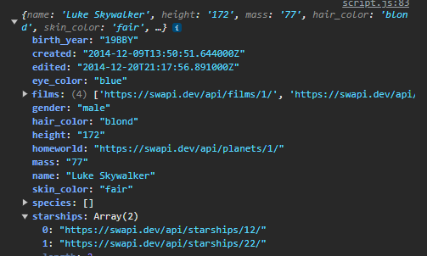 result

fetch is used to access data

bootstrap 101

lesson.208

bişey anlatmıyor dökümanı oku

react.js

lesson.266 install and create template

create-react-app is deprecated and should not be used BUT many people are still using it.
nevertheless vite is the new black

1. install node.js which comes with npm
2. open terminal in vscode / use cmd
3. "npm create vite@latest" / + "my-react-app -- --template react"
https://vitejs.dev/guide/
4. follow the prompts
5. cd "projectname"
6. npm run dev

lesson.270 import react

import './App.css'

import { useState } from 'react'

import viteLogo from '/vite.svg'

lesson.271 jsx syntax

export default App
app.jsx
export keyword makes app importable

import React from 'react'
import ReactDOM from 'react-dom/client'
import App from './App.jsx'
import './index.css'

ReactDOM.createRoot(document.getElementById('root')).render(
<React.StrictMode>
<App />
</React.StrictMode>,
)
this is main.jsx
main.jsx imports necessary parts? react and reactDOM and App.jsx which is rendered page
index.css contains necessary styles

reactDOM creates root,,, renders App in StrictMode (ref. lesson.189 strict mode "use strict")

also there's an index.html
<!doctype html>
<html lang="en">
<head>
<meta charset="UTF-8" />
<link rel="icon" type="image/svg+xml" href="/vite.svg" />
<meta name="viewport" content="width=device-width, initial-scale=1.0" />
<title>Vite + React</title>
</head>
<body>
<div id="root"></div>
<script type="module" src="/src/main.jsx"></script>
</body>
</html>

which has div#root in body and a script module main.jsx
meaning at first index.html runs main.jsx as a script

lesson.272 react component

import React from 'react';

class Item extends React.Component
{
render()
{
return (
<div>
<h1>Hello World</h1>
<p>paragraf</p>
</div>
)
}
}

export default Item;
filename : MyItem.jsx (if you set .js gives error)

import Item from './MyItem'
in app.jsx
<Item/>
</div>
and use it like an html tag

lesson.273 props

tag attributes are accessible from class with the use of this.props.attrname

<Item name="mahmud"/>

class Item extends React.Component
{
render()
{
return (
<h1>Hello World {this.props.name}</h1>
)
}
}
or
class Item extends React.Component
{
render()
{
var son = this.props.name;

lesson.274 onClick
<h1 onClick={() => this.clickme()} ...

class Item extends React.Component
{

clickme()
{
console.log("click ", this.props.name);
}
this is also function declaration

lesson.275 state
constructor(props)
{
super(props);
this.state =
{
clicks: 0
}
}

in order to use state for class constructor is needed
clickme()
{
console.log("click ", this.props.name);
this.setState({
clicks: this.state.clicks + 1
});
}
updated function

note: don't fetch in render function (in class components), try not to update anything in render function because it might go into infinite loop/become unstable

lesson.294 react router dom

in order to change pages react router dom is necessary

npm install react-router-dom

lesson.295 use react router

in main.jsx (vite) import BrowserRouter and wrap app with it

import {BrowserRouter} from 'react-router-dom';

createRoot(document.getElementById('root')).render(
// <StrictMode>
<BrowserRouter>
<App />
</BrowserRouter>
// </StrictMode>
)
remove strict mode if switch is gonna be used
also, switch is deprecated, in order to use it, react-router-dom@5.2.0 should be installed

in app.jsx , import Routes and Route
import {Route, Routes } from 'react-router-dom'

return (
<>
<Navbar searchText={searchText} setSearchText={setSearchText} />
<Routes>
<Route path="/" element={<Home/>}/>
<Route path="/about" Component = {AboutView} />
<Route path='/search' element={<SearchView keyword={searchText} searchResults={searchResults} />} />
<Route path='*' element = {<div><h1>NOT FOUND</h1></div>} />
</Routes>

</>
)
app.jsx

routes should be encapsulated in <routes>
element = {html} and Component = {component} both same

check outlet
https://www.youtube.com/watch?v=u_mhdJTA93s

..outlet / nested routing
<Route path="/about" Component = {AboutView} >
<Route path='extra' element={<div>this is extra info</div>} />
<Route path='bonus' element={<div>this is bonus info</div>} />
</Route>
instead of "/path" use "path"

<Link to="extra">extra</Link> <span> </span> <Link to="bonus">bonus</Link>

</div>
</div>
</div>

<Outlet></Outlet>
aboutView.jsx
outlet is necessary and it will be a placeholder for nested element

path

result

lesson.296 links
import { Link, useNavigate } from "react-router-dom";

import Link
<Link className="nav-link active" aria-current="page" to="/about">About</Link>

link is similar to <a> but is used for internal routing

lesson.297 props / useState

function App() {

const [searchResults, setSearchResults] = useState([]); //hook
const [searchText, setSearchText] = useState('');

same as state in class components, no need to implement Set functions,
usage: setSearchText("string"); <- works without implementation

NOTE: useState set function will re-render the app which might cause to infinite loop / bug / crash

send searchText and setSearchText to navbar
<Navbar searchText={searchText} setSearchText={setSearchText} />
app.jsx

<input className="form-control me-2" type="search" placeholder="Search" aria-label="Search"
value={searchText} onChange={searchBarUpdate}/>
navbar.jsx

navbar will use these props on input field
const searchBarUpdate = (e) =>
{
setSearchText(e.target.value);
}

setSearchText is the state function that was sent as props
which will affect searchText on the app.jsx
in a way this is a pass-by-reference

lesson.298 useNavigate / force route

import { Link, useNavigate } from "react-router-dom";
import useNavigate

const Navbar = ({searchText,setSearchText}) =>
{
const history = useNavigate();
const searchBarUpdate = (e) =>
{
history('/search');
setSearchText(e.target.value);
}
inputfield onChange function
history('/search') routes browser to search input whenever input field is changed

