step1. create project and download apps
1. go to start.spring.io and configure project (maven)
add dependencies (spring web, spring security, spring data jpa, h2 database, devtools, lombok)
2. download spring boot suite 4 (there's a video how to install)
3. download and import lombok to spring suite
4. import project acquired from start spring
some information
application.properties is where some configuration parameters are set
application can be changed as application.yaml, syntax changes
(e.g. spring: <tab> dependency: )
wsapplicationtests is where tests are done (isn't in scope of this course)
you can deactivate spring security in pom.xml commenting out security starter
after running project it can be accessed from localhost:8080
react
download node.js check if it has added to the path, in project folder open cmd and use command "npx create-react-app frontend(is a name)"
it will throw an error follow these steps:
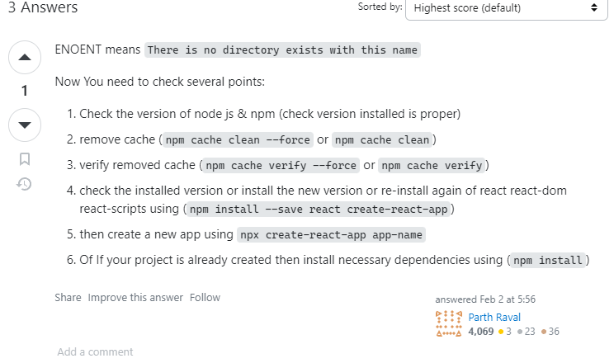

after creating frontend project, on cmd go to folder and type npm start (or yarn start)
project will run on a server shown on cmd
app.js in src folder is the main screen shown on server
note: index.js in src folder is different from the course

lesson.8 usersignup-page react
create a new js file under src folder called usersignuppage.js
import React from 'react';
we create a class called usersignup page extends React.Component
every class component must have a render method
render must return a js context
there are two types of components: functional and class or stateless and stateful
<h1> </h1> - header?
every node module (js file) needs to have an export.
export default UserSignupPage;
or export class UserSignupPage (identifier of the class)
then in index.js we can import that class and call it
root.render(
<React.StrictMode>
<UserSignupPage />
</React.StrictMode>
);

lesson.9
define label as <form> so we will able to click button by pressing enter
render()
{
return(
<form>
<h1>Sign Up</h1>
<div>
<label>Username</label>
<input />
</div>
<div>
<label> Display Name </label>
<input />
</div>
<div>
<label> Password </label>
<input type="password"/>
</div>
<div>
<label> Repeat Password </label>
<input type="password"/>
</div>
<button>Sign Up</button>
</form>
);
}

h1 is bold an big text as a title
div takes contents to a new line, label just prints that string?
input is input ( <input /> not <input></input>)
input type = password hides string
lesson.10
how to get input? we can define a onchange function to the input label
<input onChange={function(event){ console.log(event); } }/>
or lambda expression
<input onChange={(event) => { console.log(event.target.value); } }/>
(event is a function? token, not a name)
there is a state variable overridden, to keep info
state = { username: null };
state updates should be done by setState function, not by directly accessing, because changes does not affect functions dependent on state variable.
onAgreeClicked = event =>
{
this.setState(
{
agreedClicked: event.target.checked
}
)

};

button can be disabled using
<button disabled={!this.state.agreedClicked}>Sign Up </button>
setState function is derived from React.Component, after being called updates values and recalls render function
targets have name property and this way we can create a generic function using that name variable. (event.target.name)
const {name, value} = event.target(.name, .value) is a different syntax and called object destructing. alternative could be
const value = event.target.value;
const name = event.target.name;
---- [variable] formatted?
this.setState(
{
[name]: value
}

lesson.11 spring
create a package for user, create userController class and annotate as @RestController
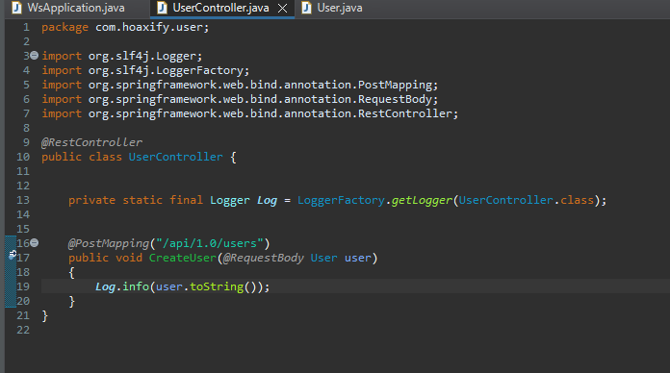
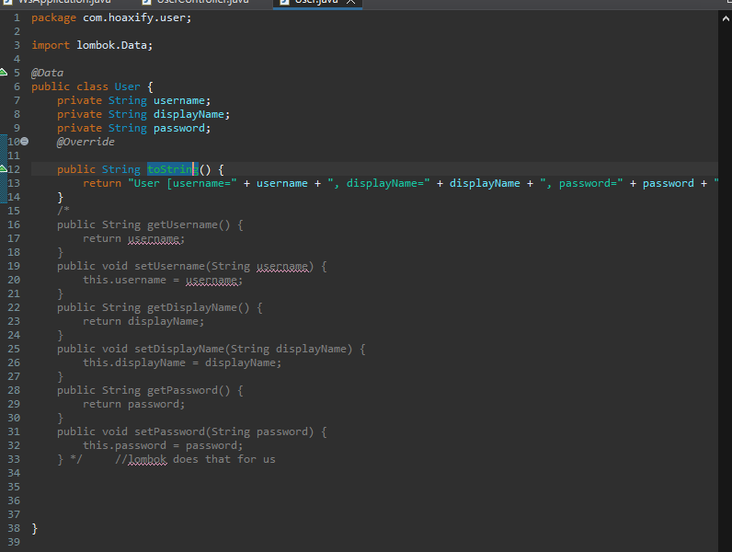
in this case contents of request(a json file "name: value") matches with the variables in the class. in Usercontroller createUser function annotated by postmapping is accessible through localhost:8080/api/1.0/users (/api/version/name style information is suggested). RequestBody annotation sends data to user automatically (getter setters are needed). logger logs.
in user class @Data annotation from lombok sets getters and setters.

lesson.12 request from react to spring
install axios in frontend folder cmd->npm install axios
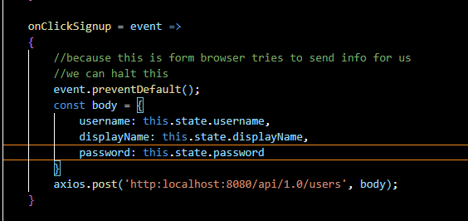
import axios and set this function as a onclick on button
onClick = {}
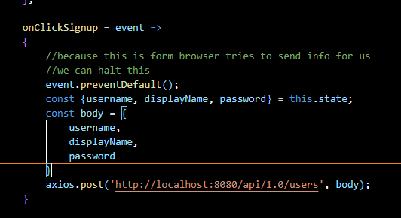
this also works
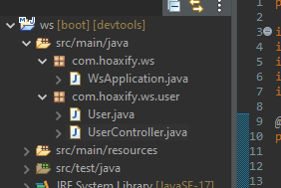 name is very important (var1.var2 and var1.var2.var3)

react and spring are currently working on different ports, so cors will block the request, to fix that either add @CrossOrigin tag on the function or open browser without cors (create shortcut for browser with parameters)

lesson.13 webpack
setting post address as "localhost:8080/api.." is a bad idea, instead we should use "/api/.." but we will get 404 error. to fix that we have to set proxy. in frontend, package.json;
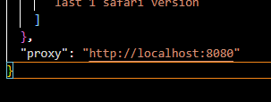 restart server
delete @CrossOrigin bc its no longer needed.

lesson.16 database
h2 database can be accessed through localhost:port/h2-console
if it gives an error change application.yaml as: 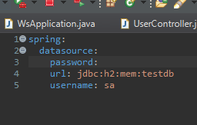
h2 database is in memory mode, any data will be deleted after termination.
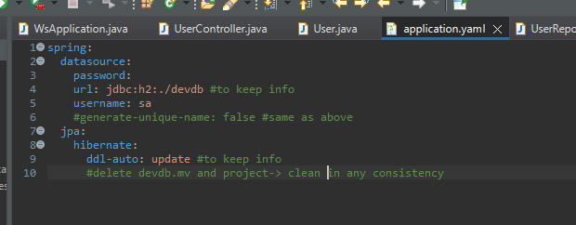
set name to something else to prevent
ddl-auto: update -> for database schemas
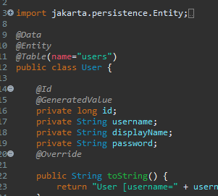
@Data - lombok
@Entity - notify h2 that this is for database (jpa)
@Table(name ...) - user is a h2 keyword so we should change it
@Id - primary key @generatedvalue - auto-increment
Create an interface for retrieving and saving data to database.
interface is in user package and extends jpaRepository. jpa repository takes two parameters T, ID, T-> type(User) ID -> type of id i believe, Long
jpa is about hibernate but he did not go into detail.
jpa connects database with class without us dealing with database structures.
after creating interface(UserRepository) create an instance and annotate it with @Autowired. this is about dependency injection...
userRepo.save(object)
what happens is, when reading code java notices instance, it will create object and set it ?????
1. instance of interface creates class, sends info to instance,
interface is extended with jpa by target class.
2. @postmapping(api/...) annotated function gets info
its parameter is @RequestBody User user, info is in user object
3. we use userRepo.save(user), this sends user to h2 table, user class is annotated as @Entity so h2 will create a table accordingly....

lesson.17 refactor
save repository operations should be done in a different class (layered approach) therefore we create a new class named UserService, annotated @Service (improves readability).
user service has repository instance and a constructor which may or may not be annotated @autowired, depends on the constructor count, this class has only one contructor, annotation can be omitted.
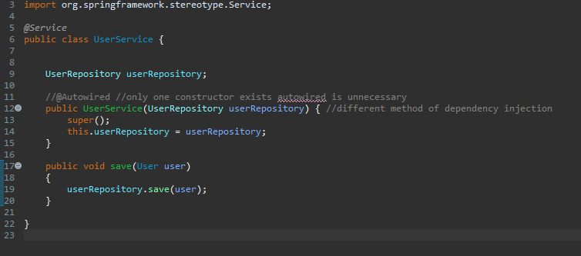
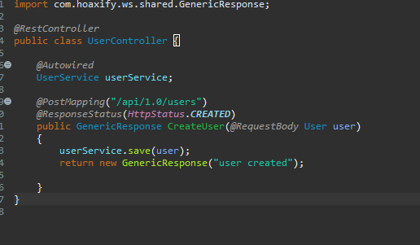
theres userservice instance instead of userrepo, annotated @autowired.
@ResponseStatus sets response code (default 200 OK)
after post operation sending a body message is recommended therefore function now returns a genericResponse instance
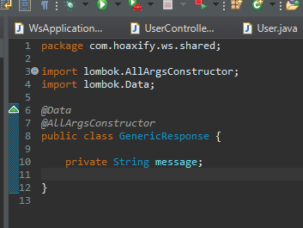
class is in shared package (accessable from everywhere)
@Data -> lombok @AllArgscon.. -> constructor takes all(every?) args
returning GenericResponse object, spring will turn object into a json file just like it turns a json file into a user class

lesson.18 encrypted password
activate spring security back in pom.xml
exclude autoconfig from @Springbootapp(exclude )
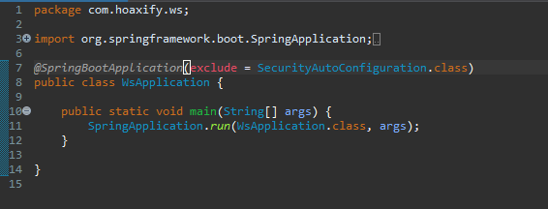
because frontend will not be able to access..
on user service create a PasswordEncoder instance and add to constructer as a new BCryptPasswordEncoder();
use passwordencoder.encode(password), save to the database...
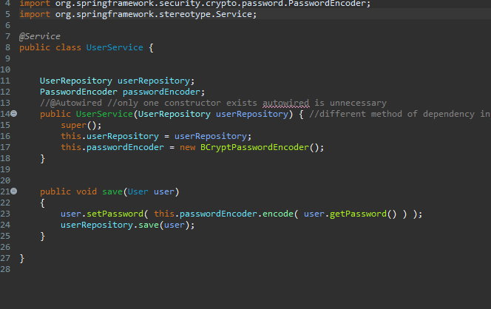

lesson.19 bootstrap ?
go to getbootstrap.com copy the code <link ref:....
paste to the index.html in public folder
<!--link href="https://cdn.jsdelivr.net/npm/bootstrap@5.3.1/dist/css/bootstrap.min.css" rel="stylesheet" integrity="sha384-4bw+/aepP/YC94hEpVNVgiZdgIC5+VKNBQNGCHeKRQN+PtmoHDEXuppvnDJzQIu9" crossorigin="anonymous"> -->

bootstrap is a helping tool? for the design of the site. after
adding link to the index file bootstrap features can be used by adding properties to the html tags. properties are defined as class = "property" but we prefer className in case of conflict with the class keyword of js. detailed information is on bootstrap docs.
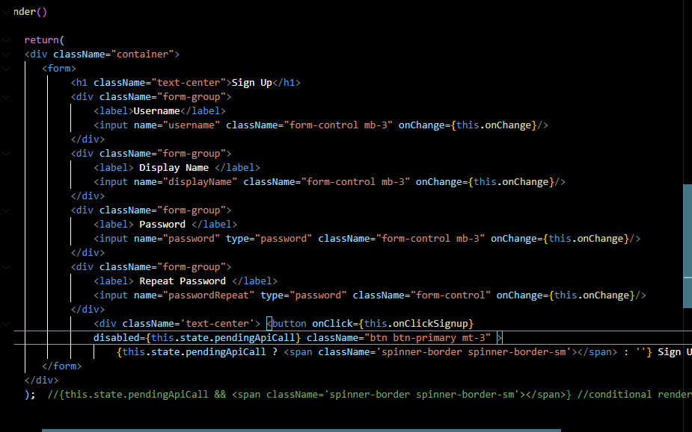
{condition ? this : else} conditional rendering
{condition && condition }
--

npm install bootstrap
npm install node-sass //// node-sass is deprecated
deprecated

lesson.20 progress
check: spinner - bootstrap
add a <span ></span> in button use className = "spinner ..."

lesson.21 refactor
create a new folder under src called pages. move signuppage.js to that folder. for axiom post call create another folder called api and new js file apiCalls.js. move axios.post to that file with an arrow function
import axios from 'axios'

export const signup = body =>
{
return axios.post('/api/1.0/users', body) //runs asyncronious

}
import on usersignup
import {signup} from '../api/apiCalls'
usage
onClickSignup = async event =>
{
//.. previous code
this.setState({pendingApiCall: true});
/*
signup(body).then((response) => {
this.setState({pendingApiCall: false});
}).catch(error =>
{
this.setState({pendingApiCall: false});
}
); */
try
{
const response = await signup(body);
} catch(error) {}

this.setState({pendingApiCall: false});
async keyword is used and await keyword makes function wait for post operation to happen

lesson.24 validate username
in previous versions of createuser function, return type was a genericResponse class containing one string variable. now we use ResponseEntity class as "public ResponseEntity<?> ("?" means any type).
if username is null or empty return ResponseEntity.status(Httpstatus.BAD_REQUEST).build();
then we create an error class to return as a body. ( super() is irrelevant)
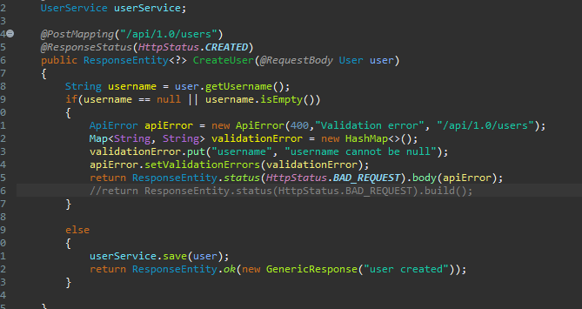
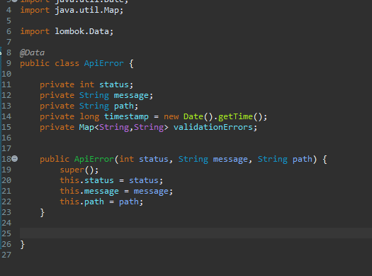
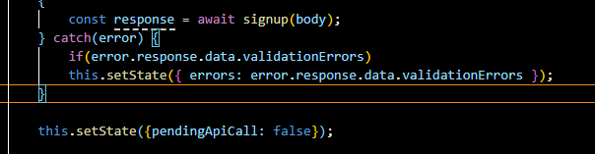
error is what backend returns as a body and if error is of expected type (if(error.response.data...) it will set a new error
errors: {} //state

const {pendingApiCall,errors} = this.state;
const {username} = errors;
return(
<div className="container">
<form>
<h1 className="text-center">Sign Up</h1>
<div className="form-group">
<label>Username</label>
<input name="username" className={username ? "form-control is-invalid" : "form-control"} onChange={this.onChange} required/>
<div className='invalid-feedback'>{username}</div>
</div>

note: check bootstrap forms validation
in order for invalid feedback to be seen "is-invalid" tag must exists. because of that we set conditional rendering for input:
username variable is accessed from errors {} in state, if it exists (username ? ) invalid feedback should appear.
onChange = event =>
{
//const value = event.target.value;
//const name = event.target.name;
const {name, value} = event.target; //object destructing
const errors = {... this.state.errors};
errors[name] = undefined
this.setState(
{
[name]: value,
errors
}
);
//console.log(this.state);
const errors = {... this.state.errors};
(spread operator, copies array)
setState( errors ) changes error to undefined, therefore if we start typing a username invalid error disappears.
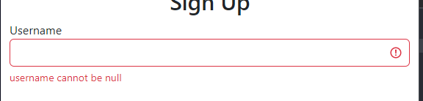

notes: backend is sending a hashmap<string, string>(validationError) with one element "username", username cannot be null". this map value is set to errors: validationError in react. react saves it as errors = { username: "username cannot be null" }
errors[name] = undefined
name = name of the target html name (username, displayName, passwordRepeat, etc)
errors[name] = 'name' element of the errors
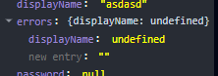 for every element it sets undefined
notes: i don't know why we set to undefined and not null

lesson.25 displayName validation
do the same for the displayName but backend needs some refactoring
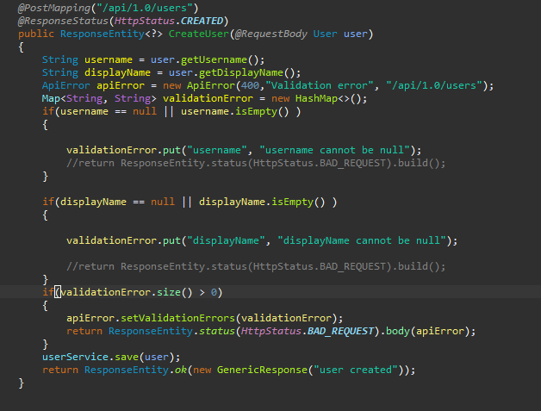
this way both empty error bodies will be sent

lesson.26 input refactoring
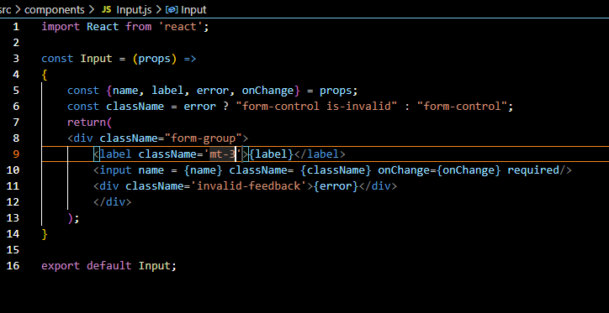
create a new class for input labels (username, displayName)

inputs take props as a parameter which is a body??
use {var} in html
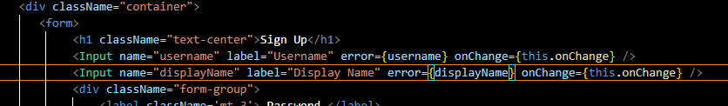
import function from class and use it in render as its a tag.
set props.

lesson.27 bean validation
- <dependency>
- <groupId>org.springframework.boot</groupId>
- <artifactId>spring-boot-starter-validation</artifactId>
- </dependency>
add this as dependency
@notnull to variables in user class
@valid in parameter
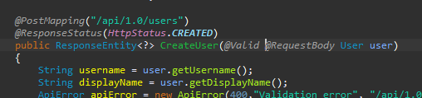
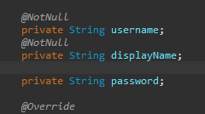

lesson.28 validation with apiError
in order to return an apiError object as an error, new function is needed.

@Autowired
UserService userService;

@PostMapping("/api/1.0/users")
@ResponseStatus(HttpStatus.CREATED)
public GenericResponse CreateUser(@Valid @RequestBody User user)
{
if(user.getUsername().isEmpty()|| user.getDisplayName().isEmpty())
{
System.out.println("true\n");
}
userService.save(user);
return new GenericResponse("OK");
}

@ExceptionHandler(MethodArgumentNotValidException.class)
@ResponseStatus(HttpStatus.BAD_REQUEST)
public ApiError handleValidationException(MethodArgumentNotValidException e)
{
ApiError apiError = new ApiError(400,"Validation error", "/api/1.0/users");
Map<String, String> validationError = new HashMap<>();
for(FieldError fieldError : e.getBindingResult().getFieldErrors())
{
validationError.put(fieldError.getField(), fieldError.getDefaultMessage());
}
apiError.setValidationErrors(validationError);
return apiError;
}

if @responsestatus is not defined function returns 200 OK.
e.bindingResult.getFieldErrors holds variables giving error
(because of the @valid and @notnull annotations, these variables are the variables of user object)
in foreach every error is put in hashmap
note: if only annotation of the variable is @notnull handler accepts empty(but not null) values. @notempty also should be used.
lesson.29 remaining validations
displayName and password also must not be null, and size of each must be between 4 and 255. (if size is more than 255 spring throws an error about db field varchar(255) which is default for database) for size, @Size(min = 4, max = 255) annotation can be used (no need for @notEmpty).
passwords are usually require more complex patterns so @Pattern annotation can be used. pattern takes a regex parameter (regexp="regex").

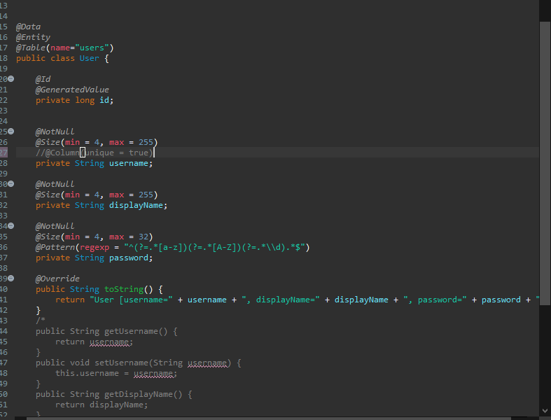
in order for user to get error message on the frontend side password section should be changed to Input(we defined). type attribute is required for passford input field arrangements must be made.
"unique in @Column is used only if you let your JPA provider create the database for you - it will create the unique constraint on the specified column. But if you already have the database, or you alter it once created, then unique doesn't have any effect."
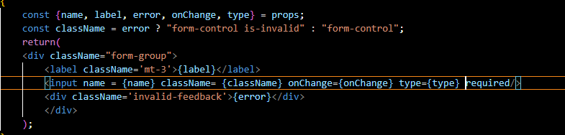
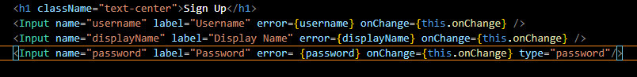
(notice username and displayName does not send type attribute)

lesson.31 custom @annotation
username must be unique and in order to detect uniqueness another annotation must be used. since there's no specific annotation for that, a new one should be created.
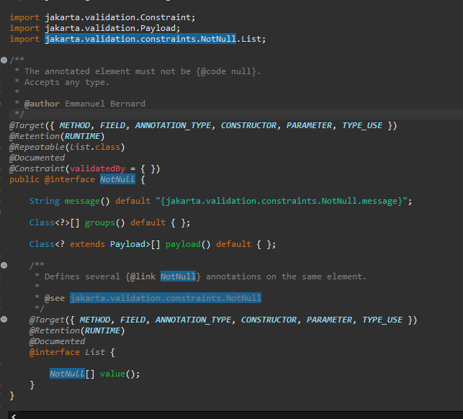
example of a annotation class, @notnull
create a new annotation in user folder, called UniqueUsername.
@Target, @Retention and @Contraint(valida.. are necessary.
copy these from notnull(or any) annotation class. since purpose of this annotation is to check username(string), @target should only be FIELD.
UniqueUsername annotation will be validated by another custom validator UniqueUsernameValidator.class (should be created).

package com.hoaxify.ws.user;

import static java.lang.annotation.ElementType.ANNOTATION_TYPE;
import static java.lang.annotation.ElementType.CONSTRUCTOR;
import static java.lang.annotation.ElementType.FIELD;
import static java.lang.annotation.ElementType.METHOD;
import static java.lang.annotation.ElementType.PARAMETER;
import static java.lang.annotation.ElementType.TYPE_USE;
import static java.lang.annotation.RetentionPolicy.RUNTIME;

import java.lang.annotation.Retention;
import java.lang.annotation.Target;

import jakarta.validation.Constraint;
import jakarta.validation.Payload;

@Target({ FIELD })
@Retention(RUNTIME) //annotation'un runtime'da cözülmesi
@Constraint(validatedBy = {UniqueUsernameValidator.class})
public @interface UniqueUsername {
String message() default "username must be unique";

Class<?>[] groups() default { };

Class<? extends Payload>[] payload() default { };
}
UniqueUsername annotation
message, groups and payload functions must be declared. (groups and payload are default)

UniqueUsernameValidator class implements ConstraintValidatorContext<A,T> : annotation and type of validated. UniqueUsername is annotation and String is the type of validated variable.
validator class must implement isValid method.

package com.hoaxify.ws.user;

import org.springframework.beans.factory.annotation.Autowired;

import jakarta.validation.ConstraintValidator;
import jakarta.validation.ConstraintValidatorContext;

public class UniqueUsernameValidator implements ConstraintValidator<UniqueUsername, String>{

@Autowired
UserRepository userRepository;
@Override
public boolean isValid(String username, ConstraintValidatorContext context) {
User user = userRepository.findByUsername(username);
if(user != null)
{
return false;
}
return true;
}

}

findByusername is not a generic function, but findBy* function is. findBy(variable) function automatically creates and runs query in database.
public interface UserRepository extends JpaRepository<User, Long>{

User findByUsername(String username); //automatically runs, no implementation
}

logical operations like greater, and etc are also possible. please check documentation.

NOTE:
spring.jpa.properties.javax.persistence.validation.mode=none
should be added to application OTHERWISE @Autowired userRepo throws error as being NULL

lesson.32 client-side validation
password and passwordRepeat values should be equal and since passwordrepeat isn't sent to server, validation should be on the client side.
passwordRepeat part is changed to <Input/> (custom tag)
render()
{
const {pendingApiCall,errors} = this.state;
const {username, displayName, password, passwordRepeat} = errors;
return(
<div className="container">
<form>
<h1 className="text-center">Sign Up</h1>
<Input name="username" label="Username" error={username} onChange={this.onChange} />
<Input name="displayName" label="Display Name" error={displayName} onChange={this.onChange} />
<Input name="password" label="Password" error= {password} onChange={this.onChange} type="password"/>
<Input name="passwordRepeat" label="Password Repeat" error={passwordRepeat} onChange={this.onChange} type="password"/>

<div className='text-center'> <button onClick={this.onClickSignup}
disabled={pendingApiCall || passwordRepeat !== undefined} className="btn btn-primary mt-3" >
{pendingApiCall ? <span className='spinner-border spinner-border-sm'></span> : ''} Sign Up </button> </div>
</form>
</div>
); //{this.state.pendingApiCall && <span className='spinner-border spinner-border-sm'></span>} //conditional rendering
}

}
add passwordRepeat to const
add passwordRepeat as a condition to 'disabled' of button
onChange = event =>
{
//const value = event.target.value;
//const name = event.target.name;
const {name, value} = event.target; //object destructing
const errors = {...this.state.errors};
errors[name] = undefined
if(name === 'password' || name === 'passwordRepeat')
{
if(name === 'password' && value !== this.state.passwordRepeat)
{
errors.passwordRepeat = 'password mismatch';
}
else if(name === 'passwordRepeat' && value !== this.state.password)
{
errors.passwordRepeat = 'password mismatch';
}
else
{
errors.passwordRepeat = undefined;
}

}
this.setState(
{
[name]: value,
errors
}
);
//console.log(this.state);
};
set passwordRepeat in errors to a value
else delete it

lesson.34 spring language support (internalization -i18n)
validation error messages are hold as files in dependencies folder (maven dependencies -> hibernate-validator-x.x.x -> org.hibernate.validator-> ValidationMessages_xx.properties ).
@Documented
@Constraint(validatedBy = { })
public @interface Size {

String message() default "{jakarta.validation.constraints.Size.message}";
(@size)
if there is a ValidationMessages_xx.properties file in resources folder, custom messages can be used for annotations.
@Size(min = 4, max = 32)
@Pattern(regexp = "^(?=.*[a-z])(?=.*[A-Z])(?=.*\\d).*$", message = "{hoaxify.constraints.password.Pattern.message}")
private String password;
(user class)
public @interface UniqueUsername {
String message() default "{hoaxify.constraints.username.UniqueUsername.message}";
(@UniqueUsername custom annotation)
ValidationMessages.properties file contains default messages and ValidationMesages_xx.properties contains messages for target language.
target language is determined by the language of the request (primary language of browser, language parameter in postman).
axios is capable of sending preferred language:
return axios.post('/api/1.0/users', body, {headers : {'accept-language' : 'tr'}});

hoaxify.constraints.username.NotNull.message = username cannot be null
(validationmessages.properties)

lesson.35 language support in react
react language support is applied with the i18next package.
(check react.i18next.com)

install packages using npm:
npm install i18next react-i18next

create i18n.js file under src and:
import i18n from 'i18next';
import { initReactI18next } from 'react-i18next';

i18n.use(initReactI18next).init(
{
resources: {
en: {
translations: {
'Sign Up' : 'Sign Up',
'password mismatch' : 'password mismatch',
'Username' : 'Username',
'Display Name' : 'Display Name',
'Password' : 'Password',
'Password Repeat' : 'Password Repeat'
}
},
tr: {
translations: {
'Sign Up' : 'Kayıt Ol',
'password mismatch' : 'şifreler aynı değil',
'Username' : 'Kullanıcı Adı',
'Display Name' : 'Görünür İsim',
'Password' : 'Şifre',
'Password Repeat' : 'Şifre Tekrar'
}
}
},
fallbackLng: 'tr',
ns: ['translations'],
defaultNS: 'translations',
keySeperator: false,
interpolation: {
escapeValue: false,
formatSeperator: ','
},
react: {
useSuspense: true //wait: true is deprecated
}
}
);

export default i18n;

import in index.js
import './i18n';

import {withTranslation} from 'react-i18next';
also import withtranslation in usersignuppage.js
const UserSignupPageWithTranslation = withTranslation()(UserSignupPage); //higher order component
export default UserSignupPageWithTranslation;
use withTranslation function and export

languages are accessed through this.props.t('token').
example:
const { t } = this.props;

<label>{t('Sign Up')}</label>

lesson.36 change language

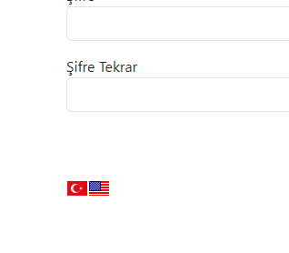
in order to create language buttons, two flag images are needed. flags can be obtained using any flag image api(?)(e.g. https://flagsapi.com) but also small flag images can be stored and used in the project.
<div>
<img src="https://flagsapi.com/TR/flat/24.png"
alt="turkish flag"
onClick={() => this.onChangeLanguage('tr')}
style={{cursor: 'pointer'}}
/>
<img src="https://flagsapi.com/US/flat/24.png"
alt="usa flag"
onClick={() => this.onChangeLanguage('en')}
style={{cursor: 'pointer'}}
/>
</div>
</form>
</div>

);
}

alt attr sets explanation of the image
onClick is set to a function in order to change language, sends abbr. as parameter. ( () => this.onChange.... type is an arrow function , if () => is not exist onClick doesn't work)
style{{cursor... } changes mouse pointer 
onChangeLanguage = language =>
{
const {i18n } = this.props;
i18n.changeLanguage(language);
setLanguage(language);
}
on Usersignuppage
set language is a custom function for axios to set its language in order to get language-appropriate error messages from spring.

export const setLanguage = (language) =>
{

axios.defaults.headers['accept-language'] = language;
}
apiCalls.js

lesson.39 loginpage
create a login page which is similar to userSignupPage
react code snippets extension creates templates using keywords
example: rcc -> react class component

lesson.41 change language (revisit)
language changing functions and buttons can be seperated as a new component. create languageSelector.js under components folder.
import react, withTranslation and setLanguage function (custom function in apiCalls.js)
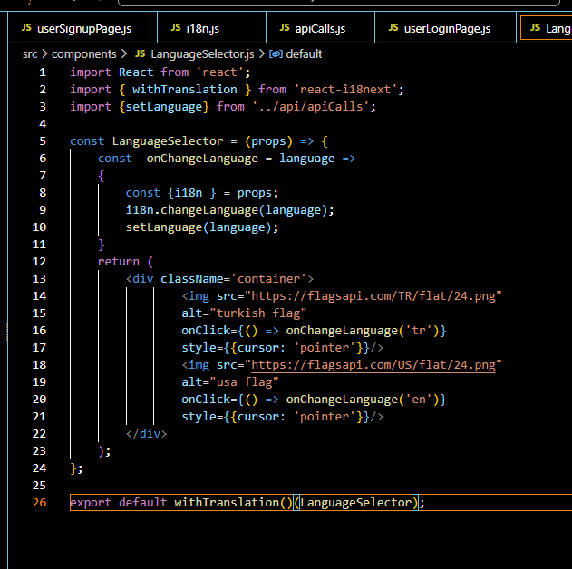
onChangeLanguage function and flag buttons originally placed in the usersignuppage and loginpage. they are moved to this new file, but both pages still use withTranslation and exported as such.
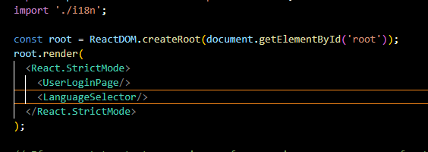
index.js
on index.js both userloginpage and languageselector can be rendered. result will be the same.
notes: although i18n is not accessed in loginpage or signup page, translation still works. withTranslation is mandatory for both classes and also language selector class. also i18n must be imported in index.js, else react doesn't recognize i18n.changeLanguage function.

lesson.42 authentication
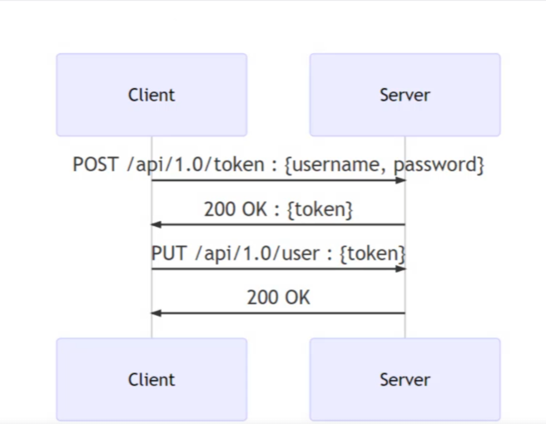
this is usual process of authentication, but since it is hard to implement at this point, basic auth will be used.
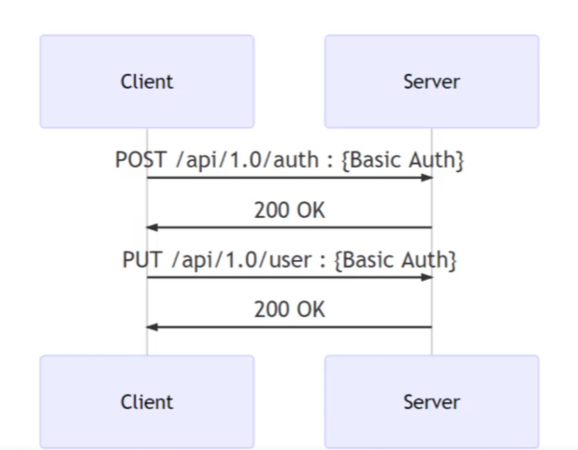
basic auth (not safe)

create login function in apiCalls.js. login function needs username and password (credentials), creds should be a parameter. creds is a json file with the form of { username: "val", password : "val"}
export const login = (creds) =>
{
return axios.post('/api/1.0/auth', {}, {auth: creds } );
}
apiCalls.js
post request body will be empty, instead auth(a config of axios) sends creds in a base64 form

onClickLogin = event =>
{
event.preventDefault();
const {username,password} = this.state;
const creds = {
username,
password
}
login(creds);
}
userloginpage.js
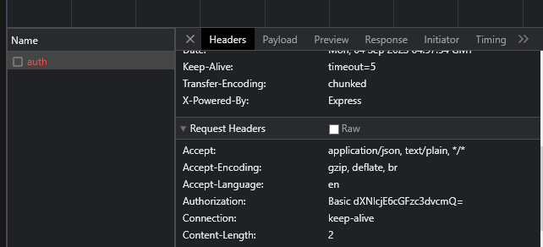
after posting a request, Authorization header sends Basic with Base64 encoded data, that can be easily decoded.
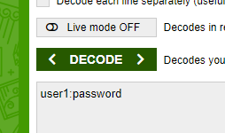
base64decode.com

lesson.43 spring temporary user
@SpringBootApplication(exclude = SecurityAutoConfiguration.class)
public class WsApplication {

public static void main(String[] args) {
SpringApplication.run(WsApplication.class, args);
}

@Bean
CommandLineRunner createInitialUsers(UserService userService){ //temporary user creating service
return new CommandLineRunner() {

@Override
public void run(String... args) throws Exception {
User user = new User();
user.setDisplayName("display1");
user.setUsername("user1");
user.setPassword("P4ssword");
userService.save(user);
}
};

}
}
since database is in test mode no permanent record will be present.
to test auth method, this function will run every time spring starts. before initialization, spring will see @bean annotation on a commandlinerunner and it will call run method
@bean annotation allows dependency injection so userservice can be used.

lambda function: if interface has only one method (commandlinerunner is an interface):
@Bean
CommandLineRunner createInitialUsers(UserService userService){ //temporary user creating service
return (args) -> {
User user = new User();
user.setDisplayName("display1");
user.setUsername("user1");
user.setPassword("P4ssword");
userService.save(user);

};

}

lesson.44 auth check
@RestController
public class AuthController {

@Autowired
UserRepository userRepository;
PasswordEncoder passwordEncoder = new BCryptPasswordEncoder();
@PostMapping("/api/1.0/auth")
ResponseEntity<?> handleAuthentication(@RequestHeader(name = "Authorization", required = false) String authorization)
{
if(authorization == null)
{
ApiError error = new ApiError(401, "unauthorized request","/api/1.0/auth");
return ResponseEntity.status(HttpStatus.UNAUTHORIZED).body(error);
}

String base64encodedString = authorization.split("Basic ")[1];
//System.out.println(base64encodedString);
String decodedString = new String( Base64.getDecoder().decode(base64encodedString) );
String[] decodedStrParts = decodedString.split(":");
String username = decodedStrParts[0];
String password = decodedStrParts[1];
User inDBUser = userRepository.findByUsername(username);
if(inDBUser == null)
{
ApiError error = new ApiError(401, "unauthorized request","/api/1.0/auth");
//generic error type, dont give out too much information
return ResponseEntity.status(HttpStatus.UNAUTHORIZED).body(error);
}
String hashedPassword = inDBUser.getPassword();
if(!passwordEncoder.matches(password, hashedPassword))
{
ApiError error = new ApiError(401, "unauthorized request","/api/1.0/auth");
return ResponseEntity.status(HttpStatus.UNAUTHORIZED).body(error);
}
return ResponseEntity.ok().build();
}
}
create a class under a new package com.hoaxify.ws.auth called AuthController
annotated with @RestController to handle post requests, @postmapping sets the path, function returns a ResponseEntity of any type (<?>). @RequestHeader is used as a parameter annotation since auth will be sent as a header from react.
required = false config avoids function to automatically handle error whenever authorization is null
header was sent is set to authorization String and it is in form "Basic <base64>". Base64.getDecoder().decode function decodes base64 part. Then it is split by ":" (username:password) and username is searched through database by using findbyusername. if username doesn't exist and error of type ApiError is sent. In this part validationError which is a var ob the ApiError class will be null and will be sent as it is. in order to avoid that:
@Data
@JsonInclude(JsonInclude.Include.NON_NULL)
public class ApiError {
annotation can be added. if username exists, then corresponding is saved to hashedpassword(string). since passwords are stored as encoded in database, passwordencoder.matches() function is used(which is from same class that is used for encoding). if password does not match same unauth response is sent.

lesson.45 authorization response
when authorization process is succesful, a response including username, displayname and image should be sent. there are different method to accomplish this:
first approach is to create a hashmap and put these variables in the map to send as a response body
String hashedPassword = inDBUser.getPassword();
if(!passwordEncoder.matches(password, hashedPassword))
{
ApiError error = new ApiError(401, "unauthorized request","/api/1.0/auth");
return ResponseEntity.status(HttpStatus.UNAUTHORIZED).body(error);
}

//Map <String, String> responseBody = new HashMap<>();
//responseBody.put("username", inDBUser.getUsername());
//responseBody.put("displayName", inDBUser.getDisplayName());
//responseBody.put("image", inDBUser.getImage());
//return ResponseEntity.ok(responseBody); //another option to return information

return ResponseEntity.ok(inDBUser); //@JsonIngore on password in user class
}
authcontroller.java

at this point one can think of sending returned user instance(from database) as a response. altought this will work it will also send hashed user password exposing it, hence being a bad practice.

one overcome of this problem might be to exclude password variable in user class from json file. this can be achieved using @JsonIgnore annotation on password var in user class. JsonIngore prevent password var being sent as a body to client but also ignore it when client sends a request, thus won't receive it.
temporary? and working solution is to use Views:
package com.hoaxify.ws.shared;

public interface Views {

class Base {

}

}
create a Views interface in shared folder create a class and leave it empty
(view classes can be extended: class Sensitive extends Base )
@PostMapping("/api/1.0/auth")
@JsonView(Views.Base.class)
ResponseEntity<?> handleAuthentication(@RequestHeader(name = "Authorization", required = false) String authorization)
{
if(authorization == null)
{
ApiError error = new ApiError(401, "unauthorized request","/api/1.0/auth");
return ResponseEntity.status(HttpStatus.UNAUTHORIZED).body(error);
}
annotate function with @JsonView
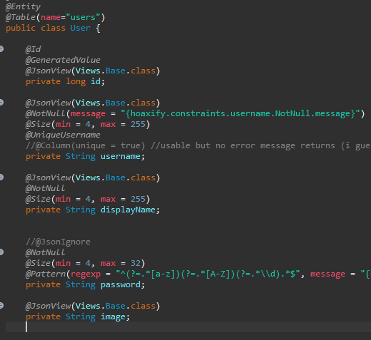

annotate every variable that might be used in the function (including api error variables, genericResponse variable)
note: Views is not a good practice when structure gets complex (hard to manage)

lesson.47 security

