microservices with java, docker, kubernetes

.1. what are microservices

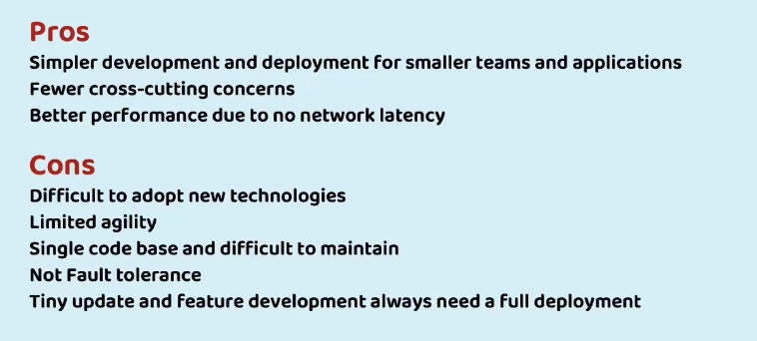
monolithic pros and cons
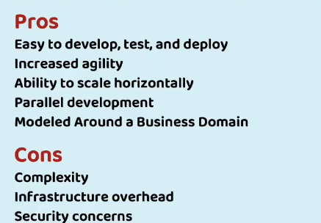
microservices pros and cons

.9. what is rest service

lightweight communication service uses json
supports crud operations (post, get, put, patch, delete)
not: put means update entire records whereas patch updates only specified fields
should have proper validation and exception handling

.12. codeium
ai tool
ctrl + i <- command alıyor

.13. enable annotation processor to use lombok annotations and install lombok plugin and modify pom.xml where it excludes lombok

.14. create schema automatically

under resources create schema.sql and type sql commands
spring boot will automatically run sql

.27. springdoc-openapi
use version according to your spring boot version
creates documentation for your controllers

section.3 microservice boundaries

.36. number of microservices

too much microservice -> too much communication
domain-driven sizing: build microservices based on domains(accounts, loans, customers)

event storming session: event roadmaps can be listed and grouped as domains

.39. strangler fit pattern

move functionality to microservices from monolithic app domain by domain until everything in monolithic app is migrated.

.42. conterization
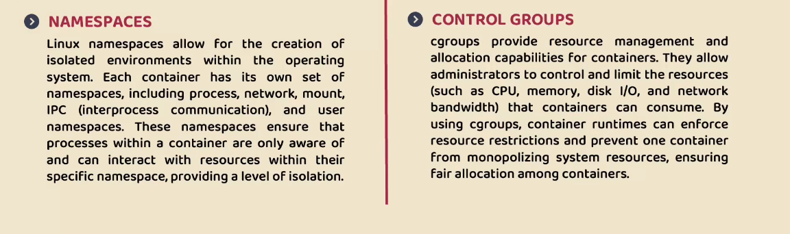

docker image: maven app + configuration + dependecies
docker container: runnable/running version of docker image

.46. create docker image of accounts microservice

<groupId>com.eazybytes</groupId>
<artifactId>accounts</artifactId>
<version>0.0.1-SNAPSHOT</version>
<packaging>jar</packaging>
<name>accounts</name>
<description>Microservice for Accounts</description>

set packaging as jar in pom.xml

create "Dockerfile" file inside project folder (no extension)

#Start with a base image containing Java runtime
FROM openjdk:21-jdk-slim
# MAINTAINER instruction is deprecated in favor of using label
# MAINTAINER eazybytes.com
#Information around who maintains the image
LABEL "org.opencontainers.image.authors"="eazybytes.com"
# Add the application's jar to the image
COPY target/accounts-0.0.1-SNAPSHOT.jar accounts-0.0.1-SNAPSHOT.jar
# execute the application
ENTRYPOINT ["java", "-jar", "accounts-0.0.1-SNAPSHOT.jar"]

on cmd which is in project folder
docker build . -t yurucura/accounts:s4

. indicates dockerfile path (it is in current directory)

-t indicates name and name has a convention username/projectname:section
after running build command you can run "docker images" to list images

docker run -p 8080:8080 yurucura/accounts:s4

first 8080 is exposed port to your local network
second 8080 is port of application that is running in the container

docker run -d -p 8080:8080 yurucura/accounts:s4 (detached mode)

docker ps : running images
docker ps -a : all images

docker start 72e37c1d0668 : starts existing container

.51. generate docker image with buildpacks

<plugin>
<groupId>org.springframework.boot</groupId>
<artifactId>spring-boot-maven-plugin</artifactId>
<configuration>
<image>
<name>eazybytes/${project.artifactId}:s4</name>
</image>
</configuration>
</plugin>

in pom.xml add image and name tags
open cmd and type mvn spring-boot:build-image

image will be created

start image using command "docker run -d -p 8090:8090 -t yurucura/loans:s4"

.52. generate docker image with google jib
<plugin>
<groupId>com.google.cloud.tools</groupId>
<artifactId>jib-maven-plugin</artifactId>
<version>3.4.2</version>
<configuration>
<to>
<image>eazybytes/${project.artifactId}:s4</image>
</to>
</configuration>
</plugin>

mvn compile jib:dockerBuild

mvn compile jib:build <- builds image without docker and uploads to remote repository

.54. push docker images

docker image push docker.io/yurucura/accounts:s4

docker pull yurucura/accounts:s4

.55. docker compose

create docker-compose.yml in one of the project folder

services:
accounts:
image: "eazybytes/accounts:s4"
container_name: accounts-ms
ports:
- "8080:8080"
deploy:
resources:
limits:
memory: 700m
networks:
- eazybank
loans:
image: "eazybytes/loans:s4"
container_name: loans-ms
ports:
- "8090:8090"
deploy:
resources:
limits:
memory: 700m
networks:
- eazybank
cards:
image: "eazybytes/cards:s4"
container_name: cards-ms
ports:
- "9000:9000"
deploy:
resources:
limits:
memory: 700m
networks:
- eazybank
networks:
eazybank:
driver: "bridge"
type cmd "docker compose up -d"
type cmd "docker compose down"
docker compose stop / docker compose start <- stops containers but does not delete, or starts stopped containers

section.5.
cloud native apps and factor methodology

cloud native applications:
predictable behaviour
os abstraction
right-sized capacity and independent
supports ci
rapid recovery & automated scalability

look for : 15 factor methodology

.65. 15 factor methodology

..1. one codebase, one application
use only one repo, let team create config for diferent environments

..2. api first

..3. dependency management
declare all dependencies in a manifest and ensure they are accessible to the dependency manager, maven is doing this for us

..4. design, build, release, run

..6. logs
logs should be redirected to log aggregator tool
(which will create a single log)

..7. disposability
microservices should be eliminated or restarted or multiplied almost instantly

..8. backing services
services should have backups (databases, ftp servers, etc)

..10. port binding
dont deploy multiple apps to the same server

..11. stateless processes

..12. concurrency

section 6
configuration management

.69. how configurations work in spring boot

spring boot configurations can be overridden
priority: application.properties is lowest
command line args : highest

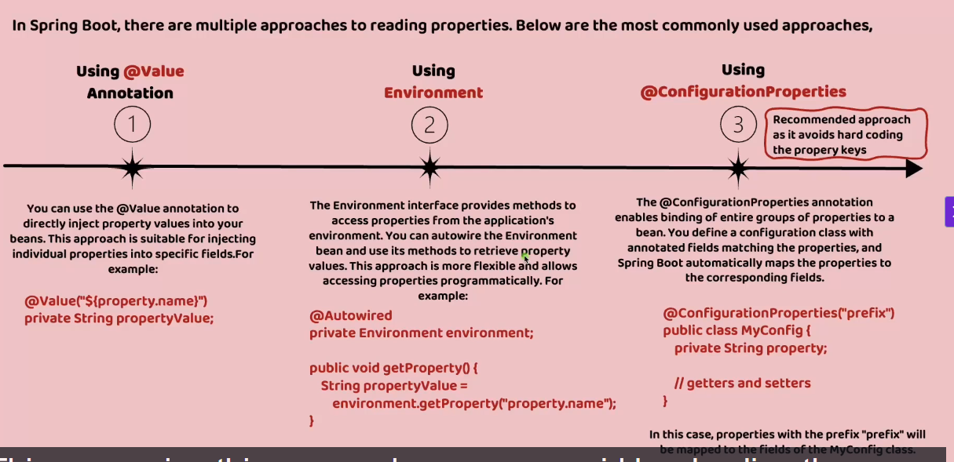
@Value("${build.version}")
private String buildVersion;
@Autowired
private Environment environment;

environment.getProperty("JAVA_HOME")

@ConfigurationProperties(prefix = "accounts")
public record AccountsContactInfoDto(String message, Map<String, String> contactDetails, List<String> onCallSupport) {

@EnableConfigurationProperties(value = {AccountsContactInfoDto.class})
(on top of spring boot application)

.74. spring profiles
spring:
config:
activate:
on-profile: "qa"
build:
version: "2.0"
accounts:
message: "Welcome to EazyBank accounts related QA APIs "
contactDetails:
name: "Smitha Ray - QA Lead"
email: "smitha@eazybank.com"
onCallSupport:
- (666) 265-3765
- (666) 734-8371
application_qa.yml
spring:
config:
import:
- "application_qa.yml"
- "application_prod.yml"
profiles:
active:
- "qa"
application.yml

.75. external configurations

..1. command line arguments
highest priority
"java -jar accounts-service-0.0.1-SNAPSHOT.jar --build.version="1.1" "

..2. build arguments
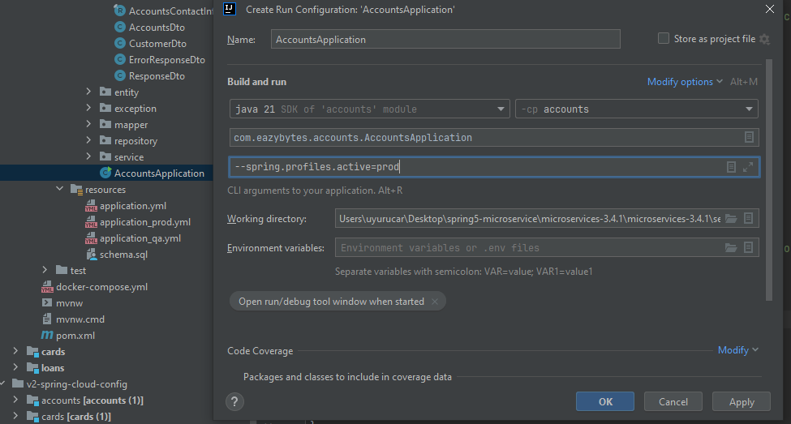
right click on class -> modify build confg

..3. env variables
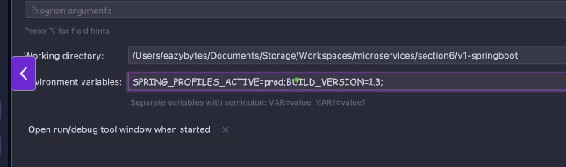

.80 spring cloud config

...

.104.

