lesson.2 create spring poject
to open spring in vs code download extensions: extension pack for java, ext pack for spring
lesson.3 create react project
use command in cmd:
npm create vite@latest frontend -- --template react
(frontend is the name of the folder)
follow the next instructions on cmd screen
lesson.8 rest controller
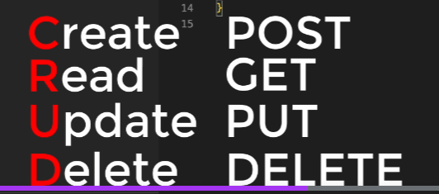 http requests
spring only reads classes on or under same package with application.java (main)
lesson.9 react
return (
<form onSubmit={onSubmit}>
<h1>Sign Up</h1>
is an option - instead of using a button to post state values
wrap input fiels in a form in order to use enter to submit
lesson.10 proxy
export default defineConfig({
plugins: [react()],
server: {
proxy: {
'/api' : 'http://localhost:8080'
}
}
})
in vite.config.js

lesson.11 spring
generated toString function in class allows object to trated as string(to be given as a string parameter)

lesson.13 deactivate spring security while using its functions
@SpringBootApplication(exclude = {ManagementWebSecurityAutoConfiguration.class,SecurityAutoConfiguration.class} ) //careful, managementwebSec shouldn't have been excluded
public class WsApplication {

lesson.14 bootstrap

get "<link href=..." part from bootstrap docs- introduction
add to the index.html to <head>

return (
<div className="container">
<div className="col-lg-6 offset-lg-3 col-sm-8 offset-sm-2">
<form onSubmit={onSubmit} className="card">
<div className="text-center card-header">
<h1>Sign Up</h1>
</div>
<div className="card-body">
<div className="mb-3">
<label htmlFor="username" className="form-label">Username</label>
<input id="username" onChange={(event) => SetUsername(event.target.value) } className="form-control"></input>
</div>
<div className="mb-3">
<label htmlFor="email" className="form-label">E-mail</label>
<input id="email" onChange={(event) => SetEmail(event.target.value)} className="form-control"></input>
</div>
<div className="mb-3">
<label htmlFor="password" className="form-label">Password</label>
<input id="password" onChange={(event) => SetPassword(event.target.value)} className="form-control"></input>
</div>
<div className="mb-3">
<label htmlFor="passwordRepeat" className="form-label">Repeat Password</label>
<input id="passwordRepeat" type="password" onChange={(event) => SetPasswordRepeat(event.target.value)} className="form-control"></input>
</div>
<div className="text-center">
<button disabled={!password || password != passwordRepeat } className="btn btn-primary mb-3">Sign Up</button>
</div>
</div>
</form>
</div>
</div>
);

col-lg-6 offset-lg-3 sets the length and offset of the div for large screens sm for small
card surrounds inputs with a card , set header and body

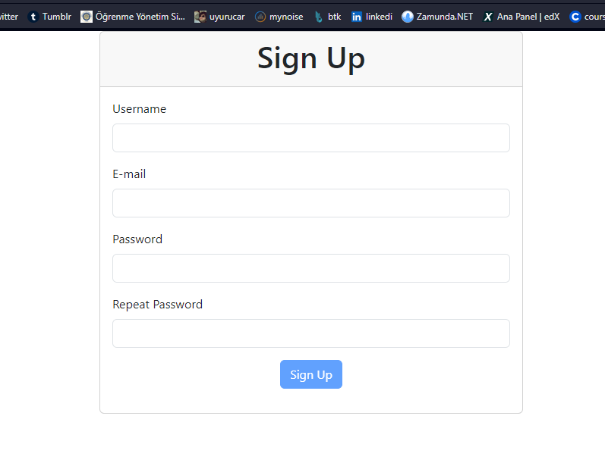
result

install bootstrap and sass using terminal:
->npm install bootstrap
->npm install -D sass

now there is no need for "<link href.." in the index.html file (delete)
create a file var.scss in src folder,
@import "node_modules/bootstrap/scss/bootstrap";
import var.scss to the main.js
$primary: rgb(255, 0, 255);

@import "node_modules/bootstrap/scss/bootstrap";

change primary color
check variables file under node_modules/bootstrap/scss/

lesson.15 axios post

signUpApi({
username,
email,
password,
})
.then((response) => {
SetSuccessMessage(response.data.message);
})
.finally(() => SetApiProgress(false));
};
signup api is imported function return axios.post(...)

lesson.19 to 22 errors
const [errors, SetErrors] = useState({});

instead of useState(), type useState({}) otherwise you can't use e.g. errors.username it throws error

<Input label="Username" identf="username" onChange={(event) => { SetUsername(event.target.value); SetErrors({}); }} err = {errors.username}></Input>
setting two functions as an arrow function is possible

useEffect(() => {
SetErrors({});
}, [username])
this is a useeffect hook?, calls function when dependent variable(s) changes. second parameter is an [] (array)

useEffect(() => {
SetErrors(
function(lastErrors) {
return {
...lastErrors,
username: undefined,
email : undefined
}
});
}, [username, email])
different approach of it.

lesson.27 custom annotaion
@Table(name="users", uniqueConstraints = @UniqueConstraint(columnNames = {"email"}))

@UniqueEmail
String email;

unique constraint for database
public class UniqueEmailValidator implements ConstraintValidator<UniqueEmail,String >{

@Autowired ////////////stays null
UserRepository userRepository;

@Override
public boolean isValid(String value, ConstraintValidatorContext context) {

User user = userRepository.findByEmail(value);
if(user != null)
{
return false;
}
return true;
}

}

spring.jpa.properties.javax.persistence.validation.mode=none
should be added to application OTHERWISE @Autowired userRepo throws error as being NULL
Note: in order to prevent this error without setting validation mode, a user manager class / record can be used removing validation from user class (check lesson 39-40)

lesson.29 hooks
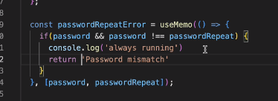
if password and passwordrepeat does not change, code uses last value in its memory

lesson.33 messages
@Autowired
MessageSource source;

String message = source.getMessage("hoaxify.contraints.create.user.success.message", null, LocaleContextHolder.getLocale());

hoaxify.contraints.create.user.success.message = user is created
hoaxify.error.validation.message = validation error
resources/messages.properties

second option:

create messages.java in shared folder
public class Messages {

public static String getMessage(String message, Locale locale)
{
return ResourceBundle.getBundle("messages", locale).getString(message);
}
}

lesson.34,35 react language support
go to https://react.i18next.com/getting-started, install using npm and use Basic sample code

import i18n from "i18next";
import {initReactI18next } from "react-i18next";
import en from "./translations/en.json";
import tr from "./translations/tr.json";

i18n
.use(initReactI18next) // passes i18n down to react-i18next
.init({
// the translations
// (tip move them in a JSON file and import them,
// or even better, manage them via a UI: https://react.i18next.com/guides/multiple-translation-files#manage-your-translations-with-a-management-gui)
resources: {
en: {
translation: en
},
tr : {
translation: tr
}
},
fallbackLng: "tr",

interpolation: {
escapeValue: false // react already safes from xss => https://www.i18next.com/translation-function/interpolation#unescape
}
});
(src/locales/index.js)

import './locales'
(main.jsx)

{
"signup": "Sign Up",
"username": "Username",
"email": "E-mail",
"password": "Password",
"passwordRepeat": "Repeat Password",
"passwordMismatch": "Password Mismatch",
"genericError": "Unexpected error occured. Please try again"
}
(src/locales/translations/en.json)

const {t} = useTranslation();
(signup.jsx)
lesson.35 buttons
import { useTranslation } from "react-i18next";

export function LanguageSelector() {

const{i18n} = useTranslation();

const onClickLanguage = (language) =>
{
i18n.changeLanguage(language);
localStorage.setItem("lang",language);
}

return (
<div>
<img
src="https://flagcdn.com/16x12/tr.png"
width="24"
height="18"
alt="Turkçe"
role="button"
onClick={() => onClickLanguage("tr")}
></img>
<img
src="https://flagcdn.com/16x12/us.png"
width="24"
height="18"
alt="English"
role="button"
onClick={() => onClickLanguage("en")}
></img>
</div>
);
}
localstorage.setItem (same as playerprefs in unity)

const lang = localStorage.getItem("lang") || navigator.language || "en"
export const i18instance = i18n.use(initReactI18next);// passes i18n down to react-i18next

i18instance.init({
// the translations
// (tip move them in a JSON file and import them,
// or even better, manage them via a UI: https://react.i18next.com/guides/multiple-translation-files#manage-your-translations-with-a-management-gui)
resources: {
en: {
translation: en
},
tr : {
translation: tr
}
},
fallbackLng: lang,

interpolation: {
escapeValue: false // react already safes from xss => https://www.i18next.com/translation-function/interpolation#unescape
}
});
(locales/index.js)

export const i18instance = i18n.use....
to get an instance of i18n in order to use in:
headers: {
"Accept-Language" : i18instance.language
}
apicalls.js

lesson.39,40 email activation
note: mail functions require spring-boot-starter-mail dependency
add new fields ( "active, bool" , "activationToken, string") to user. active is declared false in class.
activationtoken
user.setActivationToken(UUID.randomUUID().toString());
(userservice.java)
is set in service. a flaw in design is: if client sends a body including "active: true" or activation token, server accepts and sets corresponding value. to avoid:
create a new record type in user/dto/
(dto = data transfer object)

public record UserCreate(
@NotBlank(message = "{hoaxify.constraints.notblank.message}")
@Size(min = 4, max = 32, message = "{hoaxify.constraints.size.message}")
String username,

@NotBlank(message = "{hoaxify.constraints.notblank.message}")
//@Pattern(regexp ="^\\S+@\\S+$")
@Email(message = "{hoaxify.constraints.emailpattern.message}")
@UniqueEmail
String email,

//@NotBlank
@Size(min = 8, max = 32)
@Pattern(regexp="^(?=.*[a-z])(?=.*[A-Z])(?=.*\\d).*$", message = "{hoaxify.constraints.passwordpattern.message}")
String password
) {

public User toUser()
{
User user = new User();
user.setEmail(email);
user.setPassword(password);
user.setUsername(username);

return user;
}
}

change post function parameter to UserCreate
public ResponseEntity<?> CreateUser(@RequestBody @Valid UserCreate user)

since validity is checked in usercreate delete annotations from user class.

userService.save(user.toUser());
(usercontroller.java - create user function)

public void save(User user)
{
//can create a new exception catch(DataIntegrityViolationException e)
user.setPassword(encoder.encode(user.getPassword()));
user.setActivationToken(UUID.randomUUID().toString());
userRepository.save(user);
sendActivationEmail(user);

}

public void sendActivationEmail(User user)
{
SimpleMailMessage message = new SimpleMailMessage();
message.setFrom("noreply@app.com");
message.setTo(user.getEmail());
message.setSubject("Account Activation");
message.setText("http://localhost:8080/activation/"+user.getActivationToken());
getJavaMailSender().send(message);
}

public JavaMailSender getJavaMailSender()
{
JavaMailSenderImpl mailSender = new JavaMailSenderImpl();
mailSender.setHost("smtp.ethereal.email");
mailSender.setPort(587);
mailSender.setUsername("mattie.gutmann@ethereal.email");
mailSender.setPassword("TtPyA1uRXK267H9VJh");

Properties properties = mailSender.getJavaMailProperties();
properties.put("mail.smtp.starttls.enable", "true");
return mailSender;
}

userservice.java
steps to build mail service. host, port etc information is from ethereal.email

lesson.41 rollback

in a situation of mailsender failure, it is not convenient to save the user to the database
to revert save action @Transactional can be used
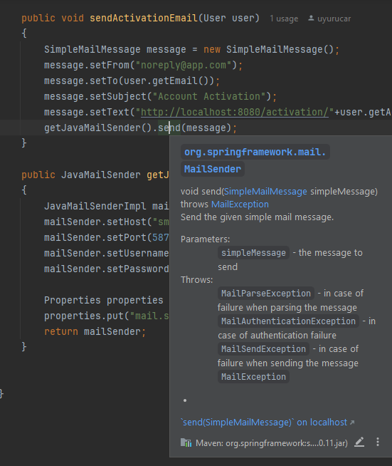
mailsender throws MailException (amongst other) hence the saveUser function

@Transactional(rollbackOn = MailException.class)
public void save(User user)
{
userservice.java

@transactional takes rollbackon parameter and is triggered when specified exception is thrown

@Transactional(rollbackOn = MailException.class)
public void save(User user)
{
try
{
user.setPassword(encoder.encode(user.getPassword()));
user.setActivationToken(UUID.randomUUID().toString());
userRepository.save(user);
sendActivationEmail(user);
//this does not catch
} catch (DataIntegrityViolationException e)
{
throw new NotUniqueEmailException("email must be unique");
}
}

when @transactional is used try catch block doesn't work as intended and whole dataintegrityviolation exp message is exposed to client

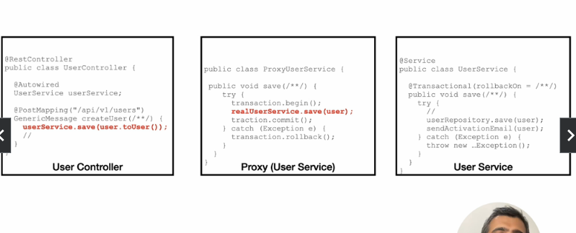
how transaction works

reason is when transaction is applied, a proxy service is opened in order to achieve save/rollback effect
when there is a problem exception is thrown at proxy hence this try catch block can not catch
in order to overcome this problem saveAndFlush method can be called instead of save because saveandflush forces spring to immediately write changes to the db without waiting for transaction to commit.
also can be save() and flush() seperately

"Normally, Hibernate holds the persistable state in memory. The process of synchronizing this state to the underlying DB is called flushing." definiton of save / flush
"flush() will synchronize your database with the current state of object/objects held in the memory but it does not commit the transaction. So, if you get any exception after flush() is called, then the transaction will be rolled back. You can synchronize your database with small chunks of data using flush() instead of committing a large data at once using commit() and face the risk of getting an OutOfMemoryException.
commit() will make data stored in the database permanent. There is no way you can rollback your transaction once the commit() succeeds"

lesson.43 jsonInclude

@JsonInclude(value = JsonInclude.Include.NON_NULL)
public class ApiError {

lesson.45 mail service refactor

move mail service to its new class
@Service
public class MailService {

annotate as service

hoaxify.email.username = chelsey0@ethereal.email
hoaxify.email.password = xJxjCVm77YmXjpNkKh
hoaxify.email.host = smtp.ethereal.email
hoaxify.email.port = 587
hoaxify.email.from = noreply@app.com
hoaxify.client.host = http://localhost:8080
move config values to application.properties

to access these values there are two ways:
@Value("${hoaxify.email.host}")
String host;

using @Value annotation

or

@ConfigurationProperties(prefix = "hoaxify")
@Configuration
public class HoaxifyProperties {
create configurationproperties/configuration class
this annotation allows springb to bind values from appl.prps to fields

it should be noted that value names follows pattern : "hoaxify.email.variable"
therefore
public class HoaxifyProperties {
public static record Email(
String username,
String password,
String host,
String from,
int port
){
}
create a record inside email

note: in order to access hoaxifyproperties data component must be instantiated by spring first. mail service init method currently in constructor which will run before spring instantiate process. in order to fix this problem init function must be declared as @PostConstruct

@PostConstruct
private void init()
{
System.out.println("----");
System.out.println(properties.getClient().host());
System.out.println("----");
mailSender = new JavaMailSenderImpl();
mailSender.setHost(properties.getEmail().host());
mailSender.setPort(properties.getEmail().port());
mailSender.setUsername(properties.getEmail().username());
mailSender.setPassword(properties.getEmail().password());
Properties properties = mailSender.getJavaMailProperties();
properties.put("mail.smtp.starttls.enable", "true");
}
mailservice.class @Service

lesson.46 storing sensitive data

hoaxify.email.password = ${HOAXIFY_EMAIL_PASSWORD}
appliaction.properties

for vscode:
"env" : {
"HOAXIFY_EMAIL_PASSWORD" : "xJxjCVm77YmXjpNkKh"
}
}
launch.json

for unix (terminal):
> set HOAXIFY_EMAIL_PASSWORD = xJxjCVm77YmXjpNkKh
> ./mvnw spring-boot
or
> HOAXIFY_EMAIL_PASSWORD = xJxjCVm77YmXjpNkKh ./mvnw spring-boot

for intellij download plugin (may or may not work)

lesson.47 application.properties profiles

it is possible to attach different values to variables in application.props in different scenarios

hoaxify.email.username = chelsey0@ethereal.email
hoaxify.email.password = xJxjCVm77YmXjpNkKh
hoaxify.email.host = smtp.ethereal.email
hoaxify.email.port = 587
hoaxify.email.from = noreply@app.com
hoaxify.client.host = http://localhost:8080
spring.profiles.active = production // production,dev
#---
spring.config.activate.on-profile = production
hoaxify.client.host = http://uyurucar.com
#---
spring.config.activate.on-profile = dev
hoaxify.client.host = http://dev.uyurucar.com

#--- is mandatory

default behavior: no profile, reads default values
attaching multiple profiles at the same time is possible
if there are two different values for different profiles, app.prop reads the last value because of top-down reading

lesson.48 refactor mail service, multi-language mail

String activationMail = """
<html>
<body>
<h1> ${title} </h1>
<a href="${url}">${click}</a>
</body>
</html>
""";

create an email template with placeholder values (for language support) (""" is necessary)

instead of using SimpleMailService, use MimeMessage
MimeMessage message = mailSender.createMimeMessage();

mailsender is JavaMailSenderImpl
create message helper
MimeMessageHelper helper = new MimeMessageHelper(message, "UTF-8");

note: using utf-8 is not enough for turkish characters to show up, use utf equalivents of characters in messages.properties

String title = Messages.getMessage("hoaxify.mail.user.created.title", LocaleContextHolder.getLocale());
String click = Messages.getMessage("hoaxify.mail.user.created.click", LocaleContextHolder.getLocale());
String activationUrl = properties.getClient().host() + "/activation/" + token;
String mailBody = activationMail.replace("${url}",activationUrl)
.replace("${title}", title)
.replace("${click}", click);
replace placeholders with actual values acquired from messages.properties (for language support)

try {
helper.setFrom(properties.getEmail().from());
helper.setTo(mail);
helper.setSubject(title);
helper.setText(mailBody,true);
} catch (MessagingException exp) { exp.printStackTrace(); }
this.mailSender.send(message);
set title / subject and send message
use helper instead of mailservice
setText(mailbody(string), true(http-form? bool));

ep.6
account activation

lesson.50 react router
import { createBrowserRouter, RouterProvider } from 'react-router-dom'

const router = createBrowserRouter(
[
{
path: "/",
Component: Home,
errorElement: <div><h1>not found</h1> </div> // returns in any error
//alternative of * path
},
{
path: "/signup",
Component: SignUp
}
]
)

ReactDOM.createRoot(document.getElementById('root')).render(
<React.StrictMode>
<RouterProvider router={router} />
</React.StrictMode>,
)
alternative way to use react router (problems with browser router still persist)

//kayıp bölümleri ekle

lesson.56 useEffect async function
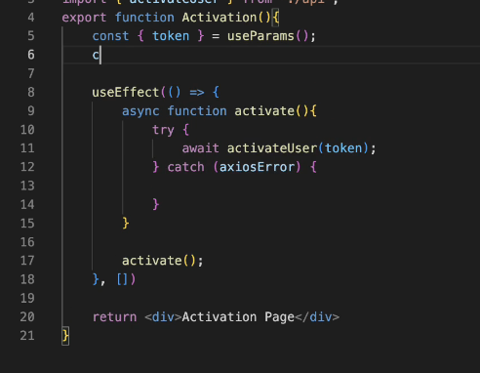

lesson.57 common components in react
//fill

lesson.58 axios config

use axios interceptor to add accept-language header to every axios request
import axios from "axios";
import { i18instance } from "../../locales";

const http = axios.create();

http.interceptors.request.use((config)=> {
config.headers["Accept-Language"] = i18instance.language;
return config;
})

export default http;

import http from "../../lib/http"

export function signUpApi(body)
{
return http.post('/api/v1/users', body);

}
use it like axios.post

lesson.59 vite / react alias

import http from "../../lib/http"

../../ is too long(?)
// https://vitejs.dev/config/
export default defineConfig({
plugins: [react()],
server: {
proxy: {
'/api' : 'http://localhost:8080'
}
},
resolve: {
alias: {
"@" : fileURLToPath(new URL("./src", import.meta.url))
}
}
})
vite.config.js

add resolve alias to start all import expression folders from src
import http from "@/lib/http"
./src/lib/http

this causes vscode to not find files

create jsconfig.json in the same level with src ( #./src -> cd .. -> touch jsconfig.json)

{
"compilerOptions": {
"baseUrl": ".",
"paths": {
"@/*" : ["./src/*"]
}
}
}
jsonfig.json

lesson.66 pagination

instead of sending big chunk of data, pagination allows program to split data into parts(pages)

@GetMapping("/v1/users")
public Page getAllUsers(@RequestParam(defaultValue = "0") int page, @RequestParam(defaultValue = "3") int size)
{
return userService.getAllUsers(page,size);
}
restcontroller

requestparam takes the url parameter ( v1/users?page=3&size=5)

public Page<User> getAllUsers(int page, int size)
{
return userRepository.findAll(PageRequest.of(page,size));
}
service
findAll(page) function is pre-defined

problems with page, pagerequest.of: accepts all sizes (e.g. 1 million) which might cause overload

better solution:

@GetMapping("/v1/users")
public Page getAllUsers(Pageable page)
{
return userService.getAllUsers(page);
}
restcontroller

public Page<User> getAllUsers(Pageable page)
{
return userRepository.findAll(page);
}
service

pageable automatically limits size to max 2000
this value can be changed

spring.data.web.pageable.max-page-size = 2000
application.properties

lesson.69 json ignore

current users endpoint returns user with password, activationtoken values
@jsonIgnore prevents fields to be added into json files (for both incoming and outgoing requests, blocking password value to be ever received, if user class is used as @requestbody)

@JsonIgnore
private boolean active = false;
@JsonIgnore
private String activationToken;
private String username;
private String email;
@JsonIgnore
private String password;
user @entity

lesson.70 projection

instead of using prebuilt jparepository functions which returns User object, create projection interface:
public interface UserProjection {
long getId();
String getUsername();
String getEmail();
String getImage();
}
no annotation

@Query(value = "select u from User u")
Page<UserProjection> getAllUsersProjection(Pageable page);
create getuser function, which is not prebuilt, therefore needs @Query to specify db command

@Query accepts jpql (jpa sql language-ish) and native sql
in order to use native query second parameter of query should be "nativeQuery: true"

@Query(value = "select u from User u where id=?1")
Page<UserProjection> getUserProjection(Pageable page, int id);

query variables are "?1" ?2" (positional parameters)
projection doesnt have to be used with Page

new fields can be added to projection and altered based on logical operations using @Value

@Value("#{target.image != null ? target.image : 'default.png'}")
String getImage();
(if target image is null set to default.png)

@Value("#{target.firstName + ' ' + target.lastName}")
String getFullname();
fullname is not a field in user, but can be cast using value

@Value uses Spring expression language
https://www.baeldung.com/spring-expression-language

lesson.76 getuser

lesson.77 dynamic error messages

@ExceptionHandler(InvalidTokenException.class)
ResponseEntity<ApiError> handleInvalidTokenException(InvalidTokenException exception, HttpServletRequest request){

httpservletrequest automatically binds itself and can be used to get uri value

public User getUser(long id)
{
return userRepository.findById(id).orElseThrow(() -> new EntityNotFoundException(id));
}
userservice.java
jparepository normally returns optional for findbyid, in order to change that behaviour .orelsethrow can be used
orelsethrow accepts lambda function
public EntityNotFoundException(long id) {
super(Messages.getMessageForLocale("hoaxify.user.not.found", LocaleContextHolder.getLocale(), id));
}
exception constructor

public static String getMessageForLocale(String messageKey, Locale locale, Object... args) {
String message = getMessage(messageKey, locale);
return MessageFormat.format(message,args);
}

messages needs another function to fit new exception requirement(showing user id in message)
hoaxify.user.not.found = user with id {0} is not found
getmessageforlocale takes message (above) from app.prop..
messsageformat binds values with args (positional parameters)
in order to use namely parameters use hashmap
String text = "The user {name} has email address {email}.";
Map map = new HashMap();
map.put("name", "Robert");
map.put("email", "rhume55@gmail.com");

System.out.println("1st : " + MapFormat.format(text, map));

NOTE: add swagger ui to dependencies , endpoint localhost:8080/swagger-ui
lesson.79 react user page

//fill

lesson.90 login endpoint

