typescript

.1. typescript overview

typescript = javascript + type annotations

typescript types does not make it to build or run environment, only works in development. as soon as code is compiled, typescript is converted to javascript

typescript compiler does not provide performance optimization

.2. typescript installation

npm install -g typescript ts-node
(note: ts-node is deprecated)
then to check it tsc –help

also cmd -> “code .” opens vscode with current directory

npm install --save-dev @types/node

instead of running “ts-node index.ts”
run “npx tsx index.ts”

.3. project init

create a folder and inside that folder type:
“npm init -y” this creates a package.json file

.4. interface

interface Todo {
id : number;
title: string;
completed : boolean
}
interface is a struct-like pattern to define an object beforehand

const todo = resp.data as Todo;

const ID = todo.id;
const title = todo.title;
const completed = todo.completed;

console.log(`
id : ${ID}
title: ${title}
completed : ${completed}
`);

if there is some typo made in assignment phase vscode automatically warns about it but program would still compile and run

const logTodo = (id:number, title:string, completed:boolean) => {
console.log(`
id : ${id}
title: ${title}
completed : ${completed}
`);

function definition with type annotations

.5. types
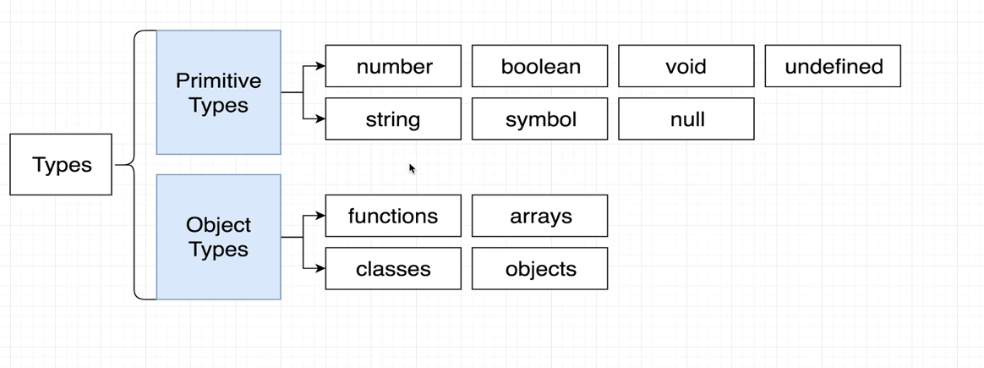

.6. type annotations and type inference

type annotation: annotation to define type of a variable
type inference: typescript trying to guess type of a variable

