2.1

(a)

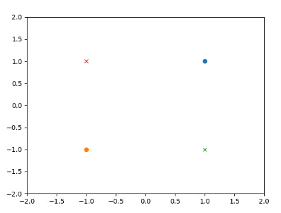

geometrically, there is no way.

(b)

phi(X_+) = {phi((1,1)), phi((-1,-1))}={[1,1,1,1]^T, [1,-1,-1,1]^T}

phi(X_-) = {phi((-1,1)), phi((1,-1))}={[1,-1,1,-1]^T, [1,1,-1,-1]^T}

(c)

first coordinates : all 1 -> not dividing -> w_1=0

second coordinates : [1,-1], [-1,1] -> cannot divide -> w_2=0

third coordinates : [1,-1], [1,-1] -> cannot divide -> w_3=0

the resulting plane is z_4=0

fourth coordinates : [1, 1], [-1,-1] -> k=0, w_4=1

2.2

assume points in R

where a has m points, b which is larger than a has m points, c:=b+2(b-a) has 1 point.

with the given initialization and k=2, c becomes one of the cluster.

the cost becomes at least m(2(b-a))^2

if m goes to infinity, the cost also goes to infinity.

however, when a and b are picked as clusters, the cost is only (2(b-a))^2

3

5.

denseSIFT is better than SIFT since it uses as many information as possible while SIFT can miss some of them. Also, denseSIFT is faster.