1.

(a)

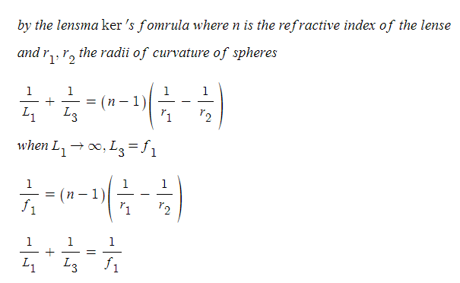

(b)

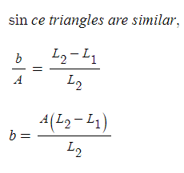

(c)

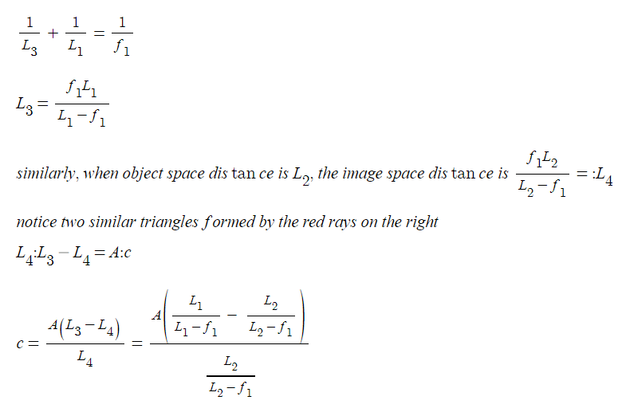

(d)

let horizontal distances from the leftmost arrow to the left lense l_1

let horizontal distances from the left lense to the intersection of rays between the lenses l_2

let horizontal distances from the intersection of rays between the lenses to the right lense l_3

let horizontal distances from the right lense to the intersection of rays on the right side of the right lens l_4

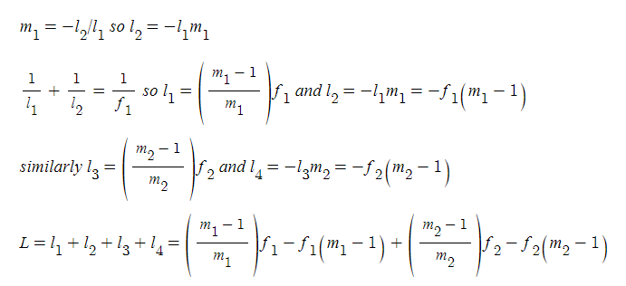

2.

(a) by using homogeneous coordinates, p and q are 3x1. so S should be 3x3.

(b) since it should be reversible, it is one-to-one. So it gives 0 nullity and full rank, which is 3.

(c) 4 different pairs since homography matrix has 8 unknowns and each pair gives 2 different equations. when setting H[2][2] also as a variable, then h^Th=1 gives one equation.

(d) it looks like more than 4 pairs are needed, however, as in c, 4 pairs are enough and h can be obtained by solving with SVD and taking the eigenvector with smallest eigenvalue.

