1

1.

(a)

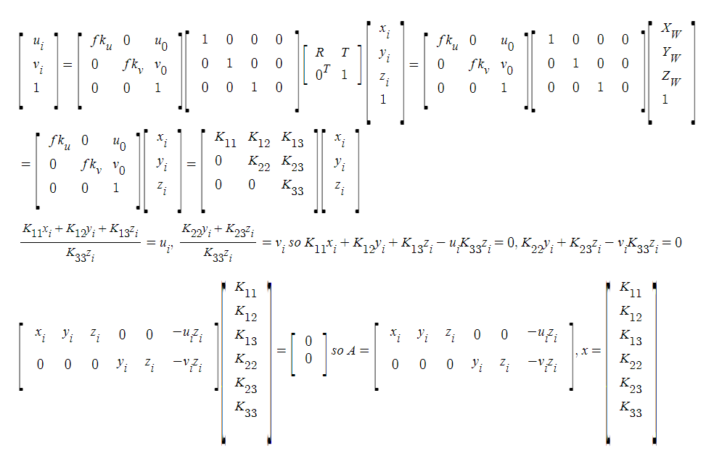

(b)

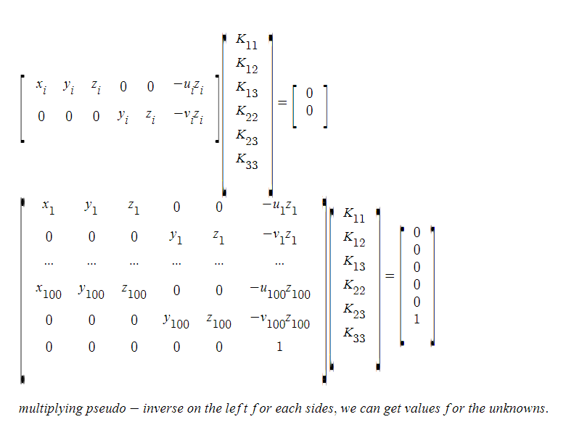

2.

(a)

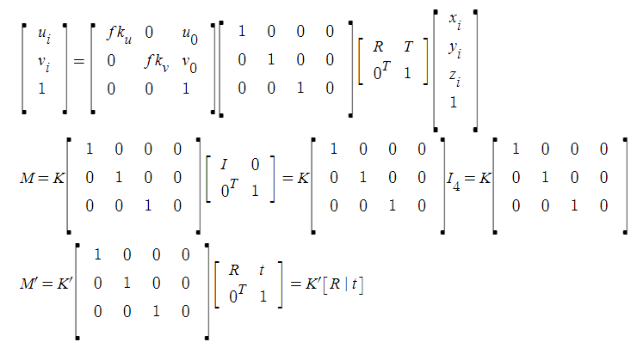

(b)

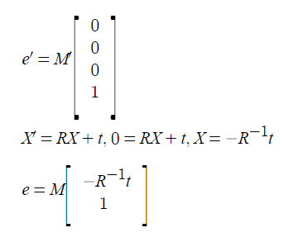

(c)

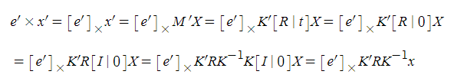

(d)

epipolar line connecting x’ and e’ on the image plane of the second camera associated with the point x on the image plane of the first camera

1.3

(a)



assume it’s infinite horizontally.

either this moves toward bottom right corner or just downwards would not be distinguishable.

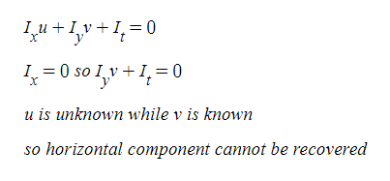

(b)



since the bottom edge of the square whose inside of black can show the vertical movement and the right edge can show the horizontal movement, the horizontal and vertical components of motion can be recovered.

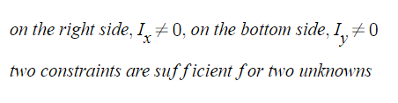

(c)

camera moves can also be interpreted as objects moving.

since even though the camera is moving toward a scene point, the color constancy and small motion are satisfied.

therefore, optical flow equation holds.

the scene point which the camera is moving towards is the focus of expansion from which other points move away. This point has no optical flow.

(d)

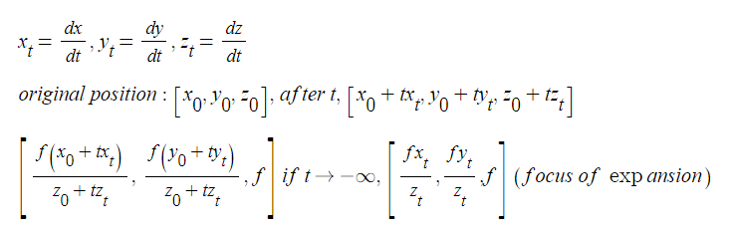

first normalize the gradients so that the values belong is in the range, [0,1].

Then I normalize the pixel value.

Then I perform lucas kanade.

First I initialize the p as 0.

Then by following the algorithm, warping images including the gradients according to p.

Then check if the warped one and the template overlap for each point and then compute the difference.

Using this difference, the gradients, and the coordinates, parts of the formula can be accumulated.

Then by multiplying the inverse of the accumulated Hessian on the left of another accumulation, dp can be obtained.

Then by the p value, the affine transformation matrix can be calculated.

By transforming an image with this and then subtracting one from the other, the cars appear.

By using hysteresis, the positions of the cars are more clear.

If th_hi is too high, the positions of the cars are neglected.

if th_lo is too low, noises appear more clearly.