4.4

6.

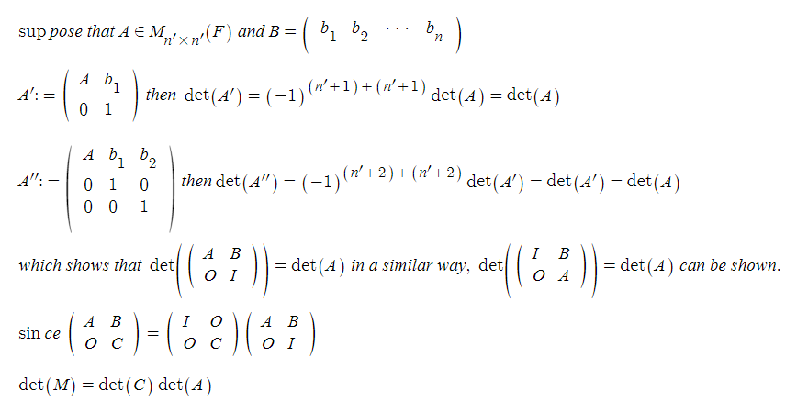

5.1

22.

(a)

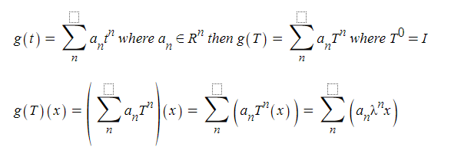

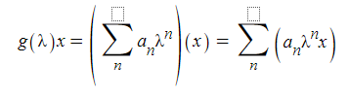

(b)

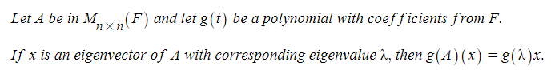

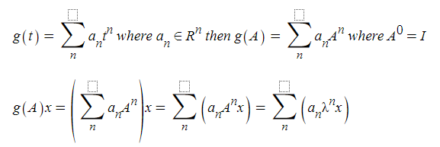

(c)

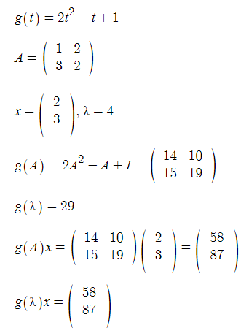

5.2

2.

d.

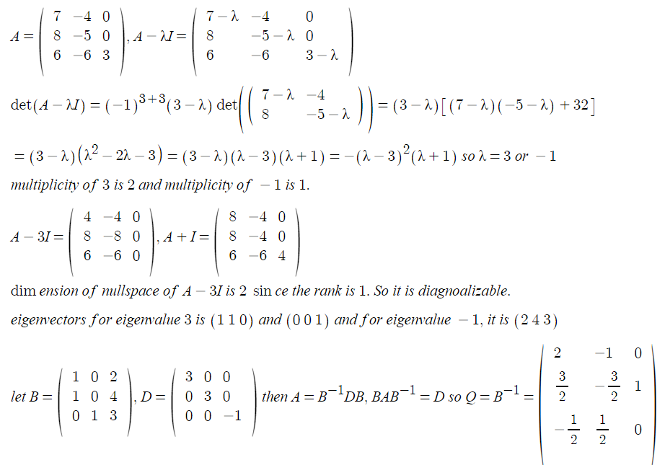

3.

e.

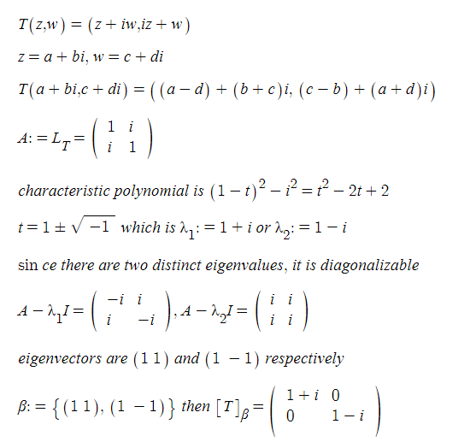

14.

c.

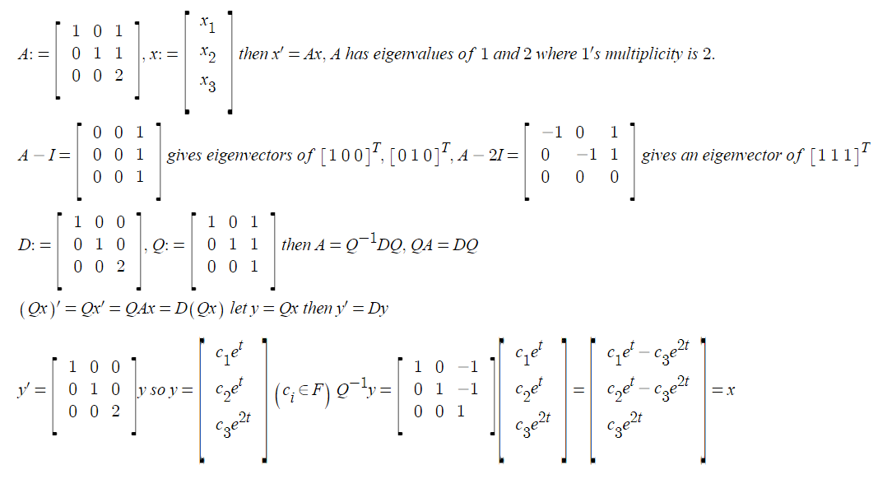

5.4

6.

d.

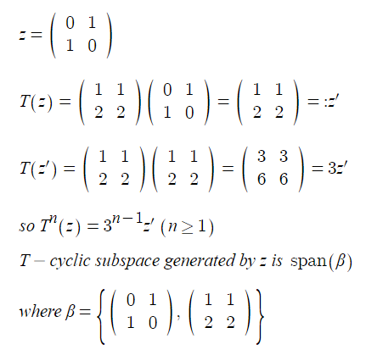

15.

since f(A) is obtained by replacing t with A in the resulting characteristic polynomial not by substituting t in det(A-tI) with A. f(B) can’t be equal to det(A-BI) if B’s dimension doesn’t match with others.

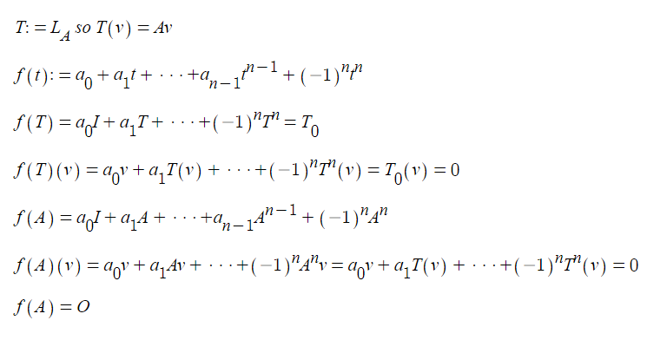

19.

