4.2

29.

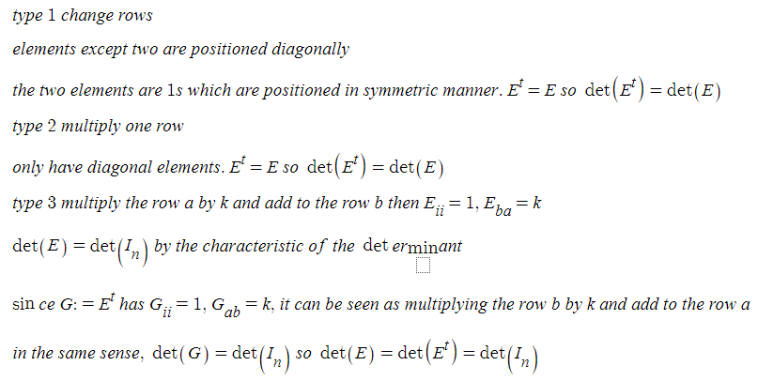

30.

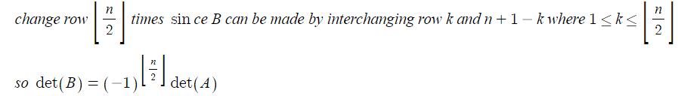

4.3

11.

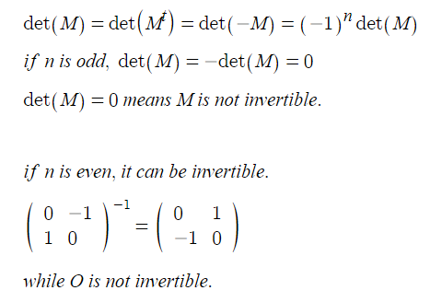

12.

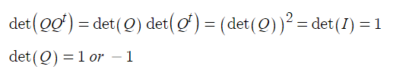

15.

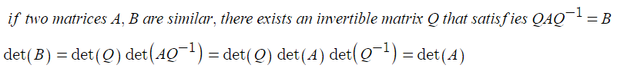

5.1

8.

(a)

if zero is an eigenvalue of T, there exists a nonzero vector v that satisfies T(v)=0v=0 since the nullity is more than or equal to 1, rank is less than n, so T is not invertible

if T is not invertible, rank of T is less than n which means nullity is more than or equal to 1

there exists a nonzero vector v that satisfies T(v)=0=0v

this shows that 0 is an eigenvalue of T

(b)

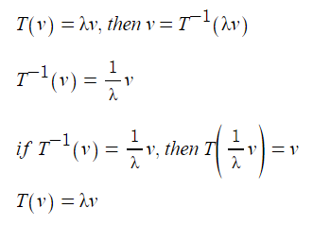

(c) A matrix A is invertible if and only if zero is not an eigenvalue of A.

this is analogous to a

if 0 is an eigenvalue of A, and if A is invertible, then there exists nonzero x that satisfies Ax=0x.

Then multiplying A inverse to left sides, x=0 which is contradictive.

if A is not invertible, the rank of A is less than n, which means there exists a nonzero vector in nullspace. That vector can be an eigenvector, and 0 is the eigenvalue for that vector.

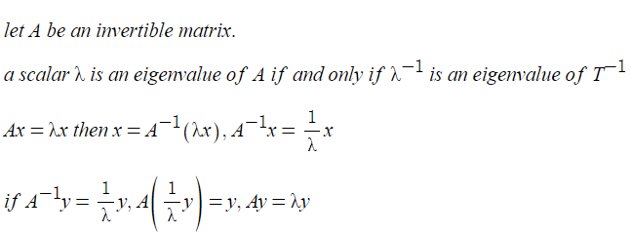

14.

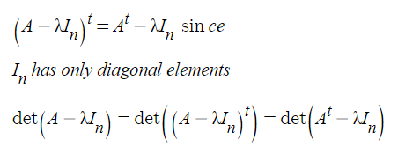

15.

(a)

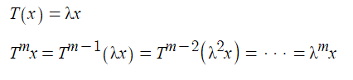

(b)