3.1

#2

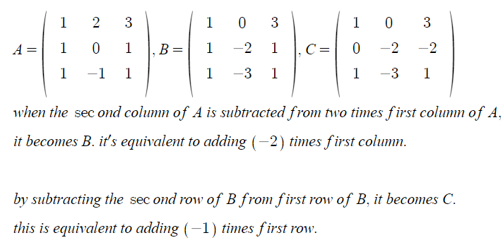

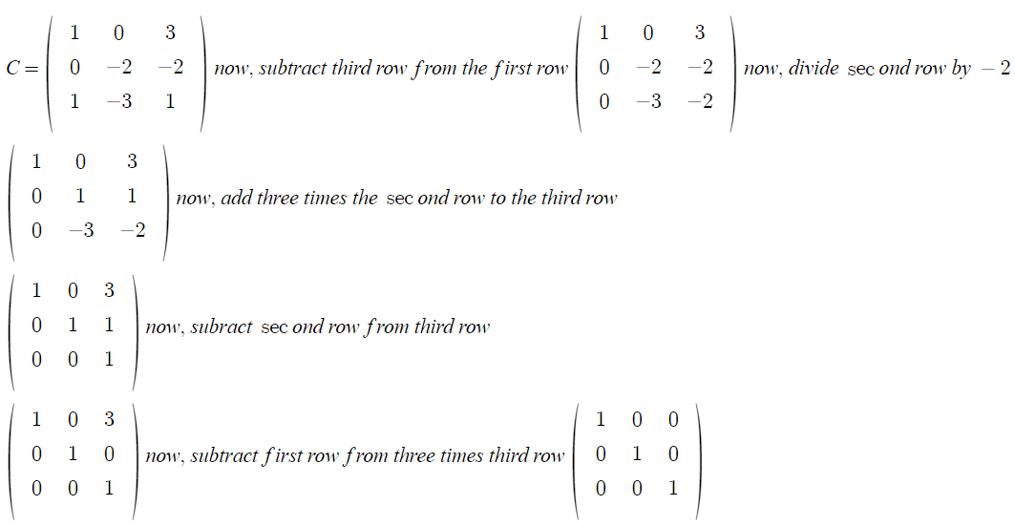

#3

(a) when this is multiplied in the left side to a matrix, it’s changing the first row and the third row of the matrix. so when it’s repeated once more, it’s going to return to the original matrix.

so itself is the inverse.

(b) when this is multiplied in the left side to a matrix, it’s multiplying the elements of the second row of the matrix. so when it’s multiplied by 1/3, it’s going to return to the original matrix.

so changing 3 to 1/3 from the matrix shown in b would make the inverse of it.

(c) when this is multiplied in the left side to a matrix, it’s adding -2 times first row to the third row of the matrix. so when 2 times first row is added to the third row, it returns to the original matrix.

so changing -2 to 2 from the matrix (c) makes the inverse of it.

3.2

#5

(d)

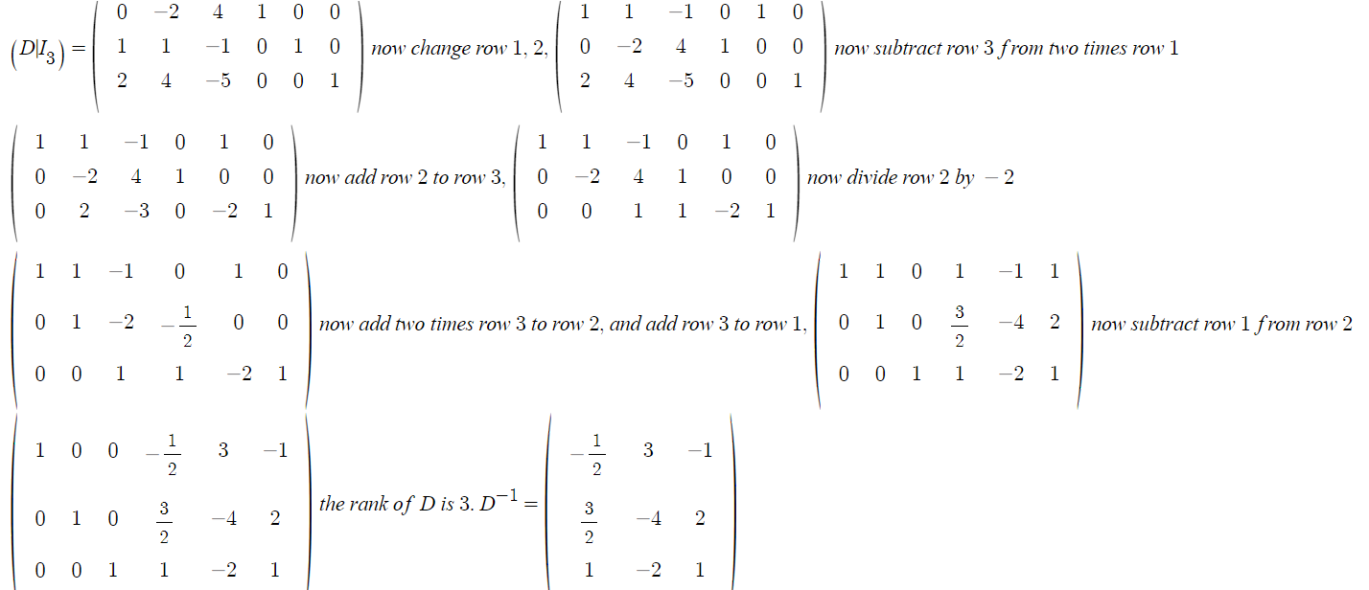

(g)

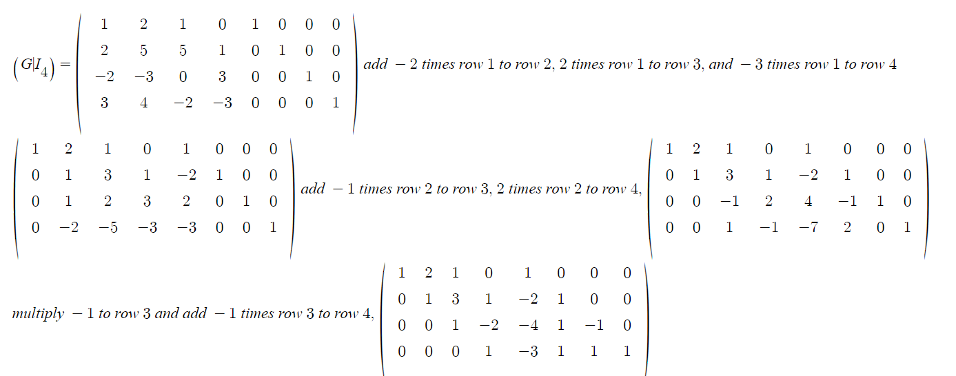

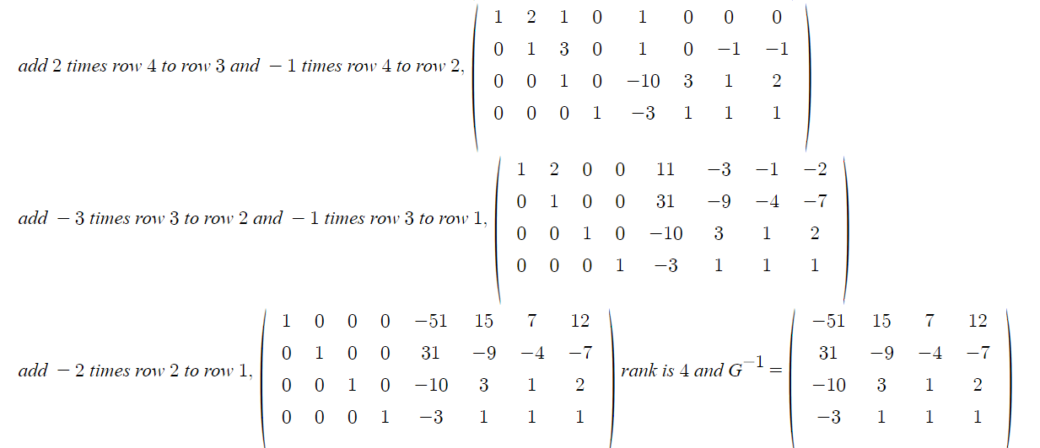

#7

since it can be transformed into the 3x3 identity matrix by elementary operations by using only column operations(or by using only row operations), one can get the inverse of an invertible matrix by getting the inverse of the product of column(or row) operations that make the matrix an identity matrix, which will also be a product of elementary matrices

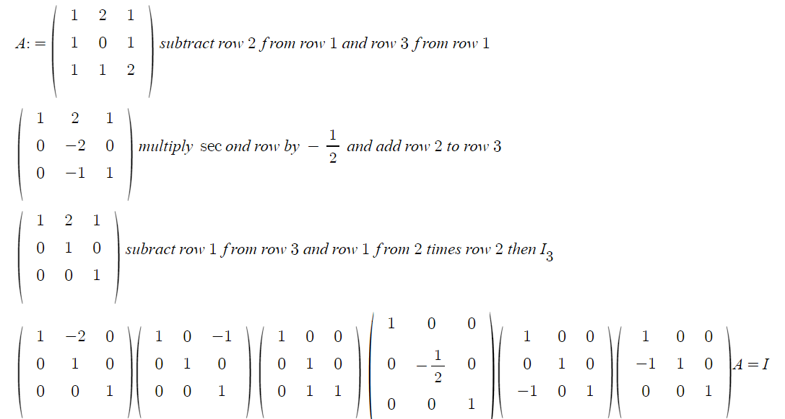

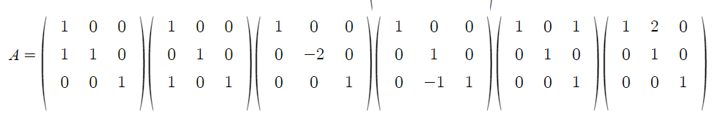

#20

(a)

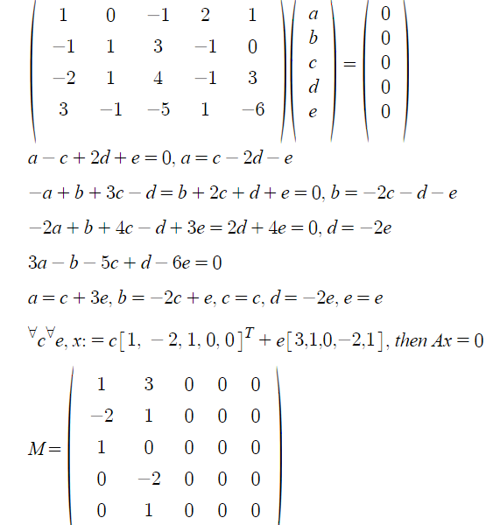

(b)

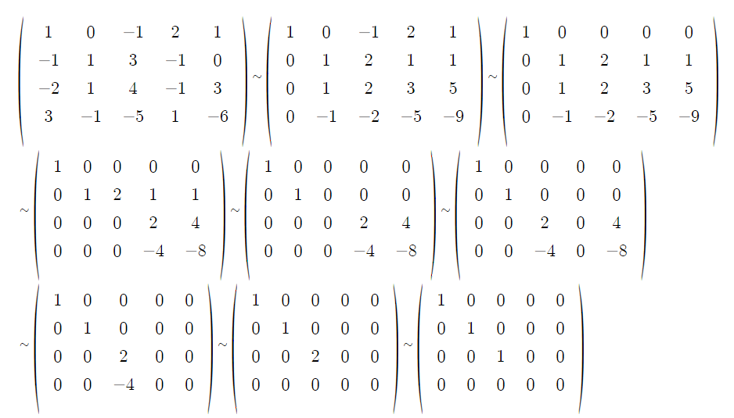

let T the left-multiplication transformation of matrix A. dim(F^5)=5, rank(T)=3 so dim(N(T))=2

if AB=O, and rank(B) more than 2, then there should exist at least 3 linearly independent columns in B. that means the dimension of nullspace should be at least 3. however as above, the dimension of nullspace is 2. so B has at most rank 2.