2.4

4.

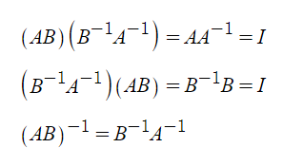

5.

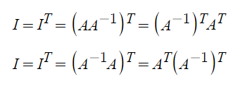

7.

(a)

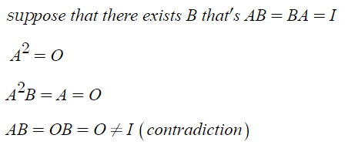

(b)

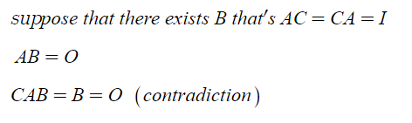

10.

(a) since AB is invertible, A, B is invertible by exercise 9.

(b)

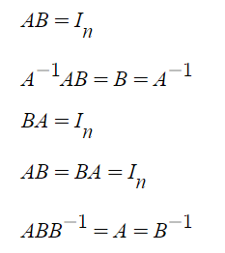

(c) let T : V->W, U : WV, where dim(V)=dim(W) and TU an identity mapping.

let α ordered bases of-> T, β ordered bases of U

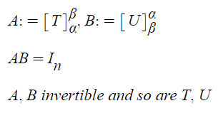

17.

(a)

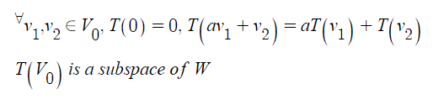

(b)

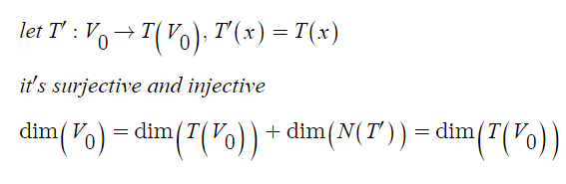

20.

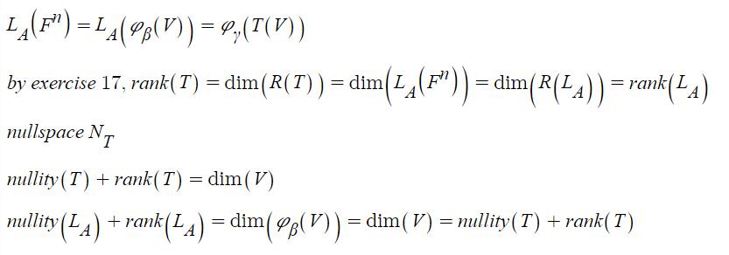

2.5

5.

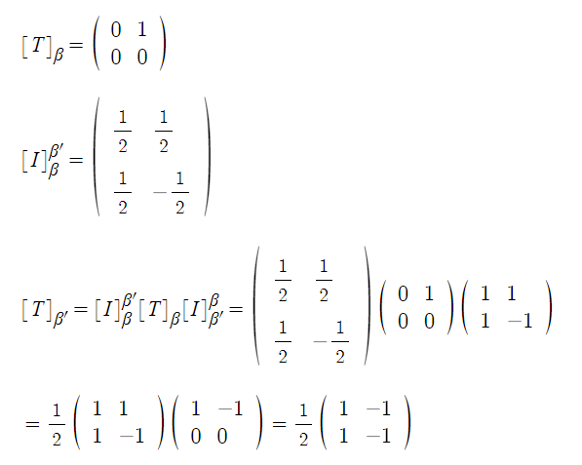

7.

(a)

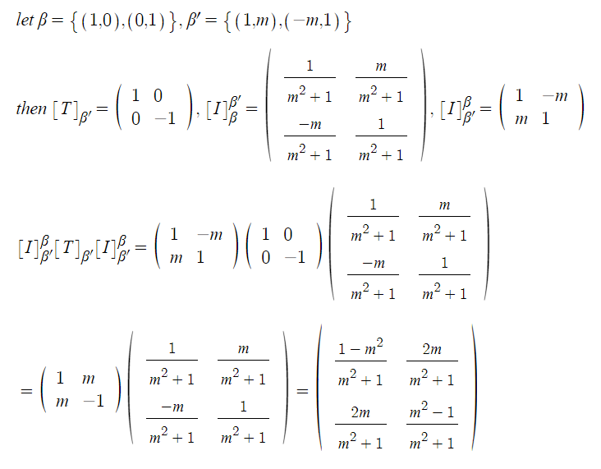

(b)

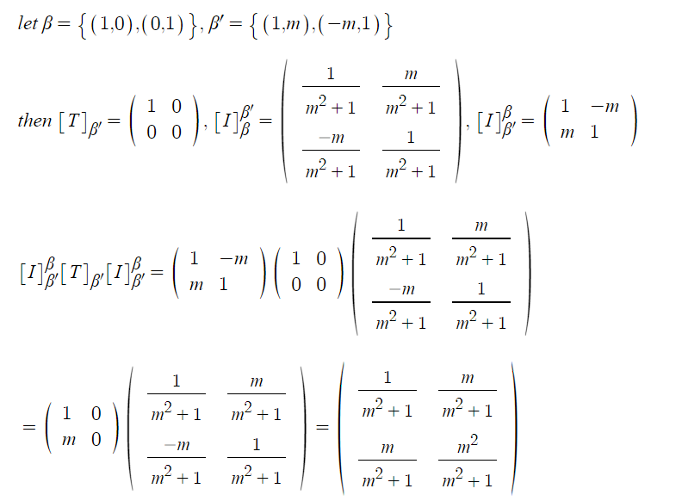

10.

