Ex1.1
2.
|x-0.6032|/|x| ≤ 0.001
|x-0.6032| ≤ 0.001*|x|
i) x≥0.6032
0.999x ≤ 0.6032
x ≤ 0.6'038'
0.6032 ≤ x ≤ 0.6'038'
ii) 0≤x<0.6032
0.6032 ≤ 1.001x
0.6'025974' ≤ x < 0.6032
iii) x<0
0.6032 ≤ 0.999x
not possible

so x is somewhere in the range [0.6'025974', 0.6'038']

10.
integer i, j; real z; array (ai)1:n, (bi)1:n
z=1
for i=1 to n do
product ← 1/bi
for j=1 to i do
product ← product * aj
z*=product
end for
end for

12.
a.
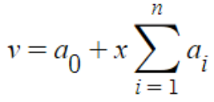
b.
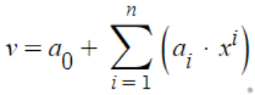
c.
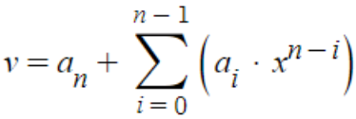
d.
e.
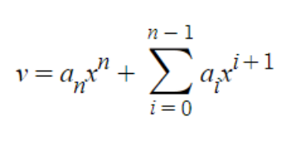

Com
1.
refer to 1.1.1.py

result
0 / 0.25 / 0.8088528856765245 / 0.06872967621384829
1 / 0.0625 / 0.8620341589090739 / 0.015548402981298892
2 / 0.015625 / 0.873801417582083 / 0.0037811443082897966
3 / 0.00390625 / 0.8766439532697916 / 0.0009386086205811495
4 / 0.0009765625 / 0.8773483279197194 / 0.0002342339706533636
5 / 0.000244140625 / 0.8775240295474305 / 5.853234294228571e-05
6 / 6.103515625e-05 / 0.8775679304389996 / 1.4631451373148252e-05
7 / 1.52587890625e-05 / 0.8775789041283133 / 3.6577620594613336e-06
8 / 3.814697265625e-06 / 0.8775816474517342 / 9.144386385884218e-07
9 / 9.5367431640625e-07 / 0.8775823332834989 / 2.2860687387549206e-07
10 / 2.384185791015625e-07 / 0.8775825046468526 / 5.724352014624401e-08
11 / 5.960464477539063e-08 / 0.8775825472548604 / 1.4635512357585867e-08
12 / 1.4901161193847656e-08 / 0.8775825574994087 / 4.390964036815603e-09
13 / 3.725290298461914e-09 / 0.8775825649499893 / 3.059616560108225e-09
14 / 9.313225746154785e-10 / 0.8775825500488281 / 1.1841544633739431e-08
15 / 2.3283064365386963e-10 / 0.8775825500488281 / 1.1841544633739431e-08
16 / 5.820766091346741e-11 / 0.8775825500488281 / 1.1841544633739431e-08
17 / 1.4551915228366852e-11 / 0.8775825500488281 / 1.1841544633739431e-08
18 / 3.637978807091713e-12 / 0.8775787353515625 / 3.8265388102587394e-06
19 / 9.094947017729282e-13 / 0.8775634765625 / 1.908532787275874e-05
20 / 2.2737367544323206e-13 / 0.87744140625 / 0.00014115564037275874
21 / 5.684341886080802e-14 / 0.8779296875 / 0.00034712560962724126
22 / 1.4210854715202004e-14 / 0.87890625 / 0.0013236881096272413
23 / 3.552713678800501e-15 / 0.875 / 0.0025825618903727587
24 / 8.881784197001252e-16 / 0.875 / 0.0025825618903727587
25 / 2.220446049250313e-16 / 0.75 / 0.12758256189037276
26 / 5.551115123125783e-17 / 0.0 / 0.8775825618903728
27 / 1.3877787807814457e-17 / 0.0 / 0.8775825618903728
28 / 3.469446951953614e-18 / 0.0 / 0.8775825618903728
29 / 8.673617379884035e-19 / 0.0 / 0.8775825618903728
26 0.8775825618903728

when 26 ≤ i ≤ 29
sin(x+h) is equal to sin(x). so the accuracy is the worst. which explains the last line of the output.
from when i=14, accuracy drops. This can be because the loss of significance in subtraction.

21.
refer to 1.1.21.a.py
a.
default
x 0.1
y 0.01
z 0.09000000000000001
z already shows an error here in default format
large format
x 0.1000000000000000055511151231257827021181583404541015625000000000000000000000000000000000000000000000
y 0.0100000000000000002081668171172168513294309377670288085937500000000000000000000000000000000000000000
z 0.0900000000000000105471187339389871340245008468627929687500000000000000000000000000000000000000000000
Since floating point numbers is stored as binary numbers and they are limited in bits, decimal numbers that are long or infinited in binary numbers are subject to errors. Unlike 0.1 and 0.01, 0.25 and 0.125 doesn't show this problem.

default
p 0.3333333333333333
q 1.0
default format doesn't show any problem except that p is shown as an infinite decimal.
large format
p 0.3333333333333333148296162562473909929394721984863281250000000000000000000000000000000000000000000000
q 1.0000000000000000000000000000000000000000000000000000000000000000000000000000000000000000000000000000
same explanation as above
according to python documentation, almost all platforms map Python floats to IEEE-754 double precision. It contains 53 bits of precision which can explain sixteen 3s of p.
(source https://docs.python.org/3/tutorial/floatingpoint.html)
I guess it performs 0.3333333333333333*3.0 and processes the result 0.9999999999999999 as 1.0.

default
u 7.6
v 2.9
w 4.699999999999999
w shows problem here
large format
u 7.5999999999999996447286321199499070644378662109375000000000000000000000000000000000000000000000000000
v 2.8999999999999999111821580299874767661094665527343750000000000000000000000000000000000000000000000000
w 4.6999999999999992894572642398998141288757324218750000000000000000000000000000000000000000000000000000
same explanation as above

b.
refer to 1.1.21.b.py
<n = 1>
x 0.0
y 0.3333333333333333
z 2.0
<n = 2>
x 0.5
y 1.3333333333333333
z 1.5
<n = 3>
x 1.0
y 3.0
z 1.3333333333333333
<n = 4>
x 1.5
y 5.333333333333333
z 1.25
<n = 5>
x 2.0
y 8.333333333333334
z 1.2
<n = 6>
x 2.5
y 12.0
z 1.1666666666666667
<n = 7>
x 3.0
y 16.333333333333332
z 1.1428571428571428
<n = 8>
x 3.5
y 21.333333333333332
z 1.125
<n = 9>
x 4.0
y 27.0
z 1.1111111111111112
<n = 10>
x 4.5
y 33.333333333333336
z 1.1
nothing special

c.
refer to 1.1.21.c.py
x 3.3333333333333335
i 3
half 0.5
j 0
c 32.22222222222222
f 90.0
nothing special

d.
refer to 1.1.21.d.py

area 3.142857142857143
circum 6.2832
<with math.pi>
area 3.141592653589793
circum 6.283185307179586

relative error
0.04024994347707008%
2.3384349967961744e-06%
the error is not too big but if one needs more precision, they need to use the pi with more precision.

Ex1.2
21.
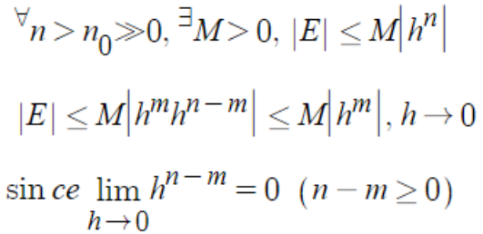
52.
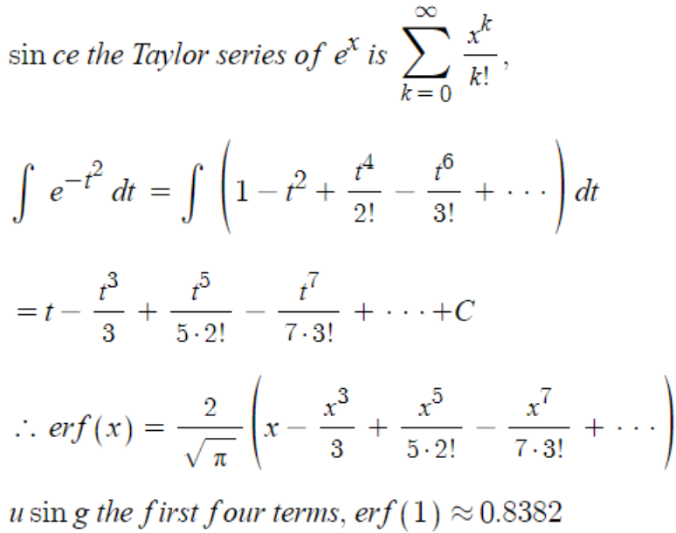

Com
12.
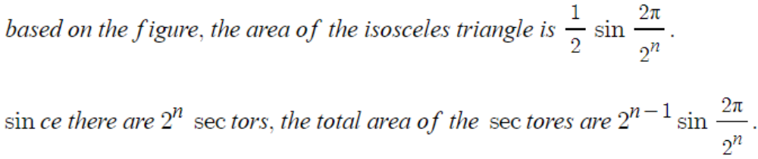
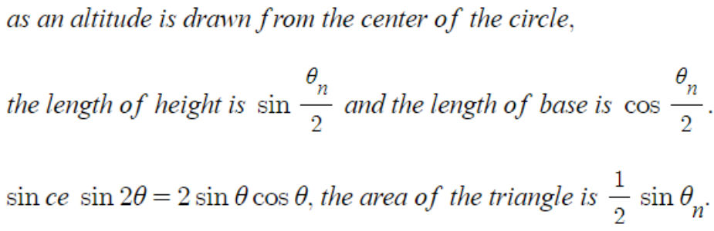
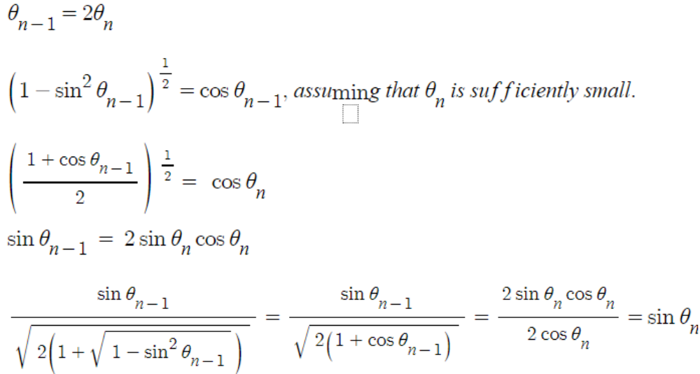

refer to 1.2.12.py

<n : 3>
sin 0.7071067811865475
p 2.82842712474619
<n : 4>
sin 0.3826834323650897
p 3.061467458920718
<n : 5>
sin 0.19509032201612825
p 3.121445152258052
<n : 6>
sin 0.09801714032956059
p 3.136548490545939
<n : 7>
sin 0.04906767432741801
p 3.1403311569547525
<n : 8>
sin 0.024541228522912285
p 3.1412772509327724
<n : 9>
sin 0.012271538285719925
p 3.141513801144301
<n : 10>
sin 0.006135884649154475
p 3.1415729403670913
<n : 11>
sin 0.003067956762965976
p 3.1415877252771596
<n : 12>
sin 0.0015339801862847655
p 3.1415914215111997
<n : 13>
sin 0.0007669903187427045
p 3.1415923455701176
<n : 14>
sin 0.00038349518757139556
p 3.1415925765848725
<n : 15>
sin 0.00019174759731070332
p 3.141592634338563
<n : 16>
sin 9.587379909597734e-05
p 3.1415926487769856
<n : 17>
sin 4.793689960306688e-05
p 3.141592652386591
<n : 18>
sin 2.396844980841822e-05
p 3.141592653288993
<n : 19>
sin 1.1984224905069707e-05
p 3.1415926535145933
<n : 20>
sin 5.992112452642428e-06
p 3.1415926535709935
with arctan 3.141592653589793
the results are almost the same.

21.
a.
refer to 1.2.21.a.py
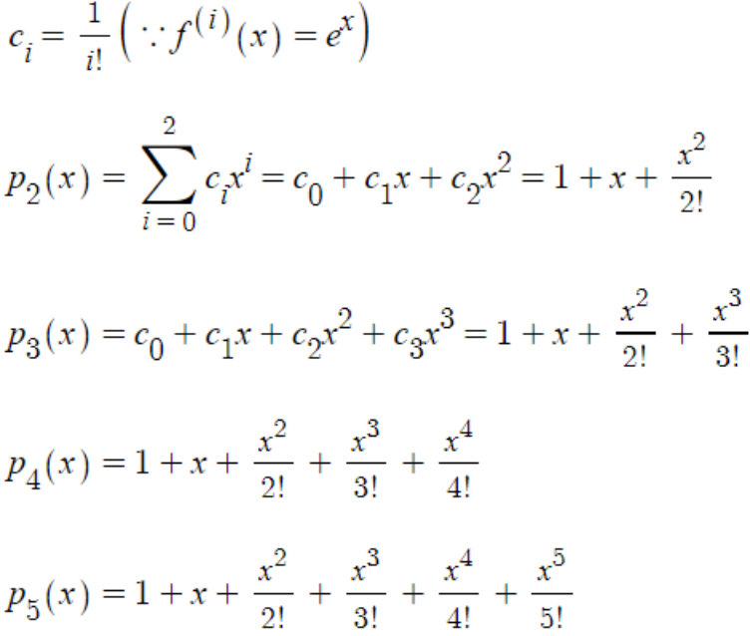
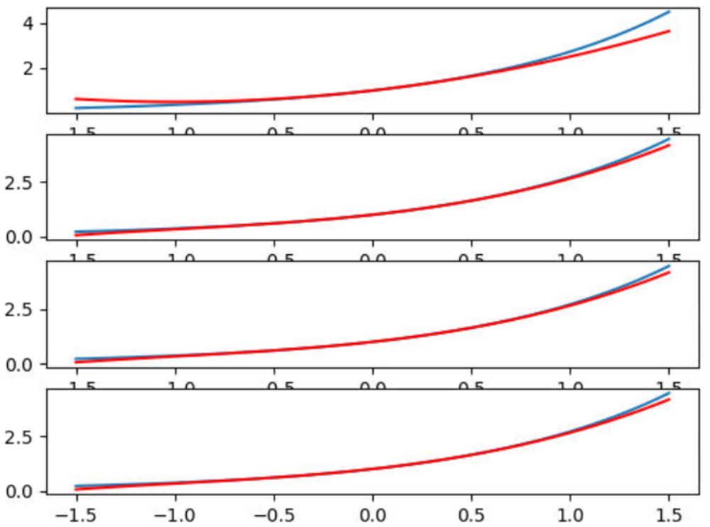
shown in order of p2, p3, p4, p5
e^x is blue
higher-order polynomials approximate better around zero

b.
refer to 1.2.21.b.py
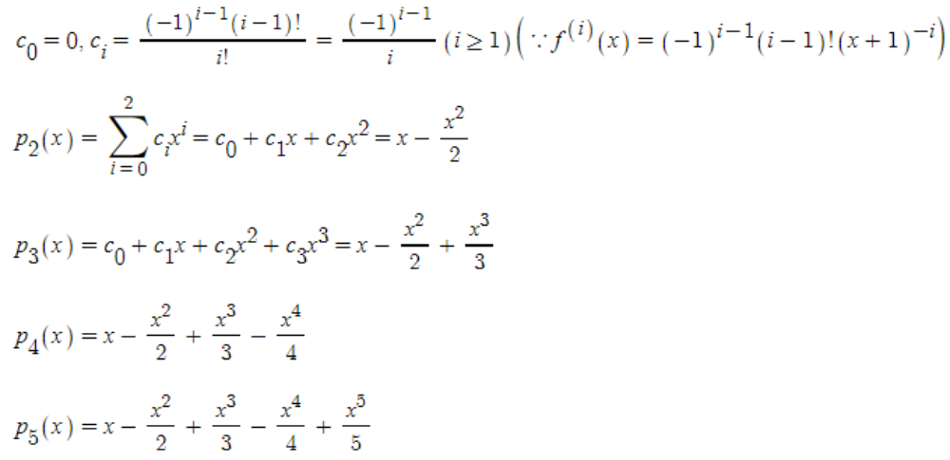
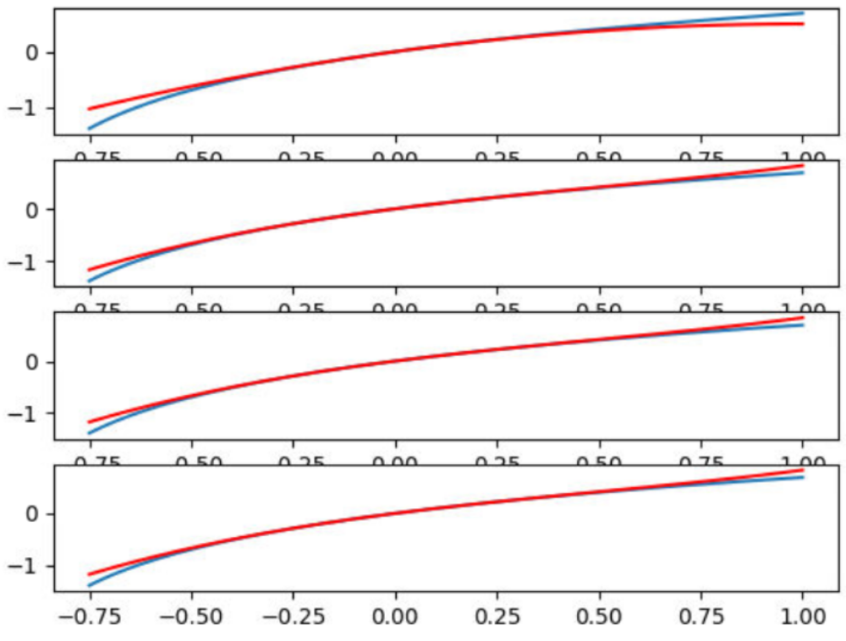
same as above
e
22.
a.
refer to 1.2.22.a
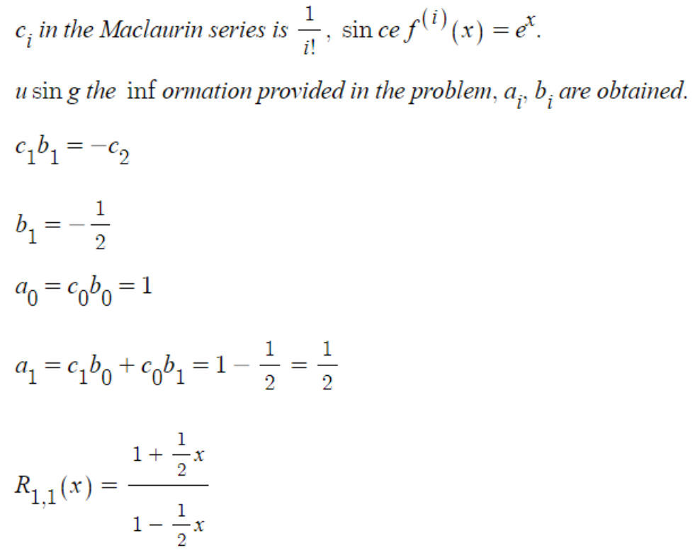
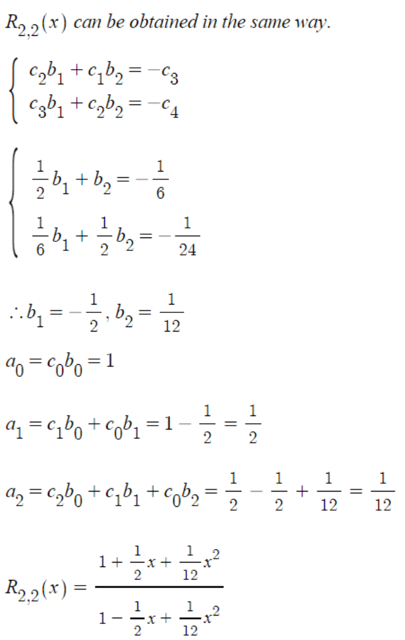
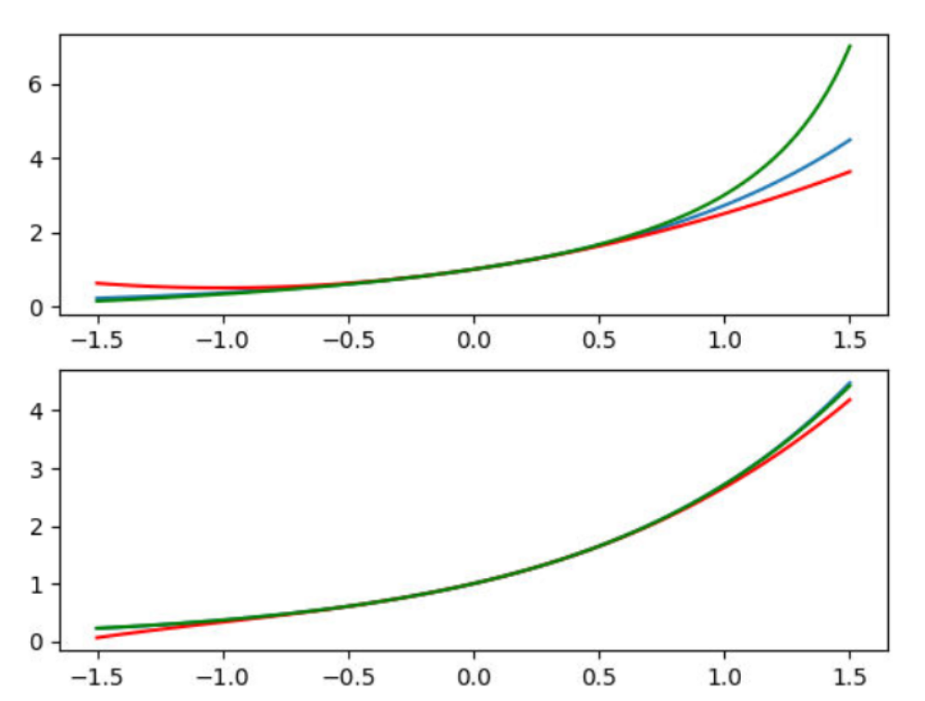
shown in the order of r11x, r22x
e^x is blue, r11x, r22x green, and maclaurin p2x, p3x red
r11x and r22x approximate better than maclaurin
r22x approximates very good in [-1.0,1.0]

b.
refer to 1.2.22.b.py
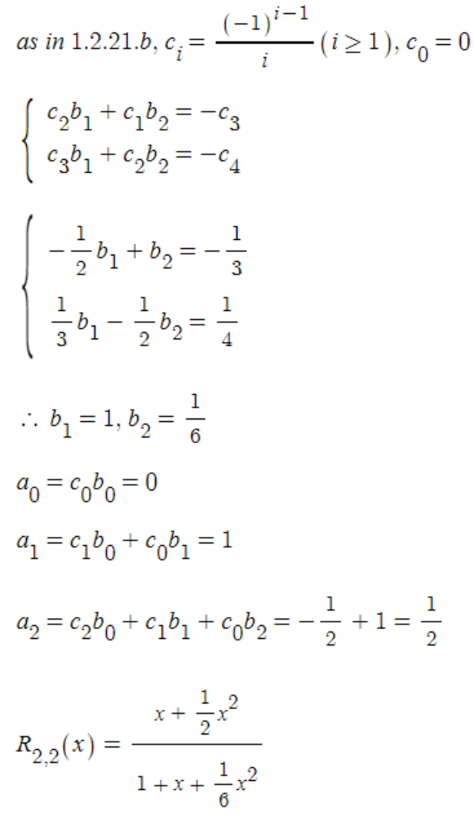
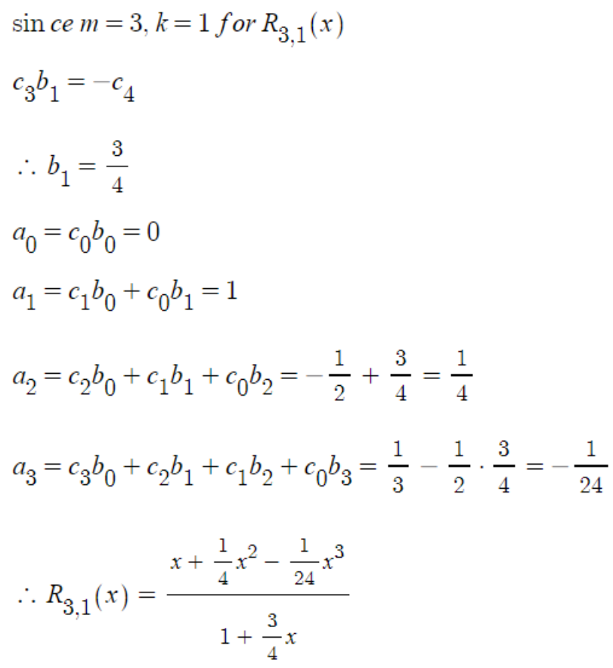
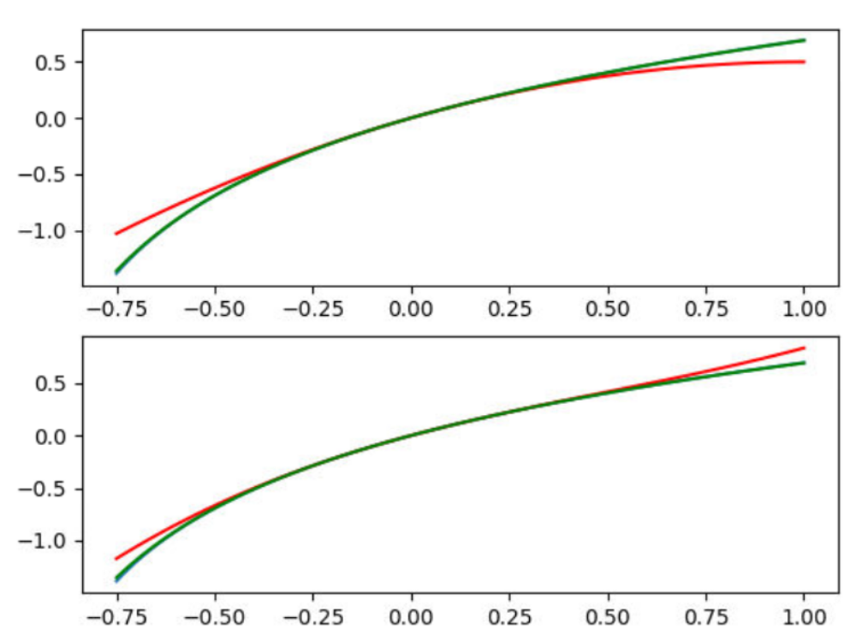
shown in the order of r22x, r31x
e^x is blue, r22x, r31x green, and maclaurin p2x, p3x red
r22x and r31x approximate better than maclaurin
r22x approximates slightly better than r31x in the figure

Ex1.3
18.
|x|<0.00005 since from six-decimal, numbers are rounded to their nearest machine number.

25.
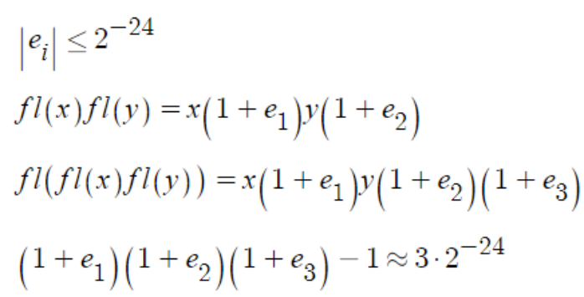

46.
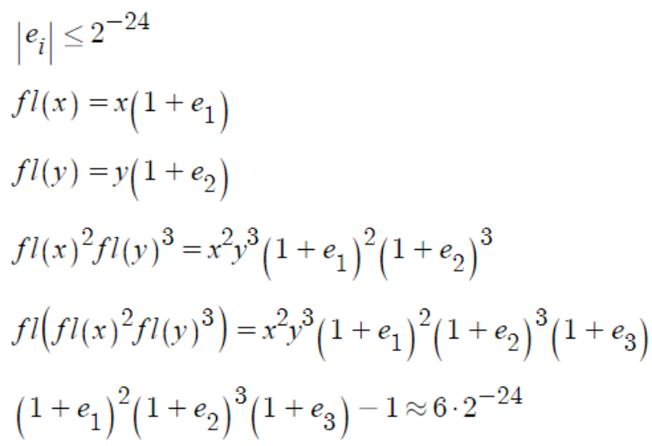

Com
7.
refer to 1.3.7.py
If there is enough time, and if a computer supports any big integers and real numbers with any precisions, the largest value of s would not exist, since x itself which is the harmonic series doesn't converge.
assuming a computer is about 4GHz and processes around 10^9 loops a second, then in a week, (10^9)*60*60*24*7 instructions are processed. since ln((10^9)*60*60*24*7) is about 34.03592, s would be less than 34.61313.

i 4500
s 8.989603744006947
ec 0.5773267225402705
i 4600
s 9.011570579975723
ec 0.5773243093804119
i 4700
s 9.03306522796091
ec 0.577321998860894
i 4800
s 9.054107561350785
ec 0.5773197845695854
i 4900
s 9.074716224705622
ec 0.5773176606175632
after almost 5000 steps, the euler constant is quite close to the one given in the problem.

Ex1.4
7.
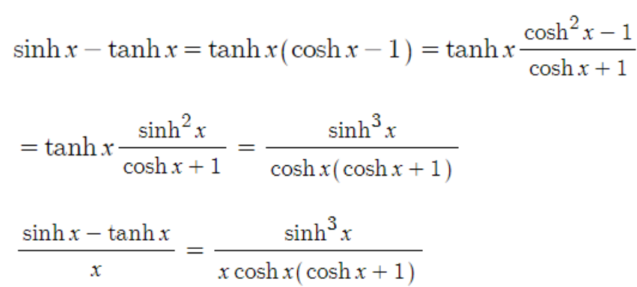

33.
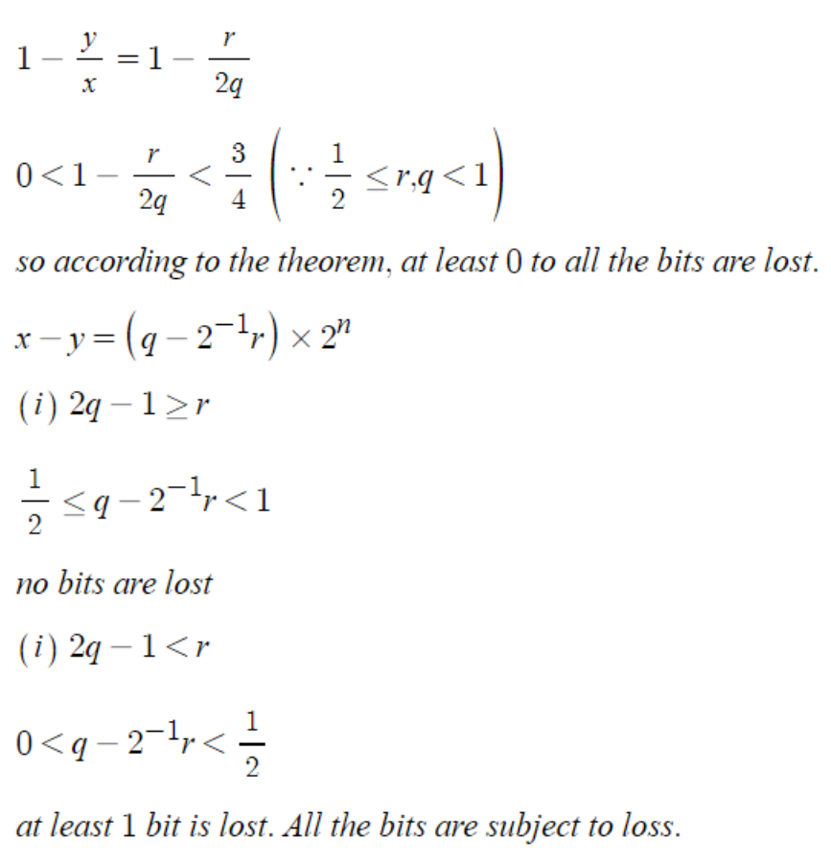

34.
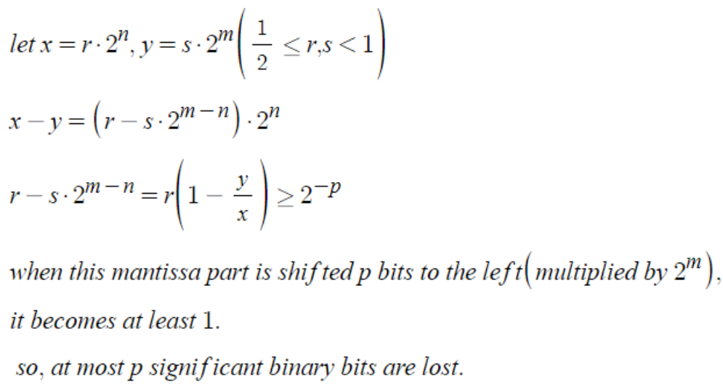

35.
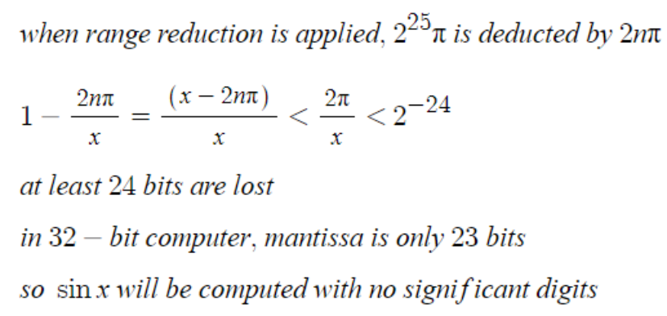

Com
15.
refer to 1.4.15.py
left one is pn and the right one is the expression in the middle of the inequality
1.435991124176917 0.00925966563056524
1.642188435222121 0.010092181924583832
1.7783228615258757 0.010324816729813335
1.8800805991023548 0.010420980512609646
1.961360593766015 0.010469755395174474
2.029036981624415 0.010497837898211237
2.087015938756524 0.010515468197662692
2.13773086254819 0.010527255575977001
2.1828006472139836 0.010535522913138085
2.2233569241536824 0.010541543909488915
2.2602218767457516 0.010546064300829716
2.2940116900558922 0.010549544237517416
2.3252000892924096 0.010552280130037062
2.3541591267780015 0.010554469894549445
2.381186342918065 0.010556249766245251
2.4065234229623114 0.010557716006360351
2.430369357209375 0.010558938193018452
2.452889940149244 0.010559967628485989
2.4742247665192183 0.010560842810890314
2.4944924762724674 0.010561593085944398
2.5137947494121162 0.01056224113896187
2.532219392031879 0.010562804729790098
2.549842750889397 0.010563297922487891
2.5667316245401457 0.010563731971232393
2.5829447919636572 0.010564115967992116
2.5985342470242694 0.010564457322543408
2.6135462041853272 0.010564762122566851
2.6280219245276886 0.010565035406915335
2.641998399274659 0.010565281375261026
2.6555089193392236 0.010565503550339805
2.6685835529658486 0.010565704904804907
2.6812495487081693 0.01056588796116209
2.6935316773244122 0.010566054871164798
2.705452523374714 0.010566207479349554
2.7170327351466312 0.010566347374172391
2.728291239856875 0.010566475929517427
2.7392454297622835 0.010566594338608404
2.749911323775151 0.010566703641727404
2.7603037083525344 0.01056680474918359
2.7704362607696233 0.010566898460305563
2.780321657355796 0.010566985479318891
2.789971668842332 0.010567066428539995
2.7993972446203794 0.01056714185965335
2.8086085874221838 0.010567212263042247
2.817615219702565 0.01056727807575042
2.826426042803364 0.01056733968842849
2.835049389822862 0.010567397450964577
2.843493072976609 0.010567451677630846
2.851764426124932 0.010567502651221972
2.859870343046773 0.010567550626803257
2.8678173119605335 0.010567595834992005
2.8756114467252907 0.010567638484585196
2.8832585150978227 0.010567678765081023
2.8907639643729612 0.010567716848764785
2.8981329446927315 0.010567752892480353
2.9053703302737963 0.01056778703941852
2.9124807387729477 0.010567819420338243
2.9194685489826426 0.01056785015494821
2.9263379170268418 0.010567879353014842
2.933092791207115 0.010567907115263786
2.93973692563159 0.010567933534304075
2.9462738927446837 0.010567958695431034
2.9527070948624243 0.01056798267722403
2.9590397748062593 0.01056800555230053
2.9652750257191034 0.01056802738768603
2.971415800137373 0.010568048245437556
2.9774649183860546 0.010568068183096635
2.983425076356571 0.010568087253951308
2.9892988527206894 0.010568105507564596
2.9950887156293993 0.010568122989967677
3.000797028939845 0.01056813974397075
3.006426058009747 0.01056815580950854
3.0119779750950517 0.010568171223808598
3.017454864382846 0.010568186021544523
3.022858726688459 0.010568200235234748
3.028191483843957 0.010568213895174594
3.0334549828012602 0.010568227029755128
3.0386509994723907 0.010568239665593282
3.0437812423266917 0.010568251827603348
3.0488473557630664 0.010568263539203926
3.053850923274174 0.010568274822373436
3.058793470417653 0.01056828569772339
3.063676467608231 0.010568296184675141
3.0685013327437196 0.010568306301533603
3.0732694336765713 0.010568316065515226
3.0779820905416773 0.010568325492823494
3.082640577950356 0.010568334598743068
3.0872461270596476 0.010568343397754365
3.0917999275255377 0.010568351903452289
3.0963031293473615 0.010568360128768717
3.1007568446111597 0.010568368085885904
3.1051621491380867 0.01056837578634795
3.109520084044302 0.01056838324105458
3.113831657217819 0.010568390460316657
3.118097844717512 0.010568397454022271
3.122319592099587 0.010568404231457773
3.1264978156754024 0.010568410801411243
3.1306334037051107 0.010568417172271083
3.134727217531126 0.010568423352005585
3.13878009265484 0.010568429348219333
the inequality holds in the result.

