4.1
1.
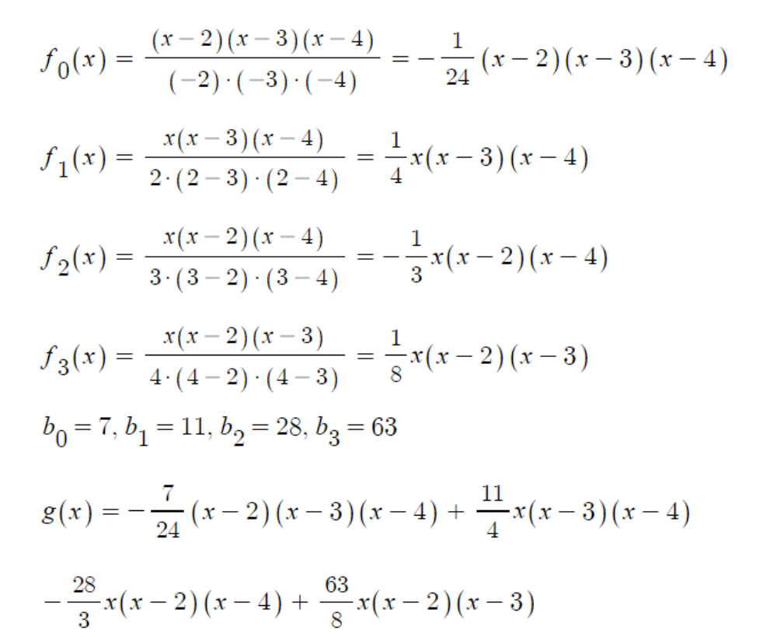

2.
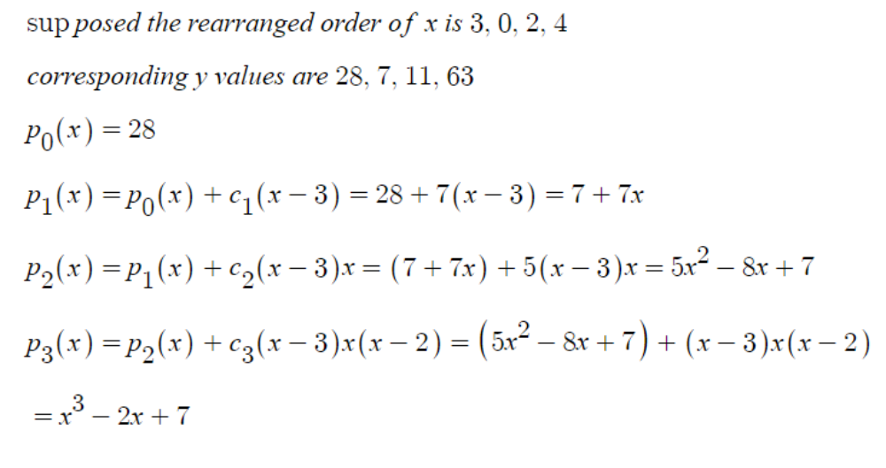
when the form in 1 is expanded, it's identical to the result of 2.

14.
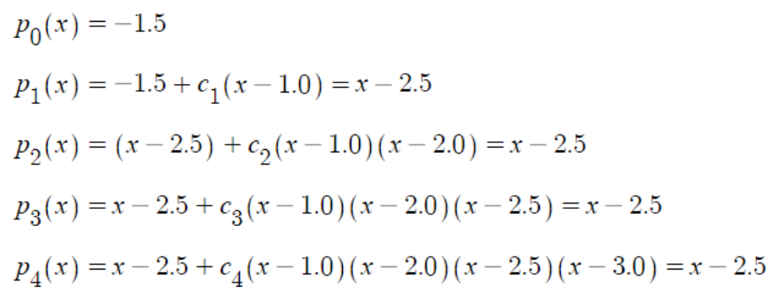

15.
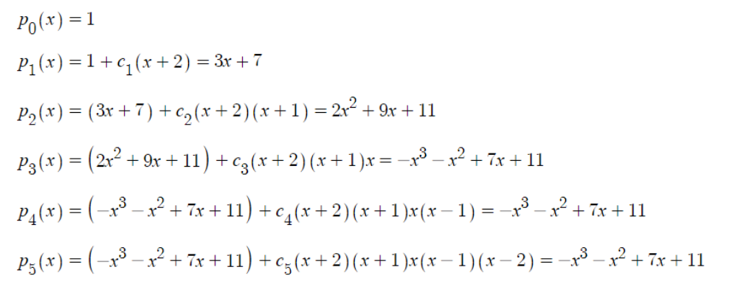
by interpolating with Newton form.

30.
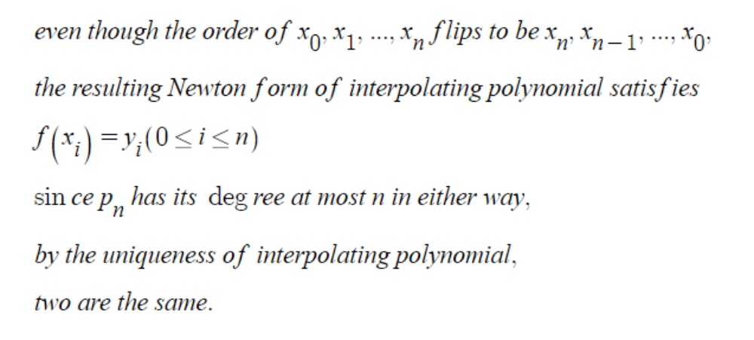

42.
since there should not be a term of degree n+1, it should be zero.

46.
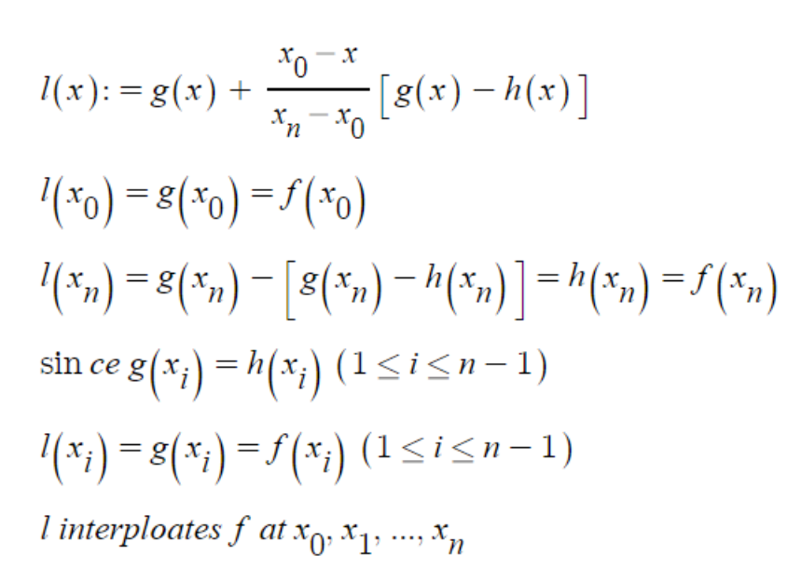

Com
1.
refer to 4.1.1.py
the polynomial is 2+46.0(x-1)+89.0(x-1)(x-2)+6.0(x-1)(x-2)(x-3)+4.0(x-1)(x-2)(x-3)(x+4)
yes p(-1)=12

3.
refer to 4.1.3.py
one try
minimum percent error 1.124825876276837e-13
maximum percent error 2.2070191810025422e-07
average percent error 2.462224235120986e-08
approximates quite good

4.2
4.
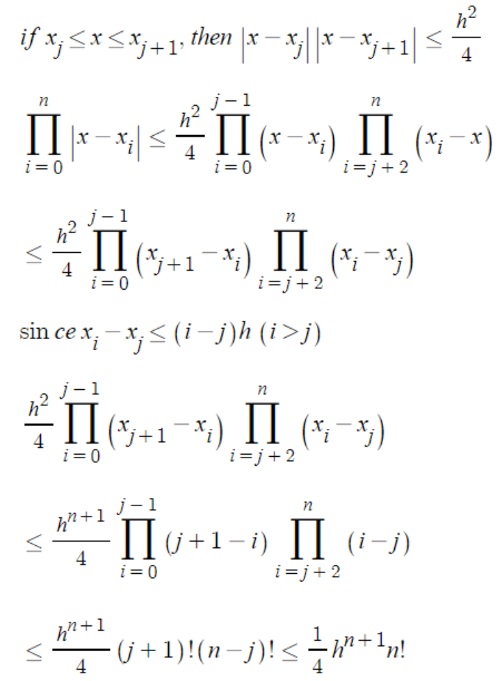

6.
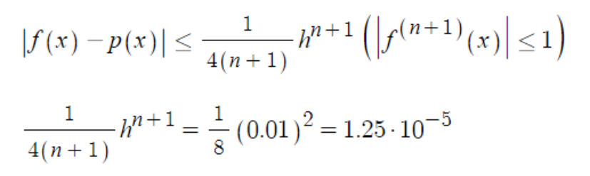

13.
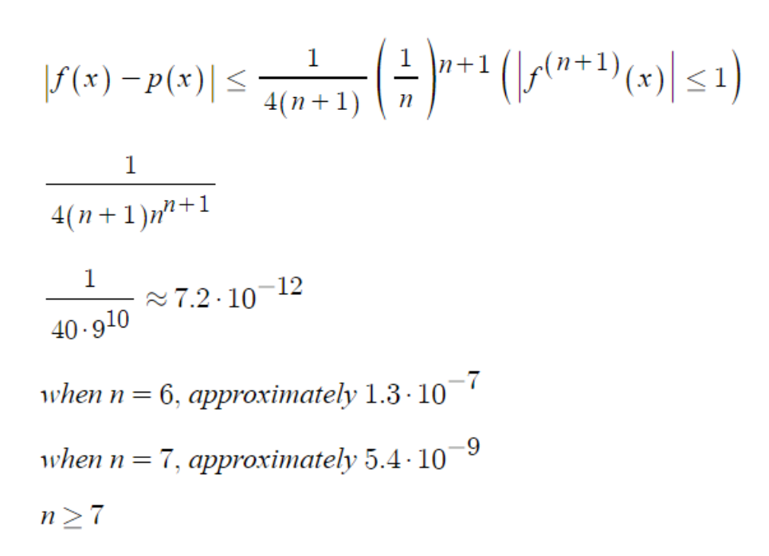

14.
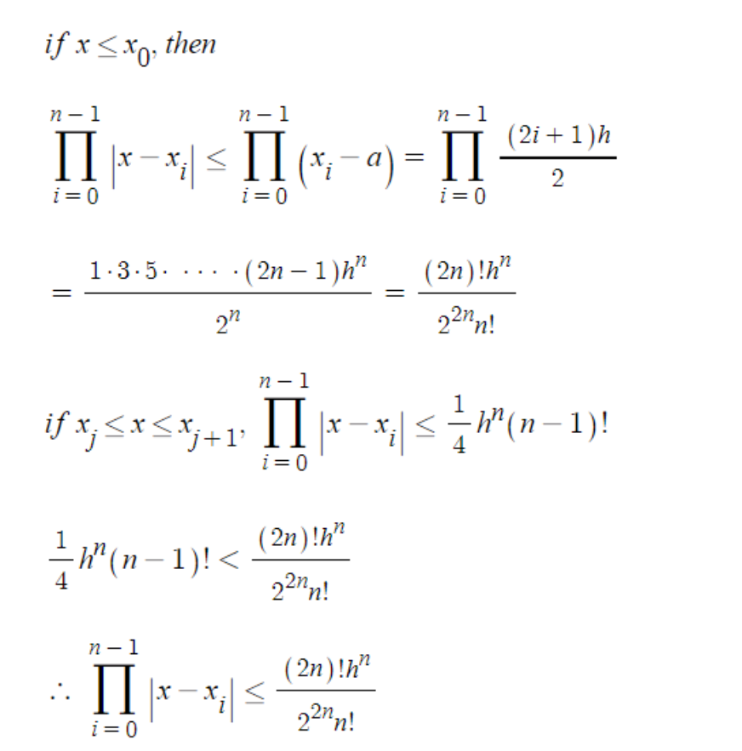

15.
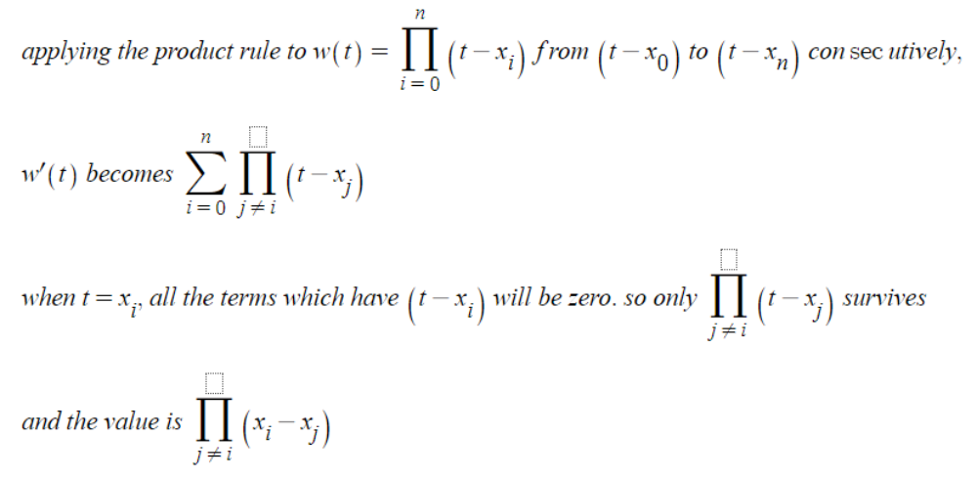

16.
it's the newton form of interpolating polynomial.
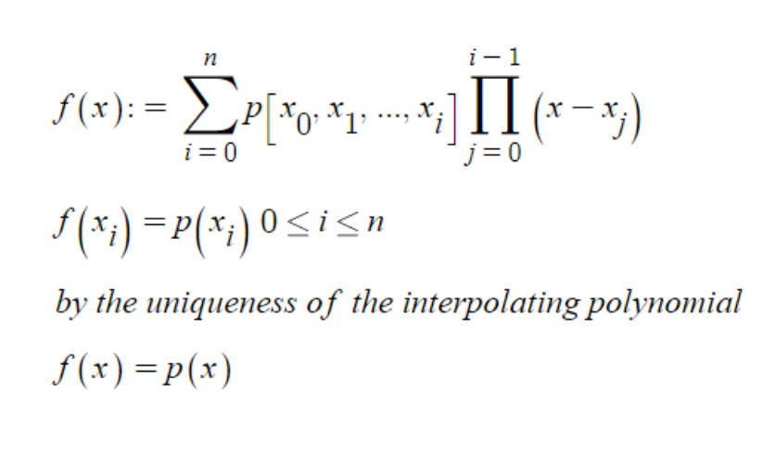

Com
1.
refer to 4.2.1.py
maximum percent error : 94237.95803410385
p(x)
[0.038461538461538464, -39.95244903304142, 0.047058823529411764, 3.4549577998641032, 0.058823529411764705, -0.4470519607088339, 0.07547169811320754, 0.20242261570456044, 0.1, 0.08065999342165579, 0.13793103448275862, 0.17976262990059808, 0.2, 0.23844593373813272, 0.3076923076923077, 0.39509305368777947, 0.5, 0.6367553359164331, 0.8, 0.942490379743985, 0.9999999999999999, 0.9424903797439852, 0.7999999999999997, 0.6367553359164332, 0.5000000000000011, 0.3950930536877839, 0.30769230769231193, 0.23844593373813736, 0.20000000000004098, 0.17976262990067826, 0.13793103448286892, 0.08065999342199147, 0.10000000000027065, 0.20242261570474962, 0.07547169811231383, -0.4470519607099369, 0.05882352941262376, 3.454957799871618, 0.04705882351619217, -39.952449033040224, 0.03846153838071152]
f(x)
[0.038461538461538464, 0.042440318302387266, 0.047058823529411764, 0.05245901639344262, 0.058823529411764705, 0.06639004149377593, 0.07547169811320754, 0.08648648648648649, 0.1, 0.11678832116788321, 0.13793103448275862, 0.16494845360824742, 0.2, 0.24615384615384617, 0.3076923076923077, 0.3902439024390244, 0.5, 0.64, 0.8, 0.9411764705882353, 1.0, 0.9411764705882353, 0.8, 0.64, 0.5, 0.3902439024390244, 0.3076923076923077, 0.24615384615384617, 0.2, 0.16494845360824742, 0.13793103448275862, 0.11678832116788321, 0.1, 0.08648648648648649, 0.07547169811320754, 0.06639004149377593, 0.058823529411764705, 0.05245901639344262, 0.047058823529411764, 0.042440318302387266, 0.038461538461538464]

9.
refer to 4.2.9.py
[0.0, 0.6513778537511822, 0.5313812255859371, 0.23194294869899712, 0.0, -0.10422934591770183, -0.10602111816406257, -0.056217399239540056, 0.0, 0.03547967374324801, 0.0420989990234375, 0.02587438523769381, 0.0, -0.02172836363315578, -0.029727172851562456, -0.021125569939613342, 0.0, 0.02421062886714931, 0.03943786621093759, 0.03411513268947597, 0.0, 0.03411513268947608, 0.03943786621093759, 0.02421062886714931, 0.0, -0.021125569939613342, -0.029727172851562456, -0.021728363633155667, 2.220446049250313e-16, 0.02587438523769403, 0.042098999023437056, 0.03547967374324901, -2.220446049250313e-16, -0.05621739923953828, -0.10602111816406212, -0.10422934591769917, -5.218048215738236e-15, 0.231942948699006, 0.5313812255859446, 0.6513778537511774, 2.220446049250313e-15]
maximum magnitude of error : 0.6514
[-0.012815499106693107, 0.012616420651714755, -0.0034790914592425226, -0.014637236892560246, -0.011001935804789031, 0.0015974604933212122, 0.013810717575293507, 0.01882842985914923, 0.014435461939898087, 0.002664416913822798, -0.011758611601853763, -0.02333440428644451, -0.027525615094974976, -0.021989341306902888, -0.007173767162480527, 0.013717061522512952, 0.03528988700233682, 0.05089980564172236, 0.05376966041262132, 0.03810022563104809, -3.3306690738754696e-16, 0.0381002256310482, 0.05376966041262132, 0.05089980564172225, 0.03528988700233682, 0.013717061522512841, -0.007173767162480638, -0.021989341306902888, -0.02752561509497531, -0.023334404286444732, -0.011758611601853652, 0.002664416913822576, 0.014435461939898198, 0.018828429859148232, 0.013810717575292175, 0.001597460493320102, -0.011001935804789142, -0.01463723689256513, -0.0034790914592458533, 0.01261642065171309, -0.01281549910669777]
maximum magnitude of error : 0.0538
it's better with Chebyshev nodes.

4.3
3.
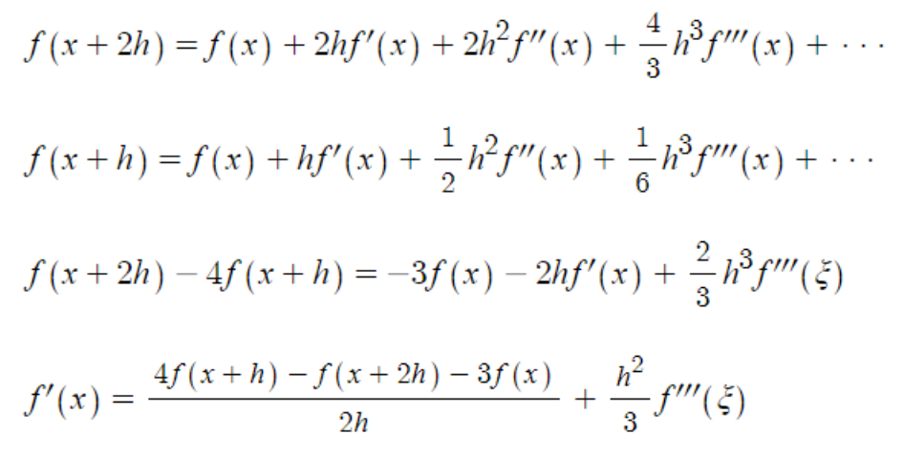

4.
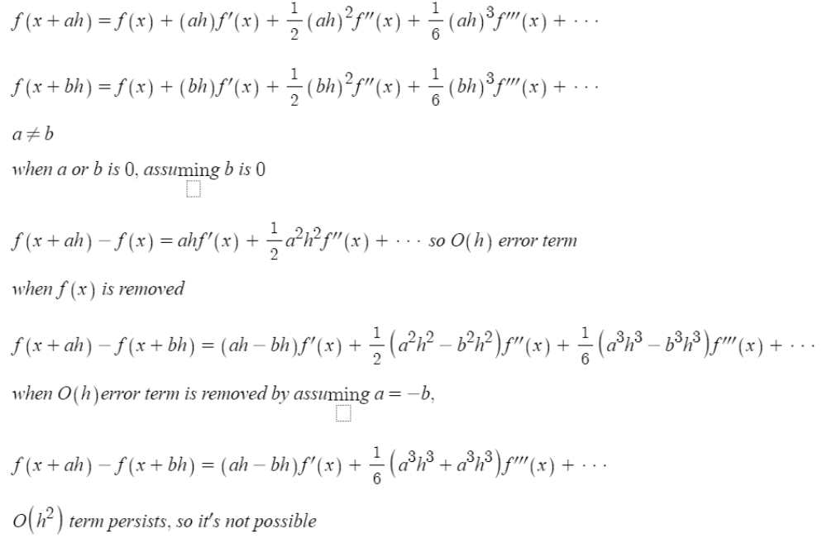

9.
a.
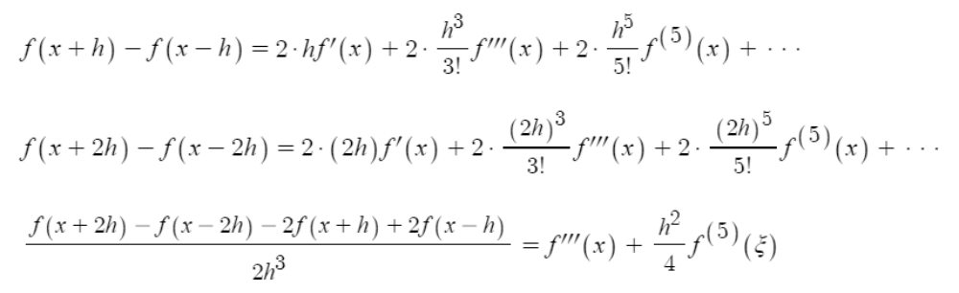
b.
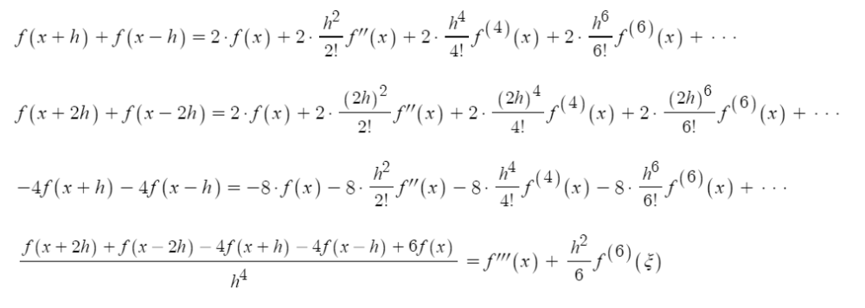
since both are bounded by square of h, accuracy is similar

10.
a.
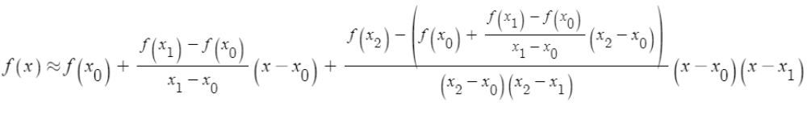

b.
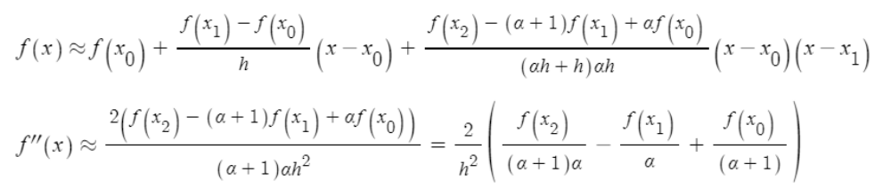

12.
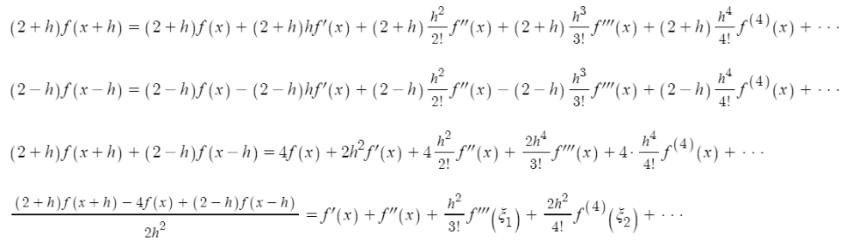

13.
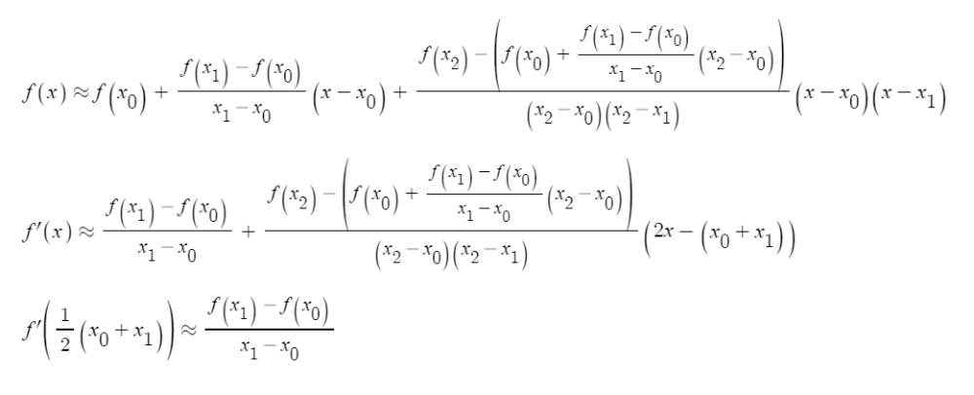

17.
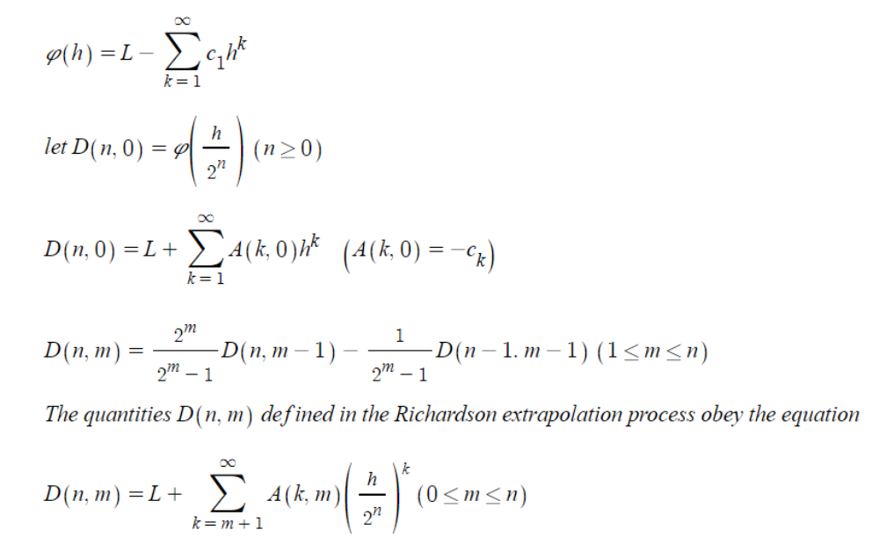
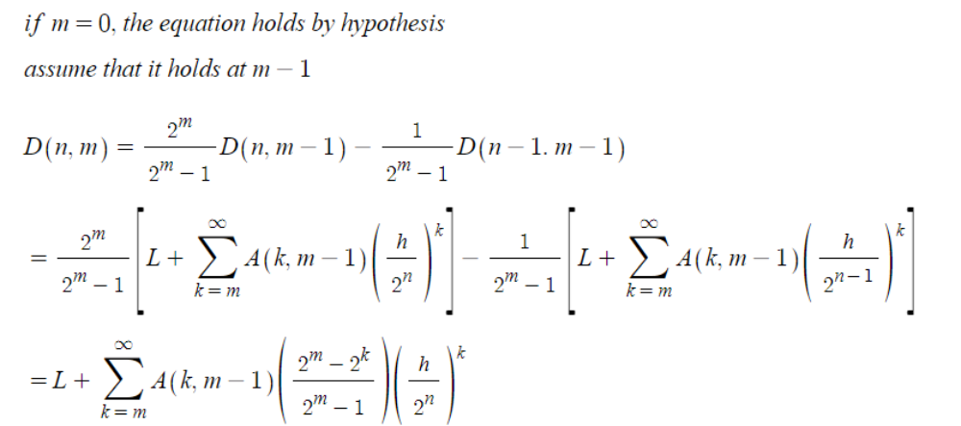
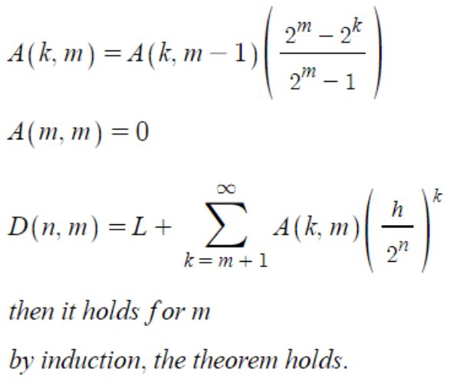

20.
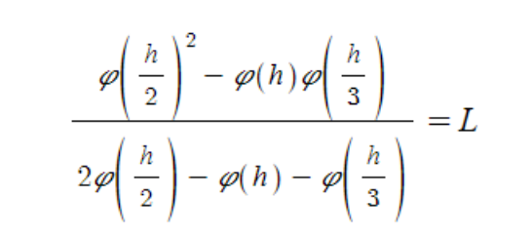

24.
(a)
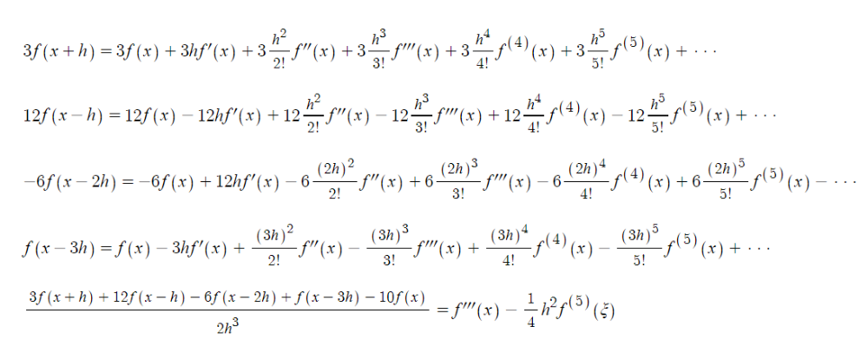
(b)
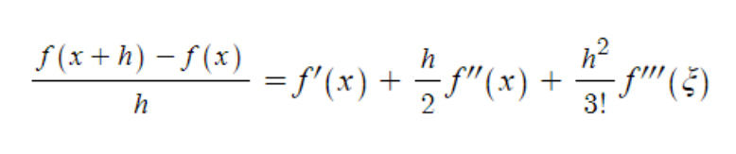
(c)
