5.1
9.
f(x):=(x^2+1)^(-1), f(0)=1, f(0.5)=4/5, 4(1)=1/2
(0.5)*(1/2)*(1+4/5)+(0.5)*(1/2)*(4/5+1/2)=(1/4)*(9/5+13/10)=(1/4)*(31/10)=31/40≈0.775
actual value : after integrating by substituting as follows, x=tanθ, F(θ)=θ, F(π/4)-F(0)=π/4≈0.78539816339
percent error : 1.32%
I-T=-1/12(b-a)h^2f''(ζ)=-(1/12)*(1/4)f''(ζ)
since f'(x)=-2x(x^2+1)^(-2), f''(x)=-2(x^2+1)^(-2)+8x^2(x^2+1)^(-3)=(6x^2-2)(x^2+1)^(-3)
t:=x^2+1 (0≤x≤1), (6(t-1)-2)t^(-3)=(6t-8)t^(-3)=6*t^(-2)-8*t^(-3) (1≤t≤2)
u:=1/t (1≤t≤2), |g(u)|:=|6u^2-8*u^3| (1/2≤u≤1) |g(u)| has the maximum when u=1/2 or 1
|g(1/2)|=1/2, |g(1)|=-2
so the error bound is as follows
|I-T|=|-(1/12)*(1/4)f''(ζ)|≤1/24≈0.41667

23.
no since it is not given that f(x) is nonincreasing for x in [1,2]
if f(x) is nonincreasing, the upper sum can be computed with first four values, while the lower sum can be computed with last four values.
an estimate is (5/4-1)*(0.5)*(10+8)+(3/2-5/4)*(0.5)*(8+7)+(7/4-3/2)*(0.5)*(7+6)+(2-7/4)*(0.5)*(6+5)=7.125

25.
a.
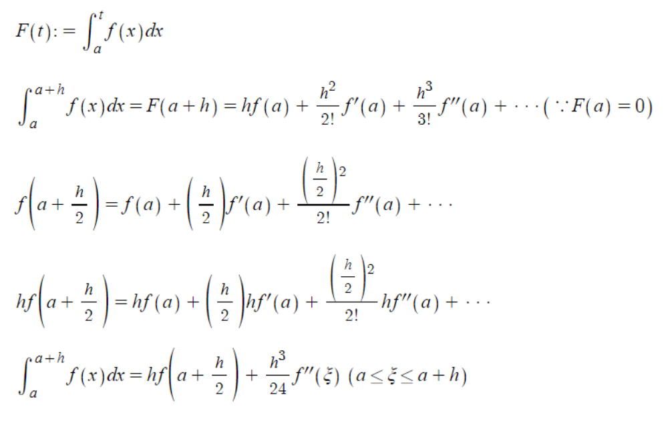
b.
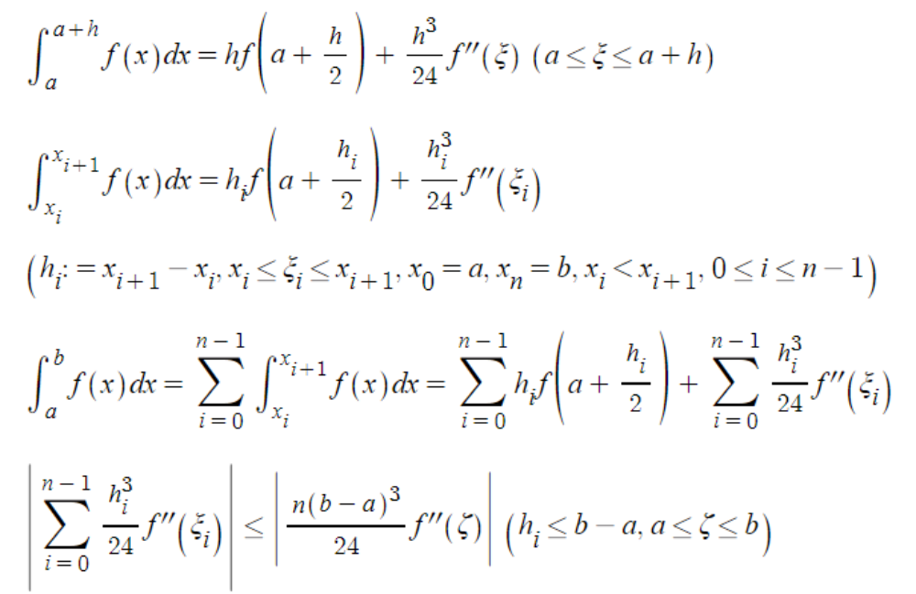
c.
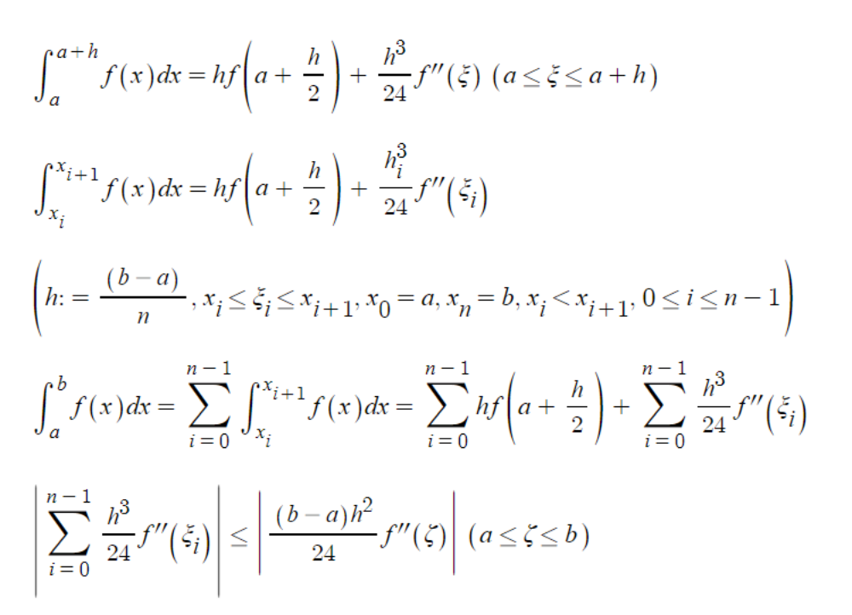

Com
1.
refer to 5.1.1.py

2.
refer to 5.1.2.py
each in the order of computed value, real value, percent error
a.
1.9926838315307691
2
0.3658084234615444%
b.
1.724005619782788
1.718281828459045
0.33311132253991155%
c.
0.43715229223102137
0.43882457311747564
0.3810818693616301%

5.2
9.
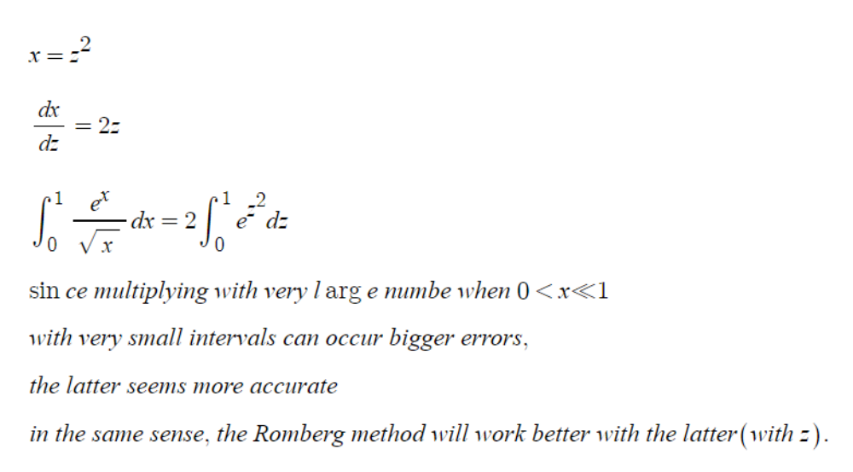

12.
R(1,1)=4*R(1,0)/3-R(0,0)/3=(h/3)*(f(a+2h)+f(a)+4(a+h))
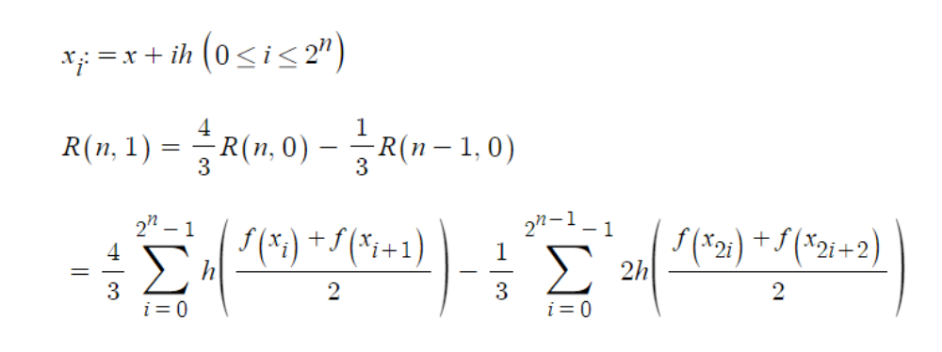

13.
using the equation from 12,
since R(2,2)=16*R(2,1)/15-R(1,1)/15
=(2h/45)*(7f(a)+7f(b)+32f(a+h)+32f(a+3h)+12f(a+2h))

22.
by refering to equation 12 and equation 3~6,
R(n,m)=R(n,m-1)+(R(n,m-1)-R(n-1,m-1))/((8^m)-1) (n≥1, m≥1)

Com
1.
refer to 5.2.1.py
[0.4953044734340177]
[0.49880688930715666, 0.49997436126486966]
[0.49967949805781153, 0.49997036764136316, 0.49997010139979603]
[0.4998974639828686, 0.499970119291221, 0.49997010273454484, 0.49997010275573134]
[0.49995194383738667, 0.4999701037888927, 0.4999701027554041, 0.4999701027557352, 0.4999701027557352]
[0.4999655630745738, 0.49997010282030285, 0.4999701027557302, 0.49997010275573533, 0.49997010275573533, 0.49997010275573533]
[0.4999689678384715, 0.4999701027597707, 0.4999701027557352, 0.4999701027557353, 0.4999701027557353, 0.4999701027557353, 0.4999701027557353]
[0.4999698190266084, 0.4999701027559874, 0.49997010275573517, 0.49997010275573517, 0.49997010275573517, 0.49997010275573517, 0.49997010275573517, 0.49997010275573517]

9.
refer to 5.2.9.py
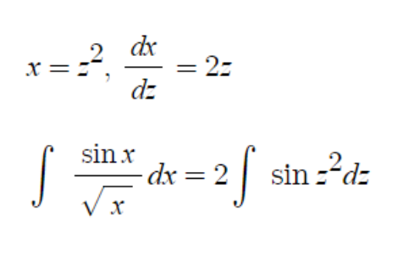
[0.8414709848078965]
[0.6681394516584712, 0.6103622739419962]
[0.6319507215184358, 0.6198878114717573, 0.6205228473070747]
[0.6233604789618817, 0.6204970647763637, 0.6205376816633374, 0.6205379171293098]
[0.6212407336189752, 0.6205341518380064, 0.6205366243087826, 0.620536607525377, 0.6205366023896752]
[0.6207125213091222, 0.6205364505391713, 0.6205366037859156, 0.6205366034601558, 0.6205366034442138, 0.6205366034452446]
[0.6205805757485695, 0.6205365938950519, 0.6205366034521106, 0.620536603446812, 0.6205366034467598, 0.6205366034467622, 0.6205366034467625]
[0.6205475960745366, 0.6205366028498589, 0.620536603446846, 0.6205366034467624, 0.6205366034467622, 0.6205366034467622, 0.6205366034467622, 0.6205366034467622]
0.6205366034467622

5.3
2.
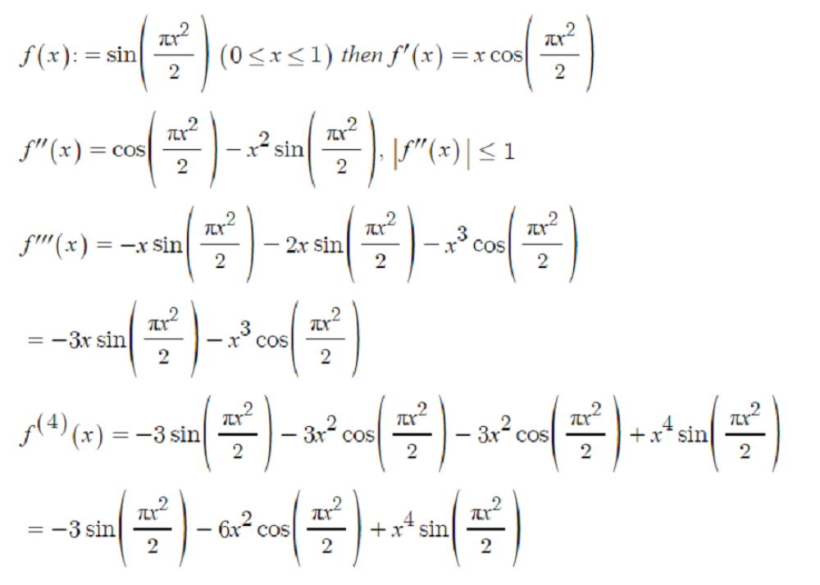
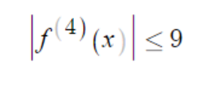

a.
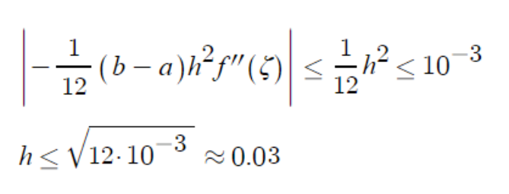
b.
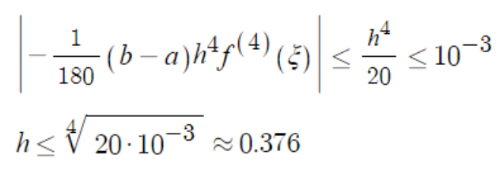
c.
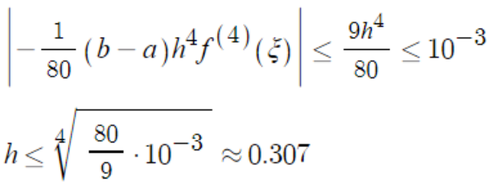

6.
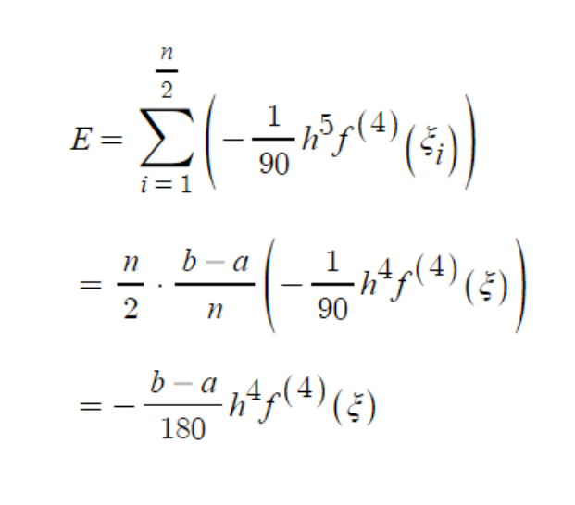

11.
if f(x)=x^2, the value of the definite integral is 1/3.
f(0)=0, f(1)=1 so β=1/3
if f(x)=1, the value of the definite integral is 1.
f(0)=1, f(1)=1 so α=2/3
if f(x)=x, the value of the definite integral is 1/2.
f(0)=0, f(1)=1 so 1/3≠1/2

Com
1.
refer to 5.3.1.py
first one is π when integrated with x=tanθ
the second one : when x=sinθ, the indefinite integral without 8 is (arcsinx)/2+(x/2)*(1-x^2)^(1/2)-(1/2)x^2+C
so this one is also π
3.14159266
3.14159231
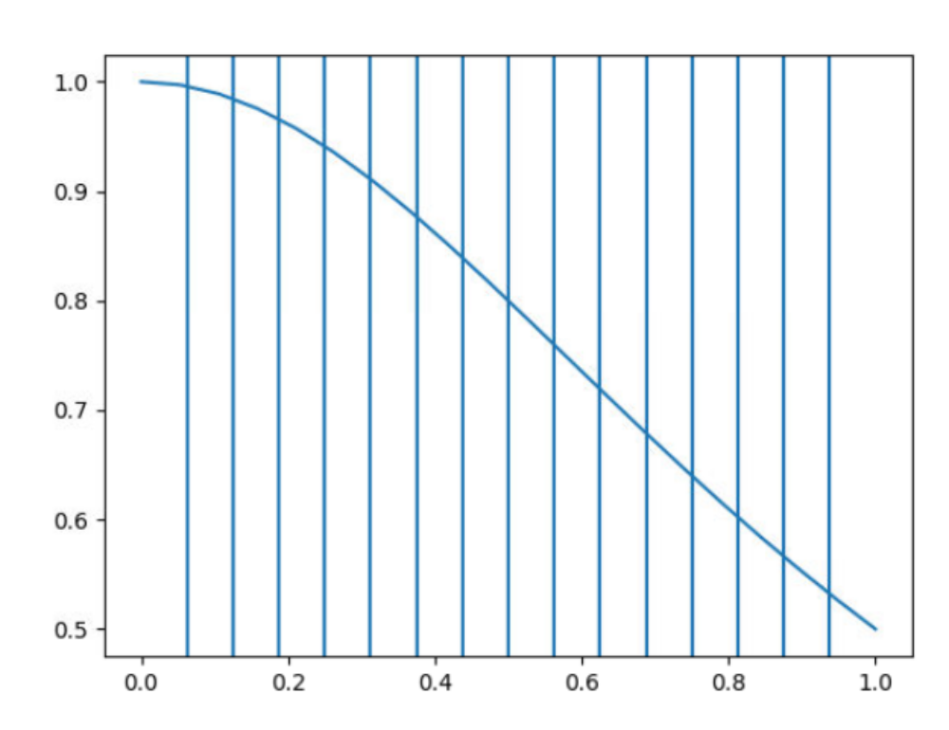
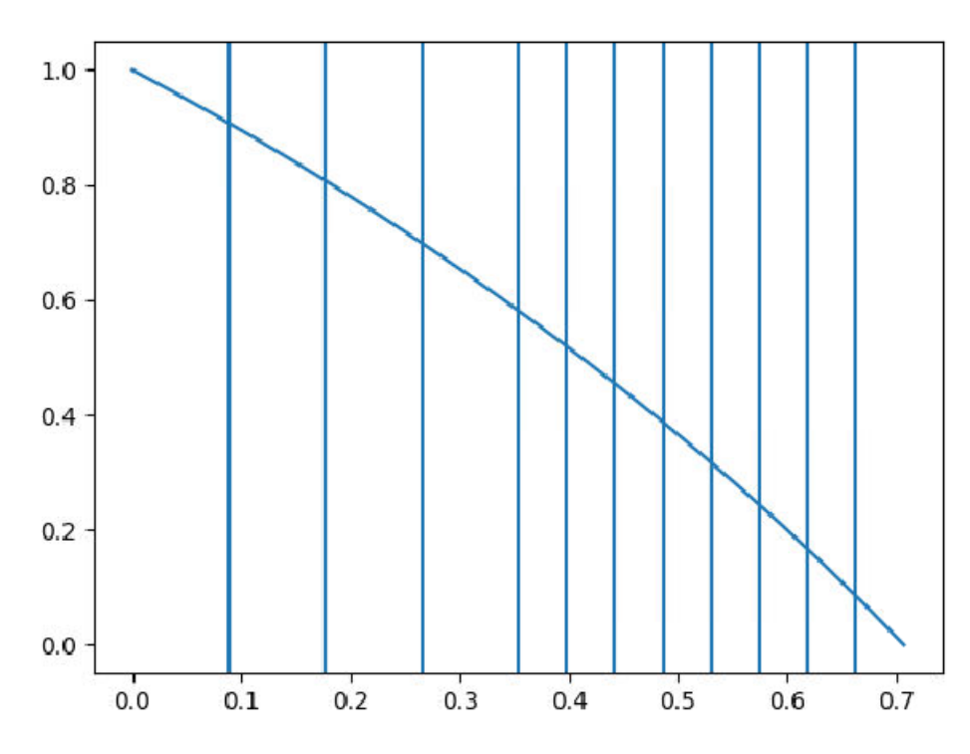

7.
refer to 5.3.7.py
mid 2.0
two 2.121320343559643
three 2.4125347690113372
four 2.4617701210266096
five 2.5817612493162225
the result is not so good because of the singularities

5.4
1.
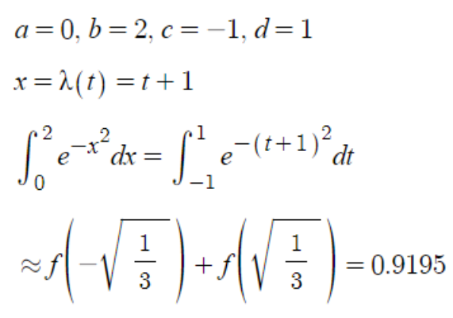

5.
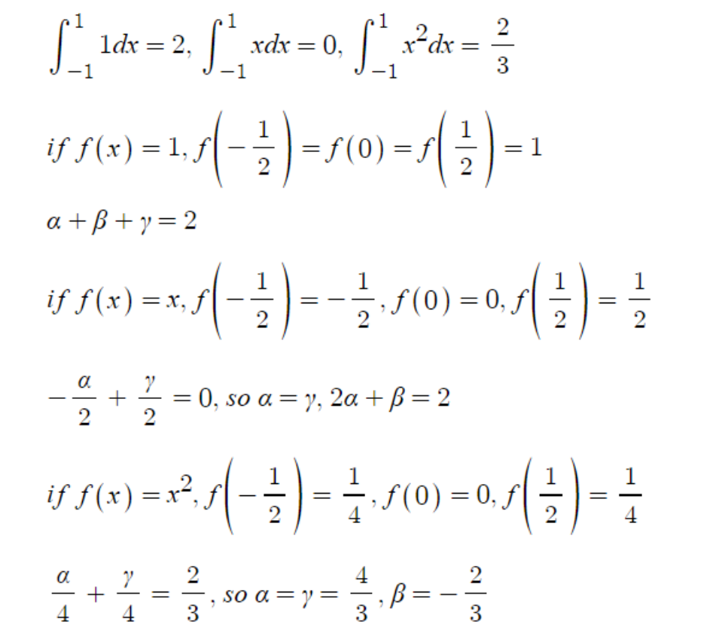

9.
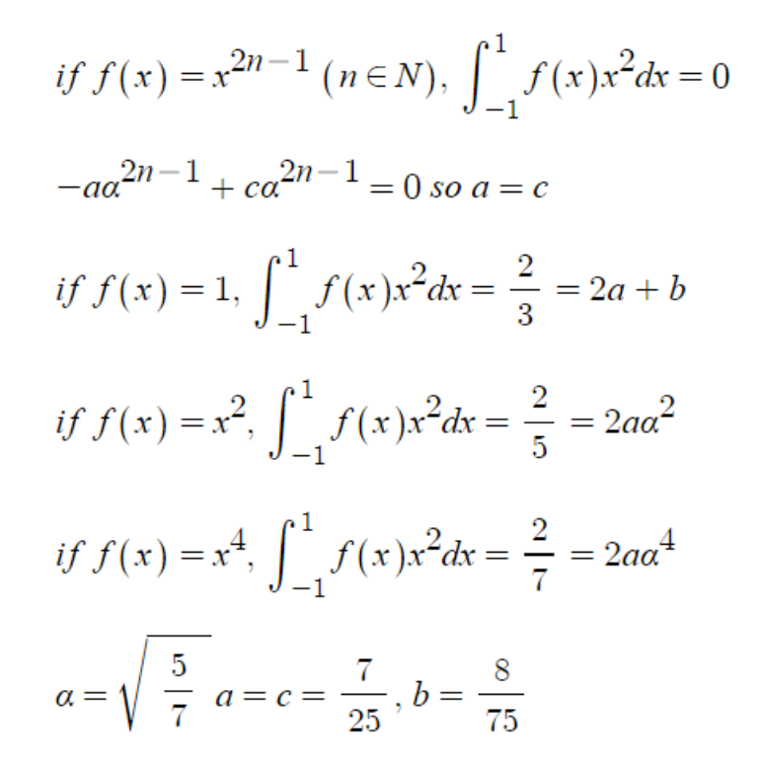

15.
a.
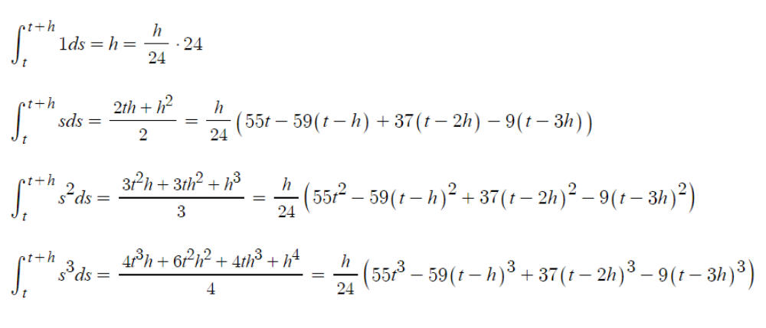
b.
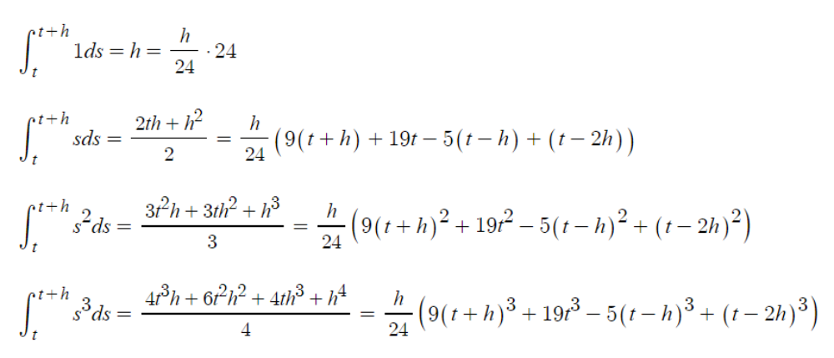

Com
1.
refer to 5.4.2.py
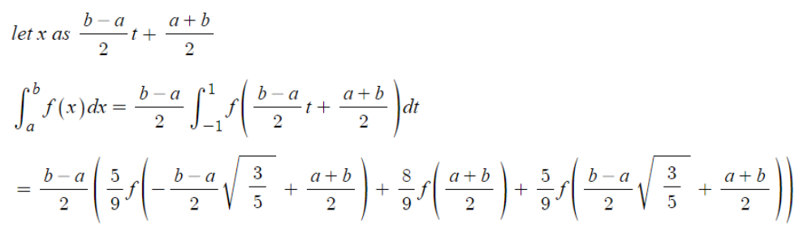

2.
refer to 5.4.2.py
a. 1.7508631779747565
b. 1.4119470964991223

14.
refer to 5.4.14.py
n=2
2.645709811204655
n=3
2.755404475587892
not so good because of the singularity
but better than newton-cotes

