3.1
14.
a.
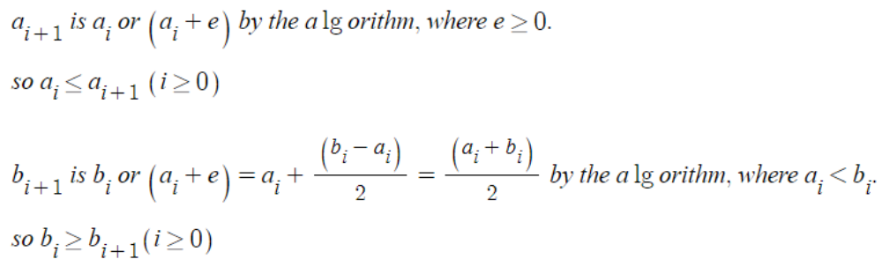
b.
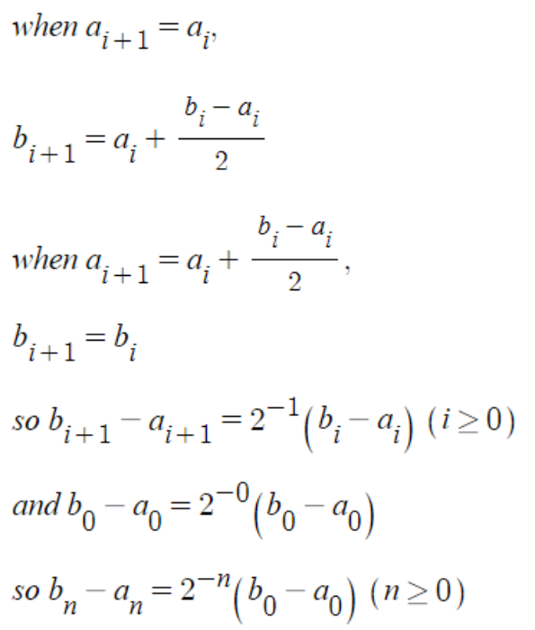
c.
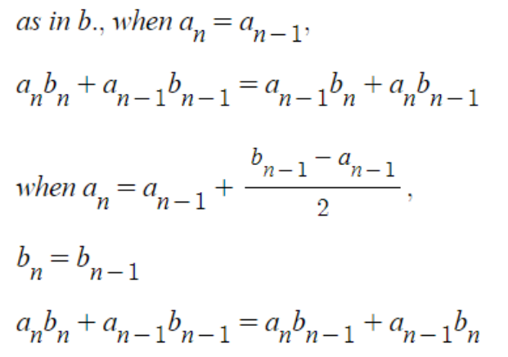

15.
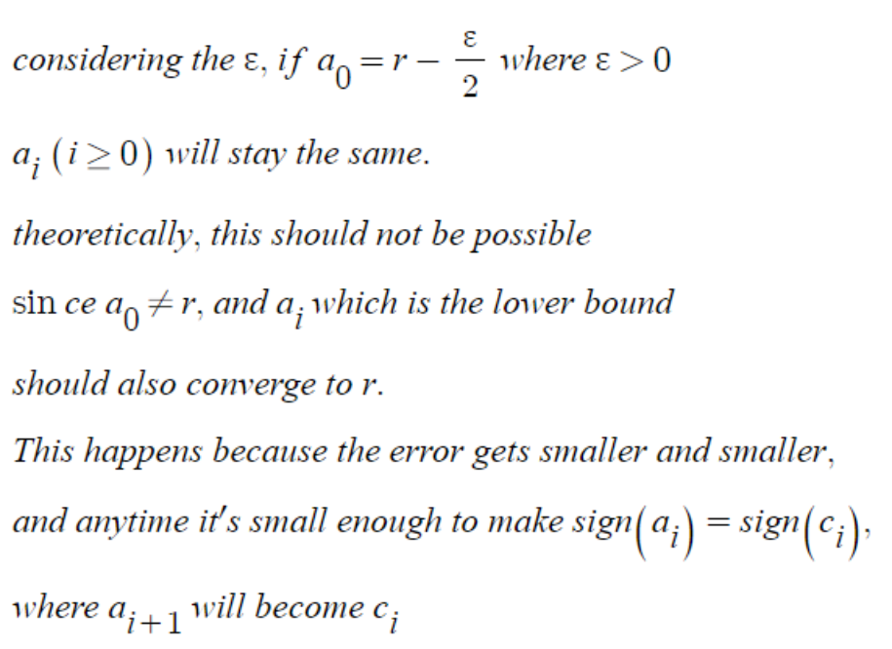

16.
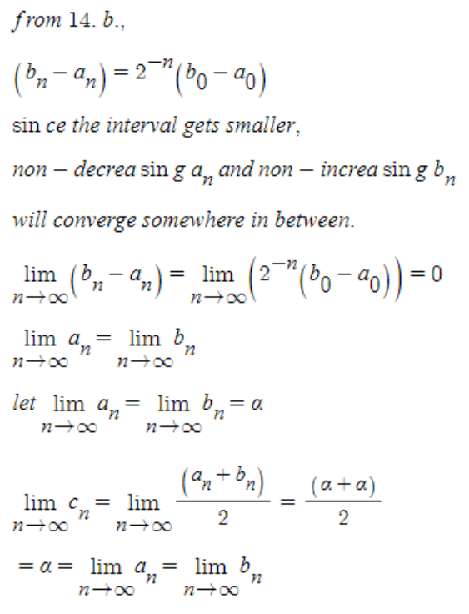

17.
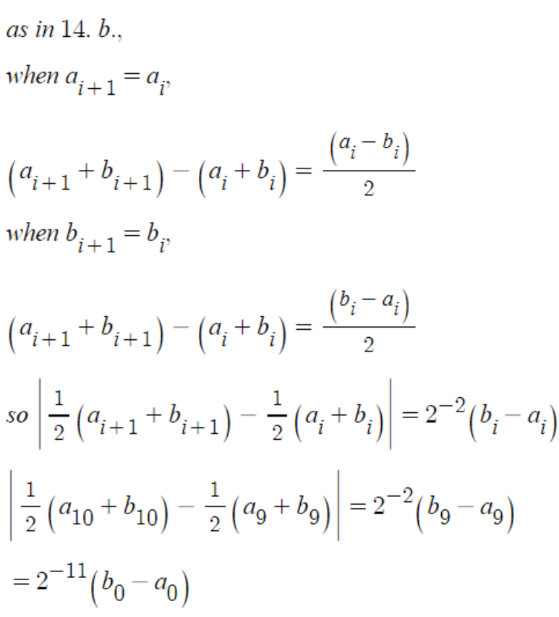
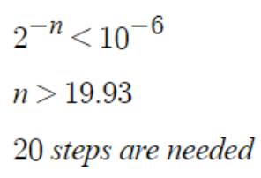

21.
since the root will be in [a, a+1]
anyways at least m bits has to be used for the binary part without the fractional part.
since ith step determines the (m-1+i)th significant bit, at least (24-m) steps are needeed.

Com
5.
refer to 3.1.5.py
I'll assume Ⲗ>0.
since the left side is too large near the origin compared to the right side, I'll start from 50.
since when Ⲗ=50, left side is bigger and Ⲗ=200, right side is bigger, I set the starting point as [50, 200].
a 50.000000 c 125.000000 b 200.000000 err 75.000000
a 125.000000 c 162.500000 b 200.000000 err 37.500000
a 125.000000 c 143.750000 b 162.500000 err 18.750000
a 125.000000 c 134.375000 b 143.750000 err 9.375000
a 125.000000 c 129.687500 b 134.375000 err 4.687500
a 125.000000 c 127.343750 b 129.687500 err 2.343750
a 125.000000 c 126.171875 b 127.343750 err 1.171875
a 126.171875 c 126.757812 b 127.343750 err 0.585938
a 126.171875 c 126.464844 b 126.757812 err 0.292969
a 126.464844 c 126.611328 b 126.757812 err 0.146484
a 126.611328 c 126.684570 b 126.757812 err 0.073242
a 126.611328 c 126.647949 b 126.684570 err 0.036621
a 126.611328 c 126.629639 b 126.647949 err 0.018311
a 126.629639 c 126.638794 b 126.647949 err 0.009155
a 126.629639 c 126.634216 b 126.638794 err 0.004578
a 126.629639 c 126.631927 b 126.634216 err 0.002289
a 126.631927 c 126.633072 b 126.634216 err 0.001144
a 126.631927 c 126.632500 b 126.633072 err 0.000572
a 126.631927 c 126.632214 b 126.632500 err 0.000286
a 126.632214 c 126.632357 b 126.632500 err 0.000143
a 126.632357 c 126.632428 b 126.632500 err 0.000072
the result is 126.632

18.
refer to 3.1.18.py
the graph is concave.
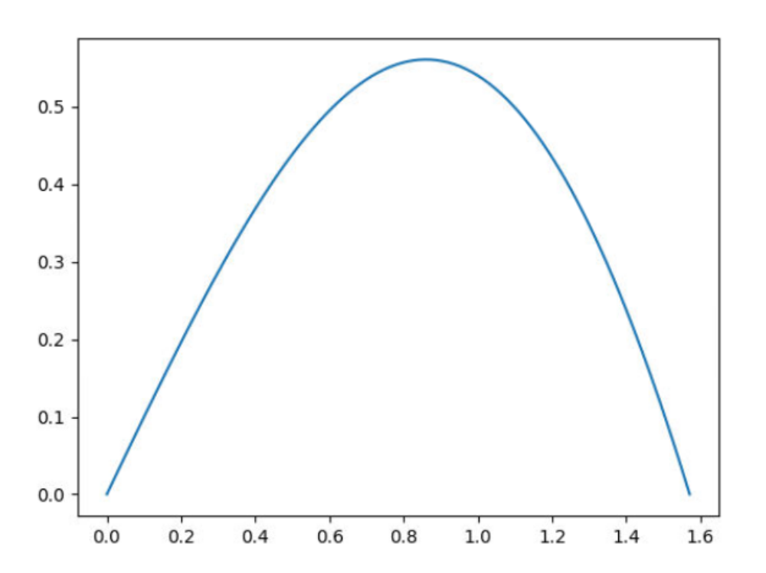
so I'll find the maximum by dividing the range by 5
values will initially grow and then decrease.
then I can make errors smaller and smaller, and get closer to the answer.
max(y)=0.561096 when x=0.860334

3.2
1.
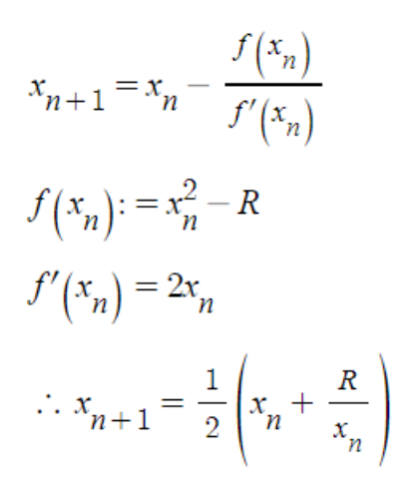

7.
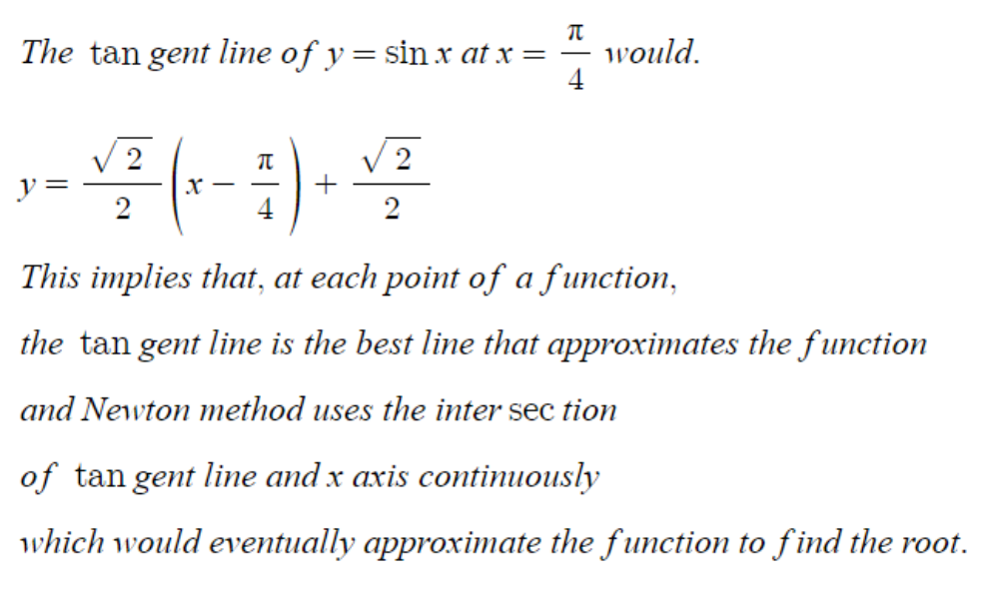

25.
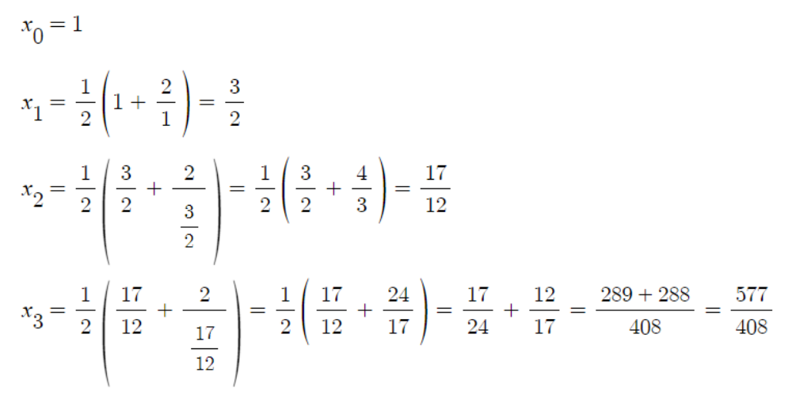
[1,2]
f(1)=-1, f(2)=2
c=1.5, f(c)=2.25-2>0
[1,1.5]
c=1.25, f(c)=1.5625-2<0
[1.25,1.5]
c=1.375, f(c)=1.890625-2<0
[1.375,1.5]

one more iteration of Newton method gives 1.4142135623746899
actual value of sqrt(2)=1.414213562373095
so it achieved 10^-6 accuracy.
However, for the bisection method to achieve the same accuracy,
around 20 steps are needed.
log2(10^6) ≈ 20

35.
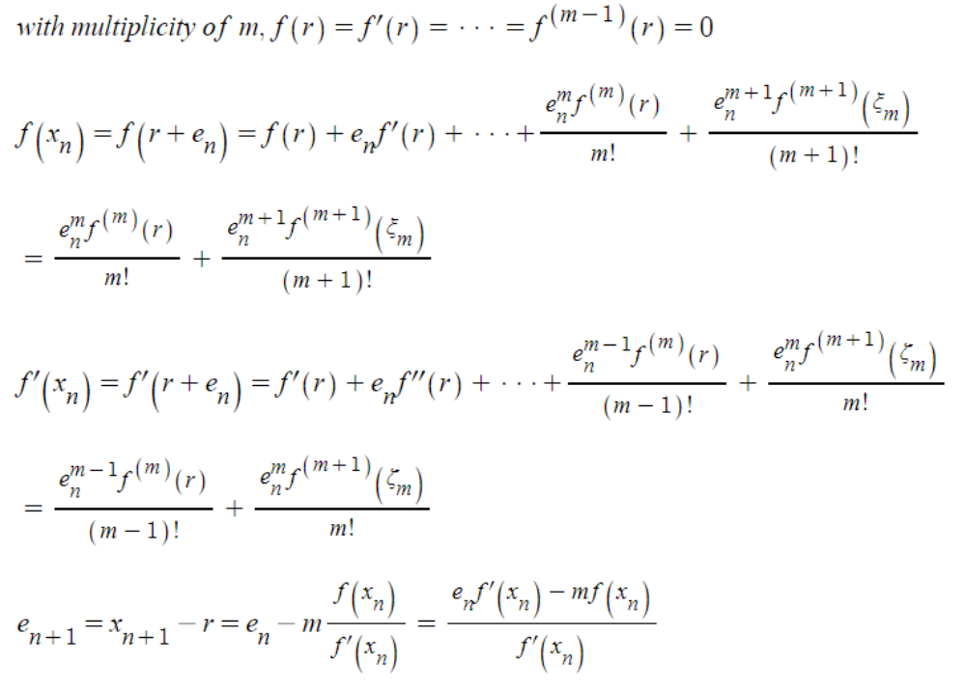
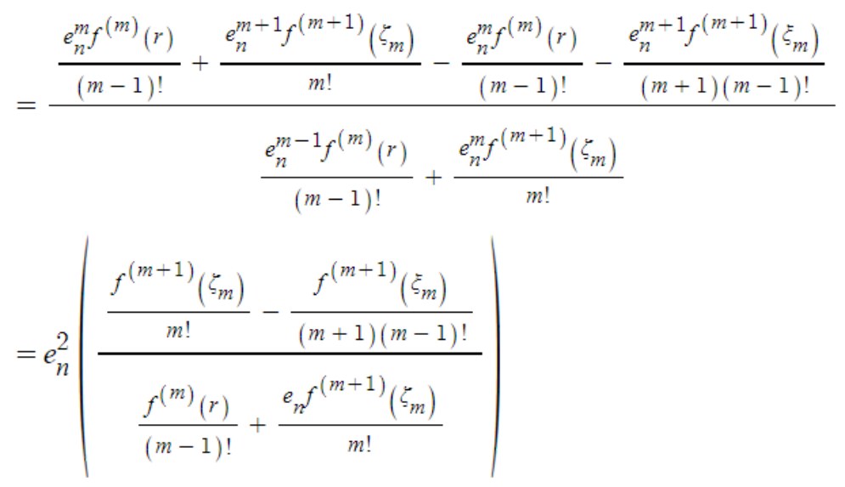

39.
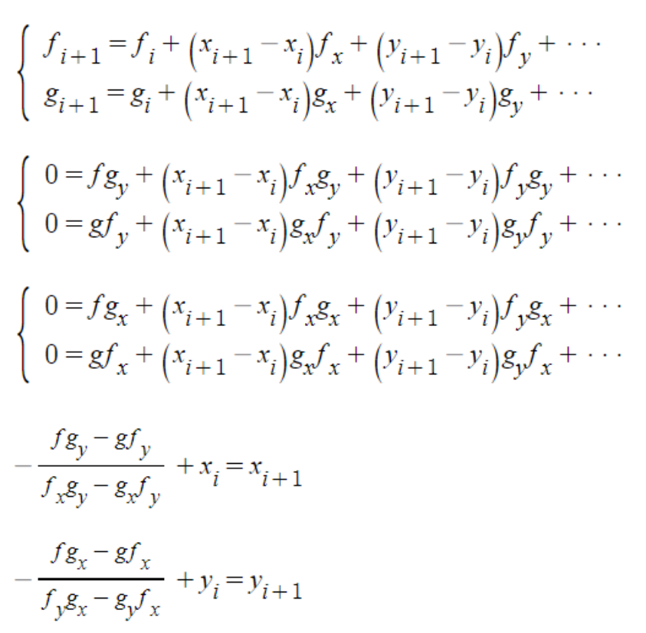

Com
4,
refer to 3.2.4.py
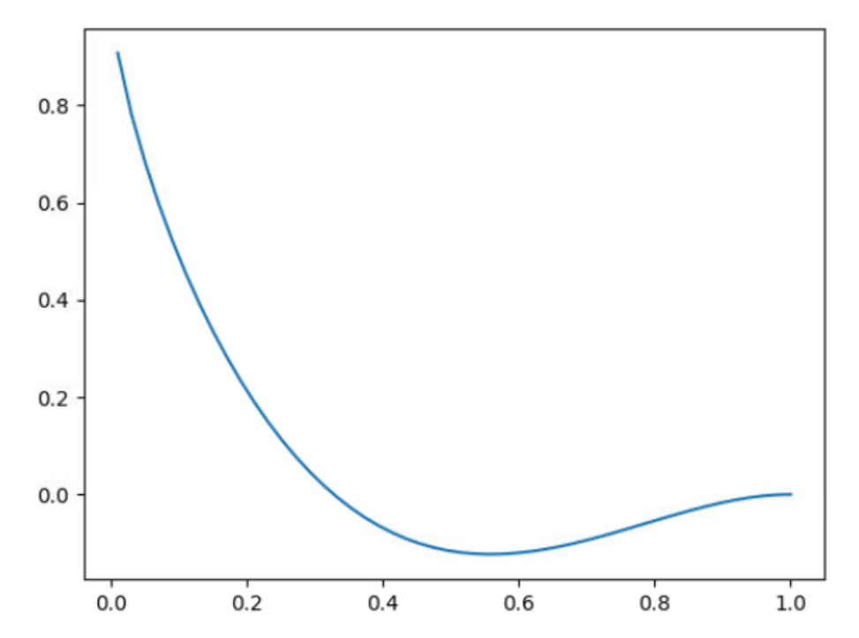
as in the graph, the root is somewhere in [0.2,0.5].
I started with x=0.4.
0.3066851107474603 1 digit
0.32678615762810165 2 digit
0.32796383968623055 5 digit
0.3279677852876076 9 digit
0.32796778533181886 15 digit

16.
refer to 3.2.16.py
-1.0
1.0
0.0
-1.0
1.0
0.0
-1.0
1.0
0.0
-1.0
it creates a cycle. 0->-1->1->0
the starting point is important.
if a function is not twice differentiable increasing convex, Newton's method might need to be used carefully.
when x=0.5
it converges to -0.5104293428.

41.
such methods as multivariate Newton's method described in 3.2.39 would be possible using jacobian matrix and the values of the functions.
this systems of equations can be simplified by subtractions and then it becomes a system of linear equations.

3.3
10.
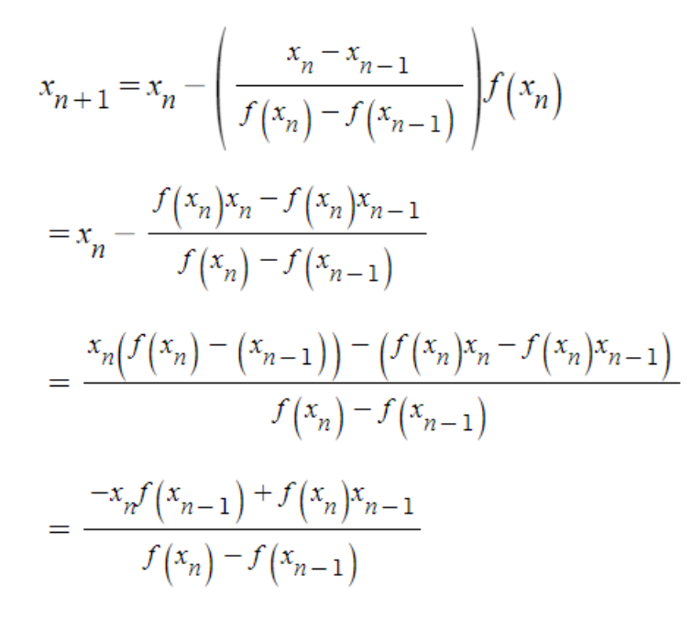
the formula suggested in the question is inferior.
the equation (3) has only one multiplication and preserve its precision as it is till before the subtraction.

12.
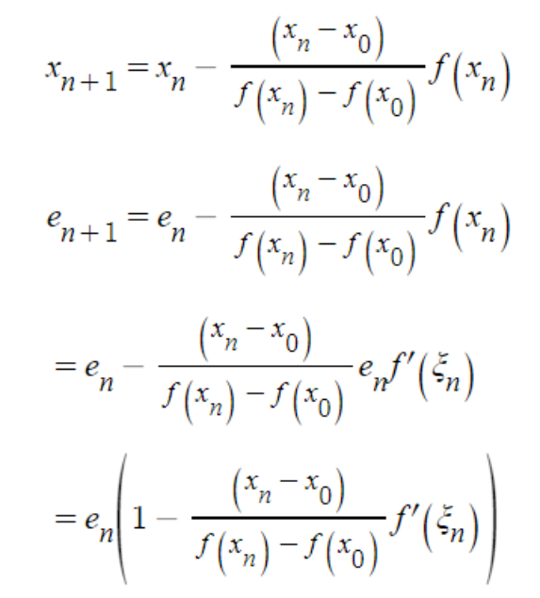

Com
7.
refer to 3.3.7.py
1.3043478260869565 2 digits
1.3760536203919975 2 digits
1.3686719535313416 4 digits
1.368807822525221 6 digits
1.3688081078326166 11 digits
1.3688081078213725 15 digits
6 steps
superlinear

Newton's
1.4117647058823528 1 digit
1.3693364705882352 3 digits
1.3688081886175318 8 digits
1.3688081078213745 15 digits
4 steps
quadratic

9.
refer to 3.3.9.py
20.022283142851588
20.043333228230253
20.523474270826753
20.119655601192417
20.170197625608026
20.271859118244492
20.233923505227796
20.239746709146683
20.240284383575844
20.24027511316006
20.2402751265292
20.24027512652954
20.24027512652954
seems like the answer from the book is wrong.

15.
a.
refer to 3.3.15.a.py
for certain range of x, x diverges to infinity.
when x=1, it stays the same.
for certain range of x, the values of x make a cycle.(e.g., 0.2->0.4->0.8->0.6->0.2)
at the end, they lose significance and become 0.
0.19999998807907104
0.3999999761581421
0.7999999523162842
0.5999999046325684
0.19999980926513672
0.39999961853027344
0.7999992370605469
0.5999984741210938
0.1999969482421875
0.399993896484375
0.79998779296875
0.5999755859375
0.199951171875
0.39990234375
0.7998046875
0.599609375
0.19921875
0.3984375
0.796875
0.59375
0.1875
0.375
0.75
0.5
0.0
0.0
0.0
0.0

b.
refer to 3.3.15.b.py
0.7481435964731942
0.4814359647319417
0.8143596473194172
0.14359647319417235
0.43596473194172347
0.3596473194172347
0.5964731941723471
0.9647319417234712
0.6473194172347121
0.4731941723471209
0.7319417234712091
0.31941723471209116
0.19417234712091158
0.9417234712091158
0.41723471209115814
0.17234712091158144
0.7234712091158144
It looks like this.
This one also loses significance and becomes 0 as follows.
0.38671875
0.8671875
0.671875
0.71875
0.1875
0.875
0.75
0.5
0.0
0.0
0.0

