11.1

6.

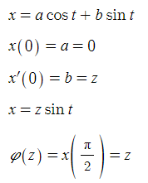

9.

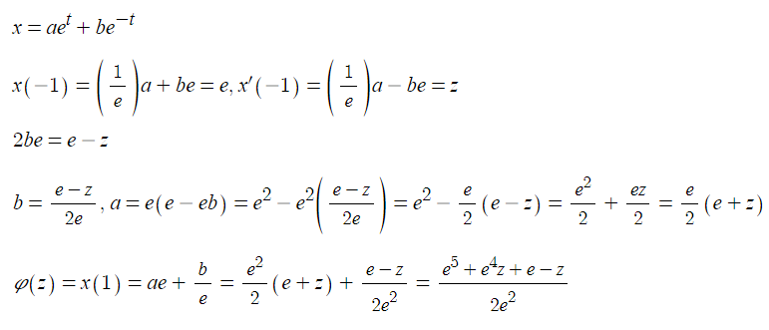

15.

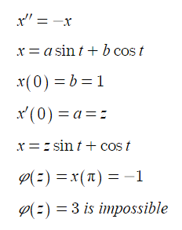

16.

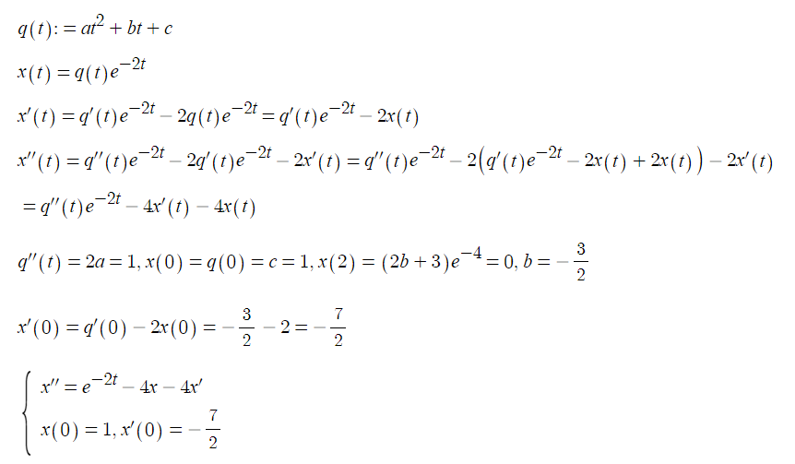

Com

1.

refer to 11.1.1.py

z=-25/2

0.9372375321588863

z=-23/2

6.3678668146937785

when x(1) with regard to z is linear,

z=-11.868090951769418

11.2

2.

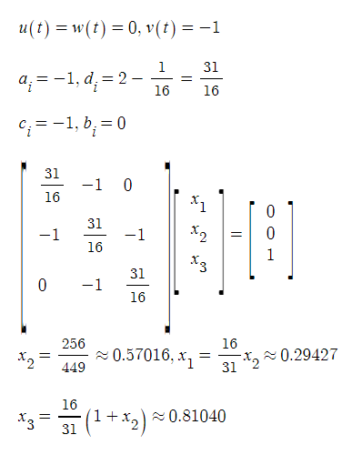

actually finite difference method uses approximation with regard to derivatives where the errors occur.

8.

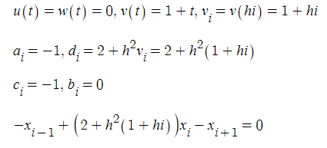

10.

pick one x(a) and determine the difference, use secant method to find the right x(a)

that produces x(b) that satisfies Ax(A)+Bx(b)=C

11.

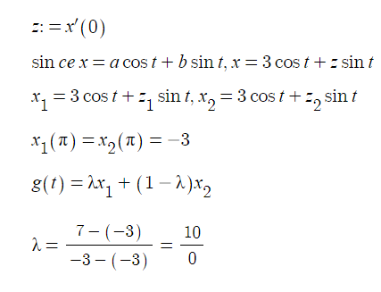

Com

3.

refer to 11.2.3.py

[-1.856578049814647, -3.742579239677249, -5.6743250564852445, -7.63924739892369, -9.572253005342015, -11.31160054338293, -12.500559356776211, -12.338188686734057, -8.878916371460614]

[0.0, 0.9321932541088741, 1.803889035302905, 2.560511784826833, 3.1587500940262245, 3.5707963267948966, 3.787068624744183, 3.81714884626275, 3.688844627456781, 3.4454673769807087, 3.1415926535897936]

9.

refer to 11.2.9.py

a.

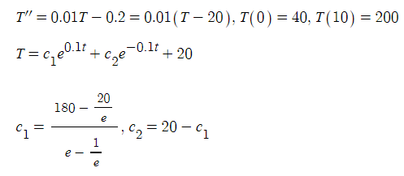

b.

if z=0, 50.708461706947574

if z=15, 226.11707331806969

if z=13, 202.72925843658686

2.0 66.0 65.95179139812663

4.0 92.8 93.74778953274318

6.0 121.44 124.50354540736095

8.0 152.992 159.45339549601167

10.0 188.6016 200.00000000000003

error can be mitigated by decreasing the step size.

1.0 53.0 52.81170043588546

2.0 66.2 65.95179139812663

3.0 79.73 79.55178333361073

4.0 93.72200000000001 93.74778953274318

5.0 108.3113 108.68188839700741

6.0 123.63782 124.50354540736095

7.0 139.847453 141.37110902500592

8.0 157.0934642 159.45339549601167

9.0 175.53794993 178.9313784210464

10.0 195.353370302 200.00000000000003

c.

2.0 65.96983436677662 65.95179139812663

4.0 93.77846210822432 93.74778953274318

6.0 124.538228334001 124.50354540736095

8.0 159.47952369313774 159.45339549601167

error can be mitigated by decreasing the step size.

1 52.81408905276428 52.81170043588546

2 65.9563189960562 65.95179139812663

3 79.55811212930867 79.55178333361073

4 93.7554863838542 93.74778953274318

5 108.69041550223828 108.68188839700741

6 124.5122487756447 124.50354540736095

7 141.37920453680755 141.37110902500592

8 159.45995234333847 159.45339549601167

9 178.93529967330275 178.9313784210464