7.1

12.

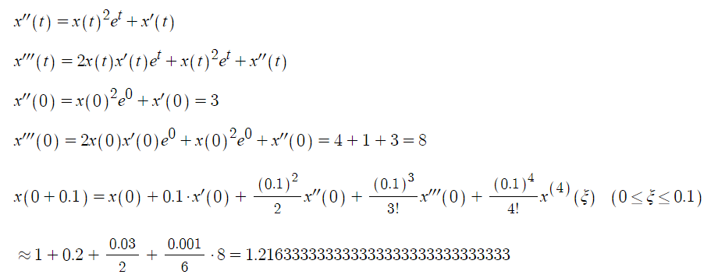

15.

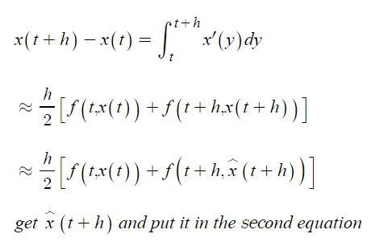

Com

3.

refer to 7.1.3.py

blue curve is from the taylor series

red curve is from y=e^x

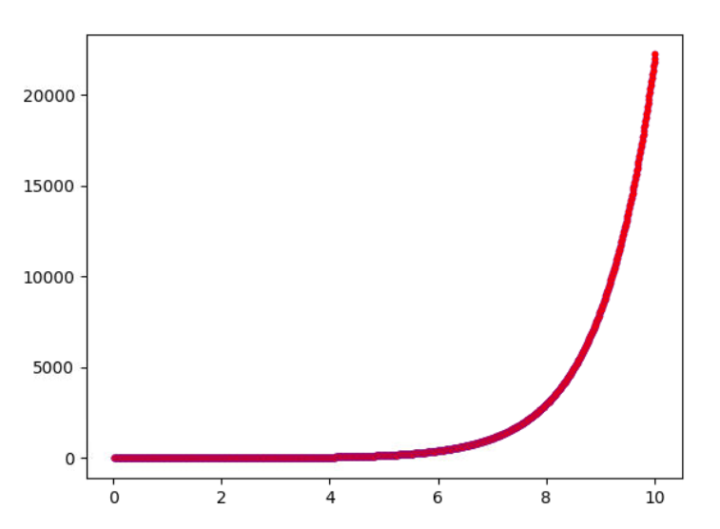

7.2

4.

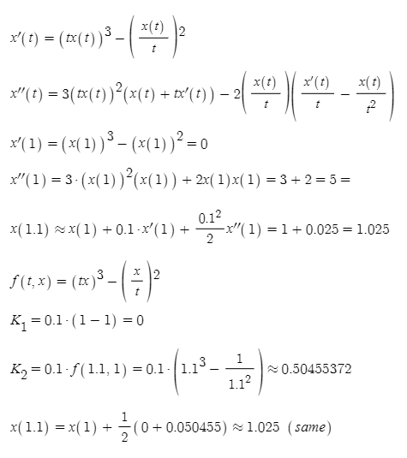

7.

a.

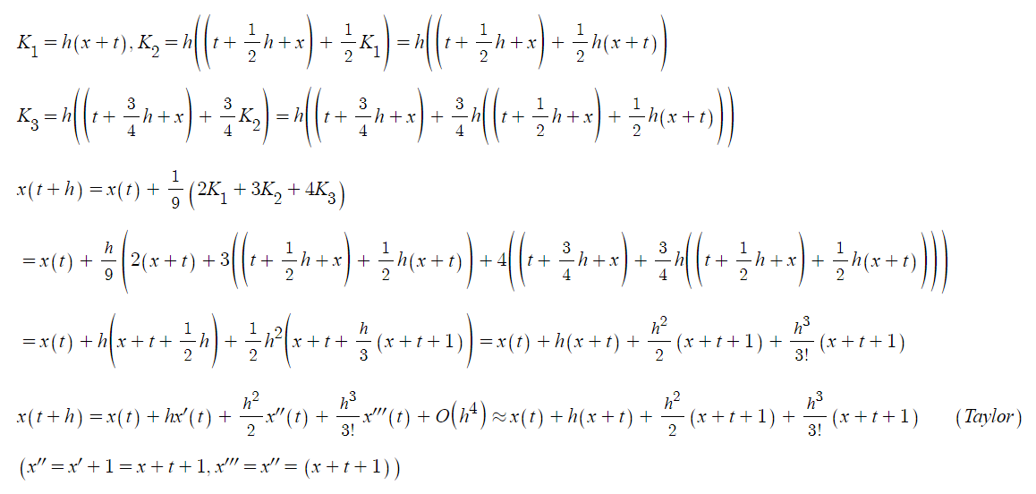

b.

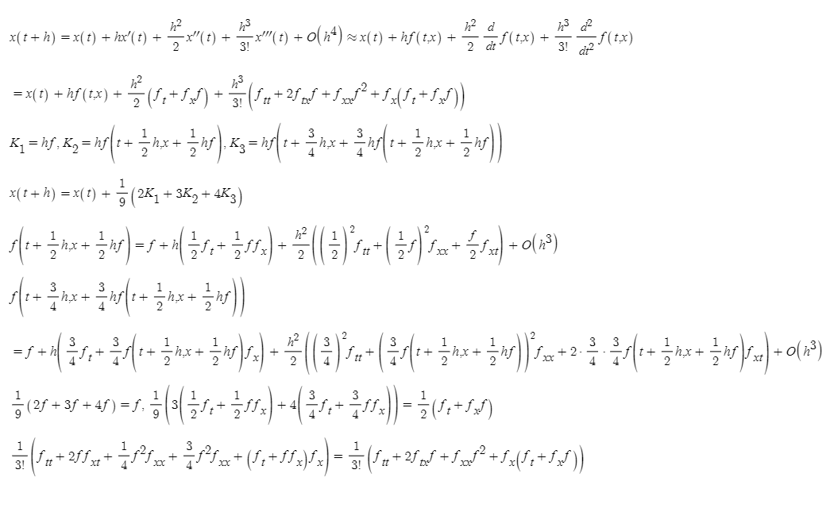

10.

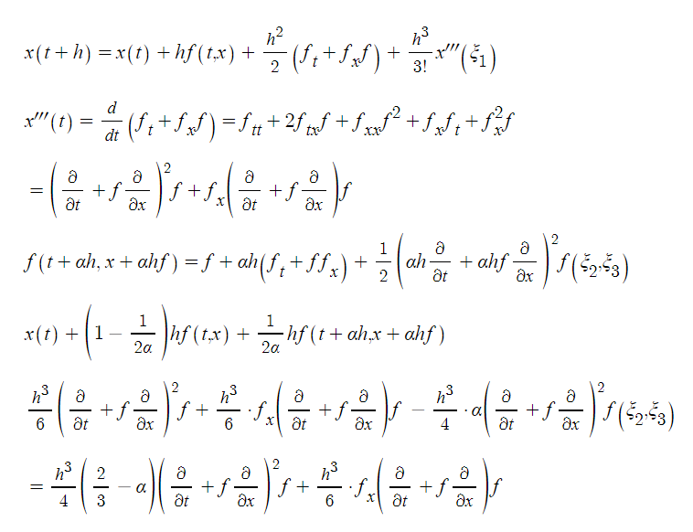

Com

8.

refer to 7.2.8.py

below is the result with h=0.09

r is real value, e is error, pe is percent error.

t -0.91 x 1.00417423375

r 1.0041742837052103 e 4.995521041273321e-08 pe 4.974755002528851e-06

t -0.8200000000000001 x 1.0172172538023996

r 1.0172173631218102 e 1.0931941063496708e-07 pe 1.07469076520154e-05

t -0.7300000000000001 x 1.0399642713115198

r 1.0399644507332475 e 1.7942172769735976e-07 pe 1.7252678932520715e-05

t -0.6400000000000001 x 1.0733291528021593

r 1.0733294145603403 e 2.617581809083447e-07 pe 2.4387497198664464e-05

t -0.5500000000000002 x 1.1183118274788393

r 1.1183121854901685 e 3.5801132924895285e-07 pe 3.201354093195654e-05

t -0.4600000000000002 x 1.176006392112721

r 1.1760068621848583 e 4.7007213721528274e-07 pe 3.997188726789856e-05

t -0.3700000000000002 x 1.2476099792000386

r 1.247610579264343 e 6.000643044679066e-07 pe 4.809708369271252e-05

t -0.28000000000000025 x 1.3344324602725557

r 1.3344332106438874 e 7.503713317369431e-07 pe 5.623146409664638e-05

t -0.19000000000000025 x 1.437907063009851

r 1.4379079866764712 e 9.236666203005228e-07 pe 6.423683774338389e-05

t -0.10000000000000026 x 1.5596019882100167

r 1.5596031111569493 e 1.1229469325524377e-06 pe 7.200209620763132e-05

t -0.010000000000000259 x 1.7012331207796716

r 1.7012344723492618 e 1.3515695902466263e-06 pe 7.944640272779226e-05

t 0.07999999999999974 x 1.8578846852717184

r 1.8581054157156056 e 0.0002207304438872626 pe 0.0118793283750402

t 0.16999999999999973 x 2.0211413794530424

r 2.021382935887768 e 0.00024155643472578703 pe 0.0119500580734693

t 0.25999999999999973 x 2.1912969666759508

r 2.191561314033838 e 0.0002643473578873845 pe 0.012062056224236806

t 0.34999999999999976 x 2.369001144906358

r 2.3692904335104585 e 0.00028928860410060153 pe 0.012209925807701725

t 0.4399999999999997 x 2.554964796918287

r 2.55528137997388 e 0.00031658305559290056 pe 0.012389361816432784

t 0.5299999999999997 x 2.749965752326291

r 2.750312205062679 e 0.0003464527363878922 pe 0.012596851213842346

t 0.6199999999999997 x 2.9548550922528616

r 2.955234232871182 e 0.0003791406183202284 pe 0.012829460829298504

t 0.7099999999999996 x 3.1705640477330603

r 3.1709789603305008 e 0.00041491259744041997 pe 0.013084684655150627

t 0.7999999999999996 x 3.3981115477711197

r 3.3985656074280097 e 0.000454059656890049 pe 0.013360332250101107

t 0.8899999999999996 x 3.6386124782294913

r 3.6391093784633277 e 0.000496900233836417 pe 0.013654446243829062

t 0.9799999999999995 x 3.8932867184924422

r 3.893830501302176 e 0.0005437828097338837 pe 0.013965240899726675

below is the result with h=0.1

t -0.9 x 1.0051708333333333

r 1.0051709180756476 e 8.474231427690881e-08 pe 8.430637292923675e-06

t -0.8 x 1.0214025708506944

r 1.02140275816017 e 1.8730947548561971e-07 pe 1.8338454051467035e-05

t -0.7000000000000001 x 1.0498584970625378

r 1.049858807576003 e 3.105134651626429e-07 pe 2.9576688114812407e-05

t -0.6000000000000001 x 1.0918242400806857

r 1.0918246976412702 e 4.575605845325015e-07 pe 4.190788003980814e-05

t -0.5000000000000001 x 1.148720638596838

r 1.1487212707001282 e 6.321032901546175e-07 pe 5.502668978779858e-05

t -0.40000000000000013 x 1.222117962091933

r 1.2221188003905088 e 8.382985758892403e-07 pe 6.859386956663911e-05

t -0.30000000000000016 x 1.3137516265967766

r 1.3137527074704765 e 1.0808736998768609e-06 pe 8.227375621992018e-05

t -0.20000000000000015 x 1.4255395632923151

r 1.4255409284924672 e 1.365200152037005e-06 pe 9.57671663261697e-05

t -0.10000000000000014 x 1.5596014137800707

r 1.5596031111569495 e 1.6973768788286492e-06 pe 0.0001088338992584784

t -1.3877787807814457e-16 x 1.7182797441351656

r 1.7182818284590446 e 2.084323879048e-06 pe 0.00012130279471774556

t 0.09999999999999987 x 1.8938218233923143

r 1.8938241877951374 e 2.3644028230851433e-06 pe 0.0001248480634222901

t 0.19999999999999987 x 2.0773087260766703

r 2.077311406416208 e 2.680339537874943e-06 pe 0.00012902926010978214

t 0.2999999999999999 x 2.2695760158887586

r 2.269579052467237 e 3.03657847844363e-06 pe 0.00013379478785471673

t 0.3999999999999999 x 2.4715471334597927

r 2.4715505715621333 e 3.438102340602711e-06 pe 0.0001391071006258906

t 0.4999999999999999 x 2.6842426384417037

r 2.6842465289378086 e 3.890496104830277e-06 pe 0.00014493810694689793

t 0.5999999999999999 x 2.908790423595483

r 2.9087948236140964 e 4.400018613459622e-06 pe 0.00015126603560139458

t 0.6999999999999998 x 3.1464370031037063

r 3.1464419767862455 e 4.973682539155533e-06 pe 0.00015807323242730248

t 0.7999999999999998 x 3.3985599880842923

r 3.3985656074280106 e 5.619343718343828e-06 pe 0.0001653445708407693

t 0.8999999999999998 x 3.666681874164441

r 3.6666882199653705 e 6.3458009296191165e-06 pe 0.00017306628076709093

t 0.9999999999999998 x 3.9524852791052103

r 3.9524924420125584 e 7.162907348146064e-06 pe 0.00018122507388018694

the error with h=0.1 shows less error since in the middle of the approximation, f(t,x) changes and with h=0.1, it deals well since it arrives and continues at 0 theoretically but with 0.9 it doesn’t arrive at 0 so error became large.

7.3

2.

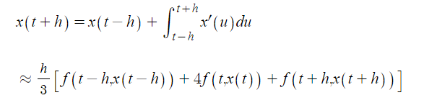

5.

let x(t)=p

p=ap

a=1

let x(t)=t

h=b+c

let x(t)=t^2

b=c=h/2

x(t+h)=x(t)+(h/2)\*(x’(t)+x’(t+h))

=x(t)+(h/2)\*(x’(t)+x’(t)+hx’’(t)+(h^2/2)x’’(t’’))

=x(t)+hx’(t)+(h^2/2)x’’(t)+(h^3/4)x’’(t’’)

since

x(t+h)=x(t)+hx’(t)+(h^2/2)x’’(t)+(h^3/6)x’’(t’)

x’(t+h)=x’(t)+hx’’(t)+(h^2/2)x’’(t’’)

error is (h^3/6)x’’(t’)-(h^3/4)x’’(t’’)=O(h^3)

Com

5.

refer to 7.3.5.py

2.75 4.640619984120999

r 4.640625 e 5.015879001035728e-06 pe 0.00010808628150380019

2.625 4.142573678228233

r 4.142578125 e 4.4467717668084106e-06 pe 0.00010734309969853401

2.5 3.7499960669466414

r 3.75 e 3.9330533585513194e-06 pe 0.00010488142289470186

2.375 3.451168403257359

r 3.451171875 e 3.471742640925868e-06 pe 0.00010059605162162108

2.25 3.2343719404729097

r 3.234375 e 3.0595270903432947e-06 pe 9.459407429080719e-05

2.125 3.087887932445307

r 3.087890625 e 2.6925546929845723e-06 pe 8.719721712891215e-05

2.0 2.9999976339123697

r 3.0 e 2.366087630267799e-06 pe 7.88695876755933e-05

1.875 2.9589823010858582

r 2.958984375 e 2.073914141753619e-06 pe 7.008871554969325e-05

1.75 2.953123192674616

r 2.953125 e 1.8073253840178438e-06 pe 6.120043628420212e-05

1.625 2.9707015717156247

r 2.970703125 e 1.5532843753440773e-06 pe 5.228675872295645e-05

1.5 2.999998708962011

r 3.0 e 1.2910379889596868e-06 pe 4.3034599631989565e-05

1.375 3.0292958894032678

r 3.029296875 e 9.85596732228089e-07 pe 3.2535494964589395e-05

1.25 3.046874425412723

r 3.046875 e 5.745872768692095e-07 pe 1.8858249086989443e-05

1.125 3.0410156847820335

r 3.041015625 e -5.978203354572997e-08 pe -1.965857493603966e-06

1.0 3.000001154694009

r 3.0 e -1.1546940088535962e-06 pe -3.848980029511988e-05

0.875 2.912112600452466

r 2.912109375 e -3.225452466004697e-06 pe -0.00011076000419814921

0.75 2.765632503247134

r 2.765625 e -7.503247133833213e-06 pe -0.0002713038511668506

0.6875 2.6667539863407934

r 2.666748046875 e -5.9394657934142e-06 pe -0.0002227231702812832

0.625 2.5488328378582388

r 2.548828125 e -4.712858238775652e-06 pe -0.00018490294392744323

0.5625 2.4104042307570457

r 2.410400390625 e -3.840132045684896e-06 pe -0.00015931511049453392

0.5 2.250003377444278

r 2.25 e -3.377444278029884e-06 pe -0.00015010863457910596

14.

refer to 7.3.14.py

t 0.1 x 0.1000124977875075

t 0.2 x 0.20019976814053192

t 0.30000000000000004 x 0.30100861798724565

t 0.4 x 0.4031713496525548

t 0.5 x 0.5076787010751099

t 0.6 x 0.6157343306651544

t 0.7 x 0.7286939027464336

t 0.7999999999999999 x 0.8479973838708559

t 0.8999999999999999 x 0.9751053389625817

t 0.9999999999999999 x 1.1114478363149007

7.

separately since they don’t share variable.

10.

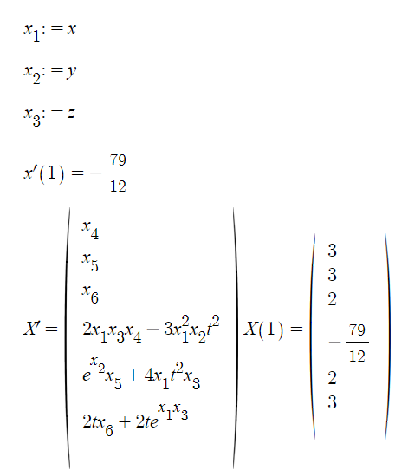

Com

2.

refer to 7.4.2.py

0.0078125 3.055997292200724 2.00771697362264

0.015625 3.1147352401591073 2.0152257261464652

0.0234375 3.1764062718438684 2.022498973537436

0.03125 3.2412211372184756 2.029506877953346

0.0390625 3.309411132366101 2.0362168011482233

0.046875 3.3812306551741007 2.0425930307738525

0.0546875 3.4569601517147928 2.048596476035701

0.0625 3.536909524832936 2.0541843285945416

0.0703125 3.6214220918155386 2.059309683928052

0.078125 3.7108791972023876 2.0639211175523973

0.0859375 3.8057056108798677 2.067962209518746

0.09375 3.9063758720185073 2.0713710094007354

0.1015625 4.013421778072748 2.0740794325203122

0.109375 4.12744126751706 2.0760125763483424

0.1171875 4.2491090087039805 2.077087943767281

0.125 4.379189089913861 2.0772145570693112

0.1328125 4.5185503138153695 2.076291943015385

0.140625 4.668184742192363 2.0742089647703117

0.1484375 4.829230326583929 2.0708424707458812

0.15625 5.002998715409712 2.0660557229011522

0.1640625 5.191009674029991 2.059696557273618

0.171875 5.395034028556644 2.0515952166142766

0.1796875 5.617147702394965 2.041561777789668

0.1875 5.859800339123564 2.0293830733896185

0.1953125 6.125903321887812 2.014818975250614

0.203125 6.41894390165307 1.9975978636798606

0.2109375 6.743134938783186 1.9774110444817017

0.21875 7.1036139322664384 1.9539057879146662

0.2265625 7.506711357277795 1.926676536103126

0.234375 7.960318193844965 1.8952536368831452

0.2421875 8.474398211508616 1.8590886777348814

0.25 9.06171615775115 1.8175350548763574

0.2578125 9.738895943498564 1.7698217187807024

0.265625 10.527997371273843 1.7150169081725903

0.2734375 11.458933832682874 1.6519767865926878

0.28125 12.573304446076826 1.5792705858275529

0.2890625 13.930708226117268 1.4950678376877309

0.296875 15.619637274730643 1.3969617565109602

0.3046875 17.77734035214567 1.2816794635249242

0.3125 20.62859761512535 1.1445788247081001

0.3203125 24.568199315362932 0.978710554269703

0.328125 30.357140532107188 0.7729022593980749

0.3359375 39.665866168586646 0.5073306631925579

0.34375 56.94718947872275 0.14132046606147763

0.3515625 98.57499887284726 -0.43086383620139257

0.359375 277.9964983464459 -1.6425962251717734

0.3671875 5041.14249359243 -9.506214548015159

0.375 315977129.73099625 -21141.43262449988

0.3828125 4.7532741776553843e+27 -5.014030701027034e+18

seems not not so accurate change too much with the h value.

3.

refer to 7.4.3.py

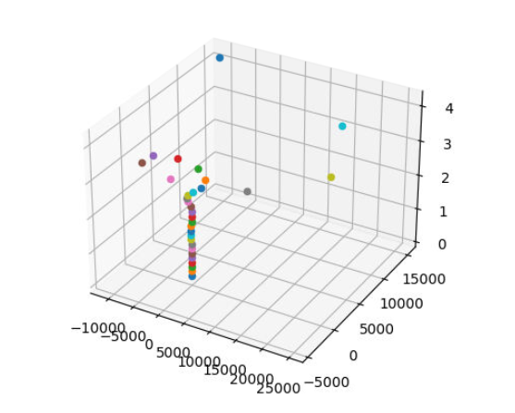

lower left is x axis, lower right is y axis, and the vertical axis is z azis.

17.

refer to 7.4.17.py

x1:=x

x2:=x’

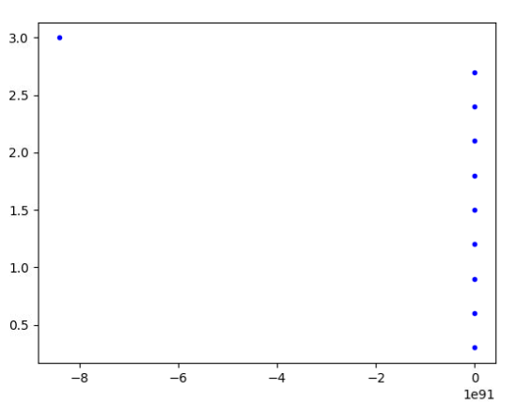

vertical : t

horizontal : x

7.5

2.

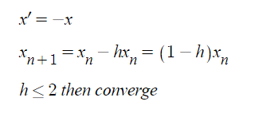

4.

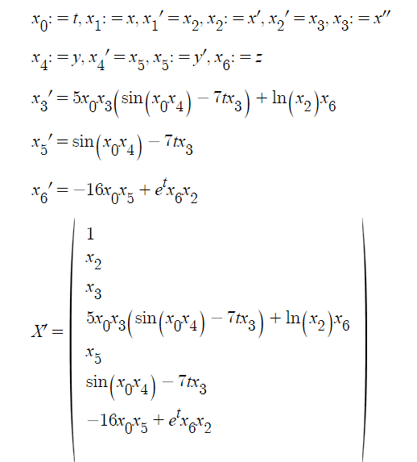

Com

4.

refer to 7.5.4.py

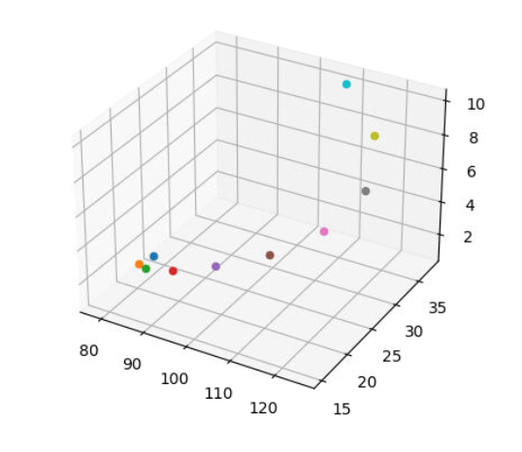

vertical axis is t

left bottom is predator

left right is prey

7b.

refer to 7.5.7b.py

the values are as follows.

0.1 [-37.77203125000002, -120.68907552083337, 35.06595319733794]

0.2 [3931.1164778429556, 548761.9470355718, 210458.8964862692]

0.30000000000000004 [-1.9331849400642575e+18, 7.634822448271081e+29, 2.885982587761712e+29]

0.4 [-1.237747142915426e+120, -4.612309770653574e+194, -1.743464995768663e+194]

0.5 [nan, nan, nan]

0.6 [nan, nan, nan]

0.7 [nan, nan, nan]

0.7999999999999999 [nan, nan, nan]

0.8999999999999999 [nan, nan, nan]

0.9999999999999999 [nan, nan, nan]

