8.1

2.

a.

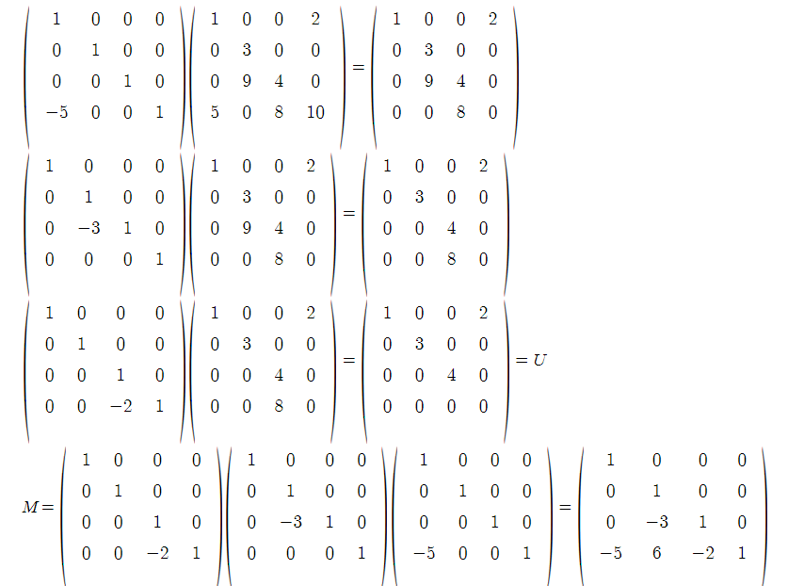

b.

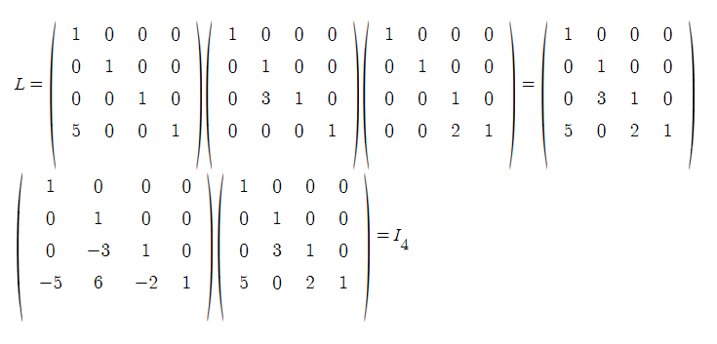

6.

a.

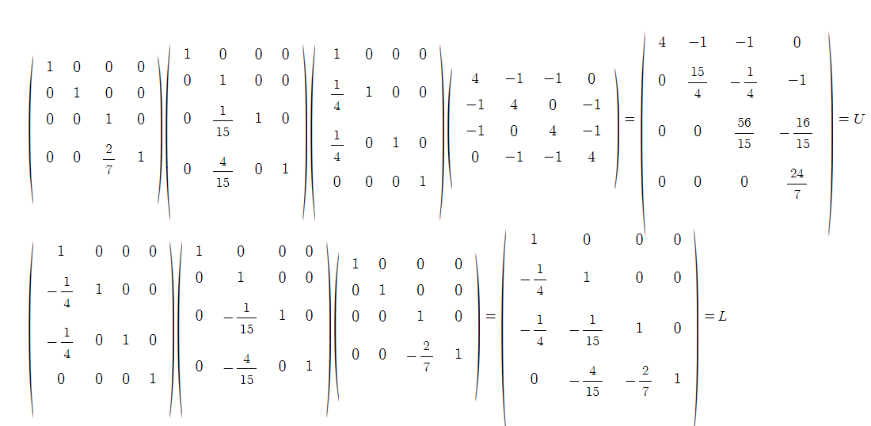

b.

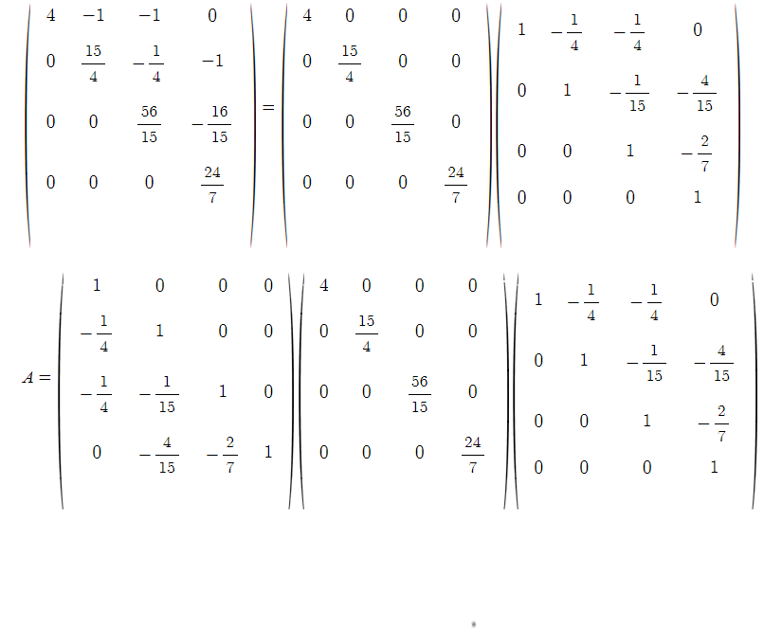

c.

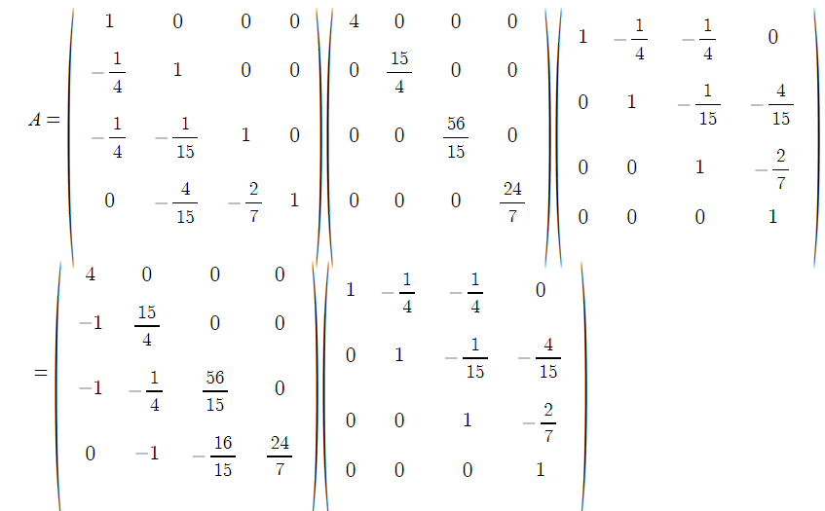

d.

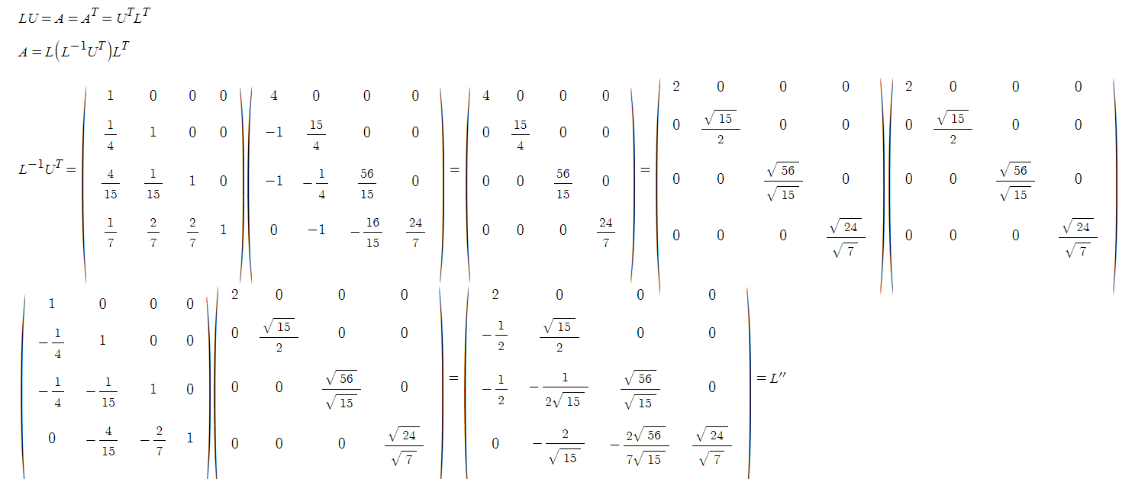

e. det(A)=det(L)det(D)det(U’)=1*(24*8)*1=192

19.

a.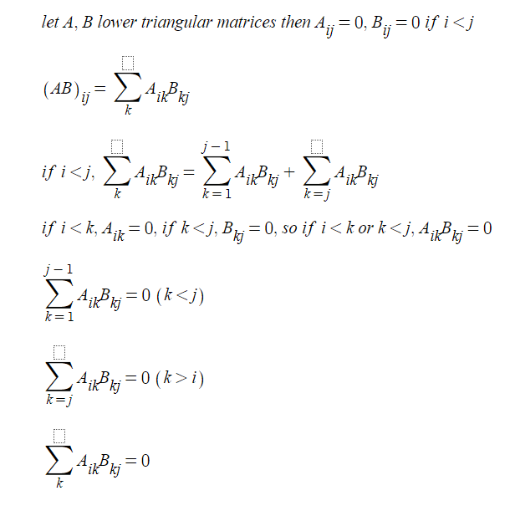

b. according to a., it’s at least lower triangular.

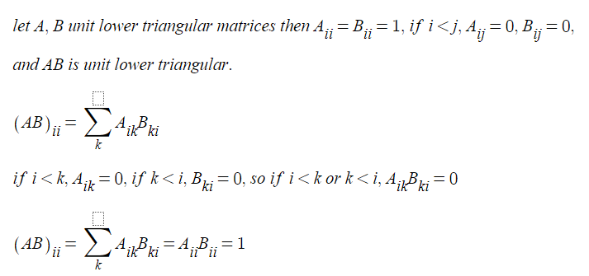

c.

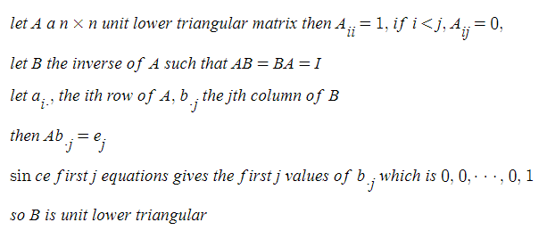

d.

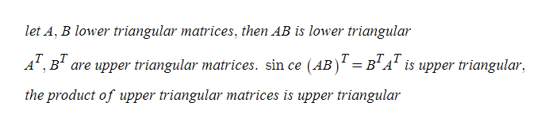

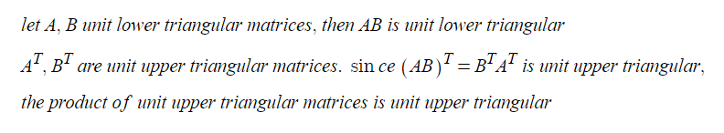

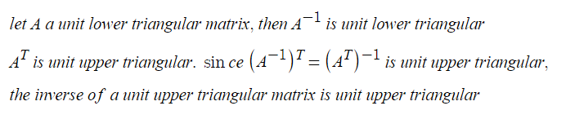

20.

a.

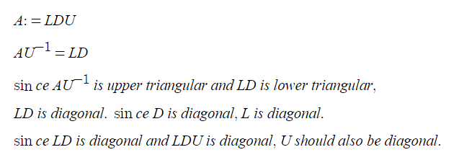

b.

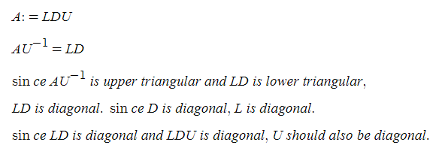

c.

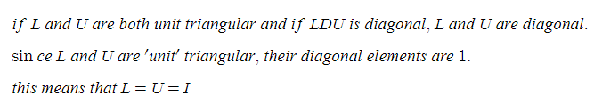

Com.

2.

refer to 8.1.2.py

Doolittle

L

[5.0, 0, 0, 0]

[7.0, 0.20000000000000107, 0, 0]

[6.0, -0.3999999999999986, 2.000000000000007, 0]

[5.0, 0.0, 3.0, 0.500000000000016]

U

[1.0, 1.4, 1.2, 1.0]

[0, 1.0, -1.9999999999999911, 0.0]

[0, 0, 1.0, 1.4999999999999947]

[0, 0, 0, 1.0]

Crout

L

[1.0, 0, 0, 0]

[1.4, 1.0, 0, 0]

[1.2, -1.9999999999999911, 1.0, 0]

[1.0, 0.0, 1.4999999999999947, 1.0]

U

[5.0, 7.0, 6.0, 5.0]

[0, 0.20000000000000107, -0.3999999999999986, 0.0]

[0, 0, 2.000000000000007, 3.0]

[0, 0, 0, 0.500000000000016]

l1, u1, l1, u1

L

[1.0, 0, 0, 0]

[1.4, 0.20000000000000107, 0, 0]

[1.2, -0.40000000000000036, 1.0, 0]

[1.0, 0.0, 1.4999999999999947, 0.500000000000016]

U

[5.0, 7.0, 6.0, 5.0]

[0, 1.0, -1.9999999999999822, 0.0]

[0, 0, 2.000000000000007, 3.0]

[0, 0, 0, 1.0]

u1, l1, u1, l1

L

[5.0, 0, 0, 0]

[7.0, 1.0, 0, 0]

[6.0, -1.9999999999999822, 2.000000000000007, 0]

[5.0, 0.0, 3.0, 1.0]

U

[1.0, 1.4, 1.2, 1.0]

[0, 0.20000000000000107, -0.40000000000000036, 0.0]

[0, 0, 1.0, 1.4999999999999947]

[0, 0, 0, 0.500000000000016]

u3, u5, l7, l9

L

[1.6666666666666667, 0, 0, 0]

[2.3333333333333335, 0.039999999999999855, 0, 0]

[2.0, -0.08000000000000007, 7.0, 0]

[1.6666666666666667, -1.7763568394002506e-16, 10.500000000000012, 9.0]

U

[3.0, 4.2, 3.5999999999999996, 3.0]

[0, 5.0, -10.000000000000044, 0.0]

[0, 0, 0.2857142857142852, 0.42857142857142855]

[0, 0, 0, 0.05555555555555496]

6.

refer to 8.1.6.py

7.

refrer to 8.1.6.py

computed columns of the inverse of A

[-0.909090909090909, -0.818181818181818, -0.7272727272727272, -0.6363636363636364, -0.5454545454545455, -0.4545454545454546, -0.36363636363636365, -0.2727272727272727, -0.1818181818181818, -0.09090909090909088]

[-0.818181818181818, -1.636363636363636, -1.4545454545454544, -1.2727272727272727, -1.090909090909091, -0.9090909090909092, -0.7272727272727273, -0.5454545454545454, -0.3636363636363636, -0.18181818181818177]

[-0.7272727272727272, -1.4545454545454544, -2.1818181818181817, -1.9090909090909094, -1.6363636363636367, -1.363636363636364, -1.090909090909091, -0.818181818181818, -0.5454545454545453, -0.27272727272727265]

[-0.6363636363636364, -1.2727272727272727, -1.9090909090909092, -2.545454545454546, -2.1818181818181825, -1.8181818181818188, -1.4545454545454548, -1.090909090909091, -0.7272727272727273, -0.36363636363636365]

[-0.5454545454545455, -1.090909090909091, -1.6363636363636367, -2.1818181818181825, -2.727272727272728, -2.2727272727272734, -1.8181818181818186, -1.3636363636363638, -0.9090909090909091, -0.45454545454545453]

[-0.45454545454545464, -0.9090909090909093, -1.363636363636364, -1.8181818181818188, -2.2727272727272734, -2.727272727272728, -2.181818181818182, -1.636363636363636, -1.0909090909090906, -0.5454545454545453]

[-0.3636363636363637, -0.7272727272727274, -1.090909090909091, -1.454545454545455, -1.8181818181818188, -2.1818181818181825, -2.545454545454546, -1.909090909090909, -1.2727272727272725, -0.6363636363636361]

[-0.27272727272727276, -0.5454545454545455, -0.8181818181818182, -1.090909090909091, -1.3636363636363638, -1.6363636363636365, -1.909090909090909, -2.1818181818181817, -1.4545454545454544, -0.7272727272727271]

[-0.1818181818181818, -0.3636363636363636, -0.5454545454545454, -0.7272727272727273, -0.9090909090909091, -1.0909090909090908, -1.2727272727272725, -1.4545454545454541, -1.636363636363636, -0.818181818181818]

[-0.09090909090909093, -0.18181818181818185, -0.27272727272727276, -0.3636363636363637, -0.45454545454545464, -0.5454545454545455, -0.6363636363636364, -0.7272727272727272, -0.8181818181818181, -0.9090909090909091]

this matches with the known result

8.2

4.

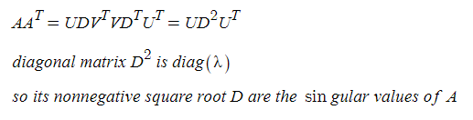

6.

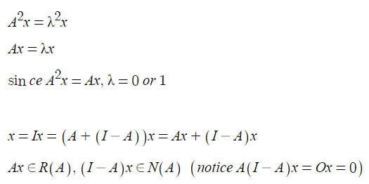

13. true

from the middle of the disc, the eigenvalue should not be farther than the magnitude of the sum of the elements in the same row except the element in diagonal position.

14. true

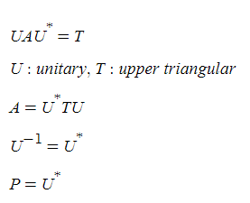

15. True

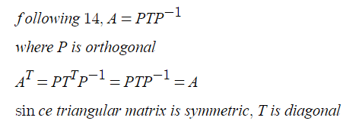

16.

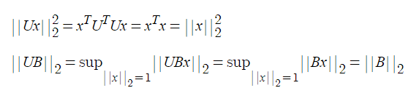

17.

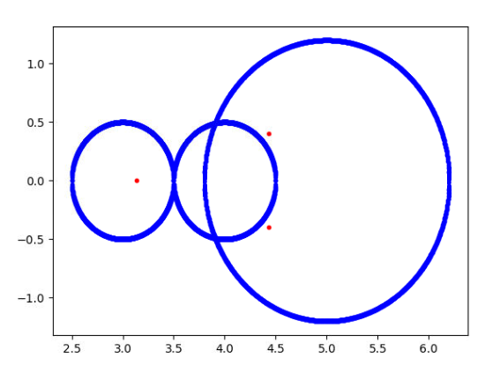

the code is as follows.

import matplotlib.pyplot as plt

import numpy as np

from math import sqrt

x=np.linspace(4-1/2,4+1/2,1000)

for v in x:

y=sqrt((1/2)**2-(v-4)**2)

plt.plot(v,y,".b")

plt.plot(v,-y,".b")

x=np.linspace(5-6/5,5+6/5,1000)

for v in x:

if (6/5)**2-(v-5)**2 >= 0:

y=sqrt((6/5)**2-(v-5)**2)

plt.plot(v,y,".b")

plt.plot(v,-y,".b")

x=np.linspace(3-1/2,3+1/2,1000)

for v in x:

y=sqrt((1/2)**2-(v-3)**2)

plt.plot(v,y,".b")

plt.plot(v,-y,".b")

plt.plot(4.43217,0.400392,".r")

plt.plot(4.43217,-0.400392,".r")

plt.plot(3.13566,0,".r")

plt.show()

Com

1.

refer to 8.2.1.py

a.

eigenvalues

[ 2.79583152 -6.79583152]

eigenvectors - each column corresponds to each eigenvalue.

[[ 0.96863191 -0.66810749]

[ 0.24849996 0.74406477]]

b.

eigenvalues

[ 5.26652176e+00+8.88267338j 5.26652176e+00-8.88267338j

9.69214673e+00+0.j -5.23387869e+00+0.j

8.68843731e-03+0.j ]

eigenvectors - each column corresponds to each eigenvalue.

[[ 0.14369289+0.30174472j 0.14369289-0.30174472j -0.42786174+0.j

0.64442482+0.j -0.33812933+0.j ]

[ 0.58690827+0.j 0.58690827-0.j 0.2786041 +0.j

0.46012634+0.j 0.0627388 +0.j ]

[-0.0581887 +0.38795358j -0.0581887 -0.38795358j -0.00436881+0.j

-0.50587636+0.j -0.18414327+0.j ]

[ 0.48164764-0.13469658j 0.48164764+0.13469658j -0.77970442+0.j

-0.23966988+0.j -0.18301298+0.j ]

[ 0.27377303+0.25469191j 0.27377303-0.25469191j 0.36243072+0.j

-0.24422912+0.j 0.90240229+0.j ]]

c.

eigenvalues

[6.84235761 2.09156745 1.04508502 0.63392223 0.41458528 0.28518697

0.2049606 0.15241759 0.11616278 0.08993111 0.07001349 0.05380986]

d.

[3.73205081 3. 2. 0.26794919 1. ]

-> [0.2679491924311226, 0.9999999999999998, 1.9999999999999998, 2.9999999999999996, 3.7320508075688776]

[3.80193774 3.2469796 2.44504187 0.19806226 1.55495813 0.7530204 ]

-> [0.1980622641951617, 0.7530203962825328, 1.554958132087371, 2.4450418679126287, 3.2469796037174667, 3.801937735804838]

[3.84775907 3.41421356 2.76536686 2. 0.15224093 0.58578644

1.23463314]

-> [0.15224093497742652, 0.5857864376269049, 1.2346331352698203, 1.9999999999999998, 2.7653668647301792, 3.414213562373095, 3.8477590650225735]

[3.87938524 3.53208889 3. 2.34729636 1.65270364 0.12061476

0.46791111 1. ]

-> [0.12061475842818314, 0.467911113762044, 0.9999999999999998, 1.6527036446661392, 2.3472963553338606, 2.9999999999999996, 3.532088886237956, 3.879385241571817]

[3.90211303 3.61803399 3.1755705 2.61803399 2. 0.09788697

0.38196601 1.38196601 0.8244295 ]

-> [0.09788696740969294, 0.3819660112501051, 0.8244294954150537, 1.381966011250105, 1.9999999999999998, 2.618033988749895, 3.175570504584946, 3.618033988749895, 3.9021130325903073]

[3.91898595 3.68250707 3.30972147 2.83083003 2.28462968 1.71537032

0.08101405 0.31749293 0.69027853 1.16916997]

-> [0.08101405277100526, 0.3174929343376376, 0.6902785321094298, 1.1691699739962271, 1.7153703234534299, 2.28462967654657, 2.8308300260037726, 3.30972146789057, 3.682507065662362, 3.918985947228995]

[3.93185165 3.73205081 3.41421356 3. 2.51763809 2.

1.48236191 0.06814835 0.26794919 0.58578644 1. ]

-> [0.06814834742186338, 0.2679491924311226, 0.5857864376269049, 0.9999999999999998, 1.4823619097949585, 1.9999999999999998, 2.5176380902050415, 2.9999999999999996, 3.414213562373095, 3.7320508075688776, 3.9318516525781364]

[3.94188363 3.77091205 3.4970215 3.13612949 2.70920977 2.24107336

1.75892664 0.05811637 0.22908795 0.5029785 1.29079023 0.86387051]

-> [0.058116365147895976, 0.22908794869358018, 0.5029785036577978, 0.8638705065376882, 1.2907902259149289, 1.758926639489354, 2.241073360510646, 2.709209774085071, 3.1361294934623114, 3.497021496342202, 3.770912051306419, 3.941883634852104]

[3.94985582 3.80193774 3.56366296 3.2469796 2.86776748 2.44504187

2. 1.55495813 0.05014418 0.19806226 0.43633704 0.7530204

1.13223252]

-> [0.05014417563635276, 0.1980622641951617, 0.4363370350639404, 0.7530203962825328, 1.1322325217648836, 1.554958132087371, 1.9999999999999998, 2.4450418679126287, 2.867767478235116, 3.2469796037174667, 3.563662964936059, 3.801937735804838, 3.9498558243636475]

[3.9562952 3.82709092 3.61803399 3.33826121 3. 2.61803399

2.20905693 1.79094307 1.38196601 0.0437048 0.17290908 0.38196601

0.66173879 1. ]

-> [0.04370479853238862, 0.17290908471479827, 0.3819660112501051, 0.6617387872822835, 0.9999999999999998, 1.381966011250105, 1.7909430734646932, 2.2090569265353066, 2.618033988749895, 2.9999999999999996, 3.3382612127177156, 3.618033988749895, 3.827090915285202, 3.9562952014676114]

[3.96157056 3.84775907 3.66293922 3.41421356 3.11114047 2.76536686

2.39018064 2. 1.60981936 0.03842944 0.15224093 0.33706078

0.58578644 1.23463314 0.88885953]

-> [0.03842943919353914, 0.15224093497742652, 0.33706077539490953, 0.5857864376269049, 0.8888595339607954, 1.2346331352698203, 1.6098193559677434, 1.9999999999999998, 2.3901806440322564, 2.7653668647301792, 3.111140466039204, 3.414213562373095, 3.6629392246050907, 3.8477590650225735, 3.961570560806461]

[3.9659462 3.86494446 3.70043427 3.47801783 3.20526927 2.89147671

2.54732598 2.18453672 1.81546328 1.45267402 0.0340538 0.13505554

0.29956573 0.52198217 0.79473073 1.10852329]

-> [0.03405380063219643, 0.13505554119128838, 0.29956572854077157, 0.5219821655586818, 0.7947307272414872, 1.1085232884469234, 1.4526740198558339, 1.815463281073396, 2.1845367189266036, 2.5473259801441657, 2.8914767115530755, 3.2052692727585126, 3.4780178344413186, 3.700434271459228, 3.8649444588087114, 3.965946199367804]

[3.96961551 3.87938524 3.73205081 3.53208889 3.28557522 3.

2.68404029 2.34729636 2. 1.65270364 1.31595971 0.03038449

0.12061476 0.26794919 0.46791111 0.71442478 1. ]

-> [0.03038449397558396, 0.12061475842818314, 0.2679491924311226, 0.467911113762044, 0.7144247806269213, 0.9999999999999998, 1.3159597133486622, 1.6527036446661392, 1.9999999999999998, 2.3472963553338606, 2.684040286651337, 2.9999999999999996, 3.2855752193730785, 3.532088886237956, 3.7320508075688767, 3.879385241571817, 3.9696155060244163]

[3.97272261 3.89163448 3.7589475 3.57828102 3.35456314 3.09389632

2.80339085 2.49097097 2.16515869 1.83484131 1.50902903 0.02727739

0.10836552 0.2410525 0.42171898 0.64543686 1.19660915 0.90610368]

-> [0.027277393194555355, 0.10836551659873073, 0.24105249758702185, 0.42171898120721285, 0.6454368567485178, 0.9061036837551462, 1.1966091506940608, 1.5090290257184016, 1.8348413090553353, 2.1651586909446645, 2.490970974281598, 2.8033908493059387, 3.0938963162448543, 3.3545631432514815, 3.578281018792787, 3.758947502412978, 3.8916344834012695, 3.9727226068054446]

[3.97537668 3.90211303 3.78201305 3.61803399 3.41421356 3.1755705

2.907981 2.61803399 2.31286893 2. 1.68713107 1.38196601

0.02462332 0.09788697 0.21798695 0.38196601 0.58578644 0.8244295

1.092019 ]

-> [0.02462331880972446, 0.09788696740969294, 0.2179869516232642, 0.3819660112501051, 0.5857864376269049, 0.8244294954150537, 1.0920190005209065, 1.381966011250105, 1.687131069919538, 1.9999999999999998, 2.312868930080461, 2.618033988749895, 2.9079809994790935, 3.175570504584946, 3.414213562373095, 3.618033988749895, 3.7820130483767356, 3.9021130325903073, 3.9753766811902755]

[3.97766165 3.91114561 3.80193774 3.65247755 3.46610374 3.2469796

3. 2.73068205 2.44504187 2.14946019 1.85053981 1.55495813

1.26931795 0.02233835 0.08885439 0.19806226 0.34752245 0.53389626

0.7530204 1. ]

-> [0.022338347549742954, 0.08885438842771864, 0.1980622641951617, 0.3475224513680102, 0.5338962563403473, 0.7530203962825328, 0.9999999999999998, 1.26931795126721, 1.554958132087371, 1.8505398128271513, 2.1494601871728483, 2.4450418679126287, 2.73068204873279, 2.9999999999999996, 3.2469796037174667, 3.4661037436596525, 3.65247754863199, 3.801937735804838, 3.911145611572281, 3.977661652450257]

the values after the arrow are calculated from the formula given.

e.

[3.77099469e+02 4.19741134e+01 1.51642553e+01 7.77808429e+00

4.73875626e+00 3.20052355e+00 2.31609946e+00 1.76150733e+00

1.39118116e+00 1.13184583e+00 9.43354831e-01 8.02217835e-01

6.93948690e-01 6.09221735e-01 5.41814808e-01 4.87449200e-01

4.43105928e-01 4.06607290e-01 3.76352314e-01 3.51144706e-01

3.30078146e-01 3.12458154e-01 2.97747834e-01 2.85529600e-01

2.75477793e-01 2.67338901e-01 2.60917179e-01 2.56064191e-01

2.50664276e-01 2.52671281e-01]

-> [377.0994687193352, 41.97411337433616, 15.164255327711809, 7.778084291052164, 4.738756263798964, 3.2005235508227874, 2.3160994627219886, 1.7615073268692525, 1.3911811639771492, 1.131845827509455, 0.943354830985789, 0.8022178353467644, 0.6939486902485623, 0.609221734920549, 0.5418148082107227, 0.48744920008501774, 0.44310592772448915, 0.4066072896955096, 0.3763523142414568, 0.35114470593329433, 0.33007814633238153, 0.31245815393464554, 0.29774783438670477, 0.2855296001320933, 0.2754777926410027, 0.26733890052225373, 0.260917178588397, 0.25606419145917686, 0.25267128056177873, 0.2506642759206793]

the values after the arrow are calculated from the formula given.

12.

refer to 8.2.12.py

a.

U

[[-1.]]

D

[3.]

V^T

[[-0.66666667 -0.33333333 -0.66666667]

[-0.33333333 0.93333333 -0.13333333]

[-0.66666667 -0.13333333 0.73333333]]

b.

U

[[ 0.6 -0.8]

[ 0.8 0.6]]

D

[5.]

V^T

[[1.]]

8.3

3.

a. with the power method, iterate the following procedure.

x_n+1 = Ax_n

print T(x_n+1)/T(x_n)

then the eigenvalue with biggest absolute value will be the ratio. and x would become the eigenvector.

b. by taking a proper μ value and using A-μI, by inverse power method, the eigenvalue closest to μ can be acquired. by solving Ax=λx, a eigenvector can be acquired.

c. by using inverse power method, the least dominant eigenvalue is acquired. by solving Ax=λx, a eigenvector can be acquired.

d. by taking a proper μ value and using A-μI, by inverse power method, the eigenvalue closest to μ can be acquired. by solving Ax=λx, a eigenvector can be acquired. by using power method, the eigenvalue farthest from μ is acquired. by solving Ax=λx, a eigenvector can be acquired.

6.

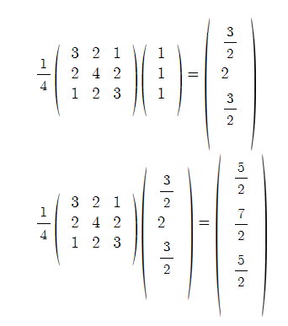

this gives an eigenvalue of around 1.7

this is to find the least dominant eigenvalue of A by finding the most dominant eigenvalue of C.

7. since Ax=λx, x^TAx/x^Tx=λ

Com

1.

a.

refer to 8.3.1.py

[11. 11. 8. 8.] r 11.0 s 0

[115. 115. 70. 70.] r 10.454545454545455 s 0

[1175. 1175. 650. 650.] r 10.217391304347826 s 0

[11875. 11875. 6250. 6250.] r 10.106382978723405 s 0

[119375. 119375. 61250. 61250.] r 10.052631578947368 s 0

[1196875. 1196875. 606250. 606250.] r 10.026178010471204 s 10.000542593597396

[11984375. 11984375. 6031250. 6031250.] r 10.013054830287206 s 10.000135637359955

[1.19921875e+08 1.19921875e+08 6.01562500e+07 6.01562500e+07] r 10.00651890482399 s 10.000033908650096

[1.19960938e+09 1.19960938e+09 6.00781250e+08 6.00781250e+08] r 10.003257328990228 s 10.000008477119408

[1.19980469e+10 1.19980469e+10 6.00390625e+09 6.00390625e+09] r 10.001628134158254 s 10.000002119277156

[1.19990234e+11 1.19990234e+11 6.00195312e+10 6.00195312e+10] r 10.00081393455966 s 10.000000529819118

[1.19995117e+12 1.19995117e+12 6.00097656e+11 6.00097656e+11] r 10.000406934158054 s 10.000000132454774

[1.19997559e+13 1.19997559e+13 6.00048828e+12 6.00048828e+12] r 10.000203458799593 s 10.000000033113688

[1.19998779e+14 1.19998779e+14 6.00024414e+13 6.00024414e+13] r 10.000101727330064 s 10.000000008278422

[1.19999390e+15 1.19999390e+15 6.00012207e+14 6.00012207e+14] r 10.000050863147615 s 10.00000000206961

so the biggest eigenvalue is 10.0

[0.08 0.08 0.14 0.14] 0.07999999999999996

[0.004 0.004 0.022 0.022] 0.0499999999999999

[-0.0004 -0.0004 0.0038 0.0038] -0.10000000000000063

[-0.0002 -0.0002 0.0007 0.0007] 0.4999999999999987

[-5.20e-05 -5.20e-05 1.34e-04 1.34e-04] 0.25999999999999956

[-1.16e-05 -1.16e-05 2.62e-05 2.62e-05] 0.22307692307692195

[-2.44e-06 -2.44e-06 5.18e-06 5.18e-06] 0.2103448275862018

[-5.00e-07 -5.00e-07 1.03e-06 1.03e-06] 0.2049180327868609

[-1.012e-07 -1.012e-07 2.054e-07 2.054e-07] 0.20239999999988115

[-2.036e-08 -2.036e-08 4.102e-08 4.102e-08] 0.20118577075039978

[-4.084e-09 -4.084e-09 8.198e-09 8.198e-09] 0.20058939095974515

[-8.180e-10 -8.180e-10 1.639e-09 1.639e-09] 0.20029382956424804

[-1.6372e-10 -1.6372e-10 3.2774e-10 3.2774e-10] 0.2001466991936162

[-3.27559999e-11 -3.27560001e-11 6.55420000e-11 6.55420000e-11] 0.2000732955067951

[-6.55239993e-12 -6.55240007e-12 1.31078000e-11 1.31078000e-11] 0.2000366326892712

[-1.31059993e-12 -1.31060007e-12 2.62150000e-12 2.62150000e-12] 0.20001830479952376

[-2.62131925e-13 -2.62132075e-13 5.24294001e-13 5.24293999e-13] 0.20000911061171545

[-5.24275255e-14 -5.24276745e-14 1.04858200e-13 1.04858200e-13] 0.20000435035539102

[-1.04855655e-14 -1.04857145e-14 2.09715802e-14 2.09715798e-14] 0.20000115143780944

[-2.09706546e-15 -2.09721454e-15 4.19431010e-15 4.19430990e-15] 0.19999545728219265

[-4.19354659e-16 -4.19503741e-16 8.38861451e-16 8.38861349e-16] 0.19997213584121337

[-8.38114188e-17 -8.39605012e-17 1.67772246e-16 1.67772194e-16] 0.19985808440735808

[-1.67026628e-17 -1.68517452e-17 3.35544508e-17 3.35544252e-17] 0.1992886295711503

[-3.28090079e-18 -3.42998321e-18 6.71089342e-18 6.71088058e-18] 0.19642980489602638

[-5.96547314e-19 -7.45629726e-19 1.34218055e-18 1.34217413e-18] 0.1818242462430179

[-5.96765098e-20 -2.08758922e-19 2.68437068e-19 2.68433856e-19] 0.10003650750473532

[ 4.76976618e-20 -1.01384751e-19 5.36878946e-20 5.36862890e-20] -0.7992702973433273

[ 6.91724972e-20 -7.99099152e-20 1.07378197e-20 1.07370169e-20] 1.4502282629072387

[ 7.34674644e-20 -7.56149480e-20 2.14768436e-21 2.14728295e-21] 1.0620906771360237

[ 7.43264578e-20 -7.47559545e-20 4.29597083e-22 4.29396377e-22] 1.0116921613668828

[ 7.44982565e-20 -7.45841558e-20 8.59495224e-23 8.58491696e-23] 1.0023114069450905

[ 7.45326162e-20 -7.45497961e-20 1.72049574e-23 1.71547810e-23] 1.0004612153341446

[ 7.45394882e-20 -7.45429241e-20 3.44851794e-24 3.42342974e-24] 1.00009220054267

[ 7.45408626e-20 -7.45415498e-20 6.93466818e-25 6.80922717e-25] 1.0000184384085173

[ 7.45411374e-20 -7.45412749e-20 1.40574979e-25 1.34302928e-25] 1.0000036876137113

[ 7.45411924e-20 -7.45412199e-20 2.90558032e-26 2.59197782e-26] 1.0000007375200228

[ 7.45412034e-20 -7.45412089e-20 6.28156441e-27 4.71355187e-27] 1.0000001475038958

[ 7.45412056e-20 -7.45412067e-20 1.49151476e-27 7.07508493e-28] 1.000000029500775

[ 7.45412061e-20 -7.45412063e-20 4.15903892e-28 2.39007581e-29] 1.000000005900155

[ 7.45412061e-20 -7.45412062e-20 1.41981248e-28 -5.40203193e-29] 1.000000001180031

the smallest eigenvalue is 1/1.00=1.00

now I did the inverse power method with A-(2.1)I

[0.08293322 0.08293322 0.2138804 0.2138804 ] 0.08293321693583611

[-0.00455352 -0.00455352 0.05717627 0.05717627] -0.05490592478577335

[-0.00576653 -0.00576653 0.01761778 0.01761778] 1.266388944185826

[-0.00251964 -0.00251964 0.0058095 0.0058095 ] 0.43694252213445134

[-0.00093608 -0.00093608 0.00196966 0.00196966] 0.3715132894313695

[-0.0003313 -0.0003313 0.00067494 0.00067494] 0.35391995843996427

[-0.00011532 -0.00011532 0.0002322 0.0002322 ] 0.3480795452065639

[-3.99011989e-05 -3.99011989e-05 8.00000340e-05 8.00002505e-05] 0.3460101905440312

[-1.37762968e-05 -1.37762968e-05 2.75787070e-05 2.75765421e-05] 0.3452602230346601

[-4.75263233e-06 -4.75263233e-06 9.49760863e-06 9.51925765e-06] 0.3449862032517037

[-1.63911534e-06 -1.63911534e-06 3.38687684e-06 3.17038665e-06] 0.3448857859392303

[-5.65247198e-07 -5.65247198e-07 4.80942167e-08 2.21299611e-06] 0.3448489470775199

[-1.94917259e-07 -1.94917259e-07 1.12143504e-05 -1.04346685e-05] 0.3448354270081278

[-6.72134090e-08 -6.72134089e-08 -1.08110667e-04 1.08379522e-04] 0.3448304645297129

[-2.31771086e-08 -2.31771086e-08 1.08249730e-03 -1.08240459e-03] 0.34482864248245493

[-7.99211541e-09 -7.99211538e-09 -1.08244935e-02 1.08245255e-02] 0.34482797478902266

[-2.75590299e-09 -2.75590301e-09 1.08245100e-01 -1.08245089e-01] 0.34482772647827514

[-9.50311548e-10 -9.50311524e-10 -1.08245095e+00 1.08245095e+00] 0.34482764920689823

[-3.27693483e-10 -3.27693539e-10 1.08245095e+01 -1.08245095e+01] 0.34482742431048774

[-1.12999332e-10 -1.12998888e-10 -1.08245095e+02 1.08245095e+02] 0.34483240533398746

[-3.89501764e-11 -3.89537291e-11 1.08245095e+03 -1.08245095e+03] 0.34469386401652574

[-1.35855771e-11 -1.35500500e-11 -1.08245095e+04 1.08245095e+04] 0.3487937246317326

[-3.24007488e-12 -3.52429197e-12 1.08245095e+05 -1.08245095e+05] 0.2384937238493724

[-1.63709046e-11 -1.36424205e-11 -1.08245095e+06 1.08245095e+06] 5.052631578947368

[ 1.52795110e-10 1.23691279e-10 1.08245095e+07 -1.08245095e+07] -9.333333333333334

[-1.51339918e-09 -1.22236088e-09 -1.08245095e+08 1.08245095e+08] -9.904761904761905

[ 1.39698386e-08 9.31322575e-09 1.08245095e+09 -1.08245095e+09] -9.23076923076923

[-1.49011612e-07 -1.11758709e-07 -1.08245095e+10 1.08245095e+10] -10.666666666666666

[ 1.54972076e-06 1.19209290e-06 1.08245095e+11 -1.08245095e+11] -10.4

[-1.43051147e-05 -1.04904175e-05 -1.08245095e+12 1.08245095e+12] -9.23076923076923

[ 1.44958496e-04 1.22070312e-04 1.08245095e+13 -1.08245095e+13] -10.133333333333333

[-1.52587891e-03 -1.15966797e-03 -1.08245095e+14 1.08245095e+14] -10.526315789473685

[ 1.56250000e-02 1.07421875e-02 1.08245095e+15 -1.08245095e+15] -10.24

[-1.56250000e-01 -1.17187500e-01 -1.08245095e+16 1.08245095e+16] -10.0

[ 1.50000000e+00 1.25000000e+00 1.08245095e+17 -1.08245095e+17] -9.6

[-1.40000000e+01 -1.00000000e+01 -1.08245095e+18 1.08245095e+18] -9.333333333333334

[ 1.52000000e+02 1.12000000e+02 1.08245095e+19 -1.08245095e+19] -10.857142857142858

[-1.40800000e+03 -1.08800000e+03 -1.08245095e+20 1.08245095e+20] -9.263157894736842

[ 1.53600000e+04 1.02400000e+04 1.08245095e+21 -1.08245095e+21] -10.909090909090908

[-1.47456000e+05 -1.06496000e+05 -1.08245095e+22 1.08245095e+22] -9.6

another eigenvalue is 1/-10+2.1=2

I repeated with A-5.1I

[ 2.24489796 2.24489796 -3.87755102 -3.87755102] 2.244897959183681

[-19.95002082 -19.95002082 40.02498959 40.02498959] -8.886827458256063

[ 200.01019983 200.01019983 -399.99490008 -399.99490008] -10.025563461292696

[-1999.9979184 -1999.9979184 4000.0010408 4000.0010408] -9.99947962696195

[ 20000.00042482 20000.00042482 -39999.99978759 -39999.99978759] -10.000010620410615

[-199999.99991331 -199999.99991331 400000.00004336 400000.00004336] -9.999999783257191

[ 2000000.00001774 2000000.00001774 -3999999.99999125 -3999999.99999125] -10.000000004423358

[-19999999.99999696 -19999999.99999696 40000000.00000295

40000000.00000295] -9.999999999909765

[ 2.e+08 2.e+08 -4.e+08 -4.e+08] -10.000000000001878

[-2.e+09 -2.e+09 4.e+09 4.e+09] -10.0

[ 2.e+10 2.e+10 -4.e+10 -4.e+10] -10.000000000000036

[-2.e+11 -2.e+11 4.e+11 4.e+11] -10.000000000000036

[ 2.e+12 2.e+12 -4.e+12 -4.e+12] -10.000000000000034

[-2.e+13 -2.e+13 4.e+13 4.e+13] -10.000000000000037

[ 2.e+14 2.e+14 -4.e+14 -4.e+14] -10.000000000000034

[-2.e+15 -2.e+15 4.e+15 4.e+15] -10.000000000000036

[ 2.e+16 2.e+16 -4.e+16 -4.e+16] -10.000000000000036

[-2.e+17 -2.e+17 4.e+17 4.e+17] -10.000000000000034

[ 2.e+18 2.e+18 -4.e+18 -4.e+18] -10.000000000000036

[-2.e+19 -2.e+19 4.e+19 4.e+19] -10.000000000000037

another eigenvalue is 1/-10+5.1=5

7.

refer to 8.3.7.py

a.

[1. 0.8 0.1] r 10.0 s 0

[ 1. 0.75 -0.11111111] r 7.200000000000001 s 0

[ 1. 0.73076923 -0.18803419] r 6.499999999999998 s 0

[ 1. 0.72222222 -0.22085048] r 6.23076923076923 s 0

[ 1. 0.71818182 -0.2359147 ] r 6.1111111111111125 s 0

[ 1. 0.71621622 -0.24309495] r 6.054545454545453 s 6.00383141762451

[ 1. 0.71524664 -0.24658756] r 6.0270270270270245 s 6.000956937799041

[ 1. 0.7147651 -0.24830578] r 6.013452914798206 s 6.000239177230335

[ 1. 0.71452514 -0.24915656] r 6.006711409395972 s 6.000059790732432

[ 1. 0.71440536 -0.24957942] r 6.003351955307263 s 6.000014947459683

[ 1. 0.71434552 -0.24979007] r 6.001675041876046 s 6.000003736850951

[ 1. 0.71431561 -0.24989515] r 6.00083728718951 s 6.000000934211886

[ 1. 0.71430066 -0.24994761] r 6.000418585182082 s 6.0000002335528855

[ 1. 0.71429319 -0.24997382] r 6.000209277990933 s 6.000000058388246

[ 1. 0.71428945 -0.24998691] r 6.000104635345821 s 6.000000014597049

the dominant eigenvalue is 6

b.

[-0.05714286 0.05714286 1. ] 0.4861111111111111

[-0.1875 -0.0625 1. ] 0.45714285714285713

[-0.19011407 -0.08365019 1. ] 0.4565972222222222

[-0.1557377 -0.07377049 1. ] 0.4638783269961977

[-0.11662651 -0.05686747 1. ] 0.47244990892531874

[-0.08333333 -0.04116466 1. ] 0.48

[-0.05796935 -0.02881249 1. ] 0.48591588576528333

[-0.03968626 -0.01978459 1. ] 0.4902714802272857

[-0.02690571 -0.01343308 1. ] 0.4933628606363329

[-0.01813079 -0.00905874 1. ] 0.4955080249151369

[-0.01217116 -0.00608335 1. ] 0.49697561574024807

[-0.00815066 -0.00407458 1. ] 0.4979706063199312

[-0.00544974 -0.00272462 1. ] 0.4986412669309728

[-0.00364016 -0.00182 1. ] 0.4990916126692648

[-0.00242985 -0.0012149 1. ] 0.49939327381588566

[-1.62125860e-03 -8.10620022e-04 1.00000000e+00] 0.4995950136441363

[-1.08143793e-03 -5.40715873e-04 1.00000000e+00] 0.49972978662576767

[-7.21223424e-04 -3.60610680e-04 1.00000000e+00] 0.49981975914093507

[-4.80932841e-04 -2.40466077e-04 1.00000000e+00] 0.4998797956947537

[-3.20673837e-04 -1.60336804e-04 1.00000000e+00] 0.4999198443926621

[-2.13805590e-04 -1.06902757e-04 1.00000000e+00] 0.49994655431590745

[-1.42547279e-04 -7.12736267e-05 1.00000000e+00] 0.49996436572007513

[-9.50360548e-05 -4.75180231e-05 1.00000000e+00] 0.4999762421152373

[-6.33593836e-05 -3.16796904e-05 1.00000000e+00] 0.49998416065588747

[-4.22404834e-05 -2.11202412e-05 1.00000000e+00] 0.4999894401021839

[-2.81607195e-05 -1.40803596e-05 1.00000000e+00] 0.4999929599192539

[-1.87739895e-05 -9.38699468e-06 1.00000000e+00] 0.49999530654669017

[-1.25160714e-05 -6.25803568e-06 1.00000000e+00] 0.4999968710017348

[-8.34408243e-06 -4.17204121e-06 1.00000000e+00] 0.49999791398809545

[-5.56273710e-06 -2.78136855e-06 1.00000000e+00] 0.4999986093195928

the least dominant eigenvalue is 2

c. A-5I gives -3 as the farthest eigenvalue from 5. so 2 is the eigenvalue of A

[ 1. 0.6 -0.8] -4.0

[-0.42857143 -0.14285714 1. ] -1.7500000000000004

[ 0.72222222 0.38888889 -1. ] -2.5714285714285716

[-0.46341463 -0.2195122 1. ] -2.2777777777777795

[ 0.43269231 0.22115385 -1. ] -2.5365853658536595

[-0.31086142 -0.15355805 1. ] -2.567307692307693

[ 0.24094708 0.12116992 -1. ] -2.6891385767790257

[-0.17112569 -0.08531045 1. ] -2.759052924791086

[ 0.12223412 0.06120628 -1. ] -2.8288743059061074

[-0.08451665 -0.04222732 1. ] -2.8777658815132043

[ 0.05812667 0.02907397 -1. ] -2.915483350902213

[-0.03946617 -0.01972947 1. ] -2.9418733251095324

[ 0.02667862 0.01334053 -1. ] -2.9605338307270768

[-0.01793958 -0.00896938 1. ] -2.9733213839181056

[ 0.0120336 0.00601694 -1. ] -2.9820604195018507

[-0.00805406 -0.00402698 1. ] -2.9879664040884424

[ 0.00538404 0.00269204 -1. ] -2.9919459389158196

[-0.00359574 -0.00179787 1. ] -2.9946159563994903

[ 0.00240006 0.00120003 -1. ] -2.9964042562697646

[-1.60131518e-03 -8.00657019e-04 1.00000000e+00] -2.997599936838148

d. A-4I gives -1 as the nearest eigenvalue from 4. so 3 is the eigenvalue of A

[ 1. 0.6 -0.7] 2.5

[-0.6 -0.2 1. ] -0.2999999999999998

[ 1. 0.53846154 -0.88461538] -2.166666666666663

[-0.9047619 -0.42857143 1. ] -0.7307692307692308

[ 1. 0.51111111 -0.96666667] -1.1842105263157887

[-0.97647059 -0.48235294 1. ] -0.9222222222222207

[ 1. 0.50289017 -0.99132948] -1.0421686746987955

[-0.9941349 -0.49560117 1. ] -0.9797687861271691

[ 1. 0.50072993 -0.99781022] -1.0103244837758116

[-0.9985348 -0.4989011 1. ] -0.994890510948907

[ 1. 0.50018295 -0.99945115] -1.002567865003668

[-0.99963377 -0.49972533 1. ] -0.9987193560190266

[ 1. 0.50004577 -0.9998627 ] -1.0006411430664959

[-0.99990845 -0.49993133 1. ] -0.9996796338672769

[ 1. 0.50001144 -0.99996567] -1.0001602344000369

[-0.99997711 -0.49998283 1. ] -0.9999198956354567

[ 1. 0.50000286 -0.99999142] -1.000040055390884

[-0.99999428 -0.49999571 1. ] -0.9999799731067425

[ 1. 0.50000072 -0.99999785] -1.0000100136471712

[-0.99999857 -0.49999893 1. ] -0.9999949932265491

8.4

3. d according to Spectral Radius Theorem

6. c according to Spectral Radius Theorem.

7. b, d according to Theorem 2 and Spectral Radius Theorem.

8. a according to Theorem 2

9. c according to Theorem 3

Com

3.

refer to 8.4.3.py

Jacobi - 72 turns to get four decimal places of accuracy

64 [-0.9997915121293829, 0.9997596007741004, -0.9999436683022578, 0.9997487449356047]

65 [-0.9998171372136813, 0.9997891480541032, -0.9999505919919697, 0.9997796265088182]

66 [-0.9998396127388451, 0.9998150637085358, -0.9999566646897415, 0.9998067124419676]

67 [-0.9998593258141835, 0.9998377940842684, -0.9999619910013533, 0.9998304692703486]

68 [-0.9998766159706937, 0.9998577306906622, -0.9999666626570258, 0.9998513061606813]

69 [-0.9998917810071964, 0.9998752169014791, -0.9999707601251686, 0.999869582007835]

70 [-0.9999050821207537, 0.9998905538972622, -0.9999743539752101, 0.9998856115825235]

71 [-0.9999167484045778, 0.9999040058334456, -0.999977506108873, 0.999899670975891]

72 [-0.9999269807944274, 0.9999158044032713, -0.9999802708155331, 0.9999120023390108]

73 [-0.9999359555290527, 0.9999261528193573, -0.999982695714672, 0.9999228180644012]

74 [-0.9999438271859351, 0.9999352293199293, -0.9999848225710022, 0.9999323044368104]

75 [-0.9999507313434872, 0.9999431902345062, -0.9999866880172635, 0.9999406248467643]

76 [-0.99995678691633, 0.9999501726793478, -0.9999883241828073, 0.9999479226012893]

77 [-0.999962098203347, 0.9999562969171194, -0.9999897592485971, 0.9999543233945407]

Gauss-Seidel - 36 turns to get four decimal places of accuracy

30 [-0.9995480582546837, 0.9995204940864524, -0.9999152739204347, 0.9995438031557904]

31 [-0.9996520517844818, 0.9996308302371302, -0.9999347697164553, 0.9996487758001714]

32 [-0.9997321160040269, 0.9997157776161527, -0.9999497794550021, 0.9997295938362772]

33 [-0.9997937571394306, 0.9997811782773003, -0.9999613353951134, 0.9997918153321582]

34 [-0.9998412144130473, 0.9998315299953611, -0.9999702322690626, 0.9998397194230794]

35 [-0.9998777515859006, 0.9998702955898853, -0.9999770819381766, 0.999876600598861]

36 [-0.9999058814150791, 0.9999001410723571, -0.9999823554721439, 0.9999049952745738]

37 [-0.9999275384626233, 0.9999231189947886, -0.9999864155457096, 0.9999268562264486]

38 [-0.9999442121404246, 0.9999408096090973, -0.9999895413807683, 0.9999436868894117]

39 [-0.9999570491409834, 0.9999544295451707, -0.9999919479491856, 0.999956644752244]

40 [-0.999966932298455, 0.9999649154816908, -0.9999938007569754, 0.9999666209611163]

41 [-0.9999745413034686, 0.9999729885639808, -0.9999952272265833, 0.9999743016060462]

42 [-0.9999803994472313, 0.9999792039990578, -0.9999963254600607, 0.9999802149051055]

43 [-0.999984909609635, 0.9999839892386735, -0.9999971709858008, 0.9999847675313606]

SOR - 11 turns to get four decimal places of accuracy

1 [-0.19999999999999998, 0.105, -1.15675, 0.15475833333333333]

2 [-0.4762533333333332, 0.5187950833333331, -0.8814015291666666, 0.6722299431944442]

3 [-0.7659479997777776, 0.8194108943902775, -1.0170345211740972, 0.8493592024421548]

4 [-0.9284179219347368, 0.9321875341746013, -0.9971223803138752, 0.9642311590824055]

5 [-0.9730622914266034, 0.9874409172417384, -0.9998462652295277, 0.9900506665715187]

6 [-0.9992291534489147, 0.9976275016792153, -1.0024435899030029, 1.0008355022374529]

7 [-0.999707758503545, 1.0018080523419175, -0.9992606720516022, 1.0013894451137557]

8 [-1.0016096404595554, 1.0009650694931587, -1.0007105738729947, 1.000930318458873]

9 [-1.0004494276702212, 1.0006254950785878, -0.9997663819522797, 1.0004759118137039]

10 [-1.0003391670950017, 1.0002201198046823, -1.000122628499181, 1.0001447450867473]

11 [-1.000078828779344, 1.0000761187353628, -0.9999545194501134, 1.000060545010307]

12 [-1.0000292616236257, 1.0000193372692432, -1.0000140110788514, 1.000004216286464]

13 [-1.0000043864424513, 0.9999999713139136, -0.9999944450829247, 1.0000016298655285]

14 [-0.999997769174164, 0.9999990090862525, -1.0000005239050407, 0.9999972599043914]

15 [-0.9999993065248508, 0.9999982059075018, -0.9999998788227701, 0.9999991262048624]

16 [-0.9999988271810597, 0.9999994690444441, -0.9999997579781166, 0.9999993631158034]

17 [-0.9999998473961871, 0.9999996440924536, -1.0000001417392466, 0.9999998182856982]

18 [-0.999999803159126, 0.9999999366259168, -0.999999915829072, 0.9999999413173852]

19 [-1.000000000404668, 0.9999999697543414, -1.0000000437629397, 0.9999999852212569]

20 [-0.9999999845318281, 1.0000000012908676, -0.9999999827053278, 1.0000000039332502]