9.4

5.

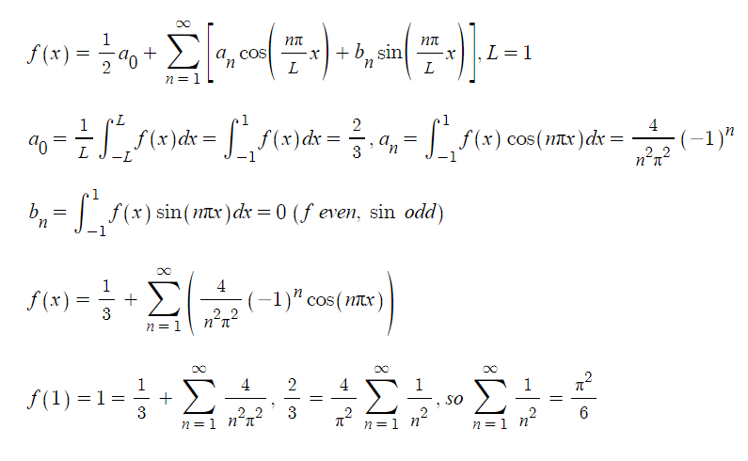

8.

a.

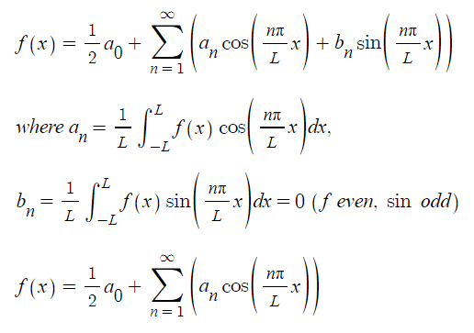

b.

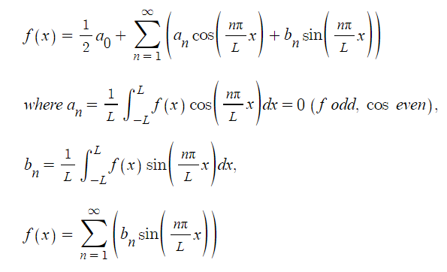

18.

a.

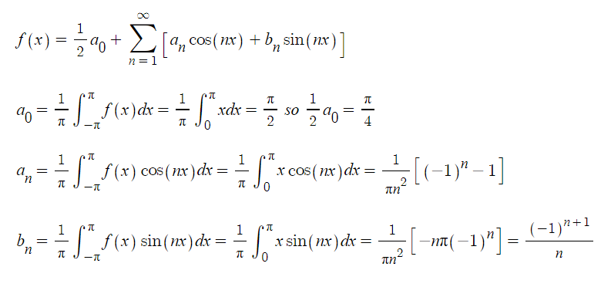

b.

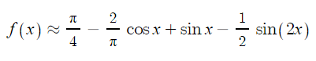

c.

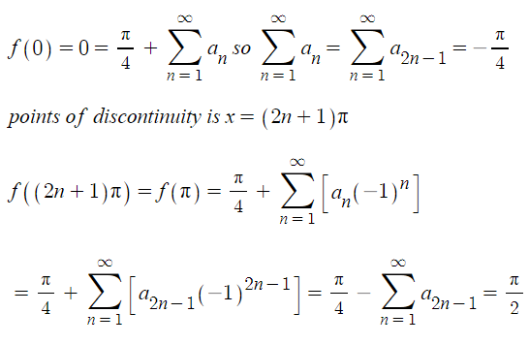

the fourier transformation of a piecewise continuous function passes through the middle points at the points of discontinuity.

d.

blue : N=5

green : N=10

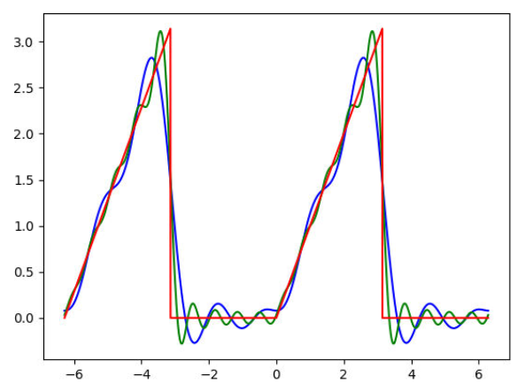

blue : N=15

green : N=20

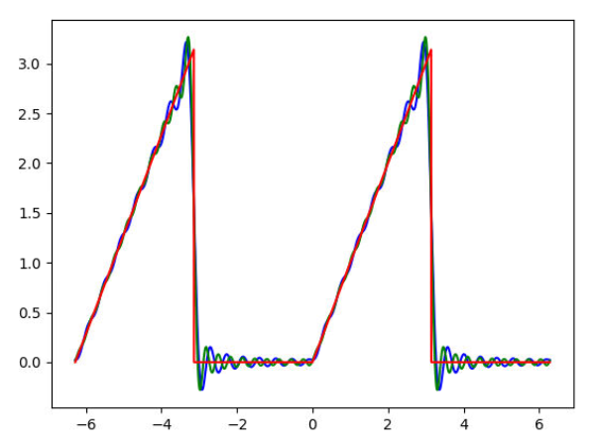

Com

2.

refer to 9.4.2.py

a.

when n=5

(0.30901699437494745+0.9510565162951535j)

(-0.8090169943749473+0.5877852522924732j)

(-0.8090169943749476-0.587785252292473j)

(0.30901699437494723-0.9510565162951536j)

(1-2.4492935982947064e-16j)

b.

omega(1) (0.30901699437494745+0.9510565162951535j)

omega(1)\*\*5 (0.9999999999999999-1.1102230246251565e-16j)

omega(2) (-0.8090169943749473+0.5877852522924732j)

omega(2)\*\*5 (1-6.661338147750939e-16j)

omega(3) (-0.8090169943749476-0.587785252292473j)

omega(3)\*\*5 (1.0000000000000002-8.881784197001252e-16j)

omega(4) (0.30901699437494723-0.9510565162951536j)

omega(4)\*\*5 (1-1.1102230246251565e-15j)

omega(5) (1-2.4492935982947064e-16j)

omega(5)\*\*5 (1-1.2246467991473533e-15j)

c.

sum (-2.220446049250313e-16-1.3390705736695499e-16j)

sum of squares -2.6781411473390997e-16j

product (1-8.00040872142049e-16j)

d.

n 2 det (-2+8.572527594031472e-16j)

n 3 det (-3.749777238447949e-15-5.196152422706631j)

n 4 det (-1.2706639012108669e-14-15.999999999999998j)

n 5 det (-55.90169943749471+3.4134844607149996e-14j)

n 6 det (216.00000000000006-2.9976021664879237e-13j)

n 7 det (1.309775076845045e-12+907.4926996951548j)

n 8 det (5.911715561524029e-12+4095.9999999999986j)

n 9 det (19683.000000000007-3.4964031669915136e-11j)

n 10 det (-100000.00000000001+1.6209256159527288e-10j)

n 11 det (-1.9273179187178793e-09-534145.7391115276j)

n 12 det (-9.1165475168964e-09-2985984.000000002j)

n 13 det (-17403307.34637107+1.352508676439851e-08j)

n 14 det (105413504.00000013-2.048068736826284e-07j)

n 15 det (3.4529678176925717e-06+661735513.9184074j)

6.

refer to 9.4.6.py

blue : N=5

green : N=10

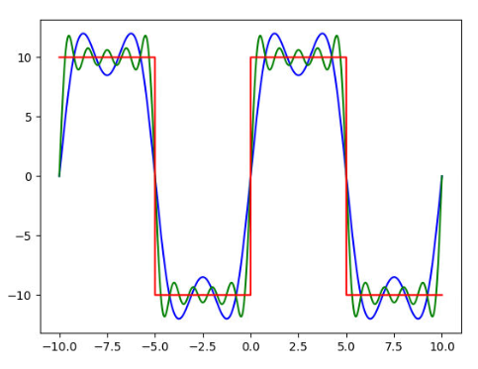

blue : N=15

green : N=20

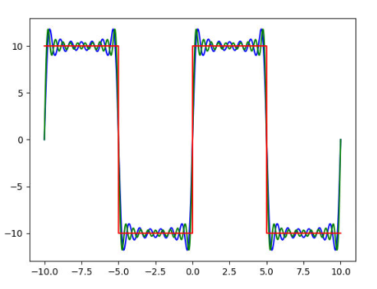

10.1

Com

1.

refer to 10.1.1.py

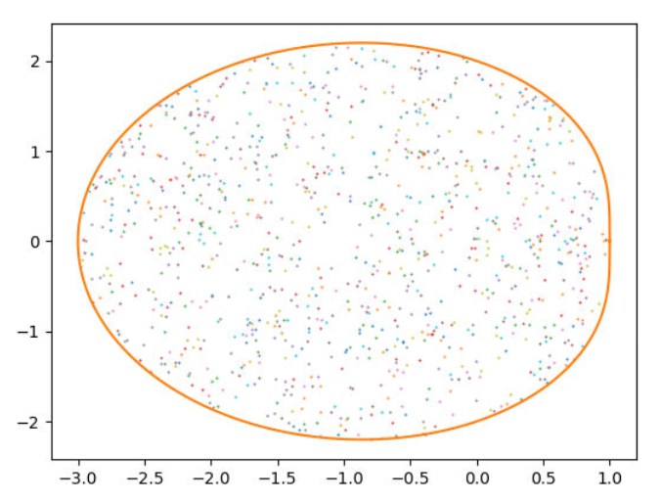

10.2

Com.

3.

refer to 10.2.3.py

monte 3.1536

anal 3.141592653589793

18.

refer to 10.2.18.py

since the max value is c, the area under the graph is in the rectangle defined by two ranges about x and y.

using monte carlo method, the area can be approximated with random points in the area.

since the rectangle has the area of c(b-a), kc(b-a)/n is the approximation.

2.3572 (actual value : 2.3333333333333333)

1.1694 (actual value : 1.1666666666666667)

1.0372 (actual value : 1.0414067516069045)

24.

refer to 10.2.24.py

41470334315794.57

10.3

Com

1.

refer to 10.3.1.py

0.666097

anal : 0.666666667

12.

refer to 10.3.12.py

0.23401

17.

refer to 10.3.17.py

0.0132