9.1

3.

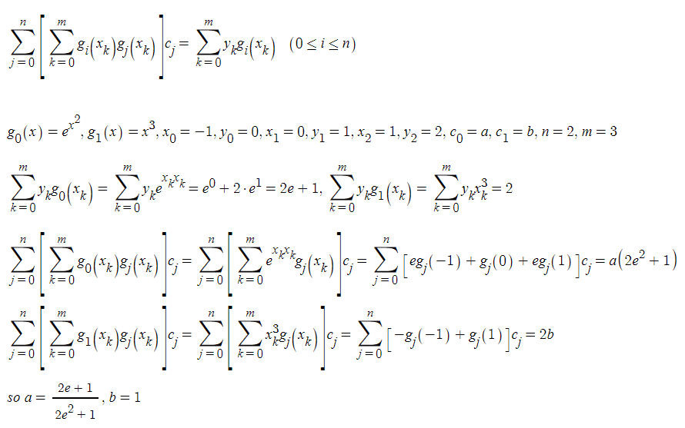

8.

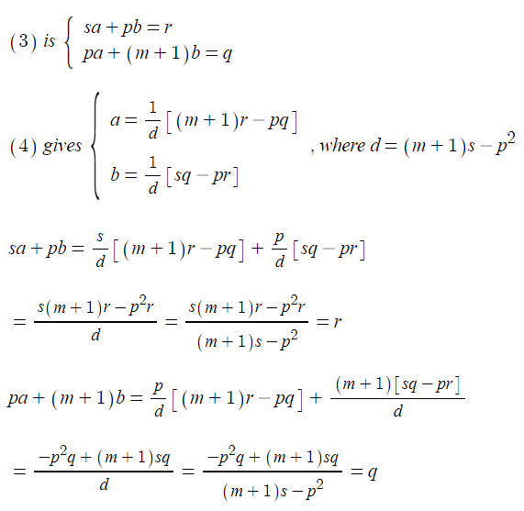

for it to have a solution, d should not be 0.

9.

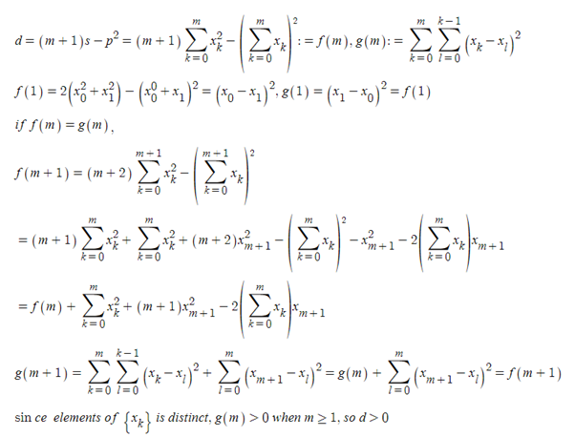

10.

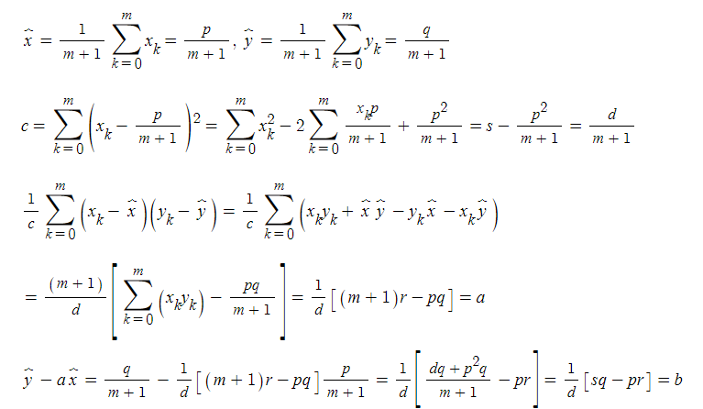

13.

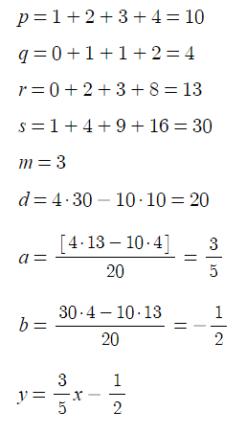

18.

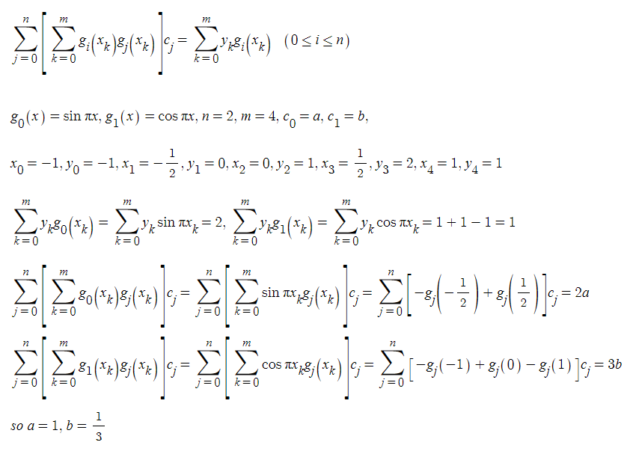

Com

3

x [-5. -4. -3. -2. -1. 0. 1. 2. 3. 4. 5.]

y [ 3. 3.5 1. 3.5 5. 0.5 3. 2.5 -2. -2.5 2. ]

a -0.38181818181818183 b 1.7727272727272727

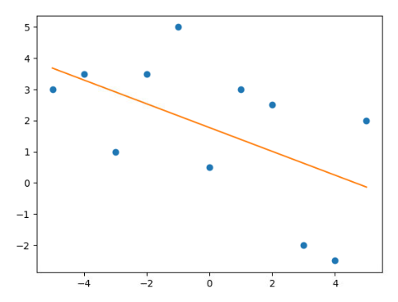

9.2

1.

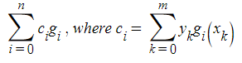

3.

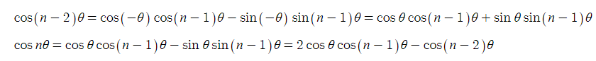

4.

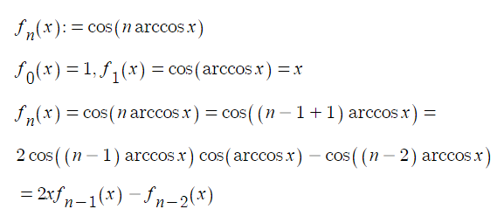

5.

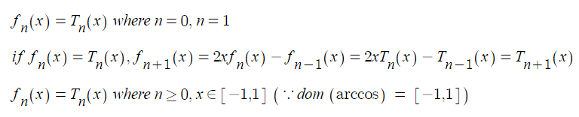

6.

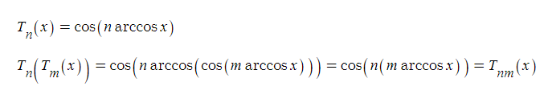

7.

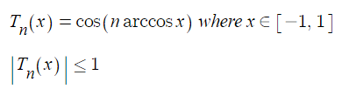

18. a 19. b

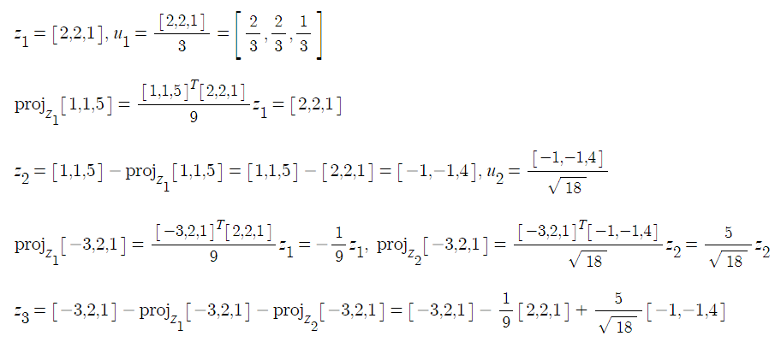

Com

10.

a. refer to 9.2.10.py

using existing library

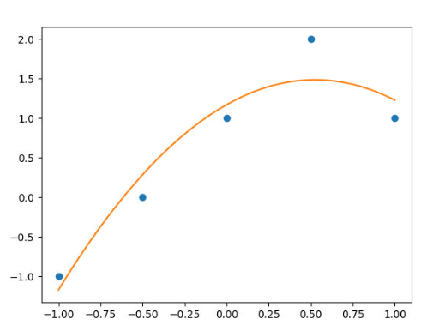

[ 0.6 1.2 -0.57142857]

corresponds to 1, x, 2x^2-1 in order.

Gaussian elimination gives the same result

[0.6, 1.2, -0.5714285714285714]

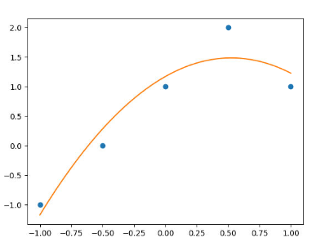

9.3

3.

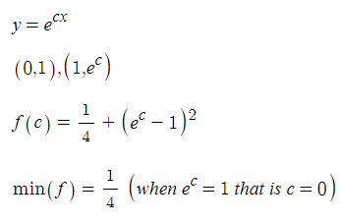

4.

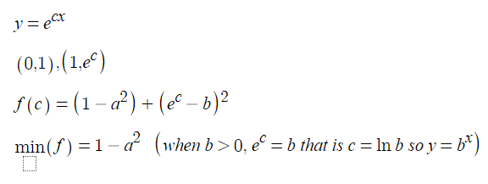

8.

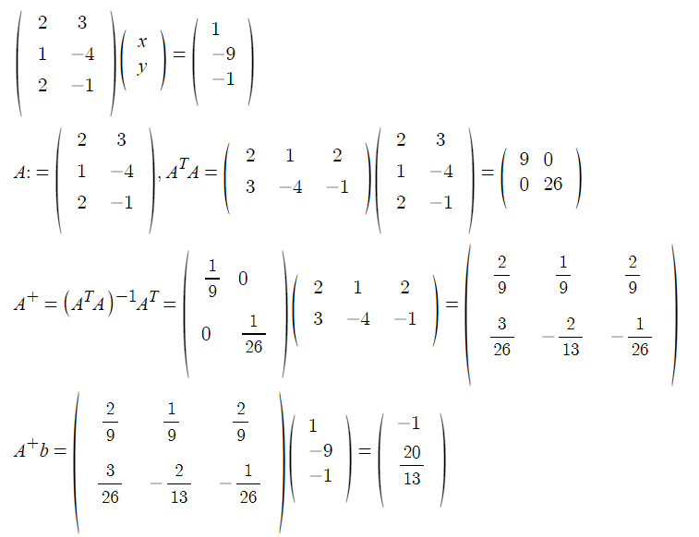

16.

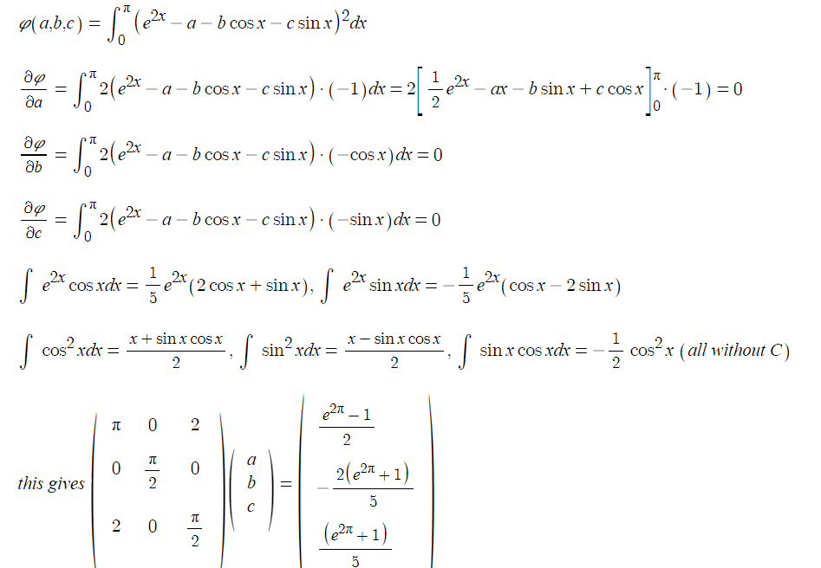

26.

d



b is not true since non square matrix doesn’t have an inverse

27.

c

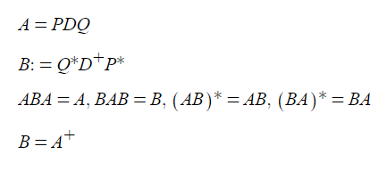

Com

4.

refer to 9.3.4.py

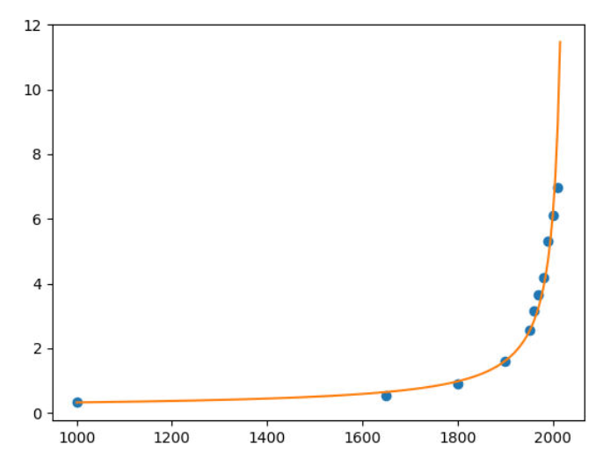

around 2030, the population becomes infinite

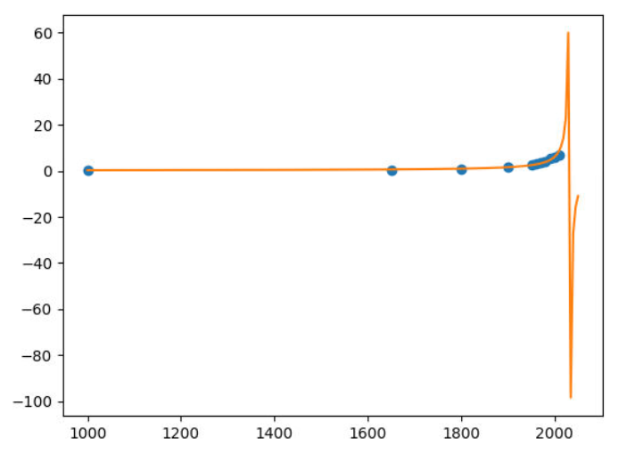

a, b, c is as follows

[ 2.32719099e-01 -6.71398406e-05 -4.92061543e-04]