13.1

5

a.

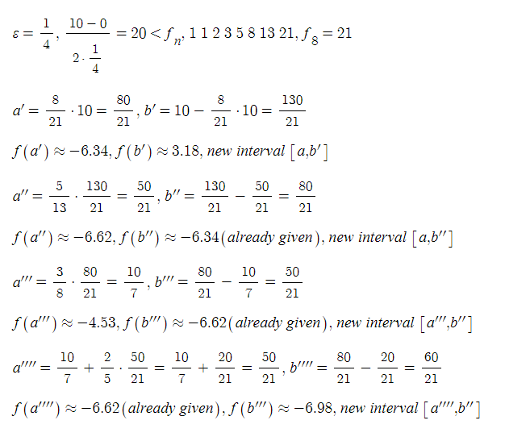

7.

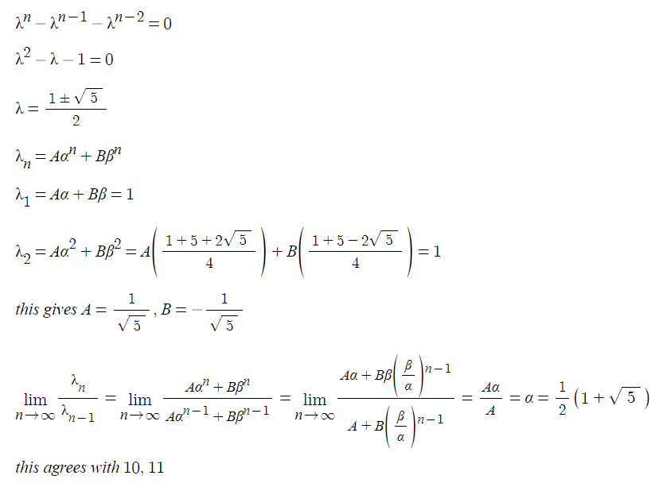

10.

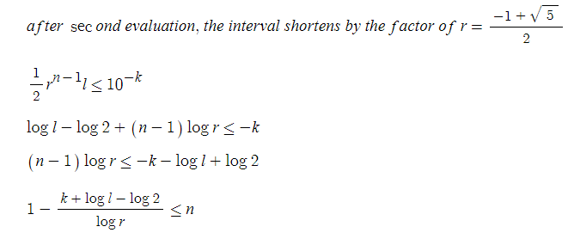

11.

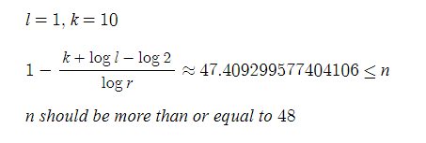

12.

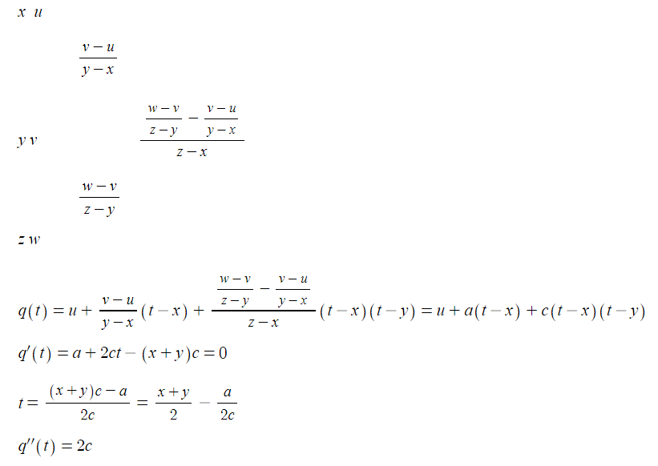

15.

a.

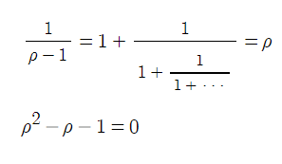

b.

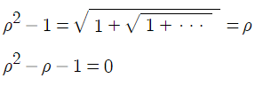

c.

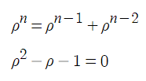

d.

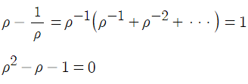

16.

a since f is at least partly decreasing as it goes from y to x

Com

2.

a.

refer to 13.1.2.py

after 47 iterations with error bound of 10\*\*(-10)

0 1.4612117136544081e-10

13.2

7.

a.

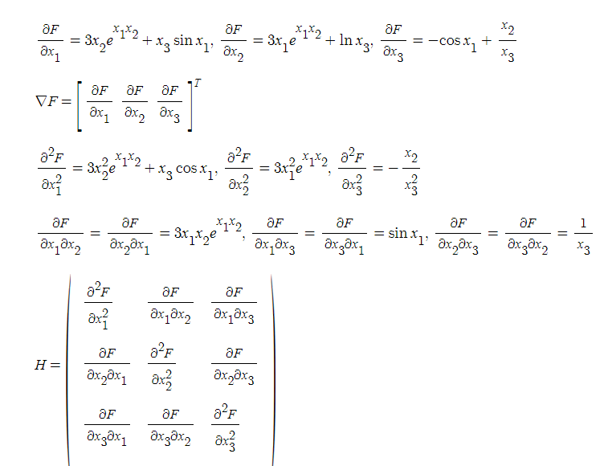

b.

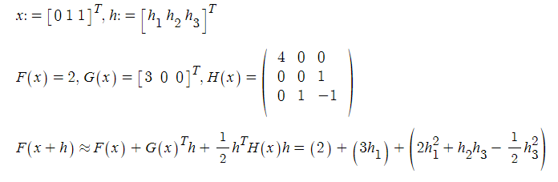

c.

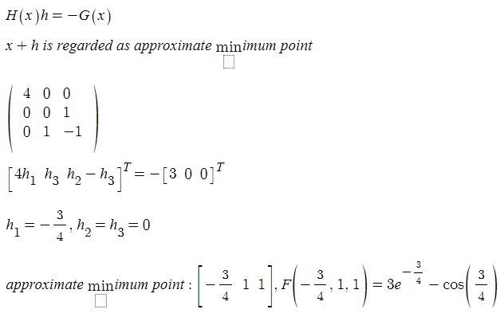

12.

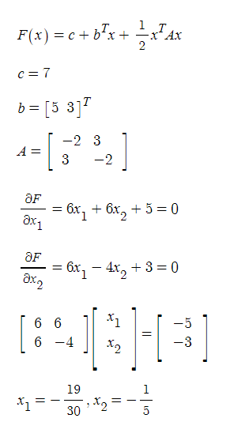

20.

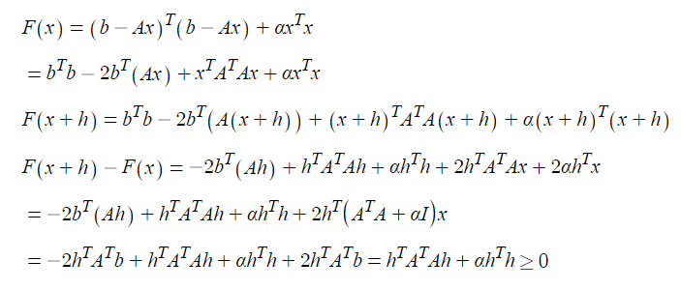

21.

d.

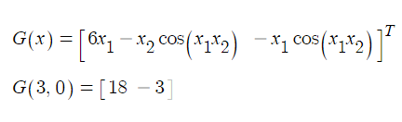

22.

a.

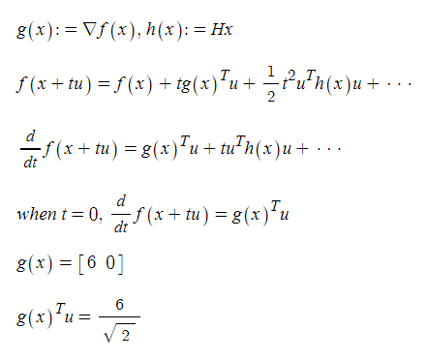

23.

c.

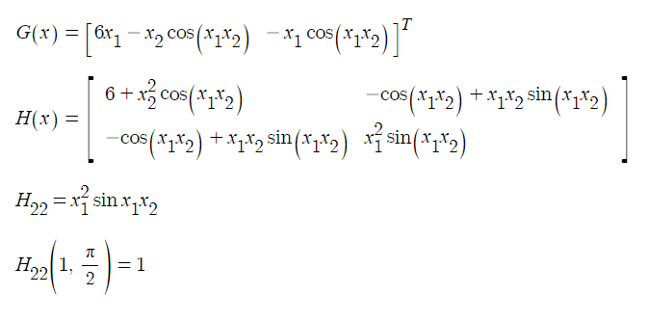

24.

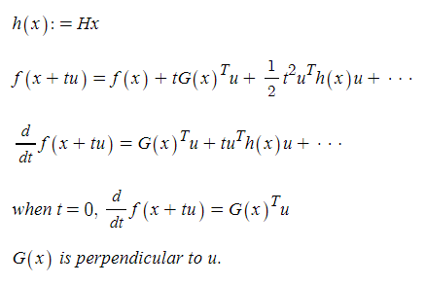

25.

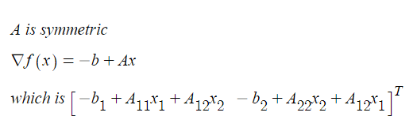

Com

1.

refer to 13.2.1.py

a.

resulting value 8.177661197416674e-10

where x=[1.00002202, 1.00004222]

e.

resulting value -668.5593031185017

where x=[7.15947776e-04, -6.97374668e+00, 8.91578556e+00, 7.94961694e+01]