12.1

9.

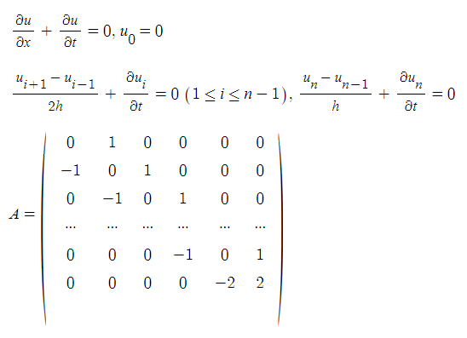

12.

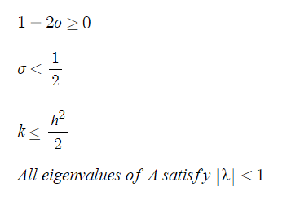

so b

13.

c

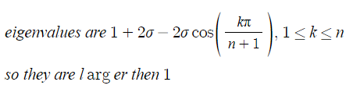

Com

1.

refer to 12.1.1.py

when t=0.125

[0, 0.01462928727111331, 0.028696358985372115, 0.04166061204037114, 0.053023835387358526, 0.06234935670159955, 0.06927882009243586, 0.07354595122841577, 0.07498678301183145, 0.07354595122841577, 0.06927882009243586, 0.06234935670159955, 0.053023835387358526, 0.04166061204037114, 0.028696358985372115, 0.01462928727111331, 0]

12.2

2.

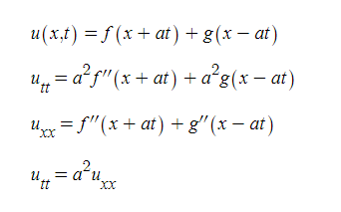

4.

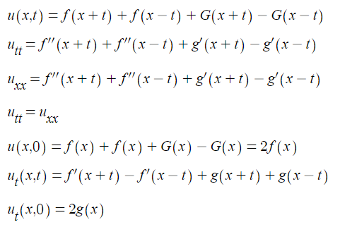

Com

7.

refer to 12.2.7.py

[0.0, -0.09999999999999998, -0.19999999999999996, -0.30000000000000004, -0.4, -0.5, -0.6000000000000001, -0.7000000000000001, -0.8, -0.9, -1.0, -0.8999999999999999, -0.7999999999999998, -0.7, -0.5999999999999999, -0.5, -0.3999999999999999, -0.2999999999999998, -0.19999999999999996, -0.09999999999999987, 0.0]

after 20 iterations

[0, -0.028381055268255462, -0.016735385703214395, 0.012726380813092006, 0.0038318732285913676, -0.0107614986222873, 0.008694996511985437, -0.0040089332121173715, 0.00021438046696789503, 0.0019083490916270152, -0.0025620923661337364, 0.0019083490916270013, 0.00021438046696807544, -0.004008933212117746, 0.00869499651198509, -0.010761498622287535, 0.0038318732285912427, 0.012726380813092186, -0.016735385703213534, -0.028381055268255156, 0]

12.3

1.

a.

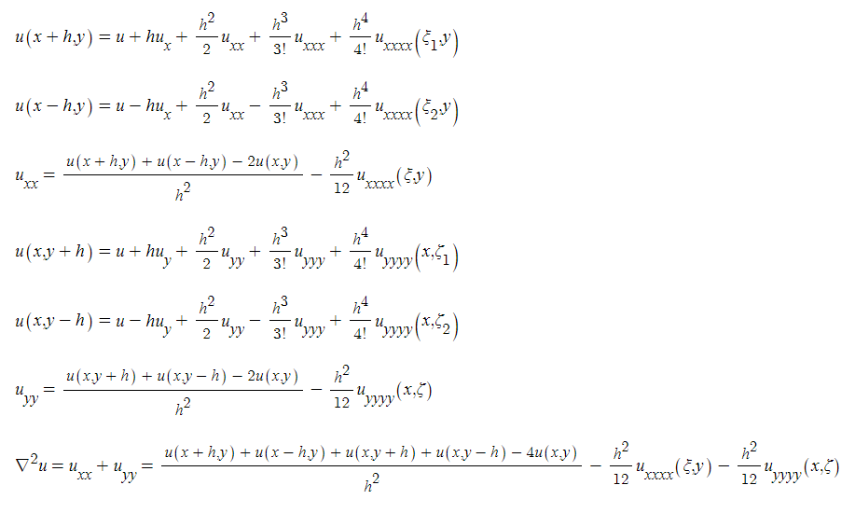

b.

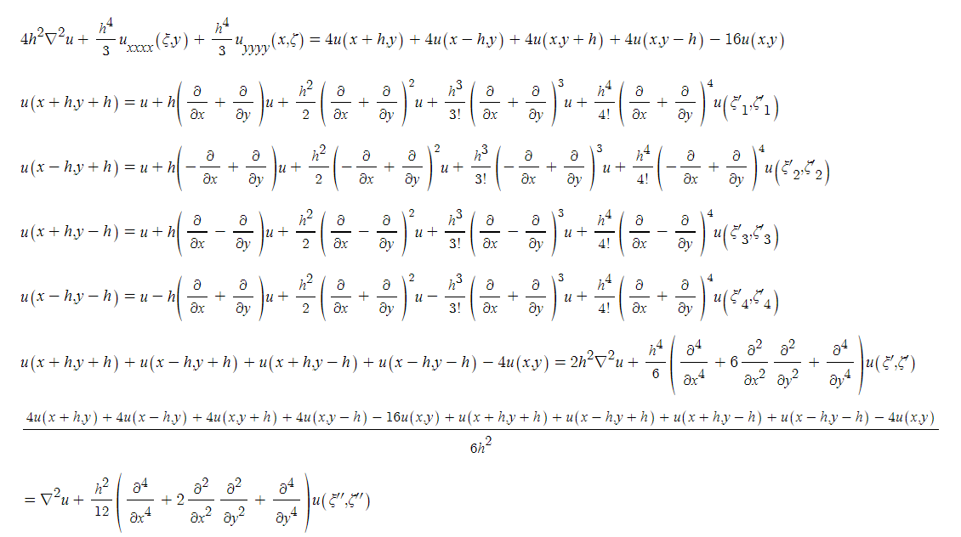

3.

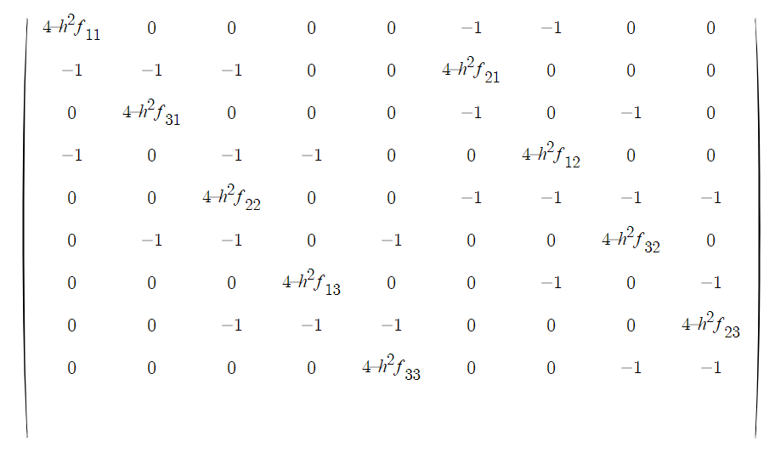

7.

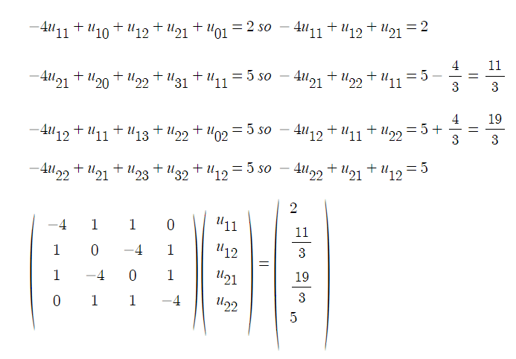

10.

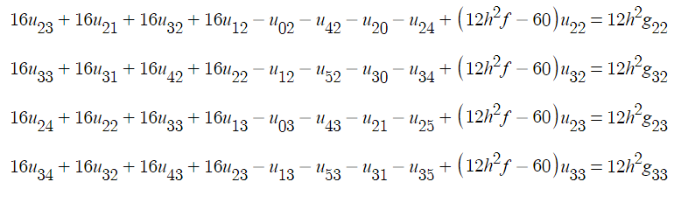

it has higher accuracy but the formula has more terms which means it takes more time to compute.

Com

2.

refer to 12.3.2.py

h=0.1, u=xy, 15 iterations

y=1.5-h percent error

before

0.0% -176.4228631237918% -161.46690324253098% -148.66535977155814% -137.74363298584663% -128.45987618184193% -120.60124870560077% -113.98058551531933% -108.43343793354165% -103.81544510247618% -100.0% -96.87617775792197% -94.34689749614965% -92.32729198978515% -90.74326225959115% -89.53019665441555% -88.63183620812453% -87.99927003120777% -87.59004626341861% -87.36738569092674% 0.0%

after

0.0% -6.016825467293399% -10.343873994719372% -13.252485696144433% -15.04255197838234% -16.0049870329766% -16.394650009750144% -16.415612539443273% -16.215073641176225% -15.880481634346047% -15.437729452206042% -14.85461359115794% -14.057093597549516% -12.96132152986944% -11.513988306609155% -9.725413951765706% -7.680859062457659% -5.525372112380108% -3.429473514485362% -1.550024247046152% 0.0%

h=0.2, u=0, 20 iterations

y=1.5-h percent error

before

0.0% -100.0% -100.0% -100.0% -100.0% -100.0% -100.0% -100.0% -100.0% -100.0% 0.0%

after

0.0% -3.4022081074961754% -5.124106093717433% -5.6016333075998865% -5.2332836615687865% -4.3655474678118% -3.281928408069396% -2.1950735539737396% -1.245122542668774% -0.5061409184525298% 0.0%

h=0.25, u=(1+x)(1+y), 40 iterations

y=1.5-h percent error

before

0.0% -65.88265039116436% -46.858762816635846% -37.9203443023191% -35.53642070645722% -37.244642458254106% -41.35129408547476% -46.711732225583745% 0.0%

after

0.0% 0.0380490800546723% 0.052422105326232996% 0.061495211236217436% 0.06739777593159241% 0.06790725057844622% 0.059904374942316825% 0.03954261447755343% 0.0%

h=0.05, u=(1+x+1/2\*x^2)(1+y+1/2\*y^2), 100 iterations

y=1.5-h percent error

before

0.0% 6.446225549982739% 2.0122989415312977% -1.761945372806015% -4.953735654005604% -7.633193708454885% -9.863900093245968% -11.703418376084446% -13.203781231842179% -14.411940977347795% -15.370186976870478% -16.1165321922265% -16.685071002870572% -17.10631028212428% -17.40747558526345% -17.61279418300018% -17.74375655944726% -17.819357886465998% -17.856320885928284% -17.869301397447714% -17.871077881159085% -17.872726002780087% -17.88377937112228% -17.91237742610708% -17.96540140787333% -18.048599274452716% -18.166700376460344% -18.323520642049758% -18.52205897377286% -18.764585510739433% -19.052722364379388% -19.387517393973617% -19.769511548749673% -20.198800266562365% -20.675089384833257% -21.197745987350313% -21.76584458058774% -22.378208965259812% -23.033450142742005% -23.730000571662362% 0.0%after

0.0% -0.048063193660121455% -0.09142417822940986% -0.13073958307281372% -0.1665653000127085% -0.19935901825137237% -0.22948830759518668% -0.2572402389703341% -0.2828310018633753% -0.3064147847353928% -0.3280915551246757% -0.3479136246781965% -0.36589108748355575% -0.38199638896065596% -0.3961684101410763% -0.40831652806924273% -0.41832512934648236% -0.426059007490705% -0.43136996889325785% -0.4341048161440167% -0.43411468657544755% -0.4312655177252293% -0.4254492122818359% -0.41659490542754507% -0.4046796174988272% -0.38973752006542695% -0.3718670628191305% -0.3512353032299263% -0.3280789438767091% -0.30270179940891534% -0.27546866616375393% -0.2467958289443699% -0.2171386869708565% -0.1869771922595001% -0.15679995132276692% -0.12708793567413607% -0.09829878086778215% -0.07085265255713827% -0.04512070036648792% -0.021417454438856967% 0.0%

h=0.25, u=1+xy, 200 iterations

y=1.5-h percent error

before

0.0% -96.20918337679603% -82.28625427221195% -74.70828841946334% -71.34952031398099% -70.71416648051859% -71.76173418930266% -73.77878887290629% 0.0%

after

0.0% 0.08383271368512542% 0.11458362821471933% 0.12117864925639629% 0.11487349288613845% 0.10014371739854364% 0.078038745985676% 0.04675644140158551% 0.0%